Eric Webb
Final Project Description and Requirements
MSIT 630 Database Systems (Summer 2019)
Total: 36 points
Due date: 7/28/2019 11:59PM

Project Report

Description.

This is a database for a music application. This application will hold users, songs, artist, and playlists. Users can add songs to their playlists and the playlists will hold the songs id. Many users can have many playlists. Many Playlists can have multiple songs. One song can only belong to one album. One song can only belong to one artist. One artist can have many songs. The database language is MySQL and is hosted was hosted on Amazon Web Services.

Design and Implementation

E-R Diagram.
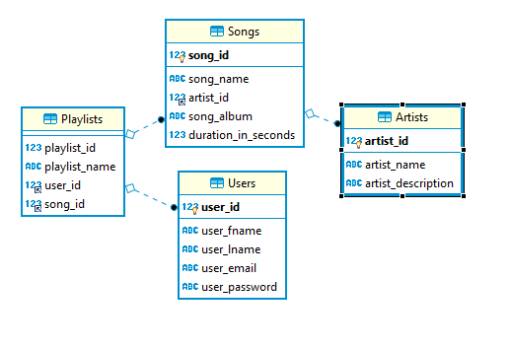
Users
The primary key “user_id” will be an auto incrementing integer with a not null constraint.
Users will have a “user_fname” which will be a varchar max of 20 characters and a not null constraint.
Users will have a “user_lname” which will be a varchar max of 20 characters and a not null constraint.
Users will have an “email” which will be a varchar max of 20 characters and a not null constraint.
Users will have a “password” which will be a varchar max of 20 characters and a not null constraint.
One user can have many playlists. This is a one to many relationship.
This table is in 3rd normal form.
create table if not EXISTS Users(
user_id INT NOT NULL AUTO_INCREMENT,
user_fname VARCHAR(20) NOT NULL,
user_lname VARCHAR(20) NOT NULL,
user_email VARCHAR(20) NOT NULL,
user_password VARCHAR(20) NOT NULL,
PRIMARY KEY ( user_id )
)ENGINE INNODB;
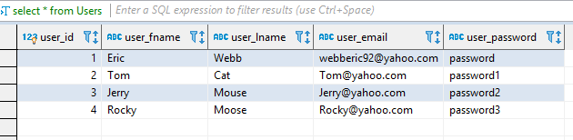
Artists
The primary key “artist_id” will be an auto incrementing integer with a not null constraint.
Artists will have a “name” which will be a varchar max of 20 characters and a not null constraint.
Artists will have a “description” which will be a varchar max of 60 characters and a not null constraint.
This table is in 3rd normal form.

create table if not EXISTS Artists(
artist_id INT NOT NULL AUTO_INCREMENT,
artist_name VARCHAR(20) NOT NULL,
artist_description VARCHAR(60) NOT NULL,
PRIMARY KEY ( artist_id )
)ENGINE INNODB;
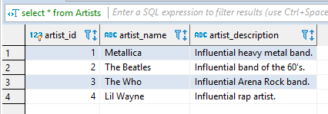

Songs
The primary key “song_id” will be an auto incrementing integer with a not null constraint.
Songs will have a “song_name” which will be a varchar max of 50 characters and a not null constraint.
Songs will have a foreign key “artist_id” which will be an integer with a not null constraint.
Songs will have a “song_album” which will be a varchar max of 50 characters and a not null constraint.
Songs will have a “duration_in_seconds” which will be an integer with a not null constraint.
One song can have one Artist, this is a one-to-one relationship.
This table is in third normal form.

create table if not EXISTS Songs(
song_id INT NOT NULL AUTO_INCREMENT,
song_name VARCHAR(50) NOT NULL,
artist_id INT NOT NULL,
song_album VARCHAR(50) NOT NULL,
duration_in_seconds INT NOT NULL,
PRIMARY KEY ( song_id ),
FOREIGN KEY artist_id(artist_id)
REFERENCES Artists(artist_id)
ON UPDATE CASCADE
ON DELETE RESTRICT
)ENGINE INNODB;
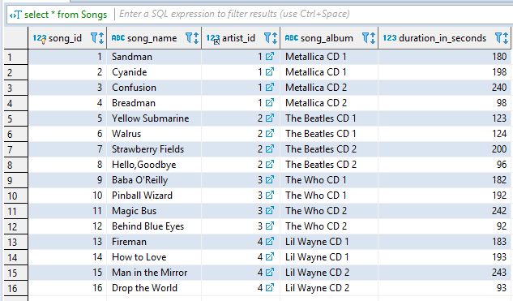

Playlists
The primary key “playlist_id” will be an auto incrementing integer with a not null constraint.
Playlists will have a “playlist_ name” which will be a varchar max of 50 characters and a not null constraint.
Playlists will have a foreign key “user_id” which will be an integer with a not null constraint.
Playlists will have a foreign key “song_id” which will be an integer with a not null constraint.
Many playlists can have many songs. This is a many to many relationship.
This table is in 3rd normal form.

create table if not EXISTS Playlists(
playlist_id INT NOT NULL,
playlist_name VARCHAR(50) NOT NULL,
user_id int NOT NULL,
song_id INT NOT NULL,
FOREIGN KEY user_id(user_id)
REFERENCES Users(user_id)
ON UPDATE CASCADE
ON DELETE RESTRICT,
FOREIGN KEY song_id(song_id)
REFERENCES Songs(song_id)
ON UPDATE CASCADE
ON DELETE RESTRICT
)ENGINE INNODB;
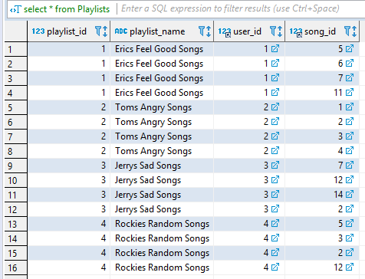

Queries
Multi-table queries;
- This query returns all the songs from Eric’s playlists.
select DISTINCT Songs.song_id,Songs.song_name from Songs, Playlists where Songs.song_id = Playlists.song_id and Playlists.playlist_name = "Erics Feel Good Songs" ;
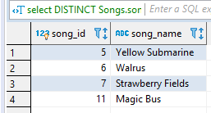

- This query returns the users and playlists that have Metallica’s Cyanide song except for Tom’s playlist. This query also uses a group by having.
select DISTINCT Users.user_fname,Users.user_lname,Playlists.playlist_name,Songs.song_name from Users,Playlists,Songs where Playlists.user_id = Users.user_id and Playlists.song_id =2 group by Users.user_fname having not user_fname= "Tom";
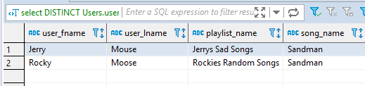

Aggregate function queries;

- This query returns the average time of all songs in each album
SELECT song_album,AVG(duration_in_seconds) as avgTime FROM Songs group by song_album;
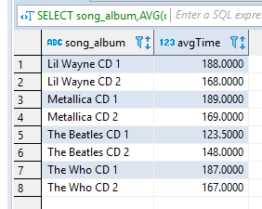

- This query returns the average time of all songs in each album having greater than the average time of the songs in Metallica’s second CD. This Query is also has a sub query and uses group by having.
SELECT song_album,AVG(duration_in_seconds) as avgTime FROM Songs group by song_album having avgTime > (select AVG(duration_in_seconds)from Songs where song_album = "Metallica CD 2");
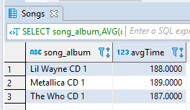

Sub-query;
- This query returns the minimum song on all albums who are longer than the minimum song from Metallica (98 seconds.)
select song_album,song_name, min(duration_in_seconds)as minAlbumSongTime from Songs group by song_album having minAlbumSongTime > (select min(duration_in_seconds) from Songs where artist_id = 1);
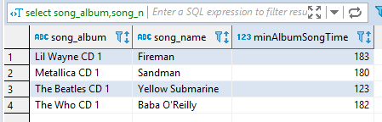

NULL query;
- This query returns all playlists from playlist ID where playlist ID in Not Null. (Returns all.)
select distinct playlist_id,playlist_name from Playlists where playlist_id is not null;
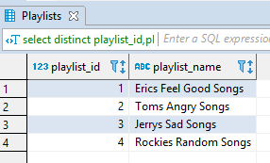

Complete list of statements.

drop table if exists Users;
create table if not EXISTS Users(
user_id INT NOT NULL AUTO_INCREMENT,
user_fname VARCHAR(20) NOT NULL,
user_lname VARCHAR(20) NOT NULL,
user_email VARCHAR(20) NOT NULL,
user_password VARCHAR(20) NOT NULL,
PRIMARY KEY ( user_id )
)ENGINE INNODB;

drop table if exists Artists;
create table if not EXISTS Artists(
artist_id INT NOT NULL AUTO_INCREMENT,
artist_name VARCHAR(20) NOT NULL,
artist_description VARCHAR(60) NOT NULL,
PRIMARY KEY ( artist_id )
)ENGINE INNODB;

drop table if exists Songs;
create table if not EXISTS Songs(
song_id INT NOT NULL AUTO_INCREMENT,
song_name VARCHAR(50) NOT NULL,
artist_id INT NOT NULL,
song_album VARCHAR(50) NOT NULL,
duration_in_seconds INT NOT NULL,
PRIMARY KEY ( song_id ),
FOREIGN KEY artist_id(artist_id)
REFERENCES Artists(artist_id)
ON UPDATE CASCADE
ON DELETE RESTRICT
)ENGINE INNODB;

drop table if exists Playlists;
create table if not EXISTS Playlists(
playlist_id INT NOT NULL,
playlist_name VARCHAR(50) NOT NULL,
user_id int NOT NULL,
song_id INT NOT NULL,
FOREIGN KEY user_id(user_id)
REFERENCES Users(user_id)
ON UPDATE CASCADE
ON DELETE RESTRICT,
FOREIGN KEY song_id(song_id)
REFERENCES Songs(song_id)
ON UPDATE CASCADE
ON DELETE RESTRICT
)ENGINE INNODB;

insert into Users ( user_fname,user_lname,user_email,user_password)
values
("Eric","Webb","webberic92@yahoo.com","password"),
("Tom","Cat","Tom@yahoo.com","password1"),
("Jerry","Mouse","Jerry@yahoo.com","password2"),
("Rocky","Moose","Rocky@yahoo.com","password3");

insert into Artists (artist_name,artist_description)
values
("Metallica","Influential heavy metal band."),
("The Beatles","Influential band of the 60's."),
("The Who","Influential Arena Rock band."),
("Lil Wayne","Influential rap artist.");

insert into Songs (song_name,artist_id,song_album,duration_in_seconds)
values
("Sandman",1,"Metallica CD 1", 180),
("Cyanide",1,"Metallica CD 1", 198),
("Confusion",1,"Metallica CD 2", 240),
("Breadman",1,"Metallica CD 2", 98),
("Yellow Submarine",2,"The Beatles CD 1", 123),
("Walrus",2,"The Beatles CD 1", 124),
("Strawberry Fields",2,"The Beatles CD 2", 200),
("Hello,Goodbye",2,"The Beatles CD 2", 96),
("Baba O'Reilly",3,"The Who CD 1", 182),
("Pinball Wizard",3,"The Who CD 1", 192),
("Magic Bus",3,"The Who CD 2", 242),
("Behind Blue Eyes",3,"The Who CD 2", 92),
("Fireman",4,"Lil Wayne CD 1", 183),
("How to Love",4,"Lil Wayne CD 1", 193),
("Man in the Mirror",4,"Lil Wayne CD 2", 243),
("Drop the World",4,"Lil Wayne CD 2", 93)
;

insert into Playlists (playlist_id,playlist_name,user_id,song_id)
VALUES
(1,"Erics Feel Good Songs",1,5),
(1,"Erics Feel Good Songs",1,6),
(1,"Erics Feel Good Songs",1,7),
(1,"Erics Feel Good Songs",1,11),
(2,"Toms Angry Songs",2,1),
(2,"Toms Angry Songs",2,2),
(2,"Toms Angry Songs",2,3),
(2,"Toms Angry Songs",2,4),
(3,"Jerrys Sad Songs",3,7),
(3,"Jerrys Sad Songs",3,12),
(3,"Jerrys Sad Songs",3,14),
(3,"Jerrys Sad Songs",3,2),
(4,"Rockies Random Songs",4,5),
(4,"Rockies Random Songs",4,3),
(4,"Rockies Random Songs",4,2),
(4,"Rockies Random Songs",4,12);

select * from Users;
select * from Artists;
select * from Songs;
select * from Playlists;

select DISTINCT Songs.song_id,Songs.song_name from Songs, Playlists where Songs.song_id = Playlists.song_id and Playlists.playlist_name = "Erics Feel Good Songs" ;
select DISTINCT Users.user_fname,Users.user_lname,Playlists.playlist_name,Songs.song_name from Users,Playlists,Songs where Playlists.user_id = Users.user_id and Playlists.song_id =2 group by Users.user_fname having not user_fname= "Tom";
SELECT song_album,AVG(duration_in_seconds) as avgTime FROM Songs group by song_album;
SELECT song_album,AVG(duration_in_seconds) as avgTime FROM Songs group by song_album having avgTime > (select AVG(duration_in_seconds)from Songs where song_album = "Metallica CD 2");
select song_album,song_name, min(duration_in_seconds)as minAlbumSongTime from Songs group by song_album having minAlbumSongTime > (select min(duration_in_seconds) from Songs where artist_id = 1);
select distinct playlist_id,playlist_name from Playlists where playlist_id is not null;

