RESD 700 Fall Term 2022
Eric Webb
Assignment 700-2

Exercise 6.1: A Foreman Thinks . (107)
A foreman thinks that the low efficiency of the machine tool operators is directly linked to the high level of fumes emitted in the workshop. He would like to prove this to his supervisor through a research study.
1. Would this be a causal or a correlational study? Why? (5 marks)
This would be a causal because the operator wants to prove a cause and effect relationship that high level of fumes cause low efficiency in operators.
2. Is this an exploratory, descriptive, or hypothesis-testing (analytical or predictive) study? Why?
This is an analytical study because the foreman wants show to his supervisor that fumes cause low efficiency in operators via an analysis of data correlating to a hypothesis test.
3. What kind of a study would this be : field study, lab experiment, or field experiment? Why?
This is a field experiment because it is set in a natural environment, the workshop. No change will have to take place besides the amount of fumes excreted. All else will be the operators normal work day.
4. What would be the unit of analysis? Why?
The unit of analysis would be the efficiency of each operator individually at different intervals of the high fume levels.
5. Would this be a cross-sectional or a longitudinal study? Why?
This is a longitudinal study because it is linear in time. This experiment would need to be repeated at different times with different levels of fumes, compared to multiple experiments at a single point in time.

Exercise 6.2 : Exposure to Thin or Heavy Models. (pg.107)
You want to examine how exposure to thin or heavy models in advertisements influences a person’s self-esteem. You believe that the effect of exposure to models in advertisements depends on the extremity of the model's thinness or heaviness. Discuss the design decisions that you as a researcher will make to investigate this issue, giving reasons for your choices.
This is a causal study because the extremeness of heavy and thin models in advertisements effects an influence on a persons self-esteem. It would be a longitudinal study because multiple samples would have to be collected over time after exposure to the models in advertisements. Different models from thin to heavy would have to be collected and accounted for discretely. Then multiple people would have to view advertisements with them and some with out models as a control. Immediately the person would fill out a self esteem survey to be analyzed based of the models they did or did not view.

Discussion Question 7: Scenario 1: (pg.109)

A specific department within an organization has a high turnover rate; employees of this department have a shorter average tenure than those of other departments in the company. Skilled workers are leaving and the worker population contains a high percentage of novice workers. Ms Joyce Lynn has no idea what is going on and wants to know more about what is happening.

a. Type of research question (exploratory, descriptive, or causal).
This will be exploratory because she is investigating the turnover rate. Currently she has no hypotheses to test a cause and effect relationship.

b. The extent of researcher interference.
The researcher interference is moderate because the researcher has to guide the research project and creates the open ended questions.

c. The study setting.
This is a Non-Contrived setting.

d. The research strategy.
The research strategy would be identifying what is causing the turnover rate. This could be influenced on working conditions, compensation, advancement, time off, etc. Surveys could be given to the current work force to observe their thoughts when there is less outside influence.

e. The time horizon for the study.
The time horizon would have to be before and after bias have occurred making the company seem more or less appetizing, such as recognition, awards, pay increases, holidays, recent time off, etc

f. The unit of analysis.
The unit of analysis would be the individual workers and how long they stay at the company.

Discussion Question 13: The Vital Role of Self-Esteem.(pg.189)
Why do some people earn more than others? Economists focused on the importance of education, basic skills, and work experience – what they called human capital – on increased productivity, and said these were reflected in greater earning power. Researchers also found that self-esteem was instrumental in acquiring human capital.
Sketch the theoretical framework and design a study
Study Introduction:
This will be a causal study in that the more human capital causes greater earning power. The argument being that the combination of education, basic skills, work experience, and self-esteem being independent variables with Human Capital being the moderating variable. The mediating variable is productivity and sits between Human Capital and the Dependent variable of earning power.
Variables:
Independent Variables | Moderating Variable | Mediating Variable | Dependent Variable
Education  Basic Skills  Work Experience  Self-Esteem | Human Capital | Productivity | Earning Power

Conceptual Model:
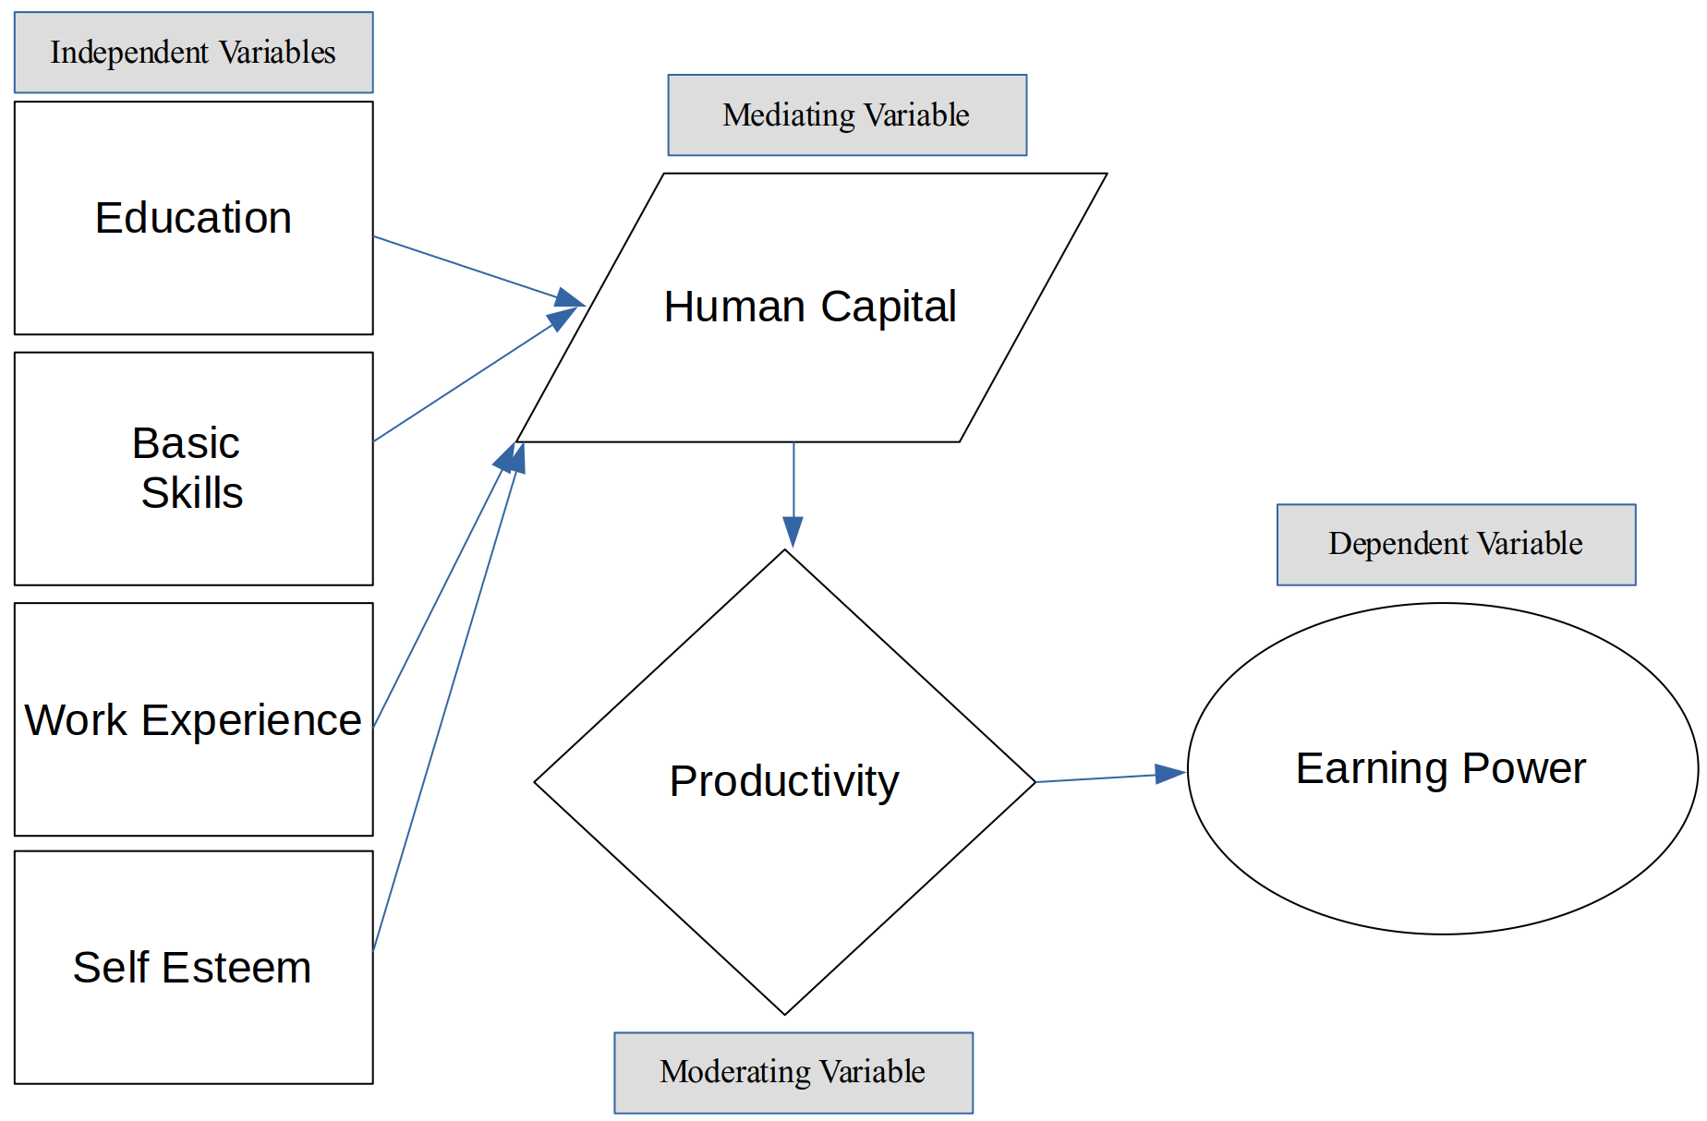
Hypotheses
Null Hypothesis : Self-Esteem , Skills, Education, and Experience does not cause greater earning power.
Directional Hypothesis : Self-Esteem , Skills, Education, and Experience do cause greater earning power.

Chapter 11 Exercise 5 (pg.180):
So, this researcher is investigating the impact of singing on the language skills of young children. He takes a group of 100 children (a nice big sample, right?) and teaches them to sing when they are 3 years of age and comes back 5 years later and assesses their language skills. He cries “Eureka!” throughout his building once he analyzes the results. What’s wrong here?
The issue here is that there is no control group. There needed to be a group of children of the same sample size but without singing lesson to compare. Also, other independent variables could have effected the outcome in the 5 years such as location and demographics.
Chapter 11 Exercise 7 (pg.180):
A group of children with emotional disorders is placed in a special program to improve the quality of their social interactions based on their extreme test scores. At the end of the program, the average increase in the quality of their interactions is 57%. What threat to internal validity negates the value of this finding, and what can you do to remedy the situation?
A few things threaten the internal validity, the first being Maturation. The children could be getting better test scores because of maturation and naturally increasing their quality of interactions. The second is Testing, since the children took a similar test before they might have been able to score higher on future ones.

Chapter 11 Exercise 8 (pg.180):
A physical trainer wants to compare the effects of two types of exercise programs on weight loss. He divides his clients into two groups: one focused on short-interval circuit training and one focused on a cardio warm-up followed by a free-weight workout. Without his knowledge, some of his clients have decided to cut out carbohydrates in their diet with the hope of increasing their weight loss. What type of threat to validity would the clients’ diet change introduce?
This is a threat to validity though history, because this experiment takes place over time, outside factors can create independent variables. In this case cutting out carbs is the independent variable that occurred on this timeline.

