7a.Read the attached article “Assessing Cyber Resilience: Cyber Dependencies.” Evans, 2017.
7a.I define in your own words the idea of Cyber Dependencies and provide an example for information security dependency.

In my own words cyber dependencies are information security critical hardware and software that projects needed to offer a minimal viable product. They work atomically in such that if one were to fail the whole operation would fail. All for one or one for all components of the project.

An example of this would be if you only had one certificate authority for your Public Key Infrastructure (PKI). At that point your PKI is cyber dependent on your single Certificate Authority.

7a.II. What are the ways in which one can measure the risks associated with Cyber Dependencies?

One way you can measure the risks associated with Cyber Dependencies is by using the Infrastructure Survey Tool (C-IST) tool developed by the Department of Homeland Security (DHS).

It is comprised of five parts that helps quantify security.
(1)Cybersecurity Management
(2)Cybersecurity Forces
(3)Cybersecurity Controls
(4) Incident Response
(5) Dependencies

The beauty of the C-IST tool is that “the methodology creates a composite index (the Cyber
Protection and Resilience Index, or CPRI) that reflects the relative effectiveness of an
organization’s cyber protection and resilience program as compared to that of other organizations
with similar critical cyber services (CCSs)” (Evans & Horsthemke, 2017. p. 5).

7a.III. Suggest a matrix measure to evaluate cyber dependencies.

Using the CPRI to to reflect and quantify CCSs into metric data can allow interpolation of that data and create a dependency curve (Evans & Horsthemke, 2017. p. 5). The dependencies curve is a great matrix because it allows you to see the effect of losing a dependency over time.
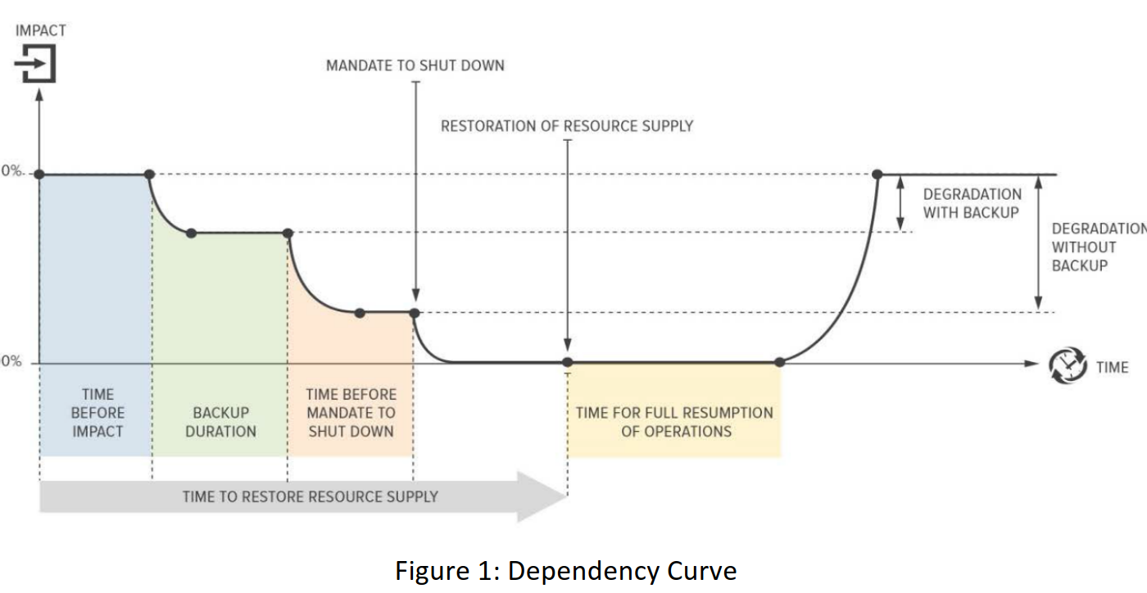

7b.Read the attached article “COBIT’s Management Guidelines Revisited: The KGIs/KPIs Cascade”. Grembergen and De Haes, 2005.

7b.I State in your own words what is the Balanced Scorecard (BSC)

The BSC uses performance drivers and outcome measures to help distinguish if investment strategies are effective.

BSC has 4 perspectives that help define domains to score.
Business contribution perspective
User perspective
Operational excellence perspective
Future perspective

(Grembergen & Haes, 2005)

7b.II In your opinion, what is the difference between the BSC, and key performance indicators(KPI) ? provide an example to support your answer.

KPI is a metric used within the balanced score card. An example of a KPI would be completing 10 points worth of work given a sprint dedicated to only 5 points. This would be a key performance indicator that performance is abundant in this category. A BSC would use this metric to decide if the project is over invested in this category or not.

7b.III. In your opinion, what are the top benefits to using the BSC, and KPI methods in the context of information security governance?

The benefit of using BSC it helps management decide if they are over or under invested in particular strategies. The KPI helps define the performance of these strategies while the KGI helps define the goals of the project. An example of this like mentioned earlier is KPIs for Jira story points and by contrast KGIs being Jira Epics that are key goals.

https://www.atlassian.com/agile/project-management/epics-stories-themes

7c.
Based on your reading of chapter 14, what are the main decision points that the CISO at your workplace/organization should make about information security operation? Provide a concrete answer rather then a generic description.

Since my current CISO is head of a very large defense contractor, very important decisions points need to be made. A specific example of a decision point is maintaining security within budget, unfortunately failing expectations on government contracts can be very disastrous for an organization. So securely developing a product within budget constraints and timelines are imperative. A more in depth example of this is when hiring contractors like myself. They can be great for short term gains without long term investment but increase risk because they are less vested in the success of the project and the organization. This along with other constrains such as work visas and security clearances need to be accounted for when defining decisions points.

References

Evans, N., Horsthemke, & W. (2017). Assessing Cyber Resilience: Cyber Dependencies. “Submitted by Argonne National Laboratory Department of Energy National Laboratory to CEUR Workshop Proceedings”.https://ceur-ws.org/Vol-2040/paper6.pdf

Grembergen, W., & Haes, S. (2005). COBIT's Management Guidelines Revisited: The KGIs/KPIs Cascade 1. Information Systems Audit and Control Association. www.isaca.org.

