RESD 700 Fall Term 2022
Eric Webb
Assignment 700-5

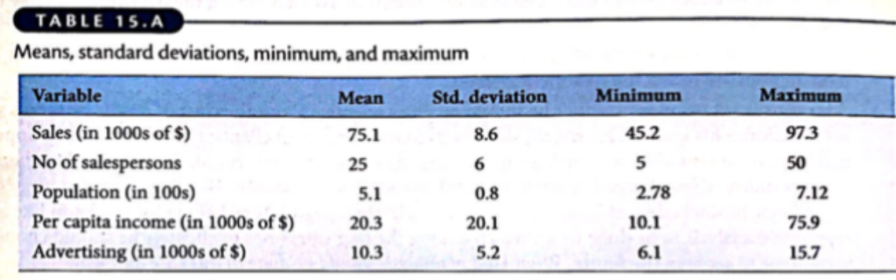
Table 15.A:
This table shows the distribution of the variables. Sales, Number of Sales, Population, and Advertising are all relatively uniformly distributed because the Minimum plus the Maximum divided by two is close to the mean of each variable. This means that Sales is pretty evenly distributed based off of the Population, Number of Salespersons , and amount spent on advertising. Per Capita Income is skewed to the right and is not uniformly distributed because its average of the Minimum and Maximum is way less than its mean value. This tells us that some salespersons are doing better than their colleagues regardless of the other variables.

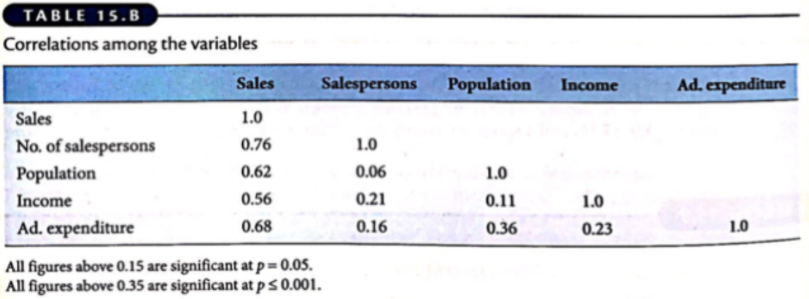
Table 15.B:
This table shows the correlations between the variables. From this we can see the highest correlation to sales is the Population and Number of Salespersons. Income has the lowest correlation with sales showing us that paying the salespersons more does not increase sales as much as the other factors do. What is shown is that the higher the income, the more salespersons will work. This is a mediating variable between Income and Sales.

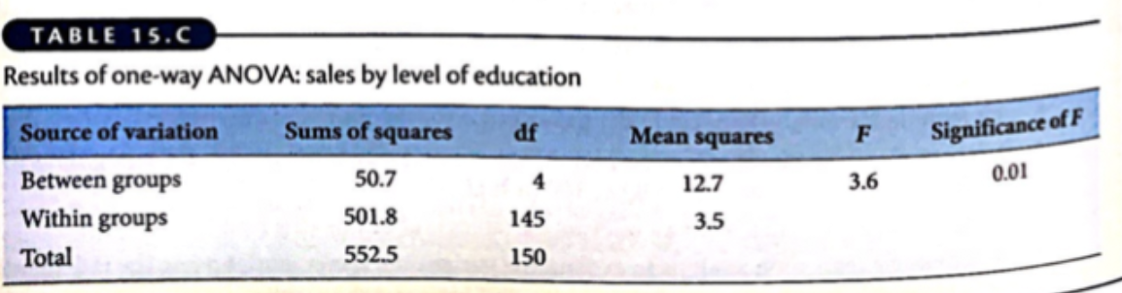
Table 15.C:
This table shows an analysis of covariance results. The independent variables being the levels of education and dependent variable being the sales. Degree of freedom is 4 meaning there are about 4 different independent variables of education levels. In this table it shows that the level of education affects sales, because the Significance of F is less than .05 weighing in a .01. This means that the independent variable of education level does weigh significantly. Since the F value is greatly higher than 1 weighing in at 3.6 this shows that it is most likely the most variance in the sample. Meaning that education level does persuade the variance of sales and probably affects it the most.

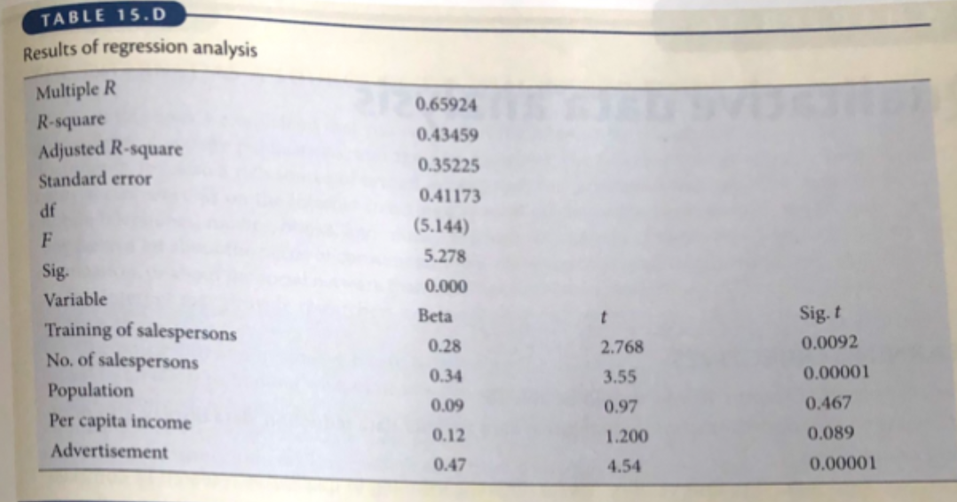
Table 15.D:
This table shows the results of the regression analysis. The dependent variable being sales and the independent variables being Number of Sales, Population, Training, Per Capita Income, and Advertisement. The R-square and the Adjusted R-square are below .50 meaning that on about 43% of our data explains that sales is our target dependent variable. Also sense R-square is different then Adjusted R-square it means some variables need to be dropped or the parameters need to be adjusted for a better result. If we look at the variables only three out of five seem to be significant. In this case the Beta value being over .20 meaning its significant or the Sig .T value being below .001. Since the F value is greater than 1 it shows the variance between groups is probably the greatest source of variance in the sample.

Dependent Variables:  -Sales Amount | Independent Variables:  - Number of salespersons  - Advertising  -Training of salespersons  - Per Capita Income

CEO Summary:
In conclusion, the amount of salespersons and amount spent on advertising are off and should be adjusted. They should be more relative to the population size. This will help allocate funds in buckets more efficiently to drive sales. Also from this analysis, the data indicates that income of salespersons do not indicate a strong correlation to sales.

Professional Recommendation:
- Base the number of salespersons and advertisement off of the areas population.
- Sales persons should be based off of performance to make an incentive for more sales.
- More variables could be provided like salespersons education and background territory to better analyze the data.

