Research-Worthy Problem Summary
The Research-Worthy Problem Summary section should include 500-words scholarly argumentation (learn what it is and how to make one in the resources above!) related to a well recognized (but not fully addressed) or emerging research-worthy problem in the context of information security, Cybersecurity Management, or cybersecurity. Start with a solid 'Statement of the Problem' that is backed by one to three solid peer-reviewed *journal* articles, followed by detailed argumentation sentences that further delineates the viability, magnitude, and impact of the problem, along with arguments for the benefits in *addressing* that research-worthy problem. Ensure all claims in this section are backed by solid peer-reviewed *journal* articles. You may incorporate one or two quote(s), especially as you introduce/define a concept or term that will be key to the discussion. Ensure quotes are taken from solid peer-reviewed *journal* articles and cited properly per APA. Excessive quotations are prohibited!

Research-Worthy Problem Summary
Statement of problem :
The problem is modern Blockchain technology naturally manifests centralization. This is due to the byzantine generals problem and similar to the CIA triad we have “The impossible triangle of blockchain, i.e., efficiency,security and decentralization, often cannot be satisfied at the same time and has been the limitation and bottleneck of blockchain’s development.” (BSS-IT)

https://www.youtube.com/watch?v=Qone4j1hCt8
Min 8:20, ( Async can recover easily and begin to make progress sync cant or stays even)
Min (10:30 async is impossible they say. Flp1985) //honeybadger attempts to defeat this.
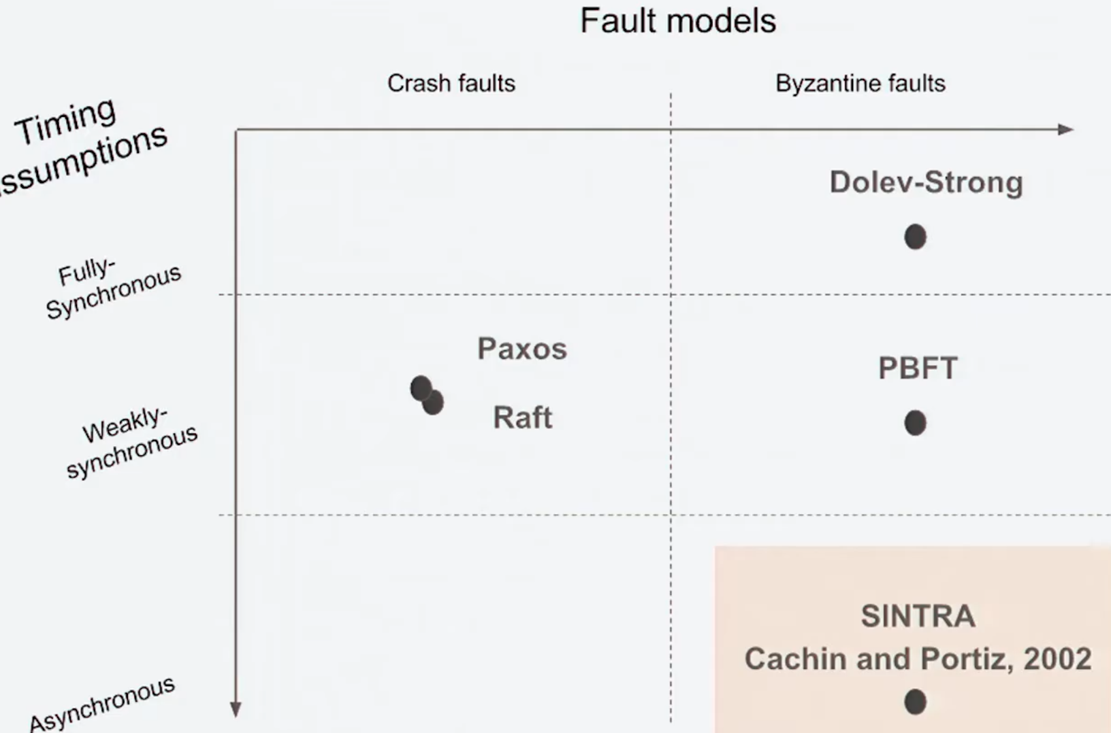
Three sources ….
what are the benefits of addressing this….

Can automate financial transactions
Hashes will be broken one day.
Thuroput is not adequate for daily use.
51% rule…
Ethereum most apps are using Infura on AWS.
Rolebacks happened in the past on ETH...

Tang, H., Sun, Y., & Ouyang, J. (2020). Excellent practical byzantine fault tolerance. Journal of Cybersecurity, 2(4), 167-182. doi:https://doi.org/10.32604/jcs.2020.011341

Xiong, H., Chen, M., Wu, C., Zhao, Y., & Yi, W. (2022). Research on progress of blockchain consensus algorithm: A review on recent progress of blockchain consensus algorithms. Future Internet, 14(2), 47. doi:https://doi.org/10.3390/fi14020047

 | Concept1  Why do people buy NFTs? Emotional value?  Stick it to the man?  Personification? | Concept 2  Resiliency of blockchain in a global pandemic ? | Concept3  Escaping/Defining/ Defeating  the manifestation of centralization in block chain technology | Concept 4  Developer support / who manages block chain? | Concept 5  Tackling latencey.
Journal 1  Blockchain  Visualization |  | Longest chain rule will apply as latency persists |  |  | Latency can cause side chains
Journal 2  C OMMITTABLE | Can represent a share of digital escrow account. |  | Centralized on github | Github/ incentivize with commitable coin
Journal 3  BSS-ITS |  |  | Sharding can cause scaling with out centralization. |  | Latency increases as nodes increase

Theory Summary
The Theory Summary section should include 1,000 words scholarly review (literature synthesis) of one key theory related risk management by uncovering the origin of the theory, discuss at least five empirical research studies that used the theory as the foundation or stream of references of major relevant work including scholarly work from other fields (peer-reviewed journals only!), and provide arguments for how such theory can be applied for risk management in the context of cybersecurity.

My theory is…
reference 5 studies that refrence that theory relatively.
How does that apply to risk managamnet and cybersecurity…..

Literature Summary Table
The Literature Summary Table section should include one table that includes an entry for five from the literature used in the prior sections. The table should be formatted following APA 7th ed. (including the caption!) and include the columns noted below:
Table 1. Literature Summary Table for [Topic Here]

Article/Study: | Description of the Problem | Methodology | Sample | Instrument | Main findings or Contributions
Carlton et al. (2019) | Low cybersecurity skills of non-IT professionals causing significant volume of cyber incidents. While information Security Education, Training, and Awareness (SETA) are provided to employees in most organizations, most are ineffective and employees still fall for social engineering attacks. | Empirical Investigation | First phase of validation included a number of Subject Matter Experts (SMEs), then 21 participants in the pilot phase, and a total of 173 non-IT professionals in the main data collection | An SMEs' validated iPad Application (prototype tool) to measures non-IT professionals' cybersecurity skills based on user performance with scenarios. | A validated tool to measure cybersecurity skills for non-IT professionals in the context of organizations. SETA programs are not enough in their current format (i.e. "awareness" only) and should be expanded to include training as well as educating the users on cybersecurity topics by allowing them to develop the skills needed to mitigate cyber-attacks.
... | ... | ... | ... | ... | ...

References
The References section should include at least 15 references of relevant peer-reviewed scholarly work. References should be taken from high peer-reviewed journals or peer-reviewed conference proceedings (e.g. IS/ACM/IEEE/IIAKM). Minimize as possible the use of conference proceedings (no more than five refs from conferences!). Be aware that you may need 40 to 50 articles in order to narrow your references to good 15 papers. Ensure all references included are cited in the text and all references cited in the text are included in the references (this is called "cross referencing").

ArtChain: Blockchain-Enabled Platform for Art Marketplace
Date Added to IEEE Xplore: 02 January 2020
ISBN Information:
INSPEC Accession Number: 19246045
DOI: 10.1109/Blockchain.2019.00068

Effective Scheme against 51% Attack on Proof-of-Work Blockchain with History Weighted Information
INSPEC Accession Number: 19246019
DOI: 10.1109/Blockchain.2019.00041

ETH Relay: A Cost-efficient Relay for Ethereum-based Blockchains
https://ieeexplore-ieee-org.ezproxylocal.library.nova.edu/document/9284781
INSPEC Accession Number: 20260591
DOI: 10.1109/Blockchain50366.2020.00032

Oyinloye DP, Teh JS, Jamil N, Alawida M. Blockchain Consensus: An Overview of Alternative Protocols. Symmetry. 2021; 13(8):1363. https://doi.org/10.3390/sym13081363
https://www.mdpi.com/2073-8994/13/8/1363#cite

Research and Implementation on the Operation and Transaction System Based on Blockchain Technology for Virtual Power Plant
Date Added to IEEE Xplore: 11 August 2022
ISBN Information:
INSPEC Accession Number: 21972564
DOI: 10.1109/ICBCTIS55569.2022.00046

L. Ambrosini, M. Piškorec and C. J. Tessone, "Visualization of Blockchain Consensus Degradation," 2022 IEEE International Conference on Blockchain and Cryptocurrency (ICBC), 2022, pp. 1-2, doi: 10.1109/ICBC54727.2022.9805498.

Committable: A Decentralised and Trustless Open-Source Protocol
INSPEC Accession Number: 21844007
DOI: 10.1109/ICBC54727.2022.9805541

Zhenyu Chen, Dong Liu, Xingyu Gao, Fangchun Di, Yunhao Huang, Dapeng Li & Jie Zhang. 2020. An efficient operation and maintenance method for power dispatching and control cloud. Power System Protection and Control(14), 175-181. https://doi:10.19783/j.cnki.pspc.190965.

Casino, F., Dasaklis, T. K., & Patsakis, C. 2019. A systematic literature review of blockchain-based applications: Current status, classification and open issues. Telematics and informatics, 36, 55-81.

Y. Yuan and F. Wang, "Towards blockchain-based intelligent transportation systems," 2016 IEEE 19th International Conference on Intelligent Transportation Systems (ITSC), 2016, pp. 2663-2668, doi: 10.1109/ITSC.2016.7795984.

Tianhao Liu, Jiqiang Liu, Jian Wang, Di Zhai, Yufei Liu, and Xudong He. 2021. Anonymous Storage and Verification Model of IIoT Based on Blockchain: Anonymous storage and verification model of IIoT production status based on blockchain. In 2021 4th International Conference on Blockchain Technology and Applications (ICBTA 2021). Association for Computing Machinery, New York, NY, USA, 144–150. https://doi-org.ezproxylocal.library.nova.edu/10.1145/3510487.3510508

A. Beikverdi and J. Song, "Trend of centralization in Bitcoin's distributed network," 2015 IEEE/ACIS 16th International Conference on Software Engineering, Artificial Intelligence, Networking and Parallel/Distributed Computing (SNPD), 2015, pp. 1-6, doi: 10.1109/SNPD.2015.7176229.
Y. Bai, H. Lei, S. Li, H. Gao, J. Li and L. Li, "Decentralized and Self-Sovereign Identity in the Era of Blockchain: A Survey," 2022 IEEE International Conference on Blockchain (Blockchain), 2022, pp. 500-507, doi: 10.1109/Blockchain55522.2022.00077.

J. M. Sobral, M. Solari and S. Matalonga, "Preliminary Results of a Multi-Vocal Literature Review of Blockchain Networks," 2020 39th International Conference of the Chilean Computer Science Society (SCCC), 2020, pp. 1-8, doi: 10.1109/SCCC51225.2020.9281265.

S. Joseph and S. Karunan, "A Blockchain Based Decentralized Transaction Settlement System in Banking Sector," 2021 Fourth International Conference on Microelectronics, Signals & Systems (ICMSS), 2021, pp. 1-6, doi: 10.1109/ICMSS53060.2021.9673610.

