RESD 700 Fall Term 2022

Eric Webb

Assignment 700-3

**1. Create one or two research questions for each of the following qualitative research approaches:**

Ethnography (Software Example)

* Example 1: Why do you use this software?
* Example 2: What specific needs does the software fail to meet?

Grounded Theory (Human Resources Example)

* Example 1: What can the company do to improve morale as a whole?
* Example 2: What can the company do to improve morale for your specific needs?

Phenomenology (New Experiences Example)

* Example 1: How was the experience trying a new food item?
* Example2: How was the experience traveling somewhere new?

Case Study (Blockchain Example)

* Example 1: What trends drove the need to use Blockchain?
* Example 2: What were you looking for in a Blockchain solution?

Historical Study: (US Presidents Example)

* Example 1: If you were president at the time would you have dropped the atomic bomb?
* Example 2: If you were president at the time how would you of handled the Cuban missile crisis?

**2. Reflective Narrative.**

For this narrative I chose the Sample Conversation Transcript: Two Ex-Smokers, while performing a qualitative analysis using a specialized tool called MAXQDA. In the transcripts two major questions are asked: *“What does it mean to be an ‘Ex-smoker”?”* and *“What are the interaction patterns of fleeting - such as short, temporary, or one-time conversational exchanges among strangers?”.* By using MAXQDA, I was able to analyze the transcript between the two ex-smokers. I did this by analyzing the characteristics described of people who are ex-smokers and the conversations exchanged between them in this transcript. I learned that the MAXQDA tool has a lot of fun and useful features to help visualize data. The first is the ability to quickly organize data via highlighting techniques with the ability to have different highlights on the same line as shown below.

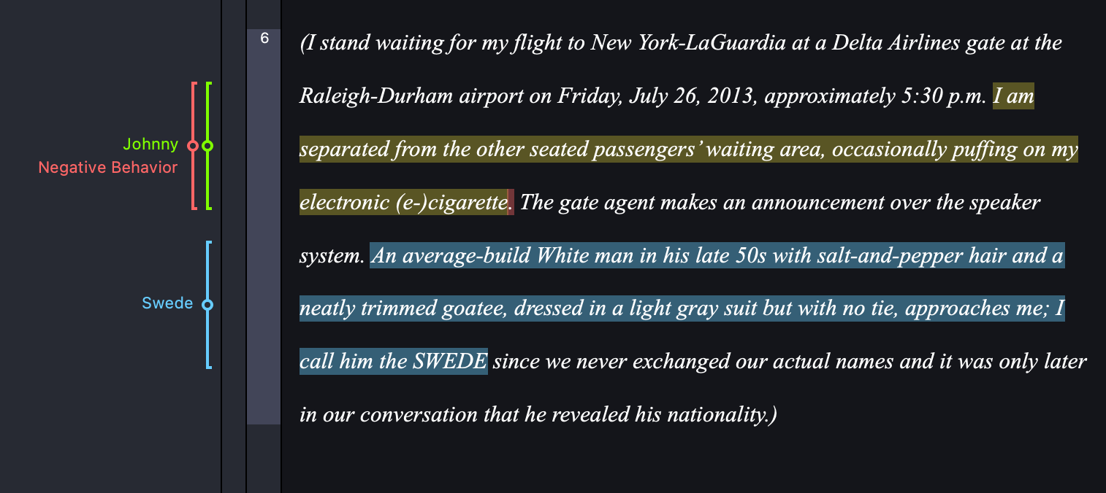

Using the MAXQDA code system I grouped the data into Swede, Johnny, Description of smokers, and Interaction between smokers. This was chosen to make note of references as I read the transcripts.

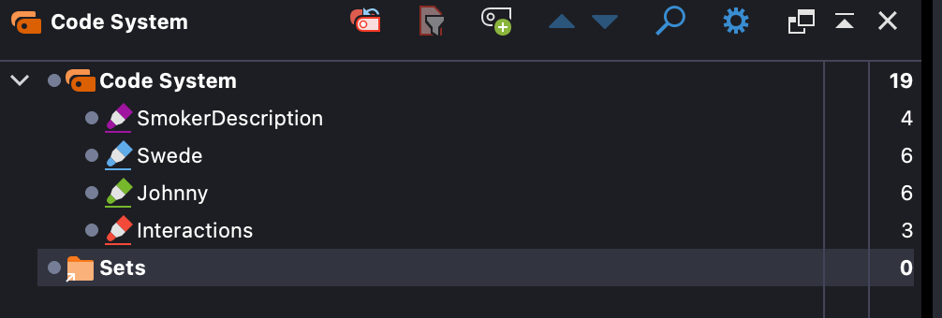  
Doing so allowed me to create a Document Portrait to highlight where those code system categories appear in the document based off their respective Code System colors. This helps visualize the data and better understand where your data lies and how it overlaps.

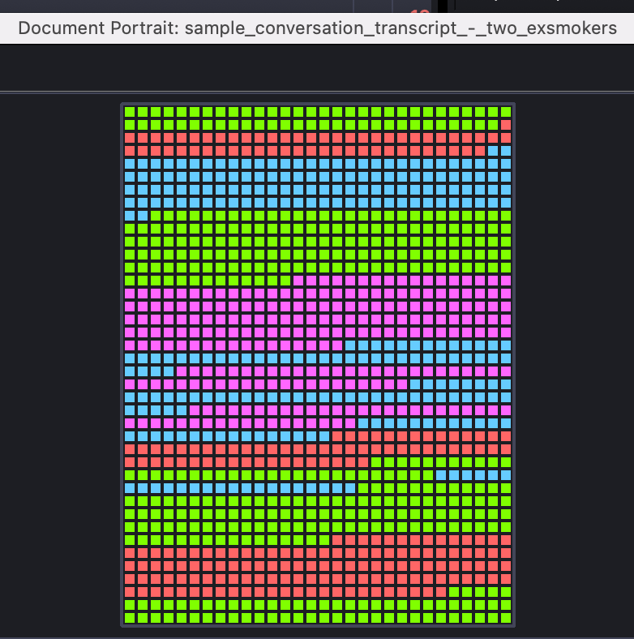

Another unique feature was the Word Cloud. In this cloud I removed all words under 4 characters long to give a better perception on the topics discussed. I enjoyed this abstract visualization of the data.

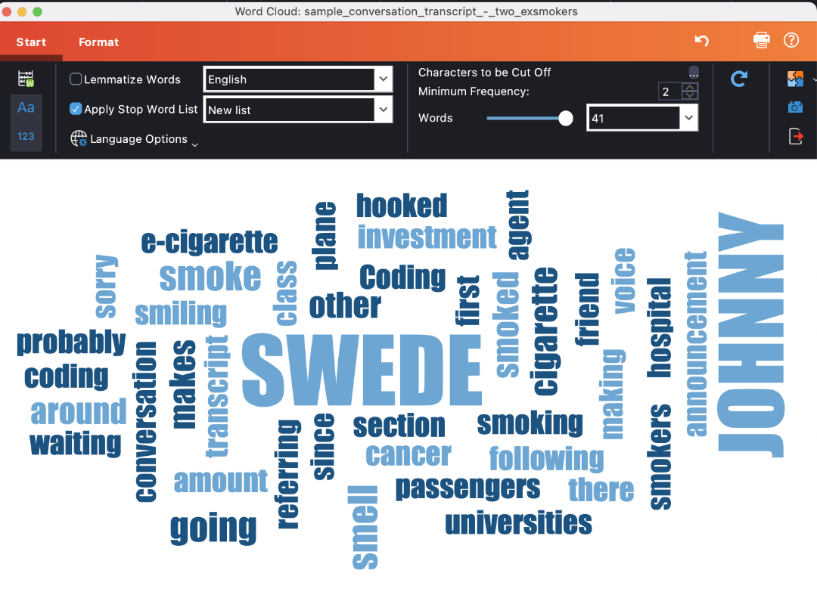

Codeline was another interesting feature, it tells you on a paragraph timeline where your categories appear relative to the paragraph index in the transcript. I found it helpful because it can show you gaps in your categorization that the previous visualizations did not. Here you can see from the gap that further analysis can be performed in the 29-52 paragraph range.

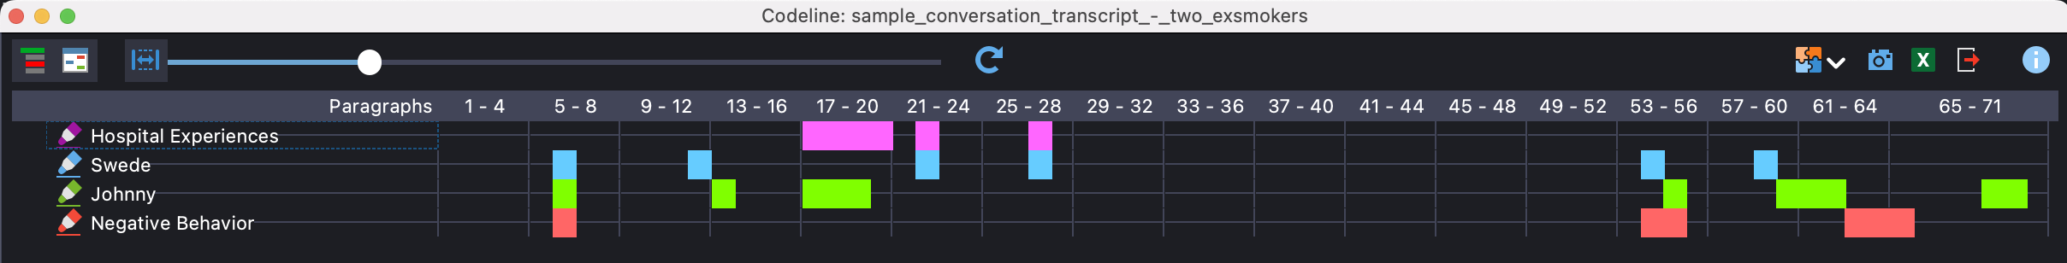

There is much to still learn about MAXQDA and its functionalities, and I look forward to further exploring these in the future. Since I use Ubuntu Linux as an operating system on my computer, I was dissatisfied with the fact that there was not a Linux distribution of this application. Overall, I found this tool to be very intuitive and beneficial for qualitative research and could see myself utilizing it in the future.