To Mint from Whitelist

Verify user is on whitelist by calling this API
https://1mwe9uiok1.execute-api.us-east-1.amazonaws.com/proof/

Example: 0x6aF9cE90BaA2640cc06f9661B37835Ab97807311

https://1mwe9uiok1.execute-api.us-east-1.amazonaws.com/proof/0x6aF9cE90BaA2640cc06f9661B37835Ab97807311

GET Response

["0x129ef6d846de85b9fb0c4a9aa59cfda674d5713c272bcfdcad8bfaa68a341f9d","0xe2c90a0bbb425449b587fcaaa3482a042e347e41e9b4b1f8b14f3c466c5a2944","0x14413163e890e8ed3b3096df22d88e6e1933b5a717b51c38f56d3dd224d274ec","0xbd710c5f1f492bd994063d062be6fe75e98b1f8933a6fe223bcf15ba987ca72d","0xd0f8bfabbf4029062ecbbc01e80fcb05cd8b1c46a1dca12379264a647a10a9ae","0x51ce262b5759a38f2e8f558be69b653940d67535eddc913d8cf023034d7d1d35","0xa6f90ac04efca6082f86709c8f1726c6e5c033afb7f8c7e1b99ba91eeb7c5d21","0x4dc343e5e23eb51e0ae1962a9ff1bdc504129eb0bda121d16781ccce1270b31f"]

THEN

Pass Response ARRAY ABOVE to Blockchain mintWhiteList([],int) Function for that user.
An example of this in web3.js is
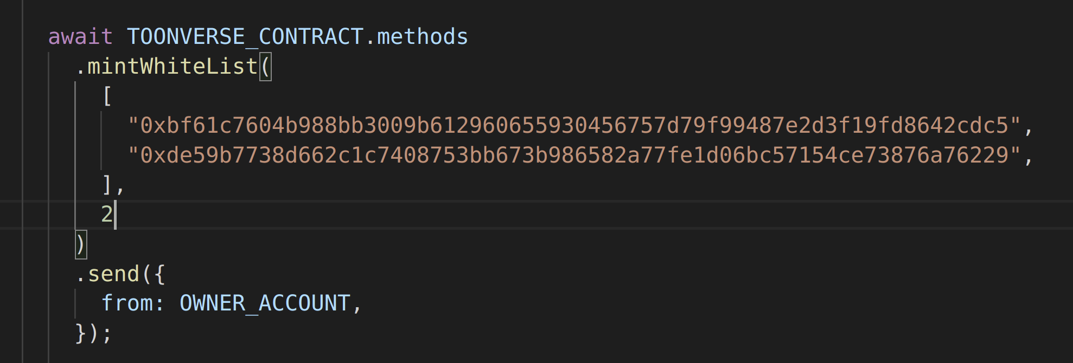

in the contract it looks like so

