Sealog-Alvin User’s Guide

Why Sealog-Alvin?
The impetus for developing a new open-source event-logging system came from the growing need to have a modern, freely-available, general-purpose event-logging capability on research vessels. There are other event-logging systems in use on research vessels however many of them are purpose-built to support a single operation, are written in a depreciated technology and difficult to maintain, or are prohibitively expensive.
Sealog is not intended to be a “one-size-fits-all” event logging solution but instead strives to provide a solution that has value “as-is” and be a platform that can be easily extended to meet custom event-logging requirements.
Sealog-Alvin is a customized version of the standard Sealog client tailored to the unique operating requirements of the Alvin HOV. These customizations were required to properly organize event data by-dive and within a specific cruise. The Sealog-Alvin client includes the ability to display image files directly within the replay/search sections. The interface also include additional pages and functionality for adding and editing cruise and lowering records which are used to organize the events for reviewing and exporting.
In addition to the client customizations corresponding customizations were made to the Sealog-Server. This corresponding Sealog-Server used with Sealog-Alvin is stored in the GitHub code repository under sealog-server-alvin.

What is an event?
An ‘event’ is any observation, whether scientific or operational in nature, that is worth recording and that may not already be directly captured in textual form by other data logging systems.
Examples of scientific events include in-situ biological and geological observations. Examples of operational events are things such as cruise/dive milestones (I.e. ‘on-station’, ‘vehicle-in-water’, ‘vehicle-on-bottom’, ‘start-of-survey’, etc). An example of an event relevant to both science and operations would be the collection of a sample and its placement on a sample tray.
Within Sealog an event is comprised of a timestamp, an author, the event’s high-level value, optionally one or more event-specific values and optionally some free-form text.
The Sealog data model also provides the ability to associated multiple ancillary data points with an event. These ancillary data points may be real-time ship/vehicle navigation, frame capture filenames, real-time sensor data, etc. Ancillary data points can be added at the time the event is created or at anytime after the event is created. Taking this modular approach adds some complication to the overall architecture but enables the flexibility to accommodate sensor failures or the need to associate datasets that are unavailable when the event is created.

The Sealog Interface
Sealog is comprised of two components, the Sealog Server and the Sealog Client. The document only covers the Alvin version of the Sealog Client. The Sealog Client user interface is completely web-based and accessible from any device with a modern web-browser.

Login Screen
The first screen users see when they open Sealog is the login screen. Logins are required in order to associate an author with an event. The login form includes the traditional username/password form, a button to login as “Guest” and a link to create a new user account. Passwords are optional when creating a new account.
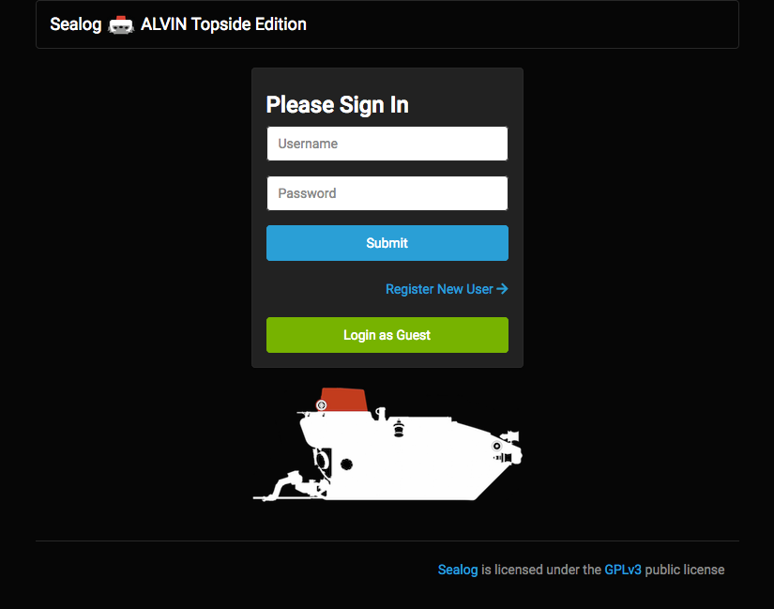

Main Screen
The main screen is where users will submit new events. The main screen includes:
- Navigation links to the rest of the Sealog interface.
- Event templates ( blue buttons),
- Text field for submitting free-form events,
- Recent event history,
- Current status of the Sealog Auto-Snap (ASNAP)

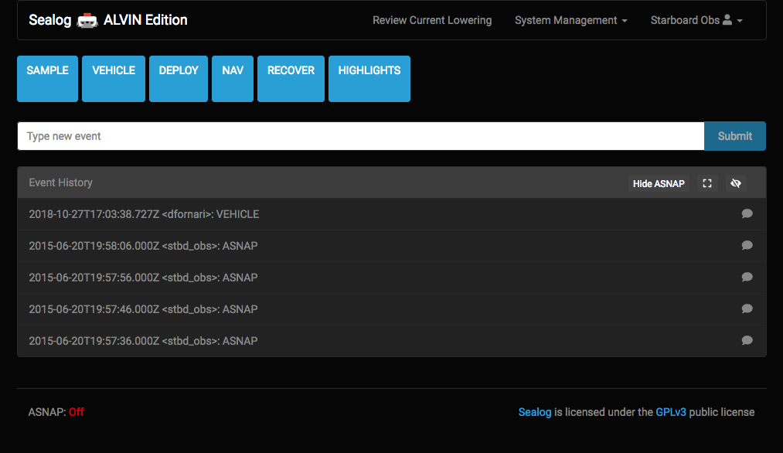
The event templates are visualized on the user-interface as blue buttons. Event templates are pre-defined event messages that allow users to quickly submit commonly used events. Clicking these buttons can optionally open a dialog window allowing users to add additional event-specific details.
The text field in the middle of the display is for submitting general free-form events. This element exists for when users want to submit an event for which there is no event template.
The recent event history panel displays recently submitted events. This panel displays all events submitted by all users and is updated automatically in real-time. Clicking on the text for an event in the event history panel will display any ancillary data associated with that event. The icons in the upper-right of the event history panel header allow the user to expand the history to display the last 25 events or hide the event history entirely. There is also a button to hide/show the automatically-created “ASNAP” events.
The Auto-Snap (ASNAP) status is displayed at the bottom of the page. This shows the current status of the Auto-Snap feature. When ASNAP is “On” ASNAP events are automatically created every 10 seconds. These ASNAP events are hidden from the event history by default. Clicking the “Show ASNAP” button with display any recently created ASNAP events.

Submitting Events
From the main page there are two ways to submit events: the event templates (blue buttons) and the free-form text field.
Event templates exist to simplify the task of submitting commonly used events. These templates can be configured for simple one-click event submissions or they can be expanded to capture additional event-specific data points. To use one of the event templates simply click on the desired blue button.
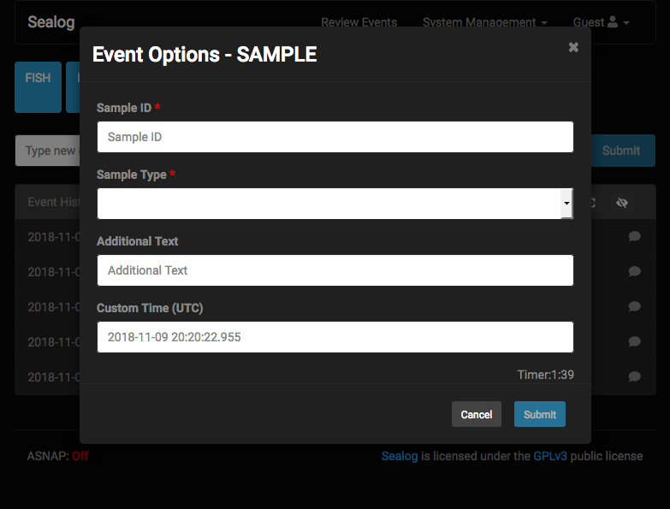
The free-form text field is for summiting events for which there is no event shortcut. To submit a free form event simply type text into the text field and click the “Submit” button to the right of the text field.

Reviewing Events
There are two options for reviewing events that have already been submitted. The first is the event history window on the main page. By default the event history window displays the last 7 events submitted regardless of author. The expand icon in the event history window header expands the history window to display the last 25 events. There is also a “hide” button which will completely hide the event history window. There is a third button in the history panel header that enables hiding/showing ASNAP events. ASNAP events are hidden from the history panel by default.
The second option for reviewing events is the Review Current Lowering page. The Review Current Lowering page displays all the events collected during the current lowering in two modes: replay and search.
In replay-mode the interface is configured with VLC-style controls. There are tools for quickly scanning through the events scanning though a filtered list of events as well as a “Play” button to have the interface automatically progress to the next event after three seconds. The top of the interface will display any ancillary data associated with the currently selected event.
The event filter form is used to build a custom filtered list of events. Events can be filtered by event value, author, time or free text. The search form IS case sensitive and currently wildcard characters are NOT supported. Use commas between event values to search for multiple event values (i.e. FISH,CORAL). Prefixing an event value with a “!” character will perform a logical NOT operation.
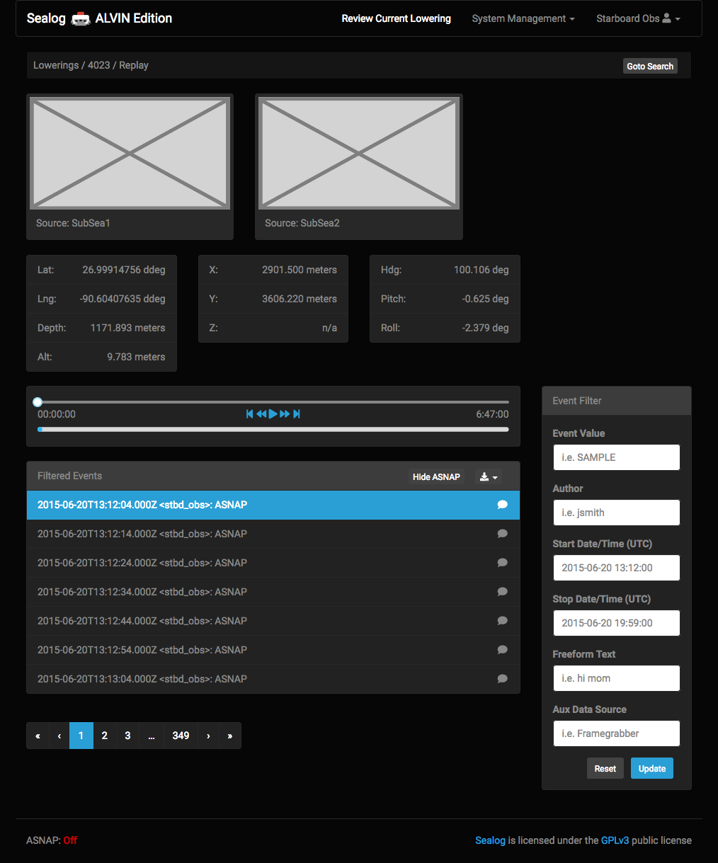
In search-mode the replay elements are removed so that it is easier to scan through the pages of events. To view any ancillary data associated with an event, simply click on the event text and a modal will appear showing the ancillary data. Use the event filter form to build a custom filtered list of events. Events can be filtered by event value, author, time or free text. The search form IS case sensitive and currently wildcard characters are NOT supported. Use commas between event values to search for multiple event values (i.e. FISH,CORAL). Prefixing an event value with a “!” character will perform a logical NOT operation.

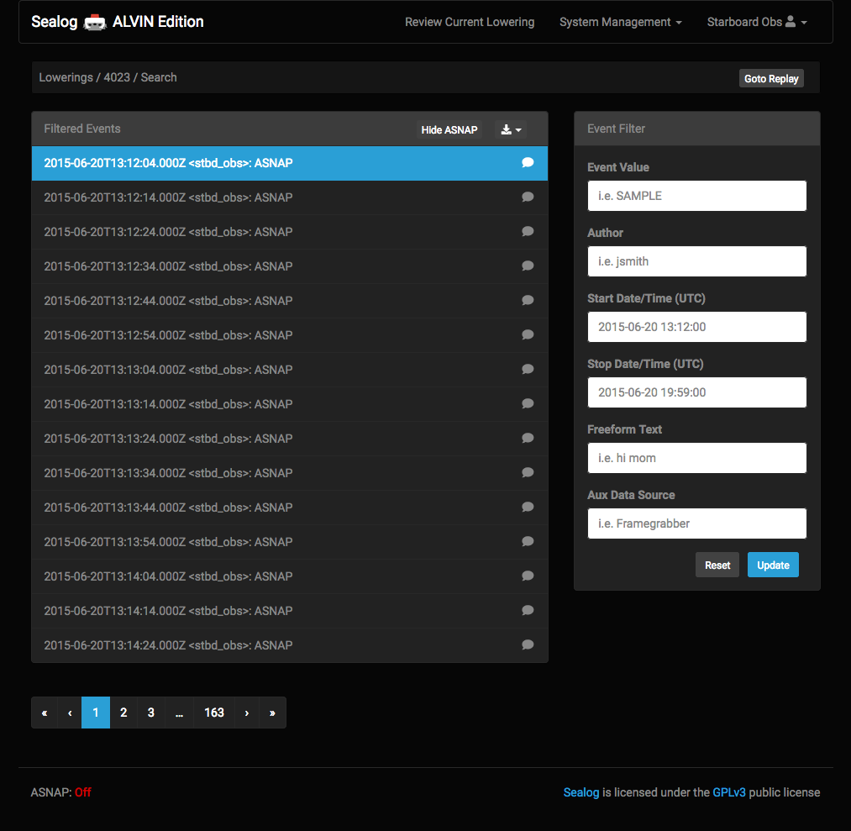
Exporting events
Sealog allows users to export all or a subset of events from the database. Events can be exported with or without their associated ancillary data and the data can be exported in either JSON or CSV format.
With Sealog-Alvin it unlikely that users will perform data exports from Sealog-Alvin because users will only have access to this version while in the submarine. It is more likely that users will leverage the export feature from the Alvin-Topside version of the Sealog client. However the process is explained here for the purpose of documentation completeness.
To export events goto the “Review Events” section of Seaplay. Use the “Event Filter” form to build the desired list of events. In the header of the “Filtered Events” panel use the download icon to select the desired type/format of download. Depending on the number of events it may take up to a minute before the browser prompts the user with a download confirmation dialog box. Please be patient.

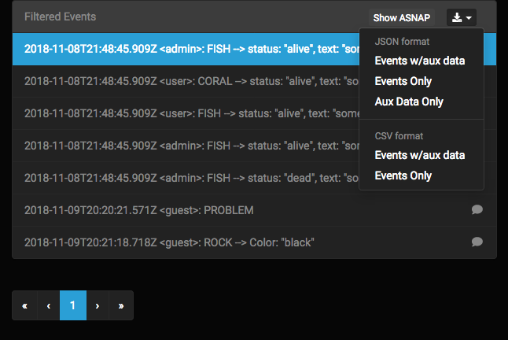
Adding Event Templates (blue buttons)
Event templates can be added and changed at anytime. To add/edit an event template go to the “System Management” dropdown menu in the top navigation bar and select “Event Templates” This will take you the Event Templates section of the Sealog interface.
The Event Templates section has 4 parts, a list of system templates, at list of non-system event templates, a button to add a new event template (blue button below table of event templates) and the form panel used for creating/editing the event templates.
When a users first arrives in the Event Templates section the create event template form is already displayed. This allows the user to immediately start building a new template. To edit an existing template simply click the pencil icon next to the template you wish to edit. To delete and existing icon simply click the trash can icon next to the desired template. Sealog will prompt the user to confirm the delete. This is to prevent accidental deletion.
There are 2 classes of event templates: system and non-system. System event templates can only be created/edited/deleted by system admins. The reason for system templates is to allow the vessel operator to define a set of event that should not be modified by the visiting science party. Examples of system events would be “Start of CTD Cast”, “End of CTD Cast”, “XBT Cast”, “Start of MB Survey”, etc. Basically these are templates for vessel-level events and should not be changed by the visiting science parties.
Non-system events can be created by any user with the role of “event-manager” or “admin”. These are the events that can/should be created by the science party to support their specialized needs.
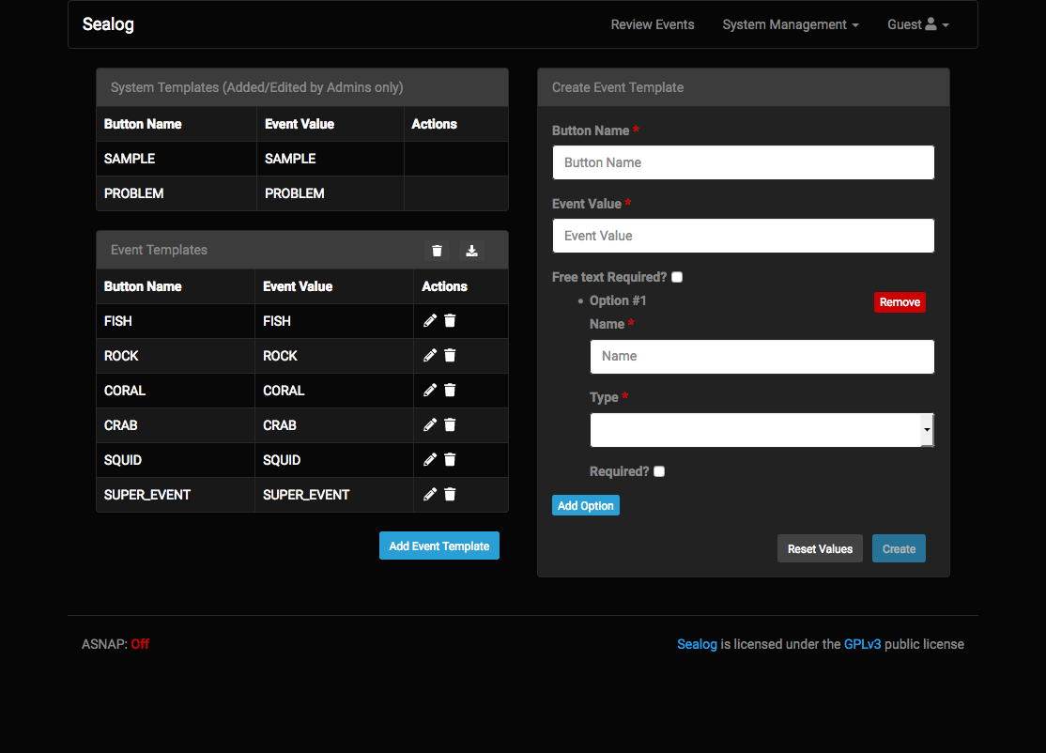
The form to create/edit a template is dynamically built for the template. The most basic event template includes:
- Button Name: the name that will appear on the blue button.
- Event Value: the string that will be submitted as the event’s value.
- Free text Required: whether or not the observer MUST add some free-form text before submitting the event.
Beyond the basic template definition it is possible to add additional event template options. To add an event template option click the blue “Add Option” button. There are three types of event template options:
Text → allows entering free-form text.
Dropdown → allows selected one value from a pre-defined list.
Checkboxes → allows selected one or more from a pre-defined list.
These additional optional are for customizing the event template so that users are aware of what additional information can/must be included when submitting a particular event. Each additional element includes a “Require” checkbox. If the Require checkbox is selected then any when an event is created using this template, Sealog will require that the user complete that section of the event options form before the event may be submitted.

Export Event Templates
Just like events, event templates can be exported to file. There are three reasons to export event templates:
- Including the event templates as part of the cruise data packages
- Moving the events to another instance of Sealog running on a different vessel
- Wanting to use the same event templates on a future cruise aboard the same vessel.
To export the event templates to file, goto to the Event Templates section of Sealog. In the Event Templates panel header, click the download icon.
Only “admin” level users can export system event templates. Any “event managers” or “admin” level users can export non-system templates.

Auto-Snap (ASNAP)
Auto-Snap (ASNAP) is used to automatically create a pre-defined event at a set interval. The reason for ASNAP is for applications where the user wants a minimum frequency of events, even through there may not be anything “event-worthy” happening. Examples of ASNAP’s uses includes regular event creation during CTD casts or ROV dives where ancillary data such as sensor values and navigation is associated with events. Having an ASNAP functionality ensures there’s minimum resolution of data for the duration of the activity.
The current status of the ASNAP functionality is displayed in the lower-left corner of the interface. To change the ASNAP status simply click the “System Management” dropdown on the top navigation bar and select Toggle ASNAP.
The ASNAP service is completely independent of the Sealog Client and is actually part of the Sealog Server. To ensure ASNAP is working be sure to “Show ASNAP” events in the event history panel and verify new ASNAP event are arriving.

Managing Lowering Metadata
In the Alvin operating model the observing scientists will develop a dive summary. Historically these summaries are written on the vehicle’s ascent to the surface. The Sealog-Alvin client allows scientists to record these summaries directly within the client’s interface.
To edit the dive summary for the current dive, use the top nav bar and navigate to “System Management” → “Lowering”. This will bring up the lowering metadata record for the current dive. Scientists may use this form to edit the various details related to the current lowering.
The lowering metadata record consists of the dive’s number, pilot, observers, start/end date and, dive summary and tags.
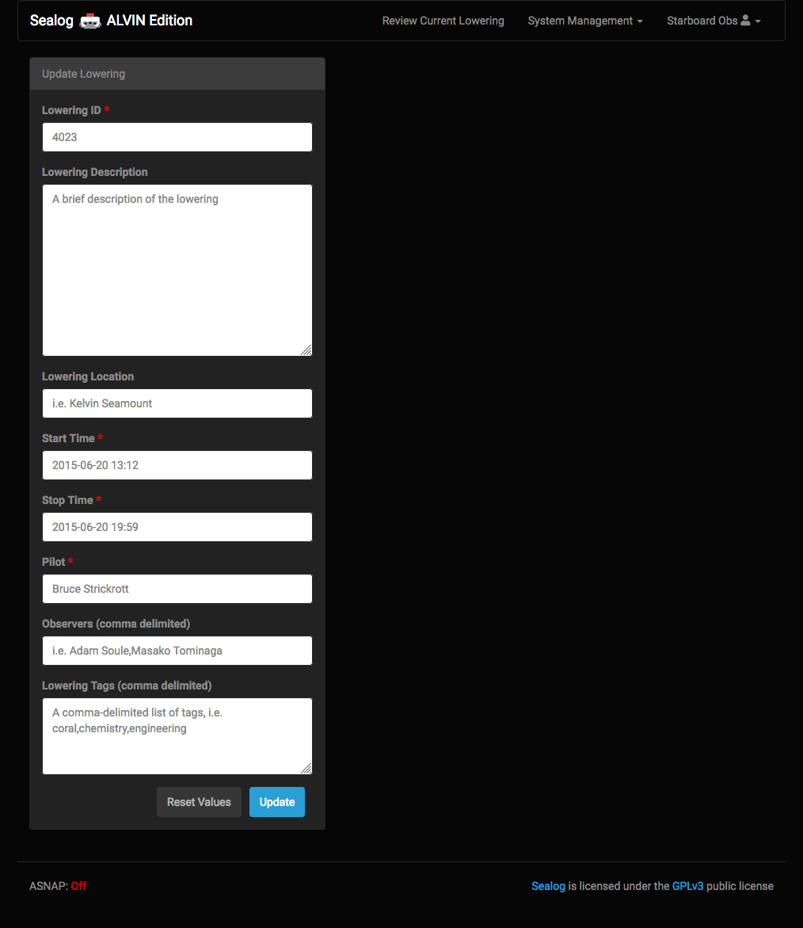
The lowering metadata record is created prior to the dive by the shipboard SSSG. In the event that a record was not created prior to the dive there will be a message indicating that no record exists and that to create the record the user must simply log into the client as “alvin” and navigate to the “Lowerings” page. The metadata record can be edited at anytime during the dive. After the dive the events and lowering metadata record will be transferred to the Alvin-Topside version of Sealog. Users will once again be able to make any necessary changes to the record.

