Khai Nguyen

1. 10000 GU = 1 Gal = 1 cm/s2 = 0.01 m /s2
2. Free-air correction = 0.3086 * 152.7 = 47.12322 mGal

Bouger correction = -0.04193 * 152.7 * 2.5 = -16.006 mGal

1. Necessary reduction:
   1. Chose a base station
   2. Determine elevation
   3. Determine latitude
   4. Calculate normal gravity - Latitude correction
   5. Free-air correction
   6. Bouguer correction
   7. Terrain correction
   8. Instrument drift
2. Excel sheet
3. Using equation 6.34, we have:

g = 4*G*pi*R3*(density)/3*z/(x2+z2)3/2 = 4* 6.6748* 10-11*pi*2700/30000 * R3 = 7.54 * 10-6 *R3

The cave manifests at horizontal position 0 on the graph. Thus, if we want to detect the cave then we have x = 0. Since z <=100, we can use z = 100 as our maximum value.

Since we want to detect the cave, we want the reading to be greater than 0.05 mGal.

Therefore, 7.54 * 10-6 * R3 > = 0.05mGal => R > 18.7 m

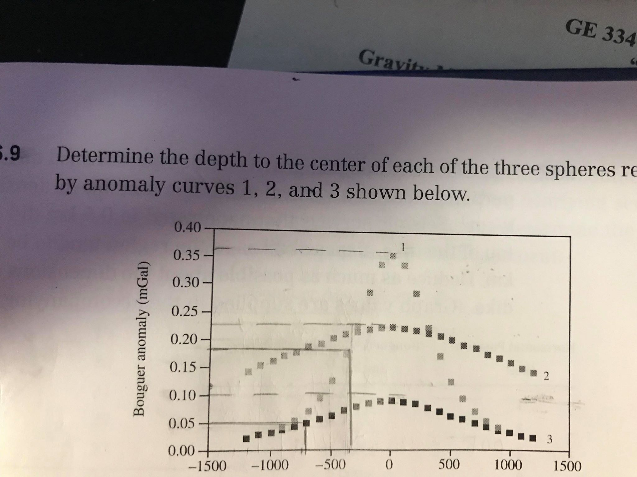

From the graph we can see that for the first curve, y_max = 0.36, so y(1/2 max) = 0.18, meaning x_(1/2 max) = 350m. Thus, the depth = 1.305 * 350 = 456.75m.

For the second curve, y_max = 0.23, so y(1/2 max) = 0.115. Thus, x(1/2 max) = 1500m, so depth = 1.305 * 1500 = 1957.5m.

For the second curve, y_max = 0.1, so y(1/2 max) = 0.05. Thus, x(1/2 max) = 750m, so depth = 750 * 1.305 = 978.75m.

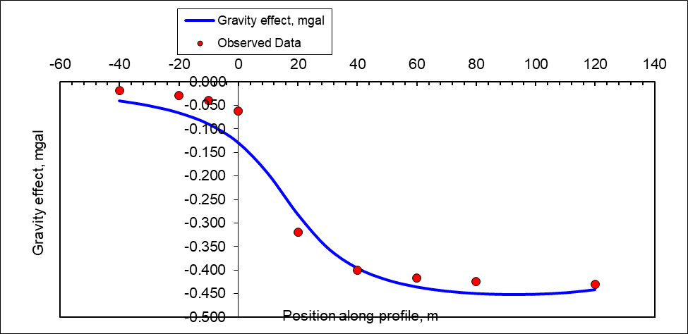

The density contrast is -1.5g/cc, the thickness of the slab is 8.5m, and the left and right locations are respectively 16m and 170m. Therefore, the depth to bedrock is about 15 + 8.5 = 23.5m from the surface.

However, this answer is not unique. There can be many interpretations of the data. For example, from the following graph, we can also conclude that density contrast = -2g/cc and thickness slab = 6m.

