target: FFA

name: CPIAUCSL lag: -4 corr: 0.08059365495369443 p-value: 0.045206384530997776

FFA l u

2021-07-13 0.524378 -0.362664 0.835855

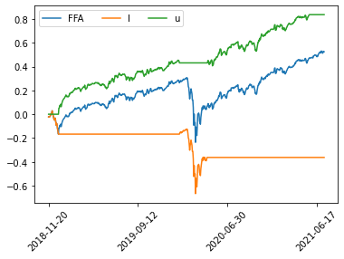

target: TPR

name: IC4WSA lag: -9 corr: -0.1220973051241417 p-value: 0.0024605275559175686

TPR l u

2021-07-06 0.370742 0.998761 -0.754586

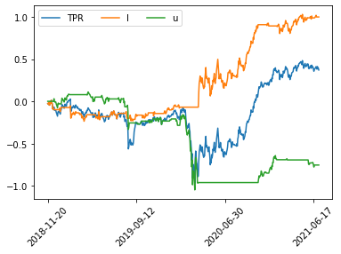

target: FFBC

name: NFCI lag: -4 corr: -0.14353783220627878 p-value: 0.000344091369693964

FFBC l u

2021-07-13 -0.03256 -0.476333 0.472162

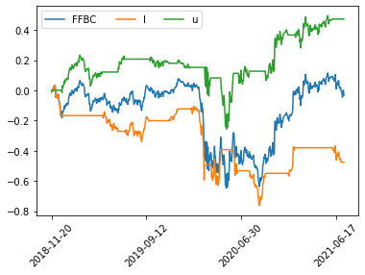

target: EOG

name: STLFSI2 lag: -62 corr: -0.08912405324567328 p-value: 0.03498388016571297

EOG l u

2021-04-15 -0.090109 -0.207803 0.116702

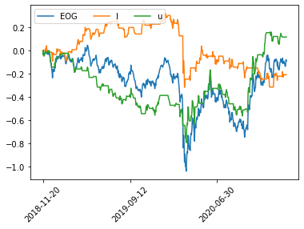

target: CSBR

name: MCD lag: -12 corr: -0.09080342772780449 p-value: 0.024915264693976744

CSBR l u

2021-06-30 0.593018 0.780742 -0.213646

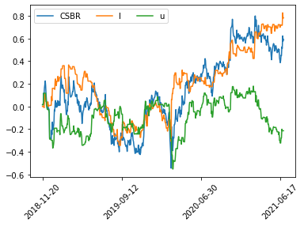

target: GES

name: SPLP lag: -48 corr: -0.10665606690359439 p-value: 0.010557172429281935

GES l u

2021-05-05 1.498351 1.846665 -0.694114

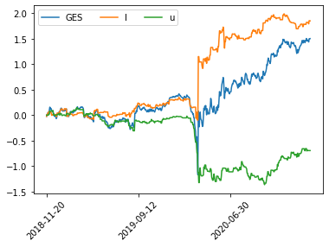

target: IVC

name: BAMLC0A0CM lag: -1 corr: -0.15235941182236815 p-value: 0.00013818142141625627

IVC l u

2021-07-16 1.02079 1.992975 -1.703196

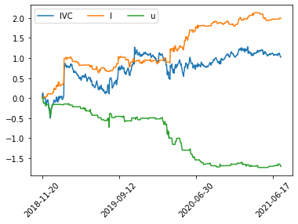

target: ARKR

name: BAMLC0A0CM lag: -1 corr: -0.2681772297064605 p-value: 1.0882399223439144e-11

ARKR l u

2021-07-16 0.331179 1.743802 -1.11828

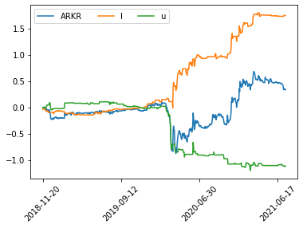

target: EVT

name: CPIAUCSL lag: -4 corr: 0.10313807903105128 p-value: 0.01029897248454966

EVT l u

2021-07-13 0.381201 -0.516989 0.905281

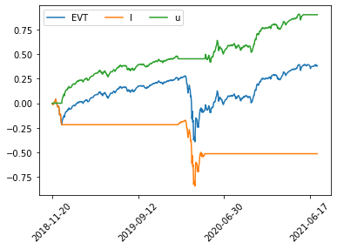

target: SMM

name: PPIACO lag: -5 corr: 0.20236481311237658 p-value: 3.9995093517975954e-07

SMM l u

2021-07-12 -0.030607 -1.215786 1.153402

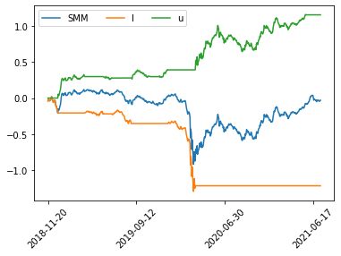

target: SMM

name: CPIAUCSL lag: -9 corr: 0.11871923881318737 p-value: 0.0032424318020843204

SMM l u

2021-07-06 -0.039206 -0.807059 0.674516

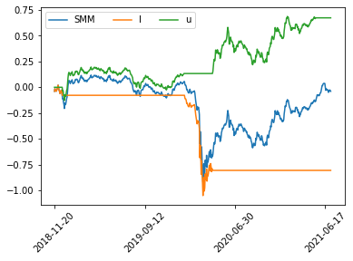

target: MPA

name: MRK lag: -2 corr: 0.19224116591455492 p-value: 1.4201518527353068e-06

MPA l u

2021-07-15 0.284407 -0.042465 0.330309

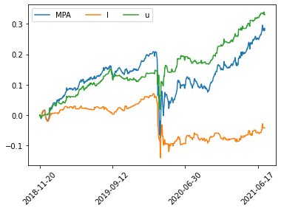

target: FFIV

name: PPIACO lag: -5 corr: 0.15189108452297523 p-value: 0.000152329285994942

FFIV l u

2021-07-12 0.175698 -0.598037 0.776288

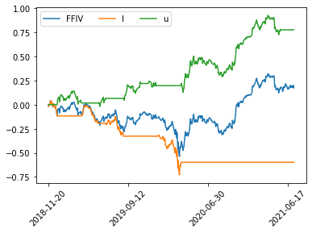

target: BKN

name: BCS lag: -12 corr: -0.1387765600372517 p-value: 0.0005878849732518544

BKN l u

2021-06-30 0.341392 0.343524 -0.081502

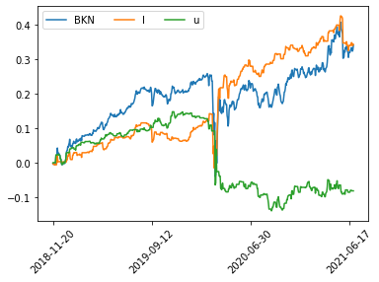

target: SQBG

name: XLU lag: -26 corr: -0.08085073738980002 p-value: 0.048506376676608357

SQBG l u

2021-06-10 2.168919 3.864993 -1.54514

