DJH

**Proprietary and Confidential**

Overview

Add overview from UpWork or from PPT

# Schedule

|  |  |  |  |
| --- | --- | --- | --- |
| **Milestone name** | **Milestone notes** | **Milestone date** | **Payment** |
| **Stage one - Building the program** | 3 weeks of building + 1 week for review and fixes and smooth run (Month)  *** The program is expected to be able to run with no support at all by the end of the development in the future | March 2, 2021 | $1,250.00 |
| **Support and updates 1** | 49 weeks of support that will include:  Technical support if the program does not function as agreed (API outdated or other)  Adding small upgrades such as; adding a row of data, scroll bard, and other | May 21, 2021 | $187.50 |
| **Support and updates 2** | As above | August 9, 2021 | $187.50 |
| **Support and updates 3** | As above | October 28, 2021 | $187.50 |
| **Support and updates 4** | As above | January 16, 2022 | $187.50 |
| **End of year Milestone** | As above | March 2, 2022 | $500.00 |

# 

# Design Questions

|  |  |
| --- | --- |
| Question | Answer |
|  |  |
|  |  |
|  |  |

# Success Criteria

A year of data gathering with a snapshot of data for every trading day and the systems recommendations.  
  
The aim to be able to analyze the strategies performance after that one year

# Testing

TBD

# Flow Overview

1. There will be 3 tests. If all 3 tests are positive, the stock is recommended.
2. Each positive test result gets a grade.
3. Grades are compared and the best stock is recommended.
4. Analysis based on 1,2, and 3 should be made when refresh is selected.

No to show me / via and online- but output to excel or CSV file available online

Point out that need to do research for APIs - experienced in finding API’s for public details

Output to google sheet at the end

Add to platform expertise:

Web experience

What's the Job and what needs to know

# Concepts

**Current price** (CP)- the price of the stock at the current moment. If the market is closed, the current price would be the last price that the stock has traded on.

**Stock Ticker** - The code of a stock that is used to identify it in the stock market

The best optimal output of the program would be a readout of the Ticker symbol of all the stocks that the program found that passed the test.

Example:

* [Ticker code]_[Dorsey Wright % gain indication]_[MarketWatch Analyst Estimates Positive]_[MarketWatch P/E ratio]_[Option return; Strike Date, Strike Price, Annual return]
* **ATVI**_40% gain_Positive_16_21/6/2019, $47.5, 125.63%

# **Option return test**

# **The aim:** This test tells us if the CP/Option premium in relation to the option strike price is a profitable trade. If it returns 30% or more - the test is positive. ***This is calculated by an excel sheet I provide The aim:

# To be the first proses that filters stocks

* 1. Scan the US stock market
  2. Find stocks that have profitable trades,
  3. Pass or not pass stock
  4. If a stock passes - grade trade
  5. Gather information that is needed for the presentation of the stock

# The proses:

* 1. If there is a CC strategy
  2. Scan stocks with all options within a two-month time span
  3. Only options with open interest and volume > 1
  4. If stock returns:
     1. Under 30% annual return - the stock does not pass
     2. = or over 30% - stock passes test
        1. 30% - 1 point > 230% - 10 points
        2. Over 230% - 11 points

Here is a quick example and right after that a detailed one

Quick example:

This stock will pass the test of this stage due to the fact there is a relevant option that surpasses a30% annual gain (**I2 = test cell**)

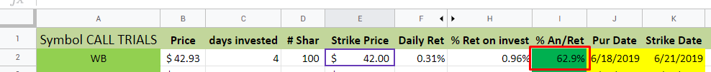

In this case, the option trade returns a 62.9% annual return. That means it passes the test (>30%)

Details elaboration:

The details I manual input (Needs to become automatic)

1. In each first column A2, a Ticker is inserted.  
   There, the google finance function automatically updates the stock price at B2  
   
2. After that, I manually input the **Strike Price** to **E2**, Strike Price is provided by a processor platform (Interactive Brokers, Chattels Schwat and more)  
   
3. Next, I will input the starting date for the trade (Today) to **J2.**
4. Then I would input the Strike Date/end date of the option to **K2**
5. This will lead to the calculation of the number of days for this trade in the **C2** days invested cell  
   
6. Next, I will input to **L2** the next data that comes from the broker - the primum for the trade.  
   
7. *** Each option trade is placed on 100 stocks. Therefore, If I trade 4 options, I infact trade 400 stocks.  
   The number of stocks in effect need to be imputed in **D2** cell 
8. Now we calculate  
   The formula calculated the profit I would make from the option deal. **(H2).**Stap on - this gets confusing:
   1. The formula calculates a different equation for two different situations the option trade can be in:
      1. The option is in the money: Strike price is under the current stock price (**B2 <E2**).
      2. The option is on or out of the money: Strike price is equal to or higher than the current stock price (**B2 <=E2**).
   2. Now there are three return cells (**H2, F2**, and the **test cell** - **I2**)
      1. H2, % Retire on Investment   
         Calculates the total return that comes from the trade  
         
      2. F2, Daily Returns   
         Calculates the return you make for every day in the trade
      3. I2, annual return (The test)  
         This calculates the daily return (E2) x 261 (Business days in a year) to calculate the annual return we can expect for such a trade  
         

# 

# **2. Momentum Test**

# 

# Use the point and figure charting moment chart (P&F) to give any stock a pass or ago

# Rate a stock in case of a pass

The proses:

1. Download a library from the web and install a P&F feather in the program
2. Once the feature is installed, output the price objective of each stock that enters the P&F.
   1. If price objective is under 30% - stock does not pass
   2. If price is = or larger then 30% - pass
      1. If 30% gets 1 point > 130% gets 10 points
      2. Any price objective over 130% gets 10 points

# 

# 

# **MarketWatch.com Test**

This test is composed out of two parts. **Analyst Estimates & P/E ratio**.

## Analyst Estimates test

* ***In this test we want to see if the recommendation for the stock is to "Buy",” Overweight”, or in the bad case "Hold" “Underweight” or "Sell"
  + The test will be positive if the recommendations are leaning strongly toward the "Buy",” Overweight” side. It will be negative if it is anything but that.
  + Each period of time needs to be calculated Individually (3M ago, 1m ago, and CURRENT). And Each period of time needs to pass the next test by itself - for the whole stock to pass the test.
  + Only if the sum of ‘Buy’ and ‘Overweight’ is 75% of the total points - the test will pass

How do you find this information:

* + 1. Go to the free website [www.marketwatch.com](http://www.marketwatch.com)  
       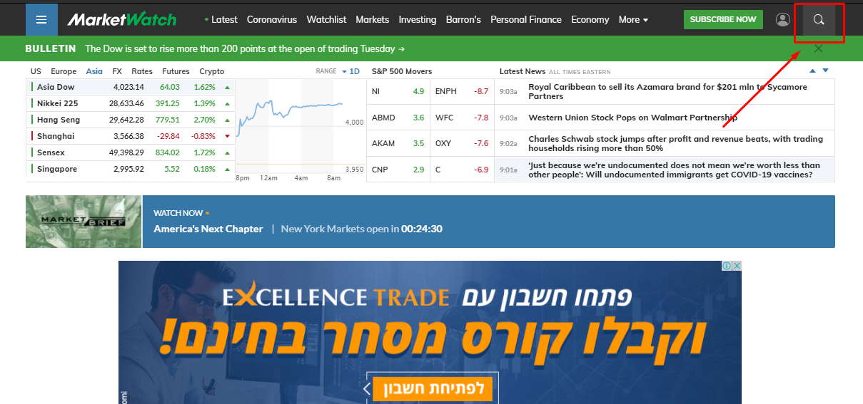
    2. Press the Magnifying glass
    3. Punch in the stock Ticker in the search window and press *enter*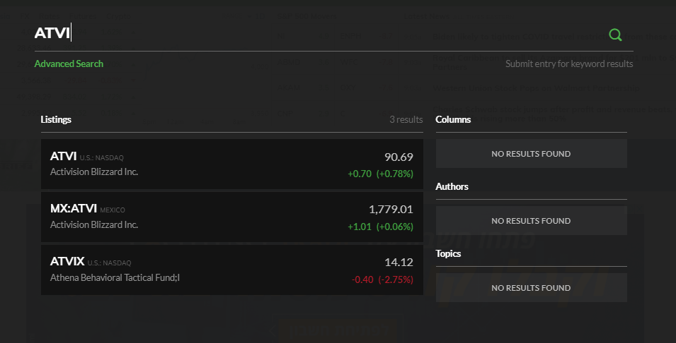
    4. In the new window that opens click on ANALYST ESTIMATES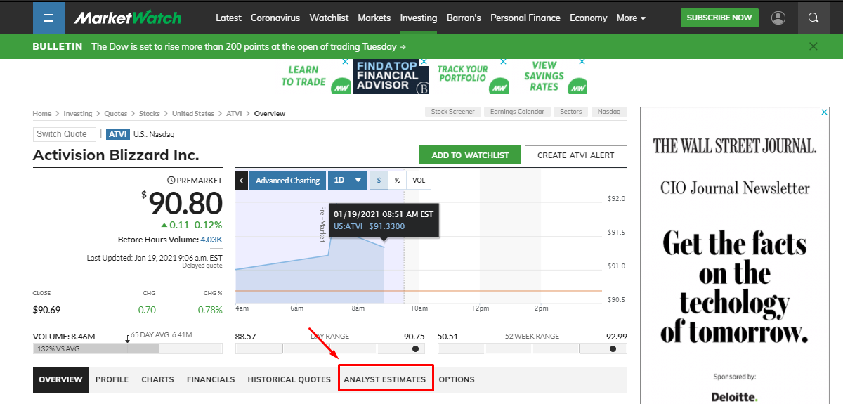
    5. In this new window scroll down to the **ANALYST RATINGS**. Here the information we need is presented on a table. From here we can get the data that will determine if the test is positive or negative.  
       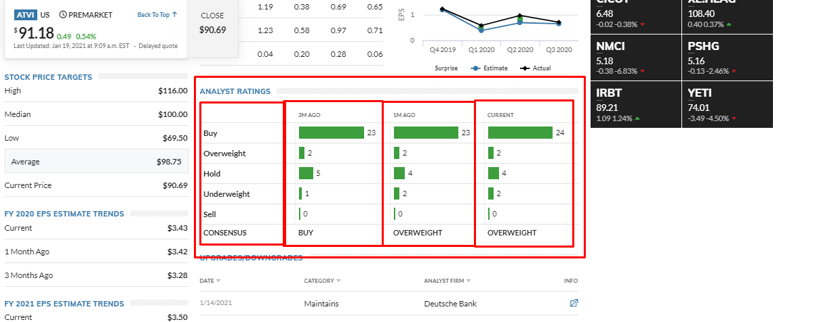

## P/E ratio test

Here we will be testing if the stock’s P/E ratio is equal or Over 17  
How do you find this information:

* + 1. Go to the free website [www.marketwatch.com](http://www.marketwatch.com)  
       
    2. Press the Magnifying glass
    3. Punch in the Stock Ticker in the search window and press *enter*
    4. Scroll down to the “KEY DATA” box. There the “P/E RATIO” is provided.
       1. If the ratio is equal to or lower than 17; the test is positive.
       2. If the P/E is N/A, add to the final Output a message of missing information  
          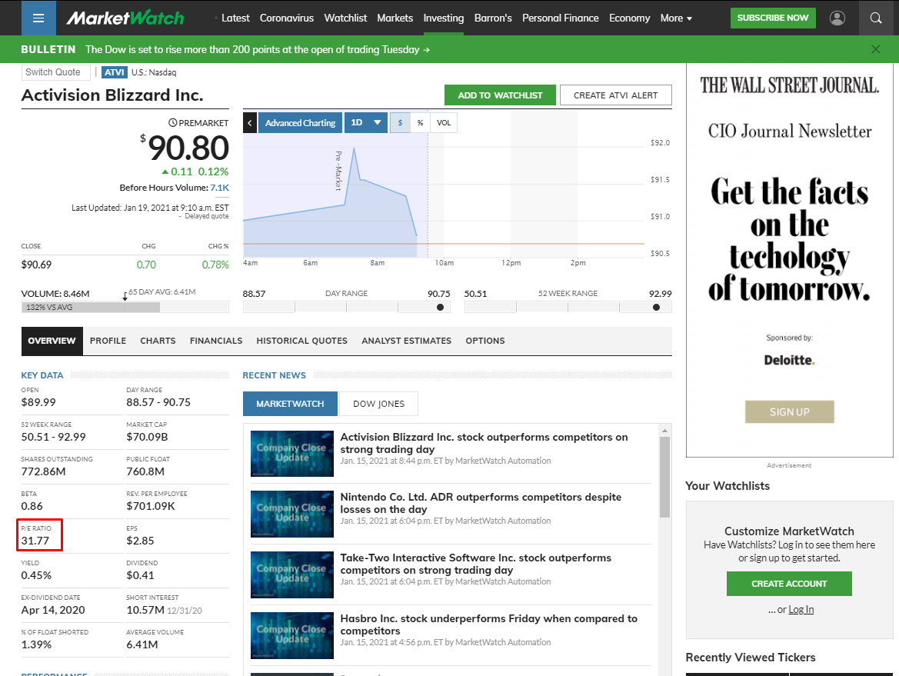

Stride price variance:

**ניסיון #1 Stock market cap**

# Market Cap Info

Other required information.

**Micro Cap:**   
0 - 300 $ Million | All range

**Small Cap:**   
300 $ Million - 2 $ Billion | +/- 70%

**Mid Cap:**   
2 $ Billion - 10 $Billion | +/- 40%

**Large Cap:**   
10 $Billion < | +/- 8%

* + 1. Go to the free website [www.marketwatch.com](http://www.marketwatch.com)
    2. Press the Magnifying glass
    3. Punch in the stock Ticker in the search window and press *enter*
    4. Scroll down till you see on the left a list of information about the stock. One sais “MARKET CAP” and has the information about the stock market capitalization  
       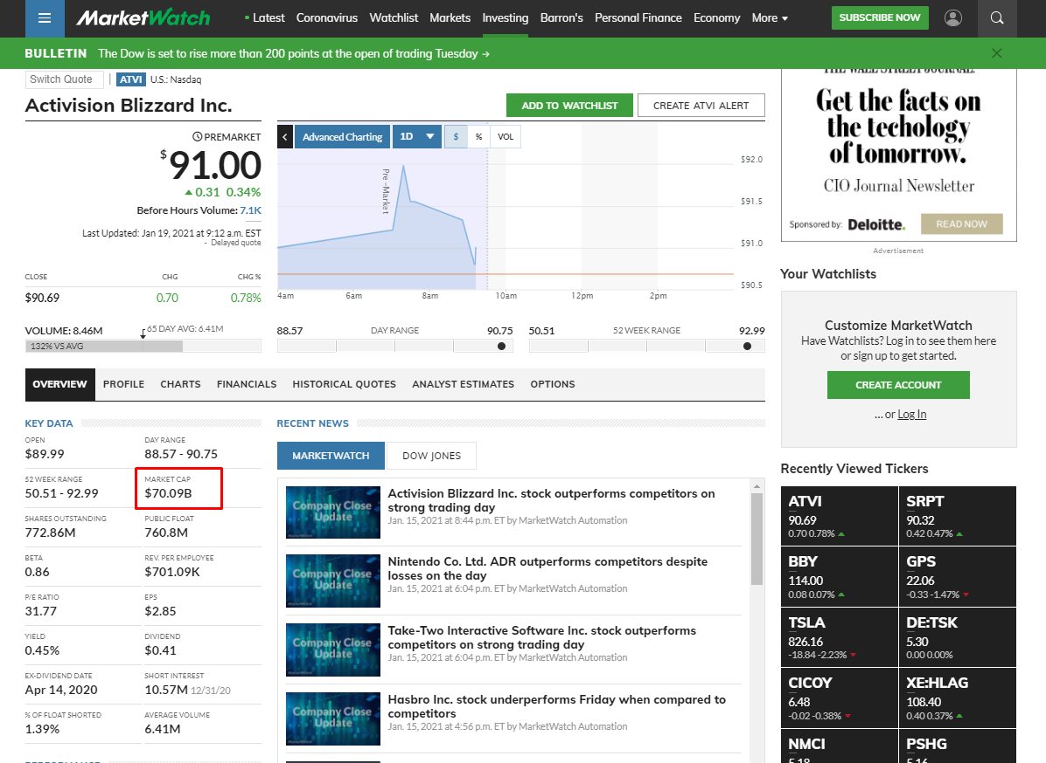

**4. The Final spreadsheet**

**The aim:**

To present all trades from highest annual return to the lowest that have passed all tests together with all the data that was presented.

Here I require a online page that shows all the data, later on, it would be the point to make manual trades via a second robot that would take the information from this page

What platform will be used:

Proposals:

* Google sheets
* Privet landing page
* Download to XML every time

Information needs to be presented:

* Stock Symbol
* Company name
* Current Price
* Strike Price
* Run date
* Strike date
* Days to expiration
* Market Cap
* Open interest
* Volume
* Premium
* Price objective (Momentum Test)
* P/E ratio
* Annual Return
* Example:  
  