**Nginx Performance Evaluation**

**Steps:**

1. **Purpose**
2. **Environment**
3. **Setup**
4. **Environment Check**
5. **Compile Nginx**
6. **Tune system**
7. **Run ab test**
8. **Monitor**
9. **Analyze**
10. **Introduce jemalloc**
11. **Redo ab test**
12. **Analyze for jemalloc**
13. **Conclusion**
14. **Future works**
15. **DPDK**

**Detailed information in every step:**

1. **Purpose**

This is a performance test on latest version of plain nginx, find bottleneck, and solve it.

A simple approach is to saturate a single core in my SUT workstation, because my 1Gb NIC can only generate very limited workload

But it will show you how to easily scale-up if you have 10Gb NIC + 10-core CPU, or more easily scale-out if you have 10x servers with single 10Gb NIC + 10-core CPU.

And the CPU saturation will help you to see the bottleneck directly, not just guessing, or trying randomly.

1. **Environment**

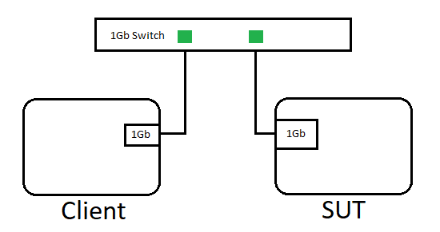

**SUT Hardware:**

NIC: Intel Corporation Ethernet Connection (7) I219-LM (No RSS)

CPU: Intel(R) Xeon(R) E-2186G CPU @ 3.80GHz (HT=off)

Memory：32GB x2 (2666MHz)

**Software:**

OS: Red Hat Enterprise Linux Server release 7.5 (Maipo)

Kernel：3.10.0-862.11.6.el7.x86_64 (with Meldown & Spectre patches)

nginx-1.15.5 + zlib-1.2.11 + pcre-8.42 + jemalloc-5.1.0

1. **Setup**

Download the latest version of Nginx from <http://nginx.org/download/nginx-1.15.5.tar.gz>

Compilation requires [zlib-1.2.11](https://www.zlib.net/zlib-1.2.11.tar.gz) + [pcre-8.42](https://ftp.pcre.org/pub/pcre/pcre-8.42.tar.gz) ( [jemalloc-5.1.0](https://github.com/jemalloc/jemalloc/releases/download/5.1.0/jemalloc-5.1.0.tar.bz2) )

1. **Environment Check**

**NIC bandwidth:**

[root@dr1 ~]# iperf3 -c www.example.com &

[ ID] Interval Transfer Bandwidth Retr Cwnd

[ 4] 0.00-1.00 sec 114 MBytes 958 Mbits/sec 0 543 Kbytes

looks good

**Stop SUT Services:**

systemctl stop ***, after doing this step, we can check system remaining services:

[root@st50 www]# systemctl -a |grep running

session-113.scope loaded active running Session 113 of user root

session-2.scope loaded active running Session 2 of user root

auditd.service loaded active running Security Auditing Service

dbus.service loaded active running D-Bus System Message Bus

getty@tty1.service loaded active running Getty on tty1

polkit.service loaded active running Authorization Manager

sshd.service loaded active running OpenSSH server daemon

dbus.socket loaded active running D-Bus System Message Bus Socket

Enable Client irqbalance service:

[root@dr1 www]# systemctl start irqbalance

1. **Compile Nginx**

[root@st50 nginx-1.15.5]# ./configure --prefix=/home/www/nginx0 --with-pcre=/home/www/pcre-8.42 --with-zlib=/home/www/zlib-1.2.11 --with-debug

1. **Tuning system**

**check irq #**

[root@st50 www]# cat /proc/interrupts |grep eno1

123: 27700 1 0 2 0 0 0 0 0 6 0 0 IR-PCI-MSI-edge eno1

**bind irq to single logical core #2:**

echo 4 > /proc/irq/123/smp_affinity

**slightly enlarge the ring cache :**

ethtool -G eno1 rx 8192

**reduce softirq a little:**

ethtool -C eno1 adaptive-tx off adaptive-rx off rx-usecs 400 # rx-frames 15 # in microseconds or packets

**Disable THP:**

echo madvise > /sys/kernel/mm/transparent_hugepage/enabled

echo madvise > /sys/kernel/mm/transparent_hugepage/defrag

**add following 2 lines into** /etc/security/limits.conf

* hard nofile 655350

* soft nofile 655350

**Change kernel parameters listed below:**

fs.file-max=500000 #open files

kernel.sysrq = 0 #sysrq keys disabled

kernel.core_uses_pid = 1 #coredump

kernel.msgmnb = 65536 #max bytes

kernel.msgmax = 65536 #max length

kernel.shmmax = 68719476736 #single share memory segment max size

kernel.shmall = 4294967296 #pages

net.core.wmem_default = 8388608 #tx window

net.core.rmem_default = 8388608 #rx window

net.core.wmem_max = 16777216 #tx window

net.core.rmem_max = 16777216 #rx window

net.core.netdev_max_backlog = 40960 #rx queue len

net.core.somaxconn = 40960 #connection

#net.core.default_qdisc=fq #google congestion control

#net.ipv4.tcp_congestion_control=bbr #google congestion control

net.ipv4.ip_forward = 0 #disable ip forward

net.ipv4.conf.default.rp_filter = 1 #reverse path filter, same port io

net.ipv4.tcp_syncookies = 1 #avoid syn flood

net.ipv4.tcp_max_tw_buckets = 6000 #TIME_WAIT #

net.ipv4.tcp_sack = 1 #selective acknowledge

net.ipv4.tcp_window_scaling = 1 #64k window

net.ipv4.tcp_rmem = 4096 87380 4194304 #rx window: min/def/max

net.ipv4.tcp_wmem = 4096 16384 4194304 #tx window: min/def/max

net.ipv4.tcp_mem = 94500000 915000000 927000000 #sys tcp mem

net.ipv4.tcp_max_orphans = 3276800 #sockets

net.ipv4.tcp_max_syn_backlog = 40960 #syn queue

net.ipv4.tcp_timestamps = 0 #better than resend

net.ipv4.tcp_synack_retries = 1 #hand shake#

net.ipv4.tcp_syn_retries = 1 #

net.ipv4.tcp_tw_recycle = 1 #

net.ipv4.tcp_tw_reuse = 1 # TIME-WAIT sockets reuse

net.ipv4.tcp_fin_timeout = 1 #close timeout

net.ipv4.tcp_keepalive_time = 30 #default 2h

net.ipv4.tcp_slow_start_after_idle=0 #

net.ipv4.ip_local_port_range = 1024 65000

vm.zone_reclaim_mode=0 #alloc remote page when used up local

kernel.kptr_restrict=0 #perf

**Change nginx.conf:**

user www;

worker_processes 10;

#worker_cpu_affinity 000000000100 000000000100;

error_log /dev/null ;

events {

use epoll;

worker_connections 4096;

}

http {

include mime.types;

default_type application/octet-stream;

#open_file_cache max=10 inactive=5m;

#open_file_cache_valid 2m;

#open_file_cache_min_uses 1;

#access_log logs/access.log main;

access_log off;

server_names_hash_bucket_size 128;

client_header_buffer_size 2k;

large_client_header_buffers 4 4k;

client_max_body_size 8m;

sendfile on; #skip user space

tcp_nopush on; #merge bundle

tcp_nodelay on; #disable nagle

keepalive_timeout 60;

gzip on;

#gzip_static on;

gzip_proxied expired no-cache no-store private auth;

gzip_min_length 1k;

gzip_buffers 16 8k;

gzip_http_version 1.1;

gzip_comp_level 4;

gzip_types text/plain application/x-javascript text/css application/xml image/svg+xml;

gzip_vary on;

server {

listen 80;

server_name www.example.com;

#access_log off;

location / {

root html;

index index.html index.htm;

}

error_page 500 502 503 504 /50x.html;

location = /50x.html {

root html;

}

}

1. **Run test**

**start nginx on the core #2:**

numactl -C 2 --localalloc nginx/sbin/nginx

**Validate logo.svg**

wget http://www.example.com/logo.svg

**run ab test:**

ab -n 800000 -c 100 http://www.example.com/logo.svg

This is ApacheBench, Version 2.3 <$Revision: 1430300 $>

Copyright 1996 Adam Twiss, Zeus Technology Ltd, http://www.zeustech.net/

Licensed to The Apache Software Foundation, http://www.apache.org/

Benchmarking www.example.com (be patient)

Completed 80000 requests

Completed 160000 requests

Completed 240000 requests

Completed 320000 requests

Completed 400000 requests

Completed 480000 requests

Completed 560000 requests

Completed 640000 requests

Completed 720000 requests

Completed 800000 requests

Finished 800000 requests

Server Software: nginx/1.15.5

Server Hostname: www.example.com

Server Port: 80

Document Path: /logo.svg

Document Length: 2649 bytes

Concurrency Level: 100

Time taken for tests: 23.820 seconds

Complete requests: 800000

Failed requests: 0

Write errors: 0

Total transferred: 2328000000 bytes

HTML transferred: 2119200000 bytes

Requests per second: 33585.56 [#/sec] (mean)

Time per request: 2.977 [ms] (mean)

Time per request: 0.030 [ms] (mean, across all concurrent requests)

Transfer rate: 95443.35 [Kbytes/sec] received

Connection Times (ms)

min mean[+/-sd] median max

Connect: 0 1 0.3 1 6

Processing: 0 2 0.5 2 22

Waiting: 0 2 0.5 1 22

Total: 1 3 0.7 3 25

Percentage of the requests served within a certain time (ms)

50% 3

66% 3

75% 3

80% 3

90% 4

95% 4

98% 5

99% 5

100% 25 (longest request)

1. **Monitor**

Network: sar -n DEV 2 4

CPU: mpstat -P ALL 2 4

Memory: numactl -H

Cache/TLB: perf stat --cpu=2 -dd

Syscall utility:

perf probe 'tcp_recvmsg'

perf probe -x /lib64/libc.so.6 malloc

perf record -e probe:tcp_recvmsg -e probe_libc:malloc -a

Hotspot capture: perf record ; perf top ; perf stat

Memory access utility: perf mem -D record

1. **Analyze**

**CPU usage: (from mpstat)**

Average: CPU %usr %nice %sys %iowait %irq %soft %steal %guest %gnice %idle

Average: 2 24.28 0.00 45.06 0.00 0.00 30.66 0.00 0.00 0.00 0.00

**Network usage: (from sar -n DEV)**

02:51:19 PM IFACE rxpck/s txpck/s rxkB/s txkB/s rxcmp/s txcmp/s rxmcst/s %ifutil

02:55:25 PM eth0 188525.00 196267.50 15738.66 106685.75 0.00 0.00 2.00 **87.40**

**Syscall usage** **in 8 seconds: (from perf record -e probe_libc:malloc -e probe:tcp_recvmsg)**

1,027,994 probe_libc:malloc

256,699 probe:tcp_recvmsg

**TLB usage: (from perf stat -dd)**

6,543,139,385 dTLB-loads # 817.829 M/sec (71.49%)

6,057,670 dTLB-load-misses # 0.09% of all dTLB cache hits (57.20%)

**Memory usage: (from numactl -H)**

node 0 size: 65371 MB

node 0 free: 63229 MB

**Memory access samples in 8 seconds: (perf mem -D record)**

total: 134024 samples

36K cpu/mem-loads,ldlat=30/P

97K cpu/mem-stores/P

**the bottleneck is memory allocator (can be misleading on RHEL 7.5 with kernel 3.10)**

**Move to SLES-15 with new kernel 4.12, lots of perf improvements**

perf record -a -g --all-kernel (all net relative)

perf record -a -g --all-user (yeah)

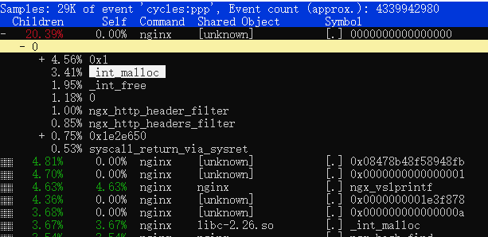

**And I got malloc usage data for this scenario:**

st250:/home/www # perf record -e probe_libc:malloc -e probe:tcp_recvmsg -aR -g --output=/tmp/perf-probes.data -- sleep 8

st250:/home/www # perf script -i /tmp/perf-probes.data 2>/dev/null | grep malloc | awk '{a[$1]++;}END{for (i in a)print i, a[i];}' | sort -rnk2 > libc.malloc.sys

st250:/home/www # cat libc.malloc.sys

nginx 998487

sleep 832

systemd 345

dbus-daemon 300

systemd-journal 254

sadc 212

systemd-logind 182

sshd 171

mpstat 62

sar 50

perf 2

1. **Introduce jemalloc**

Compile jemalloc:

[root@www jemalloc-5.1.0]# ./autogen.sh

[root@www jemalloc-5.1.0]# make & make install

Compile nginx with jemalloc:

[root@st50 nginx-1.15.5]# ./configure --prefix=/home/www/nginx0 --with-pcre=/home/www/pcre-8.42 --with-zlib=/home/www/zlib-1.2.11 --with-debug --with-ld-opt="-ljemalloc"

Restart Nginx:

export LD_LIBRARY_PATH=$LD_LIBRARY_PATH:/usr/local/lib

numactl -C 2 --localalloc nginx/sbin/nginx

#keep all other settings same

1. **Redo ab test**

[root@dr1 www]# ab -n 800000 -c 300 http://www.example.com/logo.svg

This is ApacheBench, Version 2.3 <$Revision: 1430300 $>

Copyright 1996 Adam Twiss, Zeus Technology Ltd, http://www.zeustech.net/

Licensed to The Apache Software Foundation, http://www.apache.org/

Benchmarking www.example.com (be patient)

Completed 80000 requests

Completed 160000 requests

Completed 240000 requests

Completed 320000 requests

Completed 400000 requests

Completed 480000 requests

Completed 560000 requests

Completed 640000 requests

Completed 720000 requests

Completed 800000 requests

Finished 800000 requests

Server Software: nginx/1.15.5

Server Hostname: www.example.com

Server Port: 80

Document Path: /logo.svg

Document Length: 2649 bytes

Concurrency Level: 300

Time taken for tests: 22.148 seconds

Complete requests: 800000

Failed requests: 0

Write errors: 0

Total transferred: 2328000000 bytes

HTML transferred: 2119200000 bytes

Requests per second: 36120.88 [#/sec] (mean)

Time per request: 8.305 [ms] (mean)

Time per request: 0.028 [ms] (mean, across all concurrent requests)

Transfer rate: 102648.20 [Kbytes/sec] received

Connection Times (ms)

min mean[+/-sd] median max

Connect: 0 4 24.6 3 1007

Processing: 1 4 6.0 4 225

Waiting: 0 4 5.6 4 209

Total: 1 8 25.3 7 1015

Percentage of the requests served within a certain time (ms)

50% 7

66% 8

75% 8

80% 8

90% 8

95% 9

98% 11

99% 12

100% 1015 (longest request)

1. **Analyze for jemalloc**

**CPU usage: (from mpstat)**

Average: CPU %usr %nice %sys %iowait %irq %soft %steal %guest %gnice %idle

Average: 2 19.54 0.00 35.12 0.00 0.00 32.18 0.00 0.00 0.00 13.15

**Network usage: (from sar -n DEV)**

02:51:19 PM IFACE rxpck/s txpck/s rxkB/s txkB/s rxcmp/s txcmp/s rxmcst/s %ifutil

02:51:21 PM eth0 211446.00 222039.50 17673.09 120630.16 0.00 0.00 0.00 **98.82**

**Syscall usage** **in 8 seconds: (from perf record -e probe:tcp_recvmsg -e probe_libc:malloc)**

840 probe_libc:malloc

289,287 probe:tcp_recvmsg

**TLB usage: (from perf record)**

6,861,897,872 dTLB-loads # 857.666 M/sec (76.95%)

18,741,425 dTLB-load-misses # 0.27% of all dTLB cache hits (61.60%)

**Memory usage: (from numactl -H)**

node 0 size: 65371 MB

node 0 free: 63200 MB

**Memory access samples in 8 seconds: (perf mem -D record)**

total: 113608 samples

30K cpu/mem-loads,ldlat=30/P

82K cpu/mem-stores/P

**And malloc usage data now:**

st250:/home/www # perf record -e probe_libc:malloc -e probe:tcp_recvmsg -aR -g --output=/tmp/perf-probes.data -- sleep 8

st250:/home/www # perf script -i /tmp/perf-probes.data 2>/dev/null | grep malloc | awk '{a[$1]++;}END{for (i in a)print i, a[i];}' | sort -rnk2 > libc.malloc.sys.jemalloc

st250:/home/www # cat libc.malloc.sys.jemalloc

nginx 6883

systemd 901

dbus-daemon 635

systemd-journal 462

sleep 416

systemd-logind 208

sshd 165

perf 2

**perf top shows NO memory allocator any more ~~ (actually CPU is not bottleneck)**

6.29% nginx [kernel.vmlinux] [k] system_call

5.05% nginx [kernel.vmlinux] [k] sysret_check

1.14% swapper [kernel.vmlinux] [k] memcpy

1.14% nginx [kernel.vmlinux] [k] _raw_spin_lock

1.02% nginx [e1000e] [k] e1000_xmit_frame

0.97% nginx libc-2.17.so [.] __memcpy_ssse3_back

1. **Conclusion**

Memory allocation latency is critical to nginx, glibc malloc is blamed for years, and TCmalloc and jemalloc is developed to resolve this performance issue.

As a simple comparison before and after introducing jemalloc,

RPS is increased from 33585.56 to 36087.54 (+8%)

CPU %idle is increased from 0% to 13.15% (13%) while workload is +8% (total jemalloc > 20%)

CPU %sys is reduced from 45.50% to 35.12% (-10%) while workload is +8% heavier

Network util: increased from 87.40% to 98.82% (+11%) Saturated

TLB-loads is increased from 819.362 to 857.666 M/sec (+5%) while workload is +8% heavier

Syscall probe_libc:malloc is reduced from 926,719 to 840 (99%?) …… Deviation ?

Syscall tcp_recvmsg increased from 231K to 289K, (+25%), why >8%? Deviation ?

99% latency has been reduced from 12ms to 12ms (0%) while workload is +8% heavier

1. **Future works**

This is a very simple test to resolve malloc performance bottleneck by introducing jemalloc

It demonstrates the iteration of simplifying the problem, finding performance bottleneck, fixing problem, and verifying it. And then continue this iteration into a higher performance state.

Will do more research on DPDK user-space TCP stack, because the later profile shows that bottleneck is in tcp stack of Linux kernel. I know it could be something complicated, but it’s worthy to try, there is no free lunch.

1. **DPDK**

Finally got a chance to have a look at DPDK on my server.

I chose the F-Stack implementation: https://github.com/f-stack/f-stack

The first glance of the readiness state is 99% CPU on my cores, it surprised me a bit. A minute later, I realize that it is in User Space Mode: means it should be a busy loop, and then I was released.

And the profile looks like this:

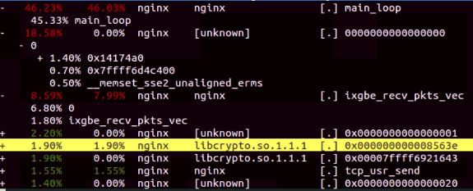

It looks like not saturated, but my driver side still using interrupt, and usage of CPU0 is 100%, I need to start multiple ab processes, let’s say 10, and we can add the throughput altogether.

And I got this:

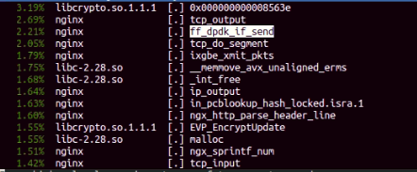

The total throughput is 91,595. Then I tried more ab, 20, 30, the throughput stays at 91k. I know the throughput of nginx server on a single logical core has reached it ceiling.

I then increase the server logical cores to 2, the throughput goes up to 183,180, well the scaling is not bad, and most importantly: there is nearly no sys & irq:

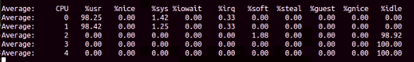

The %usr shown here is very noticeable, since there is a idle_sleep(ms) in “while (1)” of main_loop function

If set idle_sleep=0, the $usr will be constantly equal to 97-99, and set idle_sleep=1 $usr will cost about 3% when idle, but the throughput will decrease from 183,180 -> 181,563 (-1%), I will keep this anyway, since it will show me the real workload.

Enabling jemalloc increased RPS from 181,563 to 184,589 (+1.7%)

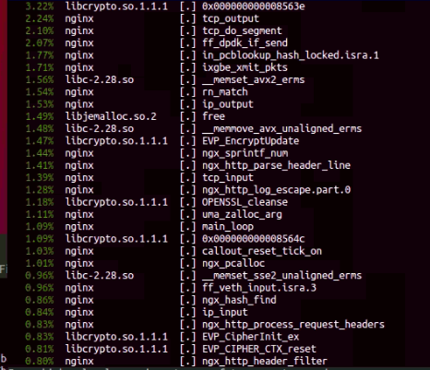

Then, I turn on gzip in nginx.conf, even though the transfer rate reduced from 13 to 3 (MB/s). it is not surprising, small packets didn’t bring any performance benefit, since the network bandwidth is not current bottleneck.

When I extend to 4 lcore, each CPU avg usage is only about 40%, I checked the hugepages were used up.

echo 2048 > /sys/devices/system/node/node0/hugepages/hugepages-2048kB/nr_hugepages

Doubling large page memory will give the CPU usage up to 80%, continue to add

echo 40960 > /sys/devices/system/node/node0/hugepages/hugepages-2048kB/nr_hugepages

Let’s add to 40960, which I assume it may support about 40 lcores, and add ab clients to 40.

And now, with 4 lcores, RPS goes up to 368,615, scaling factor = 2, not bad

Meanwhile the in/out %ifutil is about 15%

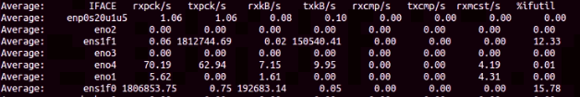

Noticeably, if I enabled the Hyper Threading in ab side, the latency on the extra lcores is much higher than the pcores only: 99% latency increases from 8ms to 200ms,

I feel super tired today, will try more lcores & other options later