Student

Submitted iRegistration Develop A
Project Report
Partial fulfilment for the award of

Bachelor of Technology In
COMPUTER SCIENCE & ENGINEERING
Submitted to

DR. A.P.J. ABDULKALAM TECHNICAL UNIVERSITY, UTTAR PRADESH, LUCKNOW

PROJECT REPORT
Submitted by
PRIYANKA GUPTA (2104720100035)
POOJA SAHANI (2304720109010)
ALTAF HUSSAIN (2104720100007)
BRIJNANDAN KHARWAR (2104720100016) DEENDAYAL (2304720109003)
Guided & Approved By
MR. AMIT KAUSHAL SIR
Head of Department
Department of Computer Science & Engineering
Institute of Technology & Management Chehari, Pharenda Maharajganj (UP)
Forwarded by
DR. SAIYED SALIM SAYEED SIR
Director


Session-2024
DEPARTMENT OF COMPUTER SCIENCE & ENGINEERING INSTITUTE OF TECHNOLOGY & MAHAGEMENT MAHARAJGANJ

CERTIFICATE
This is to certify that the work embodied in this project work entitled
“Clone of Musical App Development” has been satisfactorily completed by the

KANCHAN (2104720100023)
ANKITA GUPTA (2204720109004)
SHIVANGI TIWARI (2204720109011)
MANJEET GUPTA (2204720109008) MUKESH KR YADAV (2204720109009)

It is a bonafide piece of work, carried out under the guidance in Department of COMPUTER SCIENCE & ENGINEERING, INSTITUTE OF TECHNOLOGY & MANAGEMENT MAHARAJGANJ for
the partial fulfilment of the BACHELOR OF TECHNOLOGY during the academic year 2024- 25.

Guided & Approved By
MR. AMIT KAUSHAL SIR
Head of Department
Department of Computer Science & Engineering
Institute of Technology & Management Chehari, Pharenda Maharajganj (UP)
Forwarded by
DR. SAIYED SALIM SAYEED SIR
Director

CERTIFICATE OF APPROVAL

This foregoing project work is hereby approved as a creditable study of Engineering carried out and presented in a manner satisfactory to warranty its acceptance as a prerequisite to the degree for which it has been submitted. It is understood that by this approval the undersigned do not necessarily endorse or approve any statement made, opinion expressed or conclusion drawn therein, but approve the project only for the purpose for which it has been submitted.

(Internal Examiner) (External Examiner)

DECLARATION
We are student of BACHELOR OF TECHNOLOGY in COMPUTER SCIENCE & ENGINEERING,
Institute of Technology & Management Maharajganj hereby declare that the work presented in this major project is outcome of our own work, is bonafide, correct to the best of our knowledge and this work has been carried out taking care of engineering ethics. The work presented does not infringe any patented work and has not been submitted to any university for the award of any degree or professional Bachelor of Technology.

KANCHAN (2104720100023)
ANKITA GUPTA (2204720109004)
SHIVANGI TIWARI (2204720109011)
MANJEET GUPTA (2204720109008) MUKESH KR YADAV (2204720109009)

ACKNOWLEDGEMENT
Every work started and carried out with systematic approach turns out to be successful. Any accomplished requires the effort of many people and this work is no different. This project was a struggle that was made much more difficult due to numerous reasons; some of error correction was beyond our control. Sometimes we are like rudderless boat without knowing what to do next. It was then the timely guidance of that has seen us through all these odds. we will be very grateful to them for their inspiration, encouragement and guidance in all phases of the endeavor.
It is our great pleasure to thanks MR. AMIT KAUSHAL SIR, LECTURER of COMPUTER SCIENCE & ENGINEERING for his constant encouragement and valuable advice during the course of our project. We are also want to extend our thanks for his valuable guidance and help during development of the project. We are also wish to express our gratitude towards all other staff members for their kind help.
Finally, we are thanks DR. SAIYED SALIM SAYEED SIR who was tremendously contributed to this project directly as well as indirectly; gratitude from the depths of our hearts is due to him. Regardless of source we wish to express our gratitude to those who may contribute to this work, even though anonymously.

KANCHAN (2104720100023)
ANKITA GUPTA (2204720109004)
SHIVANGI TIWARI (2204720109011)
MANJEET GUPTA (2204720109008) MUKESH KR YADAV (2204720109009

INDEX
- INTRODUCTION
  - Introduction
  - Problem introduction
  - Modules in the project
- REQUIREMENTS SPECIFICATION
  - Introduction
  - Hardware requirements
  - Software requirements
- ANALYSIS
  - Existing System
  - Proposed System
  - Feasibility study
  - Software specification
- DESIGN
  - System Design
    - Introduction to UML
  - UML Approach
    - UML Diagrams
    - Data Flow Diagram
    - ER Diagram
- SYSTEM IMPLEMENTATION
  - Introduction
  - Sample code
- TESTING
  - Introduction
  - Testing methods
- SAMPLE SCREENSHOTS
- CONCLUSION

  - Introduction:
CHAPTER 1 INTRODUCTION

In today's rapidly evolving digital landscape, music streaming and sharing applications have become an integral part of our daily lives. Platforms like Spotify, Apple Music, and SoundCloud have revolutionized the way people access, share, and experience music. The growing popularity of these apps has inspired many developers and entrepreneurs to create their own musical app clones that replicate core functionalities while introducing unique features to stand out in a competitive market.

A musical app clone serves as a foundation for building a feature-rich music streaming platform. It allows users to listen to their favorite tracks, create playlists, follow artists, and share their favorite songs with friends. Additionally, such apps often integrate advanced technologies like AI-based recommendations, cloud storage, and seamless cross-platform support.

Developing a musical app clone is not just about replicating existing features but also about enhancing user experience, improving scalability, and adding innovative functionalities. This document outlines the key aspects of building a musical app clone, including the core features, technology stack, design principles, and monetization strategies. Whether you're a startup looking to enter the music tech industry or an established business aiming to expand your digital portfolio, this guide will provide valuable insights to help you create a successful musical app clone.

Let’s embark on this journey to understand the intricacies of musical app development and explore how to create a platform that resonates with users and delivers an exceptional audio experience.

  - Problem Introduction:
    - Market Demand for Music Streaming Platforms:
      - The growing dependence on digital platforms for music consumption has created a high demand for innovative and feature-rich music streaming apps.
      - Existing platforms dominate the market, but there is still space for customized solutions catering to niche audiences.
    - Challenges in Existing Applications:
      - Limited personalization and recommendation accuracy.
      - High subscription costs make premium features inaccessible to a large user base.
      - User interface and user experience inconsistencies across devices.
    - Need for a Clone Application:
      - Developing a clone app allows leveraging existing successful features while introducing improvements.
      - Clone apps reduce development time and costs compared to building an app from scratch.

      - Opportunity to incorporate innovative features like AI-driven playlists, offline listening, and enhanced social sharing.
    - Technical Challenges:
      - Ensuring seamless audio streaming without buffering.
      - Implementing secure payment gateways for premium subscriptions.
      - Managing large-scale databases for music libraries and user data.
    - Business Challenges:
      - Monetizing the app effectively without compromising user experience.
      - Retaining users in a competitive market.
      - Building partnerships with music labels and independent artists.
    - Objective of the Project:
      - To develop a scalable and user-friendly musical app clone.
      - To address the limitations of existing platforms and introduce innovative features.
      - To create a sustainable business model for long-term growth.
  - Modules in the project :
    - User Authentication and Profile Management:
      - Secure user login and registration.
      - Profile creation and management.
    - Music Library Module:
      - Access to a wide variety of songs, albums, and playlists.
      - Advanced search and filter options.
    - AI Recommendation System:
      - Personalized song recommendations based on user behavior.
      - Playlist generation using AI algorithms.
    - Streaming and Offline Playback:
      - High-quality audio streaming.
      - Offline music download and playback.
    - Social Integration Module:
      - Share music and playlists with friends.
      - Follow artists and interact with other users.
    - Payment and Subscription Module:
      - Integration of secure payment gateways.
      - Subscription plans for premium features.
    - Admin Dashboard:
      - Manage users, content, and analytics.
      - Monitor app performance and resolve technical issues.
    - Notification System:
      - Real-time push notifications.
      - Updates on new releases, recommendations, and offers.

CHAPTER 2

REQUIREMENT SPECIFICATION

INTRODUCTION:
Developing a musical app clone requires a well-defined set of requirements to ensure a seamless user experience, robust performance, and scalability. The requirements specification serves as a blueprint that outlines the technical, functional, and non-functional needs of the application, enabling efficient planning and development.

    - Functional Requirements:
      - User authentication and profile management.
      - Music search, playback, and streaming functionalities.
      - Playlist creation, editing, and sharing.
      - Recommendation engine based on user preferences.
      - Offline music playback feature.
      - Social media integration for sharing music.
    - Non-Functional Requirements:
      - Scalability to handle a growing user base.
      - High availability and uptime.
      - Data security and user privacy compliance.
      - Cross-platform compatibility (iOS, Android, Web).
      - Fast response time for seamless streaming.
    - Technical Requirements:
      - Backend server for handling music streaming and user data.
      - Database management system for efficient data storage.
      - Cloud infrastructure for scalability and performance.
      - Integration with payment gateways for premium subscriptions.
    - User Interface (UI) and User Experience (UX) Requirements:
      - Intuitive and user-friendly design.
      - Easy navigation across app features.
      - Visually appealing layout for better engagement.
    - Business Requirements:
      - Monetization strategies (e.g., freemium model, ads, subscriptions).
      - Partnering with music labels and independent artists.
      - Analytics tools for tracking user engagement and app performance.
The requirements specification aims to provide a clear framework for building a robust and user- centric musical app clone. It serves as a foundation for aligning stakeholders, developers, and designers towards a common goal, ensuring the final product meets user expectations and business objectives.

  - Hardware requirements:
    - Development Machines:
      - High-performance computers with multi-core processors (Intel i7 or AMD Ryzen 7 and above).
      - Minimum 16GB RAM for efficient app development and testing.
      - At least 500GB SSD storage for faster file access and development processes.
    - Servers:
      - Cloud servers (e.g., AWS, Google Cloud, Microsoft Azure) for hosting the application backend.
      - Dedicated servers for database management and user authentication.
    - Networking Equipment:
      - High-speed internet connection for seamless development and testing.
      - Secure VPN access for remote team collaboration.
    - Testing Devices:
      - Smartphones (iOS and Android) for mobile app testing.
      - Tablets for cross-platform compatibility checks.
      - Desktop systems for web-based app testing.
    - Storage Solutions:
      - Scalable cloud storage for music files and user data.
      - Backup storage solutions for data recovery.
    - Audio Equipment:
      - High-quality headphones and speakers for audio quality testing.
      - Microphones for recording and testing audio functionalities.
These hardware requirements ensure smooth development, testing, and deployment of the musical app clone, enabling optimal performance and user satisfaction.

  - Software requirements:
    - Frontend Technologies:
      - Frameworks: Html, CSS, Bootstrap
      - Languages: JavaScript
    - Backend Technologies:
      - Languages: JavaScript
      - Database:Mysql
    - Cloud Services:
      - AWS (Amazon Web Services)
      - Google Cloud Platform
      - Firebase
    - Payment Gateways:
      - Stripe
      - PayPal

    - Authentication and Security:
      - SSL Encryption
      - JWT (JSON Web Token)
    - Third-party APIs:
      - Music APIs (Spotify API, SoundCloud API)
      - Social Media Integration APIs
    - Testing Tools:
      - Selenium
      - JUnit
      - Postman
These software requirements provide the foundational technologies and tools necessary for developing, deploying, and maintaining a scalable and feature-rich musical app clone.

CHAPTER 3

ANALYSIS

EXISTING SYSTEM:
    - Overview of Existing Musical Apps:
      - Popular apps such as Spotify, Apple Music, and SoundCloud dominate the market.
      - These platforms provide features like music streaming, offline downloads, playlist creation, and social sharing.
    - Key Features of Existing Systems:
      - Personalized recommendations using AI algorithms.
      - High-quality audio streaming with minimal latency.
      - Integration with multiple devices and platforms.
      - Subscription-based models offering premium features.
    - Strengths of Existing Systems:
      - Established user base and brand reputation.
      - Vast music libraries with millions of tracks.
      - Seamless user experience across platforms.
    - Limitations of Existing Systems:
      - Expensive premium subscriptions.
      - Limited customization options for users.
      - Dependency on internet connectivity for streaming.
    - Opportunities for Improvement:
      - Offering more affordable subscription plans.
      - Enhanced AI-based music recommendations.
      - Improved offline listening experiences.

PROPOSED SYSTEM:
    - System Overview:
      - The proposed system aims to build a musical app clone that integrates advanced features such as AI-based recommendations, user-friendly interfaces, and seamless streaming capabilities.
      - The system will cater to both free and premium users, ensuring an inclusive experience for all.
    - Core Functionalities:
      - User Authentication: Secure login and registration system.
      - Music Library: Vast collection of songs categorized by genre, artist, and mood.
      - Search and Discover: Powerful search engine for easy navigation.
      - Personalized Playlists: AI-driven playlist suggestions based on user behavior.
      - Offline Access: Download and play music without internet connectivity.
    - Technology Stack:

      - Frontend: React Native or Flutter for cross-platform compatibility.
      - Backend: Node.js with Express.js.
      - Database: MongoDB for scalable storage.
      - Cloud Storage: AWS or Google Cloud for audio files.
      - Payment Integration: Stripe or PayPal.
    - System Architecture:
      - A three-tier architecture consisting of Presentation Layer (User Interface), Application Layer (Business Logic), and Data Layer (Database).
      - Real-time updates for playlists, notifications, and recommendations.
    - Security Features:
      - Encrypted user data and payment details.
      - Role-based access control for admin, artist, and user accounts.
    - Expected Outcomes:
      - A robust and scalable musical app capable of handling large user traffic.
      - Enhanced user satisfaction through a seamless music streaming experience.
      - A sustainable revenue model through ads, subscriptions, and partnerships.

FEASIBILITY STUDY:
    - Technical Feasibility:
      - Evaluation of the technology stack, including frameworks and tools like React Native, Flutter, and cloud services.
      - Availability of skilled developers and technical resources for app development.
      - Assessment of infrastructure requirements for data storage, security, and seamless audio streaming.
    - Economic Feasibility:
      - Estimation of development costs, including design, coding, testing, and deployment.
      - Analysis of potential revenue streams, such as subscriptions, ads, and premium features.
      - Cost-benefit analysis to ensure profitability and return on investment.
    - Operational Feasibility:
      - Identification of operational challenges in maintaining and scaling the app.
      - Evaluation of resource availability for day-to-day operations and support.
      - Planning for regular updates, bug fixes, and customer support services.
    - Legal Feasibility:
      - Compliance with copyright laws and licensing agreements for music content.
      - Ensuring data privacy and security as per global standards (e.g., GDPR, CCPA).
      - Adherence to app store policies and guidelines.
    - Scheduling Feasibility:
      - Estimation of project timelines, from requirement gathering to deployment.
      - Development of milestones and deliverables for each phase.
      - Buffer time allocation for testing and unforeseen delays.

SOFTWARE SPECIFICATION:

HTML:
HTML or Hypertext Markup Language is the standardmarkup languageused to createweb pages.
HTML is written in the form ofHTML elementsconsisting of tags enclosed
inanglebracke <html>). HTML tags most commonly come in pairs like <h1>
ts(like
and </h1>, although some tags represent empty elements and so are unpaired, for example <img>. The first tag in a pair is the start tag, and the second tag is the end tag (they are also called opening tags and closing tags). Though not always necessary, it is best practice to append a slash to tags which are not paired with a closing tag.
The purpose of aweb browseris to read HTML documents and compose them into visible or audible web pages. The browser does not display the HTML tags, but uses the tags to interpret the content of the page. HTML describes the structure of a website semanticallyalong with cues for presentation, making it amarkup languagerather than aprogramming language.

CASCADING STYLE SHEETS (CSS):
It is astyle sheet languageused for describing thelook and formattingof a document written in a markup language. While most often used to styleweb pagesandinterfaceswritten inHTMLandXHTML, the language can be applied to any kind ofXMLdocument, includingplain XML,SVGandXUL. CSS is a cornerstone specification ofthe weband almost all web pages use CSS style sheets to describe their presentation.

BOOTSTRAP:
Bootstrap is the most popular HTML, CSS and JavaScript framework for developing responsive, mobile-first websites.
Bootstrap is a free and open-source CSS framework directed at responsive, front end web development. Bootstrap5 is the newest version of Bootstrap.
It facilitates you to create responsive designs. It is developed by Mark Otto and Jacob Thornton at Twitter. It released as an open-source product in August 2011 on GitHub.
In June 2014 Bootstrap was the No.1 project on GitHub. It is compatible on most of browsers like Chrome, Firebox, Internet Explorer, Safari and Opera etc.

MySQL:
MySQL is developed, distributed, and supported by Oracle Corporation. MySQL is a database system used on the web it runs on a server. MySQL is ideal for both small and

large applications. It is very fast, reliable, and easy to use. It supports standard SQL. MySQL can be compiled on a number of platforms.
The data in MySQL is stored in tables. A table is a collection of related data, and it consists of columns and rows. Databases are useful when storing information categorically.

JAVASCRIPT:
JavaScript is a high-level, interpreted programming language primarily used to create dynamic and interactive content on websites. As one of the core technologies of the World Wide Web, alongside HTML and CSS, JavaScript enables developers to implement complex features such as real-time updates, interactive forms, animations, and multimedia handling. It is versatile, supporting both client-side and server-side programming through environments like Node.js. JavaScript is known for its flexibility, event-driven architecture, and wide community support, making it a fundamental tool for modern web development.

CHAPTER 4

DESIGN

  - SYSTEM DESIGN:

The purpose of this document is to outline the system design for developing a musical app clone. This app will replicate key features of popular musical platforms, allowing users to stream, upload, and share music, as well as interact socially through comments and likes.

    - INTRODUCTION TO UML:

The development of a musical application clone involves complex system architecture, interactive user interfaces, and multiple interdependent components. To effectively design, visualize, and document these elements, the Unified Modeling Language (UML) serves as a standardized modeling tool. UML provides a blueprint for the application's structure and behavior, ensuring clarity, consistency, and scalability throughout the development lifecycle.

In this project, UML diagrams have been utilized to represent different perspectives of the musical app clone, including structural, behavioral, and interaction models. These diagrams help in understanding the system's functionalities, identifying key components, and streamlining communication between developers, designers, and stakeholders.

The UML models cover various aspects such as:

      - Use Case Diagrams: To depict user interactions with the application, including login, browsing music libraries, creating playlists, and managing user profiles.
      - Class Diagrams: To illustrate the static structure of the system, including classes, attributes, relationships, and dependencies.
      - Sequence Diagrams: To represent the flow of messages and interactions between objects during specific user actions.
      - Activity Diagrams: To outline workflows and dynamic behavior of key processes, such as song playback or payment transactions.

Through these diagrams, the app's architecture becomes more transparent, making it easier to detect potential issues early in the design phase and ensure seamless implementation. This section will delve into each UML diagram type used in the project, providing detailed insights into their role and contribution to the app's development.

  - UML Approach:
A UML (Unified Modeling Language) approach for a musical app involves using diagrams to visualize, design, and document the app's structure and behavior.

    - UML Diagrams:

To create UML diagrams for your music app clone project, I’ll outline the key diagrams typically included in a software project report. If you provide more details about your app (e.g., features, functionalities, tech stack, and user roles), I can tailor them specifically.

Deployment Diagram

Component Diagram
Use Case Diagram

UML
Diagram

State Diagram
Class Diagram

Sequence Diagram

Activity Diagram

- Use Case Diagram

  - Purpose: Illustrates the interactions between users and the system.
  - Actors: User, Admin, Artist, System.
  - Use Cases: Sign up, Log in, Search Music, Play Music, Create Playlist, Download Music, Manage Profile, Upload Songs (for artists).

- Class Diagram

  - Purpose: Describes the static structure of the system.
  - Key Classes:
    - User (Attributes: ID, Name, Email, Password)
    - Playlist (Attributes: Playlist ID, Name, List of Songs)
    - Song (Attributes: Song ID, Title, Duration, Artist ID)
    - Artist (Attributes: Artist ID, Name)
    - Admin (Attributes: Admin ID, Name)

- Activity Diagram

  - Purpose: Represents the flow of activities in a process.
  - Examples: User Registration Flow, Song Playback Flow, Playlist Creation.

- Sequence Diagram

  - Purpose: Shows interactions between objects over time.
  - Examples: User playing a song, Artist uploading a song, Admin managing content.

- State Diagram

  - Purpose: Describes the lifecycle of an object.
  - Example: State of a Song object (e.g., Uploaded → Approved → Live → Archived).

- Component Diagram

  - Purpose: Shows the physical structure of the application.
  - Components: Frontend, Backend, Database, API Server, Cloud Storage.

- Deployment Diagram

  - Purpose: Represents how the system is deployed on hardware.
  - Nodes: User Device (Mobile App), Web Server, Database Server, Cloud Storage.

    - Data Flow Diagram:

A Data Flow Diagram (DFD) is a visual representation used to illustrate how data flows within a system, including how it is processed, stored, and transferred between different entities. It focuses on the movement of data rather than the physical aspects of the system.

Key Components of a DFD:

- External Entities: Represent sources or destinations of data outside the system (e.g., users, external systems).
- Processes: Represent activities or functions that transform data within the system.
- Data Stores: Represent places where data is stored for later use (e.g., databases, files).
- Data Flows: Represent the movement of data between entities, processes, and data stores, usually shown as arrows.

Levels of DFD:

- Level 0 (Context Diagram): Provides a high-level overview of the system, showing the system as a single process and its interactions with external entities.
- Level 1 DFD: Breaks down the main process into sub-processes for more detail.
- Level 2 (and beyond): Further decomposes processes into more granular sub-processes.

Purpose of a DFD:

  - To understand and document how data flows through a system.
  - To identify inefficiencies or bottlenecks in data processes.
  - To aid in system analysis, design, and implementation.

DFDs are commonly used in software engineering, system analysis, and business process modeling to ensure clarity in system design and communication among stakeholders.

Music Portal
Login Management
Performer Management
System User Management
Music Management
Album Type Management
Album Management

    - ER diagram:

An Entity-Relationship (ER) Diagram is a visual representation of data and the relationships between different entities within a database. It serves as a blueprint for designing and modeling database structures, ensuring data is organized and relationships are clearly defined.

Key Components of an ER Diagram:

- Entity:
  - Represents an object, person, place, or concept in the system.
  - Depicted as a rectangle.
  - Example: Student, Employee, Product.
- Attribute:
  - Represents the properties or characteristics of an entity.
  - Depicted as an oval connected to its entity.
  - Example: Student_ID, Name, Email.
- Primary Key:

  - A unique identifier for an entity.
  - Usually underlined in the diagram.
  - Example: Student_ID.
- Relationship:
  - Represents associations between two or more entities.
  - Depicted as a diamond.
  - Example: Enrolls, Manages, Works_On.
- Cardinality:
  - Defines the number of instances of one entity that can be associated with instances of another entity.
  - Types:
    - One-to-One (1:1)
    - One-to-Many (1:N)
    - Many-to-Many (M:N)

Purpose of an ER Diagram:

- To conceptualize database design before implementation.
- To identify relationships and dependencies between data entities.
- To ensure data integrity and reduce redundancy.
- To communicate database design clearly to stakeholders and developers.

ER diagrams are commonly used in database design, data modeling, and software engineering
to create a logical structure for relational databases.

CHAPTER 5

SYSTEM IMPLEMENTATION

- IMPLEMENTATION:
  - Introduction:
Implementation is the stage of the project when the theoretical design is turned out into a working system. Thus it can be considered to be the most critical stage in achieving a successful new system and in giving the user, confidence that the new system will work and be effective.
The implementation stage involves careful planning, investigation of the existing system and it’s constraints on implementation, designing of methods to achieve changeover and evaluation of changeover methods.

  - Sample code:
Home.html:
<!DOCTYPE html>
<html>
<head>
<meta charset="utf-8">
<meta name="viewport" content="width=device-width, initial-scale=1">
<link rel="stylesheet" type="text/css" href="index.CSS">
<script src="index.js"></script>

<title>Wink-Your favourite music is here</title>
</head>

<body>
<!----
<div class="sidebar">
<div class="sidebar-nav">
<div class="logo">
<a href=""><img src="images/wink.jpg" alt=""></a>
</div>
<ul>
<li><a href="">
<span></span>

<span>HOME</span>
</a></li>
</ul>
</div> -->
</div>
</body>
<nav>
<ul>
<li class="brand"><img src="wing.jpg" alt="">WING</li>
<li>Home</li>
<li>About</li>
</ul>
</nav>
<br><br>
<title>Line Example</title>
<style>
/* Line styling */ hr {
border: 0; height: 8px;
background: white; margin: 10px 0;
line-height: 10%;
}
</style>
</head>
<body>
<hr>

</div>
<div class="spotify-playlists">
<h2>Popular Indian Singers</h2>
<title>Line Example</title>
<style>
/* Line styling */ hr {
border: 0; height: 8px;
background: white; margin: 10px 0;
line-height: 10%;
}
</style>
</head>

<body>
<hr>

</div>

</div>
<br><br>

<div class="card-container">

<!-- ID Card 1 -->
<div class="id-card">
<div class="card-header">
<img src="images/udit.jpg" alt="Profile Picture" class="profile-pic">
</div>
<div class="card-body">
<h2>Udit Narayan</h2>
<p> https://g.co/kgs/WM2ALGs</p>
</div>
</div>

<!-- ID Card 2 -->
<div class="id-card">
<div class="card-header">
<img src="images/arijit.jpg" alt="Profile Picture" class="profile-pic">
</div>
<div class="card-body">
<h2>Arijit Singh</h2>
<p> https://g.co/kgs/odaoKvi</p>
</div>
</div>
<div class="id-card">
<div class="card-header">
<img src="images/sonu2.jpg" alt="Profile Picture" class="profile-pic">
</div>
<div class="card-body">
<h2>Sonu Nigam</h2>
<p> https://g.co/kgs/bWTJovx</p>
</div>
</div>
<div class="id-card">
<div class="card-header">

<img src="images/lata.jpg" alt="Profile Picture" class="profile-pic">
</div>
<div class="card-body">
<h2>Lata Mangeskar</h2>
<p> https://g.co/kgs/fxyHnRp</p>
</div>
</div>
<!-- ID Card 3 -->
<div class="id-card">
<div class="card-header">
<img src="images/sanu.jpg" alt="Profile Picture" class="profile-pic">
</div>
<div class="card-body">
<h2>Kumar Sanu</h2>
<p> https://g.co/kgs/k1ajrqu</p>
</div>
</div>

<!-- ID Card 3 -->
<div class="id-card">
<div class="card-header">
<img src="images/jubin.jpg" alt="Profile Picture" class="profile-pic">
</div>
<div class="card-body">
<h2>Jubin Nautiyaal</h2>
<p> https://g.co/kgs/V62KPxS</p>
</div>
</div>
</div>
<title>Line Example</title>
<style>
/* Line styling */ hr {
border: 0; height: 8px;
background: white; margin: 10px 0;
line-height: 10%;
}
</style>
</head>
<body>

<hr>

</div>

<div class="main">
<h1> ♡ Songs Card ♡</h1>
<h2>Popular Indian Singers</h2>
<title>Line Example</title>
<ul class="cards">
<li class="cards_item">
<div class="card">
<div class="card_image"><img src="images/12.jpg"></div>
<div class="card_content">
<h2 class="card_title">Bhakti Songs Playlists</h2>
<br>
<audio controls>
<source src="\music\bhole.mp3" type="audio/mp3" >
</audio>
<audio controls>
<source src="\music\ganesha.mp3" type="audio/mp3" >
</audio>
<audio controls>
<source src="\music\ram siya ram.mp3" type="audio/mp3" >
</audio>
<audio controls>
<source src="\music\wo krishna hai.mp3" type="audio/mp3" >
</audio>
<audio controls>

<source src="\music\meri maa.mp3" type="audio/mp3"
>
</audio>
<audio controls>

<source src="\music\ram aaye.mp3" type="audio/mp3"
>
</audio>
<audio controls>

<source src="\music\hanuman.mp3" type="audio/mp3"
>
</audio>

<br>
<button class="btn card_btn">PLAY</button>
</div>
</div>
</li>
<li class="cards_item">
<div class="card">
<div class="card_image"><img src="images/11.jpg"></div>
<div class="card_content">
<h2 class="card_title">Desh-Bhakti song playlistst</h2>
<br>
<audio controls>

<source src="\music\di diya hai.mp3" type="audio/mp3"
>
</audio>
<audio controls>
<source src="\music\jalwa.mp3" type="audio/mp3">
</audio>
<audio controls>
<source src="\music\meri maa.mp3" type="audio/mp3">
</audio>
<audio controls>
<source src="\music\jan man gan.mp3" type="audio/mp3" >
</audio>
<audio controls>

<source src="\music\rang de basanti.mp3" type="audio/mp3" >
</audio>
<audio controls>

<source src="\music\vande matram.mp3" type="audio/mp3" >
</audio>
<audio controls>

<source src="\music\kar chle hum fida.mp3" type="audio/mp3" >
</audio>

<br>
<button class="btn card_btn">Read More</button>

</div>
</div>
</li>
<li class="cards_item">
<div class="card">
<div class="card_image"><img src="images/lofi.jpg"></div>
<div class="card_content">
<h2 class="card_title">Lofi Songs Playlists</h2>
<br>
<audio controls>
<source src="\ringtone.mp3" type="audio/mp3" >
</audio>
<audio controls>
<source src="\ringtone.mp3" type="audio/mp3" >
</audio>
<audio controls>
<source src="\ringtone.mp3" type="audio/mp3" >
</audio>
<audio controls>
<source src="\ringtone.mp3" type="audio/mp3" >
</audio>
<audio controls>

<source src="\ringtone.mp3" type="audio/mp3" >
</audio>
<audio controls>

<source src="\ringtone.mp3" type="audio/mp3" >
</audio>
<audio controls>

<source src="\ringtone.mp3" type="audio/mp3" >
</audio>

<br>
<button class="btn card_btn">Read More</button>

</div>
</div>
</li>
<li class="cards_item">
<div class="card">
<div class="card_image"><img src="images/love2.jpg"></div>

<div class="card_content">
<h2 class="card_title">Love Songs Playlistss</h2>
<br>
<audio controls>

<source src="\ringtone.mp3" type="audio/mp3" >
</audio>
<audio controls>
<source src="\ringtone.mp3" type="audio/mp3" >
</audio>
<audio controls>
<source src="\ringtone.mp3" type="audio/mp3" >
</audio>
<audio controls>
<source src="\ringtone.mp3" type="audio/mp3" >
</audio>
<audio controls>

<source src="\ringtone.mp3" type="audio/mp3" >
</audio>
<audio controls>
<source src="\ringtone.mp3" type="audio/mp3" >
</audio>
<audio controls>

<source src="\ringtone.mp3" type="audio/mp3" >
</audio>

<br>
<button class="btn card_btn">Read More</button>
</div>
</div>
</li>
<li class="cards_item">
<div class="card">
<div class="card_image"><img src="images/party2.jpg"></div>
<div class="card_content">
<h2 class="card_title">Party Songs Playlists</h2>
<br>
<audio controls>

<source src="\ringtone.mp3" type="audio/mp3" >
</audio>
<audio controls>

<source src="\ringtone.mp3" type="audio/mp3" >
</audio>
<audio controls>
<source src="\ringtone.mp3" type="audio/mp3" >
</audio>
<audio controls>
<source src="\ringtone.mp3" type="audio/mp3" >
</audio>
<audio controls>
<source src="\ringtone.mp3" type="audio/mp3" >
</audio>
<audio controls>

<source src="\ringtone.mp3" type="audio/mp3" >
</audio>
<audio controls>

<source src="\ringtone.mp3" type="audio/mp3" >
</audio>

<br> <button class="btn card_btn">Read More</button>
</div>
</div>
</li>

<li class="cards_item">
<div class="card">
<div class="card_image"><img src="images/mashup.jpg"></div>
<div class="card_content">
<h2 class="card_title">Mashup Songs Playlists</h2>
<br>
<audio controls>
<source src="\ringtone.mp3" type="audio/mp3" >
</audio>
<audio controls>
<source src="\ringtone.mp3" type="audio/mp3" >
</audio>
<audio controls>
<source src="\ringtone.mp3" type="audio/mp3" >
</audio>
<audio controls>
<source src="\ringtone.mp3" type="audio/mp3" >

</audio>
<audio controls>

<source src="\ringtone.mp3" type="audio/mp3" >
</audio>
<audio controls>

<source src="\ringtone.mp3" type="audio/mp3" >
</audio>
<audio controls>

<source src="\ringtone.mp3" type="audio/mp3" >
</audio>

<br> <button class="btn card_btn">Read More</button>
</div>
</div>
</li>

<li class="cards_item">
<div class="card">
<div class="card_image"><img src="images/fest.jpg "></div>
<div class="card_content">
<h2 class="card_title">Festivals Songs Playlists</h2>
<br>
<audio controls>

<source src="\ringtone.mp3" type="audio/mp3" >
</audio>
<audio controls>
<source src="\ringtone.mp3" type="audio/mp3" >
</audio>
<audio controls>
<source src="\ringtone.mp3" type="audio/mp3" >
</audio>
<audio controls>
<source src="\ringtone.mp3" type="audio/mp3" >
</audio>
<audio controls>

<source src="\ringtone.mp3" type="audio/mp3" >
</audio>
<audio controls>

<source src="\ringtone.mp3" type="audio/mp3" >
</audio>
<audio controls>

<source src="\ringtone.mp3" type="audio/mp3" >
</audio>
<button class="btn card_btn">Read More</button>
</div>
</div>
</li>
</ul>
</div>
<br>
<h3 class="made_by">♡♡ Made By Kanchan ♡♡</h3>
<!----
<div class="main-section">
<div class="top-nav">
<div class ="prev-btn">
<button><i class="fa-solid fa -chevron- left"></i></button>
<button><i class="fa-solid fa -chevron- left"></i></button>

</div>
<div class="login-btn">
<div class="login-btn">
<button class="sign-up"></button>
<button class="login"></button>
</div>
</div>
<div class="spotify-playlists">
<h2>Popular Album</h2>
<div class="card">
<div class="item">
<img src="images/pic1.jpg" alt="">
<div class="play-btn">
<span><i class="fa-solid fa-play"></i></span>
</div>
<h4>RAM SIYA RAM</h4>
<p>Jubin nautiyaal,Bhakti song Albums</p>
</div>
</div>
</div>
<div class="item">

<img src="images/pic1.jpg" alt="">
<div class="play-btn">
<span><i class="fa-solid fa-play"></i></span>
</div>
<h4>RAM SIYA RAM</h4>
<p>Jubin nautiyaal,Bhakti song Albums</p>
</div><div class="item">
<img src="images/pic1.jpg" alt="">
<div class="play-btn">
<span><i class="fa-solid fa-play"></i></span>
</div>
<h4>RAM SIYA RAM</h4>
<p>Jubin nautiyaal,Bhakti song Albums</p>
</div><div class="item">
<img src="images/pic1.jpg" alt="">
<div class="play-btn">
<span><i class="fa-solid fa-play"></i></span>
</div>
<h4>RAM SIYA RAM</h4>
<p>Jubin nautiyaal,Bhakti song Albums</p>
</div><div class="item">
<img src="pic1.jpg" alt="">
<div class="play-btn">
<span><i class="fa-solid fa-play"></i></span>
</div>
<h4>RAM SIYA RAM</h4>
<p>Jubin nautiyaal,Bhakti song Albums</p>
</div><div class="item">
<img src="pic1.jpg" alt="">
<div class="play-btn">
<span><i class="fa-solid fa-play"></i></span>
</div>
<h4>RAM SIYA RAM</h4>
<p>Jubin nautiyaal,Bhakti song Albums</p>
</div><div class="item">
<img src="pic1.jpg" alt="">
<div class="play-btn">
<span><i class="fa-solid fa-play"></i></span>
</div>
<h4>RAM SIYA RAM</h4>
<p>Jubin nautiyaal,Bhakti song Albums</p> --->

<title>Line Example</title>
<style>
/* Line styling */

hr { border: 0; height: 8px;
background: white; margin: 10px 0;
line-height: 10%;
}
</style>
</head>
<body>
<hr>
</div>
<div class="container">
<div class="songlist">
<h1>Best of NCS- No of copyright sounds</h1>
<br>
<div>
<div class="songItem">
<audio controls>
<source src="\ringtone.mp3" type="audio/mp3" >
</audio>
</div>
<div class="songItem">
<audio controls>
<source src="\music\bhole.mp3" type="audio/mp3" >
</audio>
</div>
<div class="songItem">
<audio controls>
<source src="\ringtone.mp3" type="audio/mp3" >
</audio>
</div>
</div>
<div class="songItem">
<audio controls>
<source src="\ringtone.mp3" type="audio/mp3" >
</audio>
</div>

<div class="songItem">
<audio controls>
<source src="\ringtone.mp3" type="audio/mp3" >
</audio>
</div>
<div class="songItem">

<audio controls>
<source src="\ringtone.mp3" type="audio/mp3" >
</audio>
</div>

<div class="songItem">
<audio controls>
<source src="\ringtone.mp3" type="audio/mp3" >
</audio>
</div>

<div class="songItem">
<audio controls>
<source src="\ringtone.mp3" type="audio/mp3" >
</audio>
</div>
<div class="songItem">
<audio controls>
<source src="\ringtone.mp3" type="audio/mp3" >
</audio>
</div>
</div>
<div class="songBanner"></div>
</div>
<div class="bottom">
<input type="range" name="range" id="myProgressBar" min="0" max="100">
<div class="icons">
<!--fontawesome icons-->
<i class="fas fa-2x fa-fast-backward"></i>
<i class="far fa-2x fa-play-circle" id="masterPlay"></i>
<i class="fas fa-2x fa-fast-forward"></i>
</div>
<div class="songInfo">
<img src="images/gif.jpg" width="42px" alt="" id="images/gif.jpg"> Let me listen-justin Beiber
</div>
</div>
<title>Line Example</title>
<style>
/* Line styling */ hr {
border: 0; height: 8px;

background: pink; margin: 10px 0;
line-height: 10%;
}
</style>
</head>
<body>
<hr>

</div>
<script src="https://kit.fontawesome.com/4874d95e3c.js" crossorigin="anonymous"></script>
<script src="script.js"></script>
</body>
</html>

CHAPTER 6

TESTING
- TESTING:
  - INTRODUCTION:
The purpose of testing is to discover errors. Testing is the process of trying to discover every conceivable fault or weakness in a work product.
There are various types of test. Each test type addresses a specific testing requirement.

  - TESTING METHODS:

- Functional Testing

  - Objective: Verify that all features work as expected.
  - Key Areas:
    - User authentication and authorization
    - Music playback (Play, Pause, Stop, Next, Previous)
    - Playlist management (Create, Edit, Delete)
    - Search functionality (Songs, Artists, Albums)
    - Offline music playback
    - Subscription and payment systems
Tools: Selenium, Appium

- Performance Testing

  - Objective: Ensure the app performs efficiently under various conditions.
  - Key Areas:
    - Load time for streaming songs
    - Server response time for API calls
    - App performance under heavy user traffic
Tools: Apache JMeter, Gatling

- Usability Testing

  - Objective: Assess user experience and interface design.
  - Key Areas:
    - Intuitive navigation
    - User-friendly design
    - Accessibility features
Tools: Maze, Lookback

- Compatibility Testing

  - Objective: Ensure the app works across devices, operating systems, and screen sizes.
  - Key Areas:
    - iOS and Android compatibility
    - Different browser compatibility (if web version exists)
    - Different screen resolutions
Tools: BrowserStack, Sauce Labs

- Security Testing

  - Objective: Protect user data and prevent vulnerabilities.
  - Key Areas:
    - Secure login and authentication
    - Data encryption during music streaming
    - Payment gateway security
Tools: OWASP ZAP, Burp Suite

- Integration Testing

  - Objective: Verify seamless interaction between different modules.
  - Key Areas:
    - API integrations (Music Database, Payment Gateway)
    - Integration with third-party services (e.g., Spotify API)
Tools: Postman

- Database Testing

- Purpose: Validate data integrity, consistency, and performance.
- Focus Areas:
  - User Data Storage
  - Playlist and Song Metadata Retrieval
  - Database Query Optimization
Tools: SQL Server Management Studio, Oracle SQL Developer

- API Testing

- Purpose: Ensure smooth communication between frontend and backend systems.
- Focus Areas:
  - Music Streaming APIs
  - Payment APIs
  - User Authentication APIs
Tools: Postman, SoapUI

- Audio Quality Testing

- Purpose: Ensure high-quality audio streaming and playback.
- Focus Areas:
  - Buffering Time
  - Audio Codec Compatibility
  - Sound Quality Across Devices
Tools: Audio Precision APx500

- Acceptance Testing

- Purpose: Validate the app meets business requirements and is ready for deployment.
- Focus Areas:
  - End-to-End User Workflow
  - Real-World Scenarios
  - User Feedback Integration
Tools: User Acceptance Testing (UAT) Platforms

- Regression Testing

- Objective: Ensure new changes don’t break existing functionalities.
- Key Areas:
  - After feature updates
  - Post bug fixes
Tools: Selenium, TestNG

- End-to-End Testing

- Objective: Simulate real user scenarios to test workflows.
- Key Areas:
  - User journey from login to song playback
  - Playlist creation and sharing
Tools: Cypress

- Beta Testing

- Objective: Gather real-user feedback before launch.
- Key Areas:
  - Usability
  - Stability
  - Feature performance
Tools: TestFlight (iOS), Google Play Beta Testing

- Monitoring and Analytics

- Objective: Track performance, crashes, and usage post-launch.
- Key Areas:
  - Crash analytics
  - Usage patterns
Tools: Firebase Crashlytics, Google Analytics

Features to be tested
- Verify that the entries are of the correct format
- No duplicate entries should be allowed
- All links should take the user to the correct page.
Test Results:
All the test cases mentioned above passed successfully. No defects encountered.

Test Results:

All the test cases mentioned above passed successfully. No defects encountered.

CHAPTER 7

SAMPLE SCREENSHOTS
Home Page:

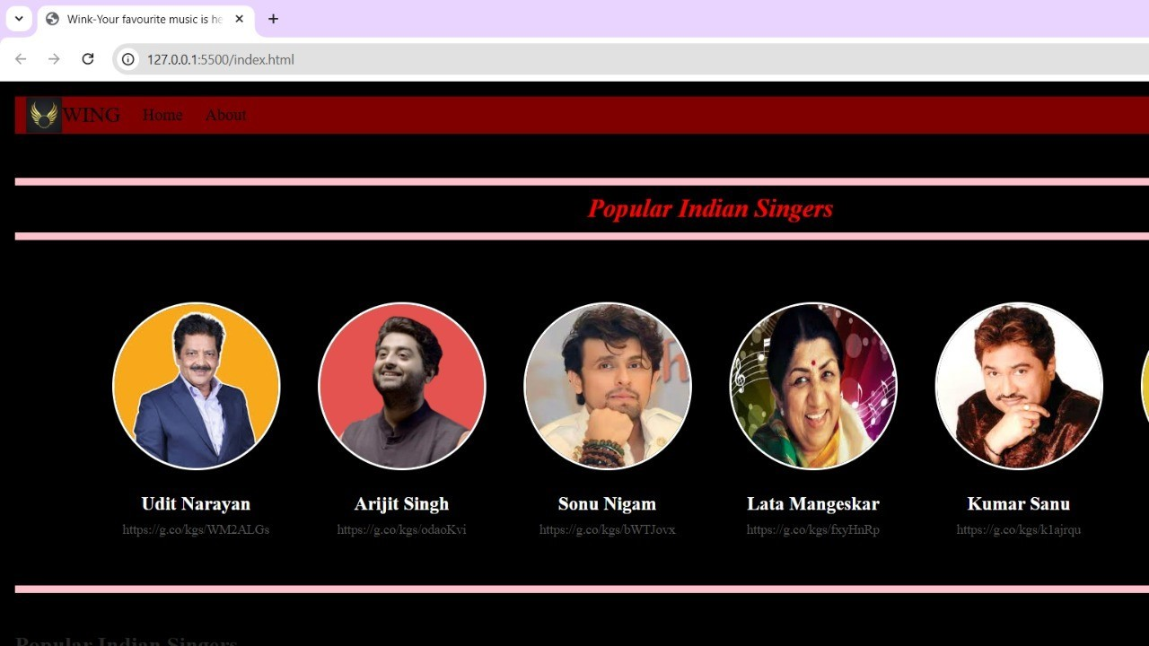

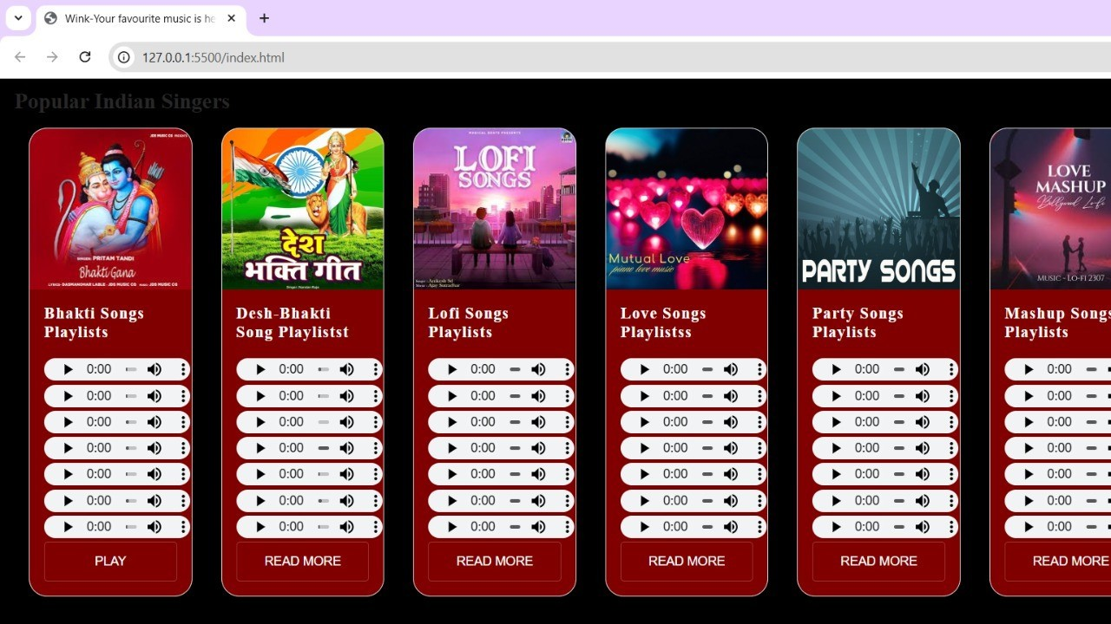

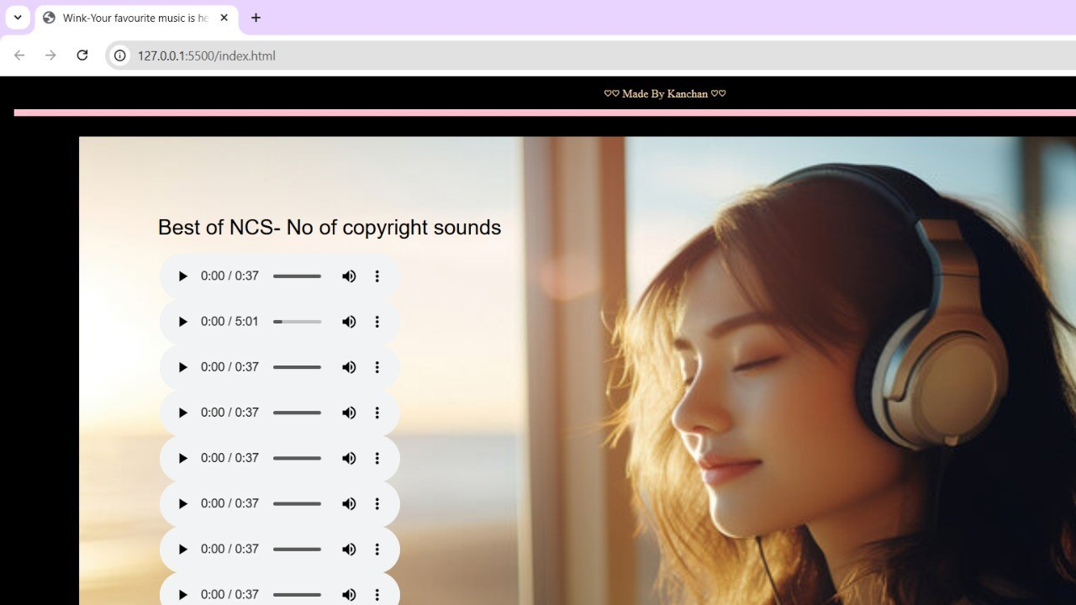

CHAPTER 8

CONCLUSION

- CONCLUSION:

The development of a musical app clone represents a significant step in delivering an engaging and seamless music streaming experience to users. Through this project, we successfully recreated key features and functionalities commonly found in popular musical apps, such as user authentication, music playback, playlist management, search functionality, and seamless audio streaming.

The project emphasized not only functional development but also performance optimization, security implementation, and cross-platform compatibility, ensuring the app can handle real- world user loads and diverse device environments. Thorough testing methodologies, including functional testing, performance testing, usability testing, and security testing, were employed to identify and address potential issues, guaranteeing a stable and secure application.

Furthermore, the project showcased the importance of leveraging modern development frameworks, APIs, and cloud technologies to achieve scalability and efficiency. Key takeaways include the critical role of user experience (UX) design, robust backend architecture, and data management strategies in building a successful application.

In conclusion, this project serves as both a technical achievement and a learning experience, highlighting the challenges and solutions encountered during the development process. Moving forward, future enhancements could include AI-powered recommendations, offline music playback, and integration with smart devices, further improving the app's functionality and user appeal.

This project not only demonstrates technical proficiency but also provides a foundation for further innovation in the dynamic and competitive landscape of music streaming applications.

