- build a use case diagram of an online examination system showing all major actor and functionality
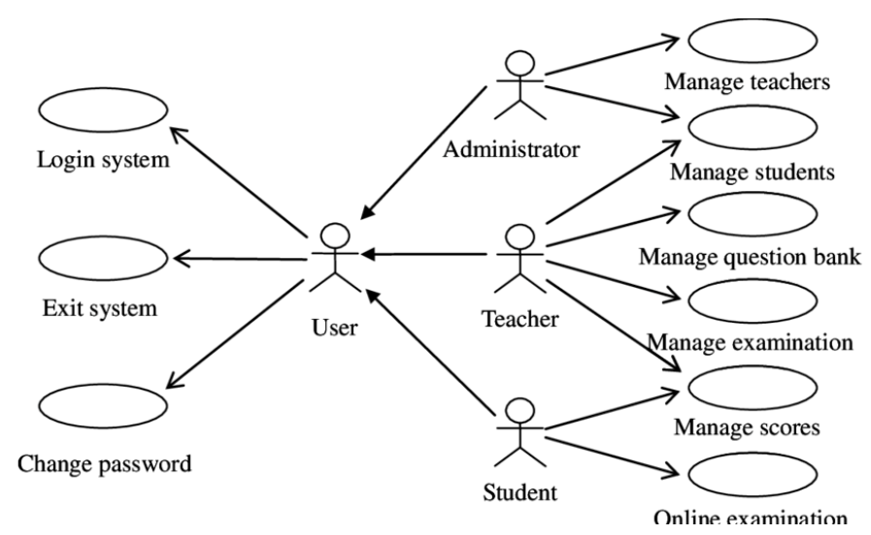

Aim
To design a Use Case Diagram for an Online Examination System showing major actors and system functionalities.

Tools Used
- UML (Use Case Diagram)
- Draw.io / StarUML / Lucidchart

Theory
A Use Case Diagram represents the functional behavior of a system by showing interactions between actors and use cases.
It helps in understanding system requirements and user roles in an Online Examination System.

Major Actors
- Student
- Instructor / Examiner
- Administrator
- System

System Functionalities
- User Authentication
- Exam Creation and Scheduling
- Online Exam Conduction
- Answer Evaluation
- Result Generation
- User and Exam Management
- Data Storage and Notification

- Construct an activity diagram representing the student registration and loging workflow in a learning management system.

Aim
To construct an Activity Diagram representing the student registration and login workflow in a Learning Management System (LMS).

Tools Used
- UML (Activity Diagram)
- Diagramming tools such as:
  - Draw.io
  - StarUML
  - Lucidchart

Theory
An Activity Diagram is a UML diagram that models the flow of activities in a system.
It shows the sequence of actions, decision points, and control flow involved in processes such as student registration and login in a Learning Management System.

Major Actor
- Student

Functionality
- Access LMS portal
- Register by entering personal and login details
- Validate registration information
- Create student account
- Login using credentials
- Authenticate student
- Display student dashboard

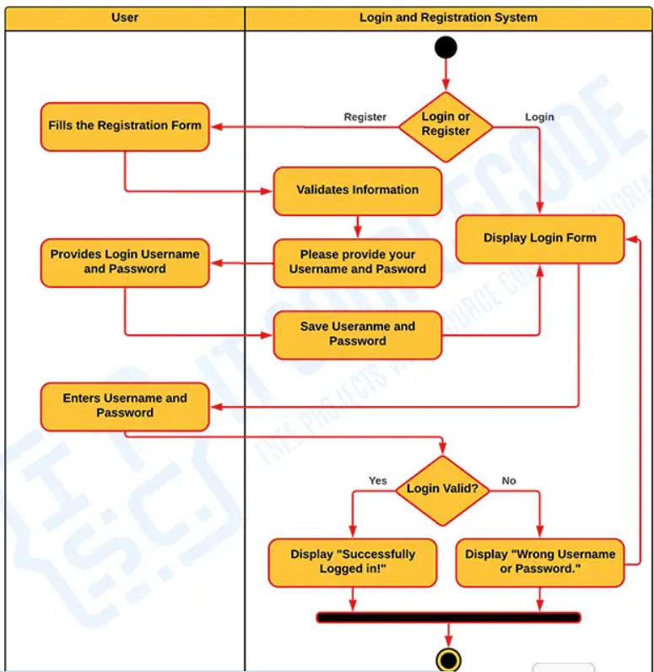

3. Build a class diagram for a library management system, including attributes, method, and a relationship.

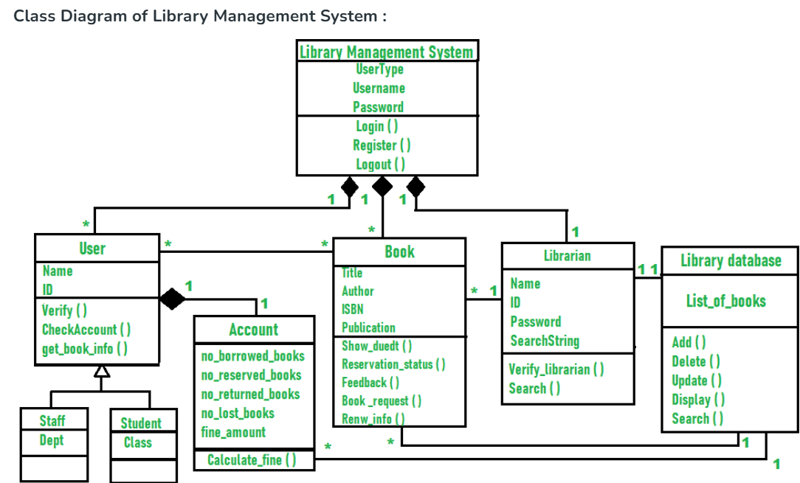

Aim
To build a Class Diagram for a Library Management System showing classes, attributes, methods, and relationships.

Tools Used
- UML (Class Diagram)
- Diagramming tools such as:
  - Draw.io
  - StarUML
  - Lucidchart

Theory
A Class Diagram is a UML diagram that represents the static structure of a system.
It shows system classes, their attributes, methods, and the relationships among them.
In a Library Management System, it helps model data related to books, members, and transactions.

Major Classes
- Book
- Member
- Librarian
- Library
- Transaction

Attributes, Methods, and Relationships
Book
- Attributes: bookId, title, author, status
- Methods: getDetails(), updateStatus()

Member
- Attributes: memberId, name, contact
- Methods: borrowBook(), returnBook()

Librarian
- Attributes: librarianId, name
- Methods: addBook(), issueBook()

Transaction
- Attributes: transactionId, issueDate, returnDate
- Methods: createTransaction(), closeTransaction()

Relationships
- Library contains Books and Members
- Member borrows Book
- Librarian manages Books
- Transaction links Member and Book

4. Construct a sequence diagram for the fund transfer process in an online banking system.

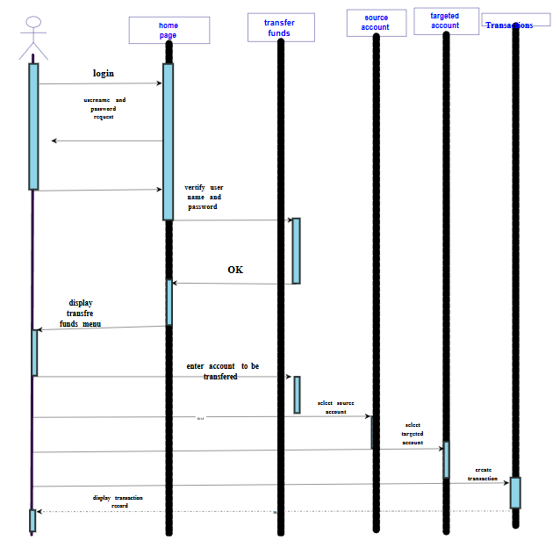

Aim
To construct a Sequence Diagram for the fund transfer process in an Online Banking System.

Tools Used
- UML (Sequence Diagram)
- Diagramming tools such as:
  - Draw.io
  - StarUML
  - Lucidchart

Theory
A Sequence Diagram is a UML diagram that shows the interaction between objects in a time sequence.
It illustrates how messages are passed between system components during operations such as fund transfer in online banking.

Major Actors
- Customer
- Bank Server
- Account
- Payment Gateway

Functionality
- Customer initiates fund transfer
- System validates user and account details
- Checks account balance
- Processes transfer through payment gateway
- Updates sender and receiver accounts
- Confirms transaction to customer

5.

