Relational Diagram

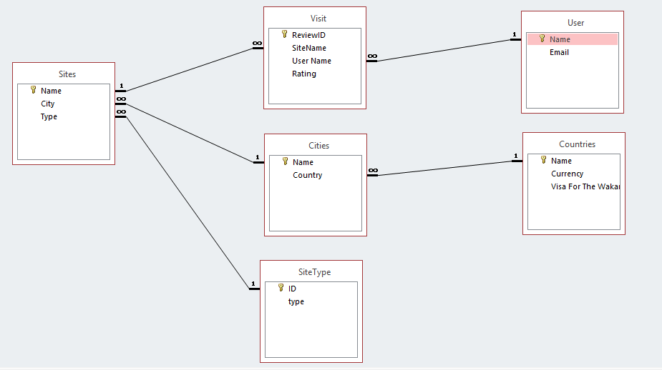

The above diagram is the relational diagram for the travel database.

Following are the primary keys and foreign keys of each table:

1. Countries
   1. Name – Primary Key
2. Cities
   1. Name – Primary Key
   2. Country – Foreign Key
3. SiteType
   1. ID – Primary Key
4. Sites
   1. Name – Primary Key
   2. City – Foreign Key
   3. Type – Foreign Key
5. Visit
   1. ReviewID – Primary Key
   2. User Name – Secondary Key
   3. SiteName – Secondary Key
6. User
   1. Name - Primary Key

Work for Ahsan

* Create the database using SQL.
* Use camel case writing style.
* The table name should be exactly like the table names in the diagram show above.

Work for Musa

* Insert the values for the tables “visit”, “sites”, “siteType”.
* The values can be found on the access database file.
* Literally, just copy paste the values.

Work for Abed

* Insert the values for the tables “countries”, “user”, “cities”.
* The values can be found on the access database file.
* Literally just copy paste the values.