**Survey on online and distance learning – Results**

**Introduction**

As the COVID-19 pandemic has led to massive educational institutional (like college, institutes, universities, schools, etc) closures across many countries have taken measures to limit the disruption to education, necessitating a move to online and distance learning, encompassing not only secondary level but also primary level.

Although distance learning offers obvious advantages for both teachers and students, such as continuity, flexibility and mutual support, many teachers have had to adjust to online teaching owing to the necessarily short notice. On top of that, it is difficult for teachers to ensure that all pupils, especially the disadvantaged and young ones, will stay engaged and take part in classes online.

This survey is to explore opinions on online and distance teaching/learning from across India from the point of view of students, teachers and parents using different set of questions according to category the user belongs to.

Basically, with the help of survey we are finding whether the respondents want to continue with the currently ongoing distance teaching/learning or they want to shift back to the general mode that is offline mode as the situation gets normal or they want the blended mode of teaching/learning which includes online + offline both.

Also, we are finding out what are the advantages and disadvantages respondents faced while having distance learning/teachings and whether it affected them or not. And what measures should be taken to improve this type of learning if the conditions not get well.

**RESULTS:-**

**For Students :-**

1.Does COVID-19 pandemic affect your education in any way?

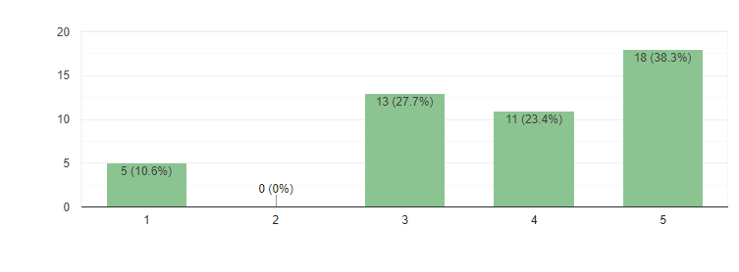

1 being "not at all affected" and 5 being "most affected". 10.6% of the respondents are not at all affected and 38.3% of the respondents are most affected.

2.How effective has remote learning been for you?

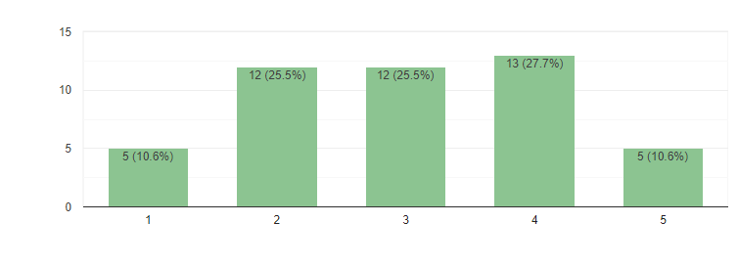

1 being "not at all effective" and 5 being "most effective". 10.6% of the respondents find remote learning not at all effective and 10.6% of the respondents find remote learning most effective.

3.Device you use for distance learning:-

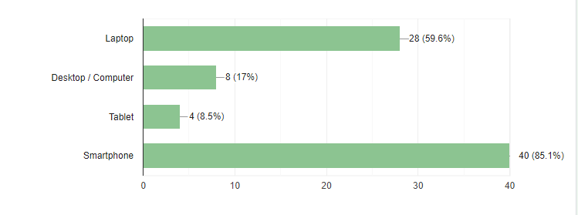

59.6% of the respondents use Laptop, 17% of the respondents use Desktop, 8.5% of the respondents use Tablet and rest 85.1% of the respondents use Smartphone for distance learning.

4.Thinking about your university, which statement best describes your faculty experience with online teaching?

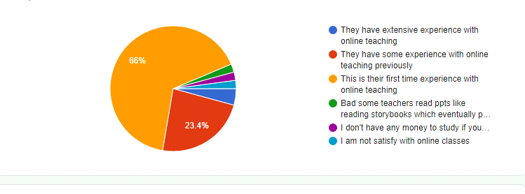

For 66% of the respondents, this is there first time experience with online teaching whereas 23.4% respondents have some prior experience with distance learning. 4.3% respondents have experience with online teaching. 2.1% respondents are not satisfied with online education experience.

5.How helpful your [School or University] has been in offering you the resources to learn from home?

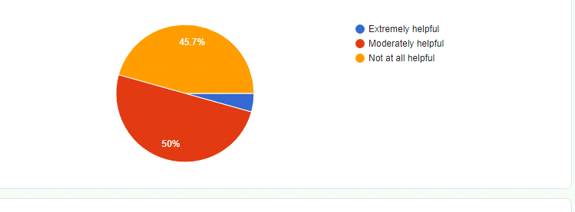

According to 50% respondents their school/university was moderately helpful in providing resources to learn from home whereas 45.7% respondents say that their university/school was not at all helpful and for remaining 4.3% , it was extremely helpful.

6.How helpful are your teachers in online classes?

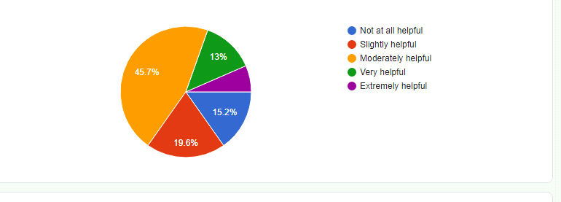

45.7% respondents said that their teachers were moderately helpful in online classes. 19.6 % respondents said that they were slightly helpful and for 15.2% respondents, they were not at all helpful.

7.As you can take online classes very easily from anywhere if still you miss them then what are the reasons for missing an online class?

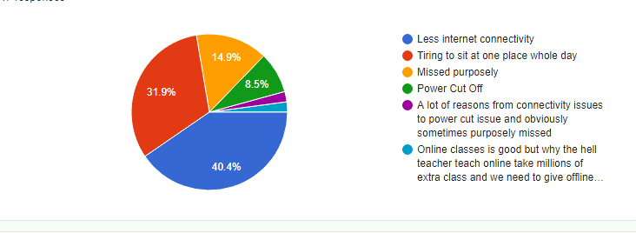

For majority of the respondents(40.4%) the rason for not able to attend the online class is Less internet connectivity and 31.9% respondents thinks that it is tiring to sit at one place whole day in front of screen and that's the reason they miss classes.

8.Most preferred method for clearing doubts in online learning.

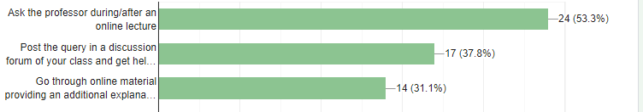

Most of respondents claim to ask the doubts during/after the online lecture.

Some of the respondents post the query on the discussion form followed by those who prefer to go through the material provided for clearing their doubts.

9.My experience with online learning from home.

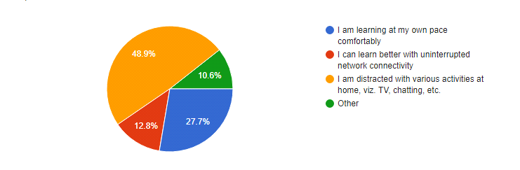

48.9% respondents feel distracted by other stuff like TV, Chatting, etc during their online lectures.

27.7% respondents are learning at their own pace comfortably.

12.8% respondents claims that they can learn better with uninterrupted network connectivity.

and 10.6% respondents have other experiences with online learning from home.

10.Is Online Education grading system biased ?

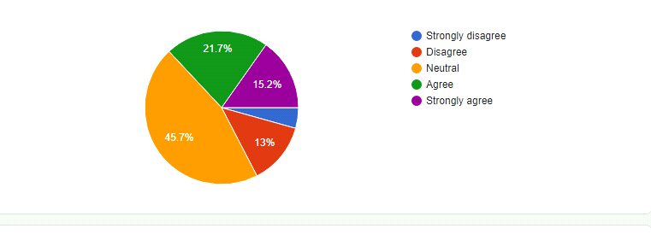

15.2% respondents strongly agree that Online Education grading system is biased whereas only 4.3% respondents strongly disagree with it.

11.Your overall experience about remote learning

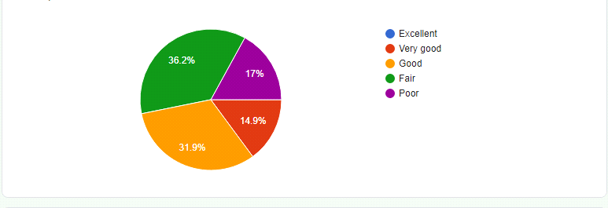

For 0% respondents the overall experience about remote learning is excellent. For 14.9% it was very good, for 31.9% it was good but for 17% it was a poor experience.

12.Education mode you would prefer in future

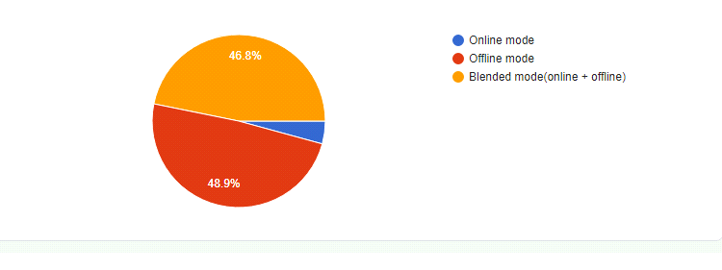

48.9% respondents want offline mode in future whereas 46.8% prefer blended mode and only 4.3% respondents prefer online mode.

**For Teachers :-**

1.Does this pandemic affected students' mental health

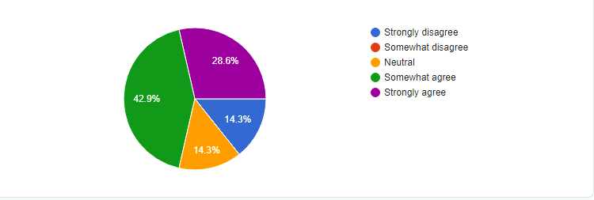

28.6% respondents strongly agree that this pandemic affected students mental health whereas 14.3% respondents strongly disagree with the same.

2.How much does the online Education System affect Your Teaching Style?

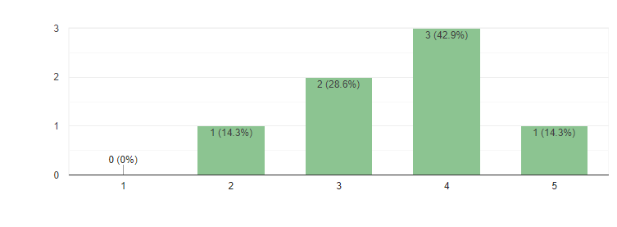

1 represent strongly disagree whereas 5 representing strongly agree for the above chart.

3.Device(s) you use for distance teaching

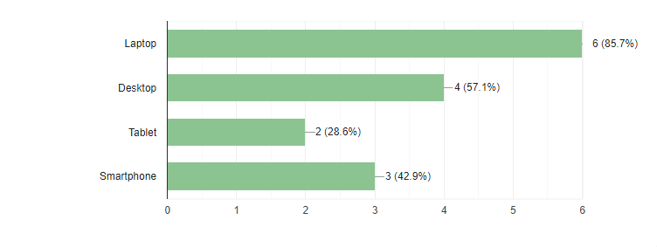

Most of the respondents use their Laptop for teaching followed by Desktop, Smartphone and Tablet.

4.What are the main challenges faced by you in switching to online learning?

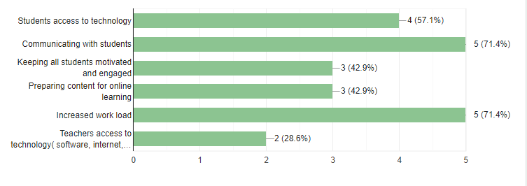

Majority of the respondents face challenges like keeping students motivated and engaged, increase work load and communicating with students.

5.Digital approaches you use for teaching

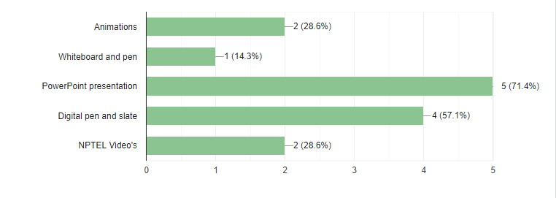

Among the respondents majority use PPT as their approach to teach in online classes followed by Digital pen and slate, Animations, NPTEL videos, etc.

6.Type of assessment you prefer for testing students ability during remote learning

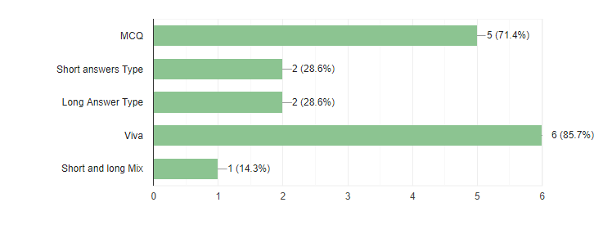

During remote learning 85.7% of the respondents use Viva as testing mode followed by MCQ with 71.4%, Short answer with 28.6%, Long answer type with 28.6% , short and long mix with 14.3%.

7.As you can take online class very easily from anywhere if still you miss then what are the reasons to miss it?

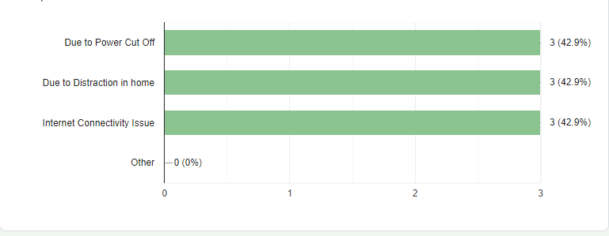

8.Are you satisfied with the technology and software you are using for online teaching?

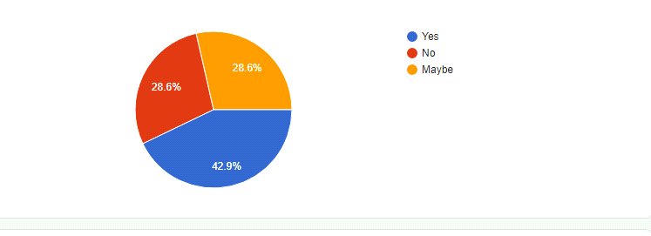

42.9% respondents are satisfied and 28.6% are not satisfied with the technology and software they use for teaching and rest are not sure.

9.Do you think students cheat in online exams

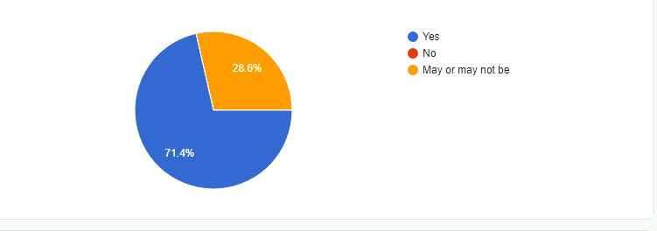

71.4% respondents believe that students cheat in online exams. 28.6% are not sure about it and 0% respondents think that students do not cheat in online exams.

10.Are your students now learning as much as they were learning before switching to distance learning?

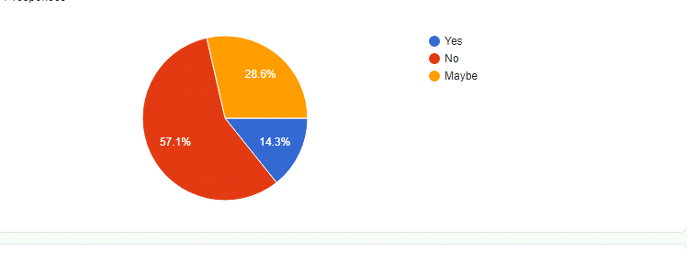

57.1% respondents don’t think that students are learning as much as they were learning in offline mode.

11.Teaching mode you would prefer in future

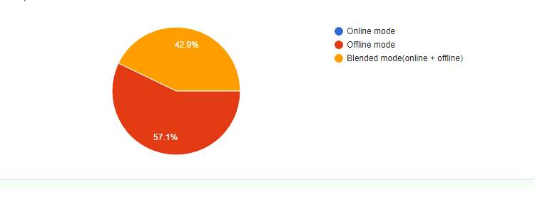

57.1% respondents want offline mode in future whereas rest 42.9% respondents want it to be in blended mode.

**For Parents :-**

1.Number of devices at home that your child(ren) can use for online learning

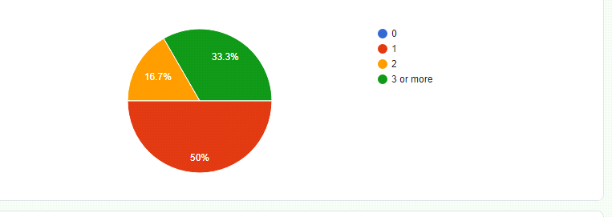

2.Are Your child is being well prepared to continue his/her education In Online mode?

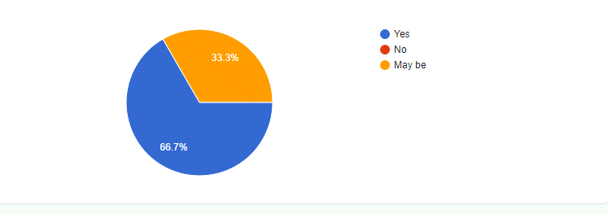

According to 66.7% respondents their child is being well prepared to continue his/her education in online mode.

3.Challenges my child is facing during online course are: (can check multiple answers)

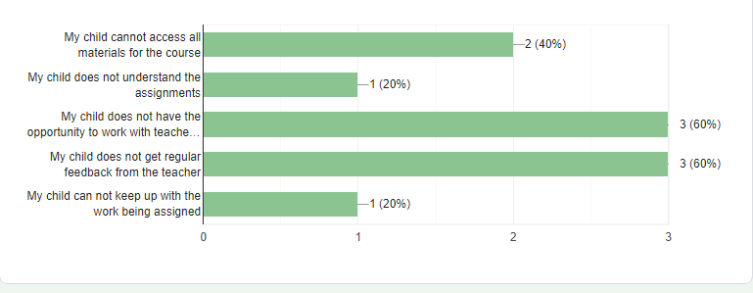

4.Do you think your child's educational program is of high quality to study in online mode?

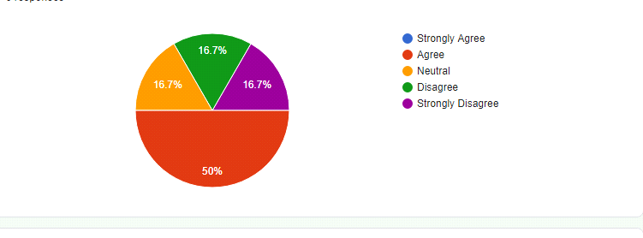

50% of the respondents agree that their child educational program is of high quality to study in online mode.

5.How well do you think you are able to support your child's education at home?

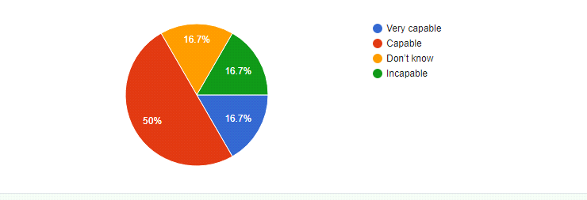

6.Do you find that academic work in online mode takes up most of your child's time and hence prevents them from enjoying other activities that they enjoy?

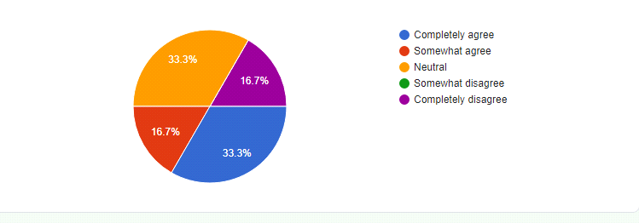

33.3% respondents completely agree that academic work in online education takes most of their child time and hence prevents them from enjoying other activities that they enjoy.

7.Is your child's sleep affected because of the amount of academic work in their online mode?

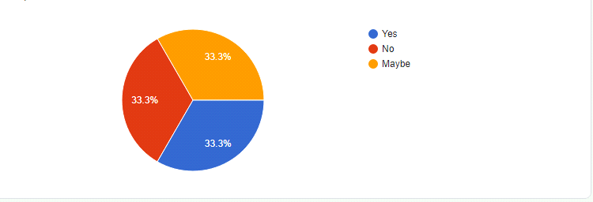

8.In online education mode parent-child relationship suffers a lot

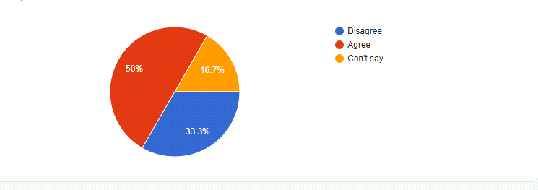

Here, 50% respondents think that due to online education parent-child relationship suffers a lot.

9.Lessons that has been most useful in online mode

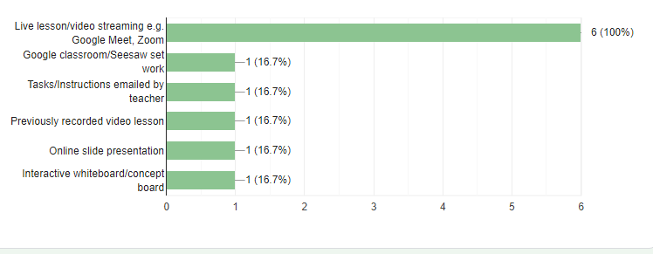

10.Do you think that the online classes affects the quality of your child’s education?

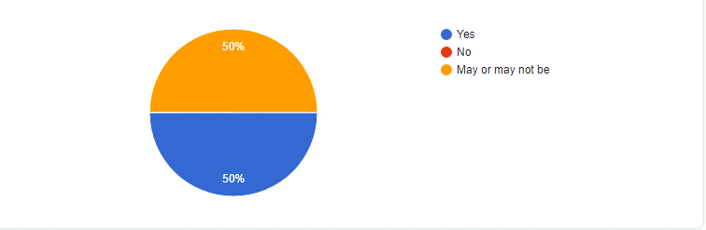

50% respondents say that online classes affects the quality of their child's education whereas 50% of the respondents are not sure about it.

11.How would you rate parent - teacher communication in Online Mode?

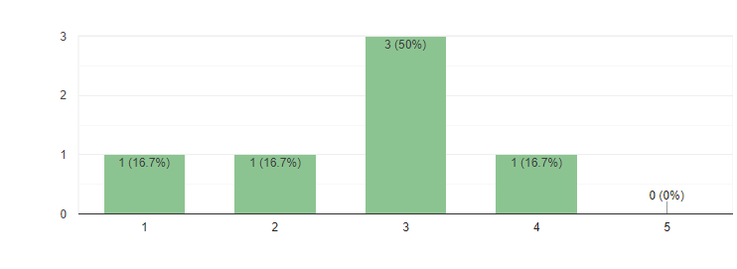

12.You are satisfied with Online Learning Mode

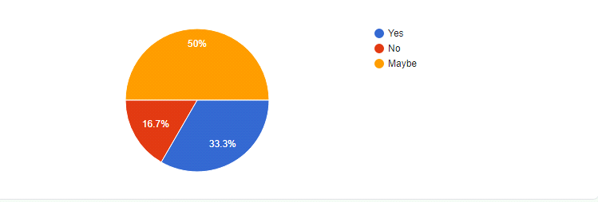

33.3% of the respondents are satisfied with the online learning mode.

13.Type of study mode you prefer for your child(ren) in future

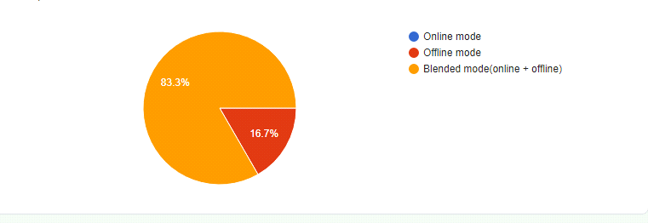

83.3% respondents wants blended mode for their children and rest 16.7% wants it to be offline whereas no one wants it to be online mode.

### **Conclusions**

Our survey attracted around 100 respondents where approximately 50 are students and around 20-30 are teachers from different educational institutes and different fields including primary level, secondary level, undergrads, postgraduate and PHD and also around 10 respondents are from parents category.

Almost every respondent reported challenges, the most frequent being access to technology, for both pupils and teachers, and increased workload and stress working from home. Several challenges related to supporting pupils were identified, together with their digital competence – and that of teachers.

Respondents feel that support in terms of more educational resources would help them meet the challenges, as well as clear guidance from the Ministry of Education, together with professional development, such as short courses on online teaching and opportunities for teachers to share resources, ideas and challenges.

These findings offer some early indications to policymakers and educational leaders that the experience of distance/online teaching and learning, although challenging, may have lasting positive effects, opening up interesting possibilities for innovation and new ways of working, especially if supported by appropriate and timely professional development.