
Delhi Chapter of Indian Society of Pathologists and Microbiologists

Registered under the societies registration act 1860 (Delhi) No. S/4185/SDM/NW/2025

MEMBERSHIP CERTIFICATE

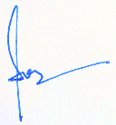
Name (membership number)
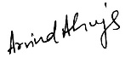

Professor Sonal Sharma Prof. Arvind Ahuja Professor Prasenjit Das
President Vice- President Secretary General

