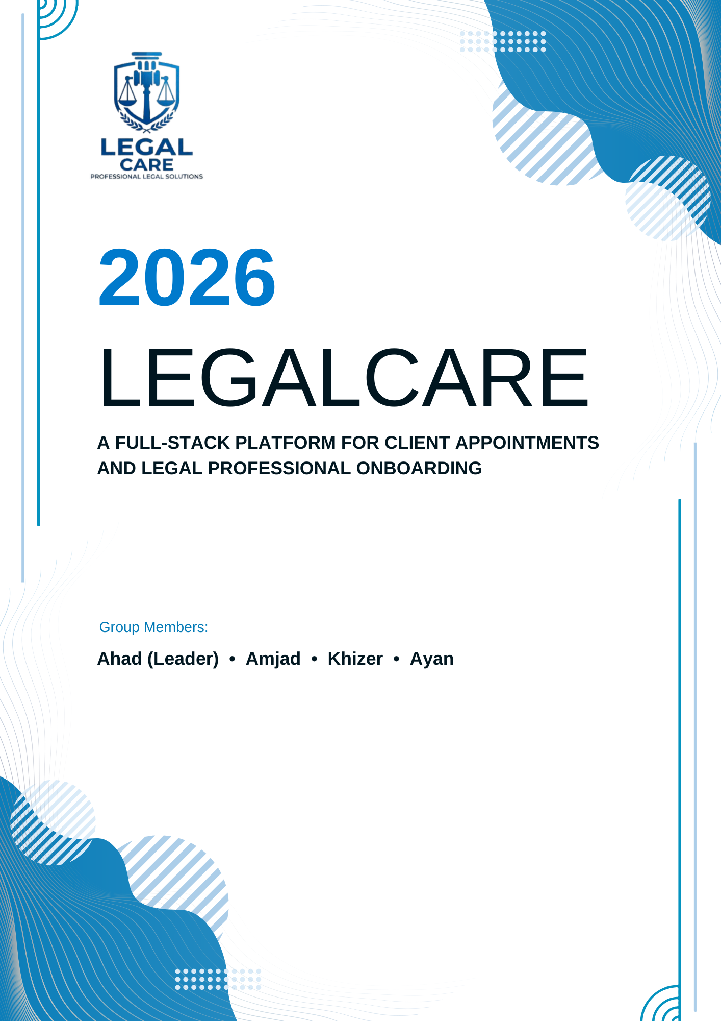

Certificate

This is to certify that the project titled “Online Lawyers Application Website System” has been successfully completed by the development team:

Ahad (Project Leader) • Amjad • Khizer • Ayan

as part of the academic requirements for the completion of the full-stack system layout.

The platform has been independently developed, tested, and deployed utilizing a backend architecture consisting of PHP engine modules, a relational MySQL/MariaDB database configuration, and responsive frontend interfaces styled with Bootstrap and native JavaScript frameworks, running on an Apache localized server environment.

Submission Date: May 18, 2026

__________________________ __________________________

Internal Project Examiner External Project Examiner

Online Lawyers Application Website System

Technology: PHP | MySQL | Apache
Version: 1.0

ACKNOWLEDGEMENT

We would like to express our sincere gratitude to our teachers, mentors, and the
eProjects Team for providing us with the opportunity and guidance to complete this
project successfully. Their support and feedback helped us understand real-world
application development and improve our technical skills.

We also thank our team members for their cooperation and dedication throughout the
development process.

Submitted by:

Ahad (Leader) • Amjad • Khizer • Ayan

Faculty Mentor:

Sir Asad

Table of Contents

Sr. No. | Section | Page No.
1 | Introduction | 2
2 | Objectives | 2
3 | Problem Statement | 3
4 | Proposed Solution | 4
5 | Features | 5
6 | User Types and Roles | 6
7 | Module Details | 7
8 | System Flow | 8
9 | Technology Stack | 11
10 | Hardware and Software Requirements | 11
11 | Database Design | 12
12 | ER Diagram Explanation | 13
14 | GUI Standards | 14
15 | Interface Design | 15
17 | Testing | 18
18 | Future Enhancements | 18
19 | Conclusion | 19

1. Introduction
In today’s digital era, access to legal services remains a critical necessity for various personal, corporate, and professional matters. However, the traditional process of locating a qualified lawyer with the precise required specialization, verifying their credentials, and securing an appointment is often fragmented, time-consuming, and logistically challenging.

The Online Lawyers Application Website System (LegalCare Portal) is a centralized, full-stack web application engineered to bridge the gap between clients and certified legal professionals. Developed utilizing a robust architecture of PHP, MySQL, and Apache, the platform enables users to search for legal experts by specialization and geographic location, view authenticated professional profiles, and seamlessly book appointment slots online. By segmenting access into dedicated modules for Administrators, Lawyers, and Customers, the system enforces secure data isolation, role-based interaction pipelines, and transparent practice workflows.

2. Objectives
The strategic and technical objectives of the system include:
- Digital Legal Access: Providing a continuous, web-based portal to modernize traditional legal matchmaking and appointment scheduling.
- Streamlined Discovery: Enabling customers to filter and identify legal experts rapidly by practice areas and regional cities.
- Dynamic Resource Scheduling: Automating the allocation, booking, and state management of real-time lawyer availability slots.
- Identity & Access Management (IAM): Enforcing secure authentication states, session tokens, and strict role-based access control (RBAC).
- Profile Synchronization: Automating the transition of a vetted application request into an active, public-facing professional profile.

3. Problem Statement
Navigating the legal landscape presents systemic inefficiencies for individuals lacking direct networks within the bar council. The core limitations identified within traditional manual ecosystems include:
[Manual Inefficiencies] ──> [Lack of Central Registry] ──> [Opaque Availability] ──>
[High Drop-off Rates]
- Specialization Mismatch: Clients routinely struggle to verify whether a practitioner possesses the precise skill set (e.g., corporate, criminal, family law) needed for their specific case profile.
- Opaque Scheduling Matrices: Traditional appointment booking relies on manual phone calls or physical visits, causing scheduling conflicts and high operational latency.
- Absence of Centralized Verification: Consumers lack a trusted digital ledger to evaluate a lawyer's biography, verified years of experience, and location metrics simultaneously.
- Administrative Overhead: Legal practices spend significant administrative resources managing scheduling matrices, reducing overall billable legal operational hours.

4. Proposed Solution
The proposed system is a web application developed using PHP and MySQL.
The system allows:

- Customers to register and search lawyers.
- Lawyers to create professional profiles.
- Admin to manage lawyers and appointments.
- Customers to book appointments online.
- Lawyers to manage their schedules and services.
The platform acts as a bridge between legal professionals and clients.

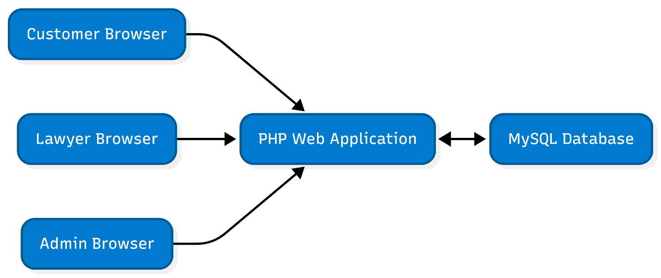

5. Features

5.1 Registration System
- Separate registration for customers and lawyers.
- Secure login system using email and password.
- Password hashing for security.

5.2 Lawyer Profile Management
- Lawyer profile with bio, experience, city, and specialization.
- Upload profile photo.
- Manage available appointment slots.

5.3 Search Functionality
Search lawyers by:
- Location
- Legal specialization
- Services

5.4 Appointment Booking
Customers can:
- View available slots of lawyers
- Book appointments
- View their booked appointments

5.5 Admin Panel
- Manage lawyers
- Approve lawyer requests
- Manage users contacts
- Manage appointments

5.6 Authentication & Security
- Session-based authentication
- Role-based access control
- Form validations
- Secure password storage

6. User Types and Roles
The system will have the following three types of users:

User Type | Responsibilities / Access
Admin | Manages lawyer profiles visible in searches, Manage lawyer requests and all appointment booking slots. Full control over the system.
Lawyer | Registers on the platform, fills in profile details (specialization, location, availability), and manages their appointment slots and view appointments requests.
Customer | Registers/logs in, searches for lawyers by service or location, views lawyer profiles, and books appointment slots.

7. Module Details
The project is divided into the following modules:

Module 1: Customer / Lawyer Registration
- New customers can register by filling a standard registration form (Name, Email, Password, Contact).
- Lawyers must fill a detailed registration form including their specialization, location, experience, and availability.
- Login for both customer and lawyer using username and password.

Module 2: Lawyer Panel
- After login, lawyer sees their personal dashboard.
- Lawyer can update their profile, specialization, location, and available appointment slots.
- Lawyer can view upcoming appointments booked by customers.

Module 3: Search Lawyers
- Customer can search lawyers by location and/or service type (Criminal, Divorce, Affidavit, Civil, etc.).
- Search results display minimal lawyer information (Name, Specialization, Location, Fee).
- Clicking on a lawyer from results opens their full profile page.

Module 4: View Lawyer Profile & Book Appointment
- Full lawyer profile page shows all details: name, photo, specialization, experience, location, and available time slots.
- Customer can select an available time slot and book an appointment.
- Booking confirmation is shown to the customer after successful booking.

Module 5: Admin Panel
- Admin can log in through a normal login page.
- Admin can manage homepage content (banners, announcements).
- Admin can approve, edit, or remove lawyer profiles.
- Admin can manage and monitor all appointment bookings and schedules.

8. System Flow

8.1 Customer Flow

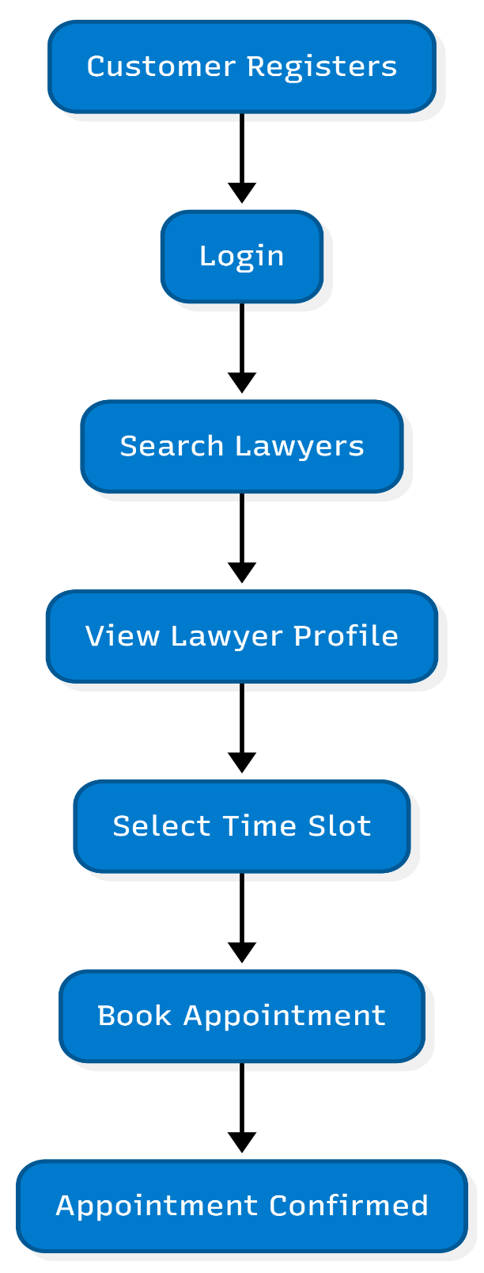

8.2 Lawyer Flow

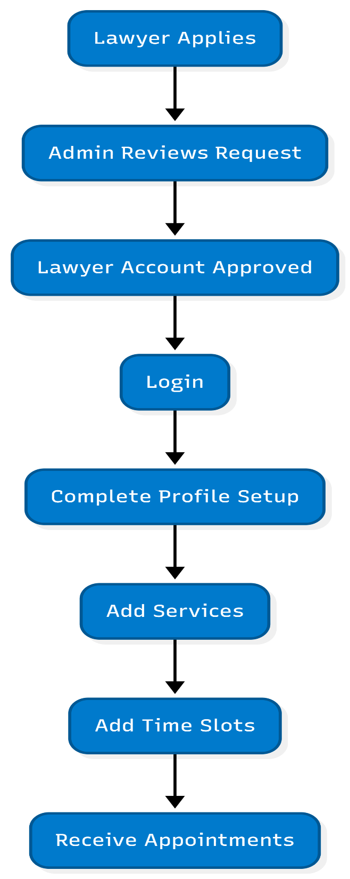

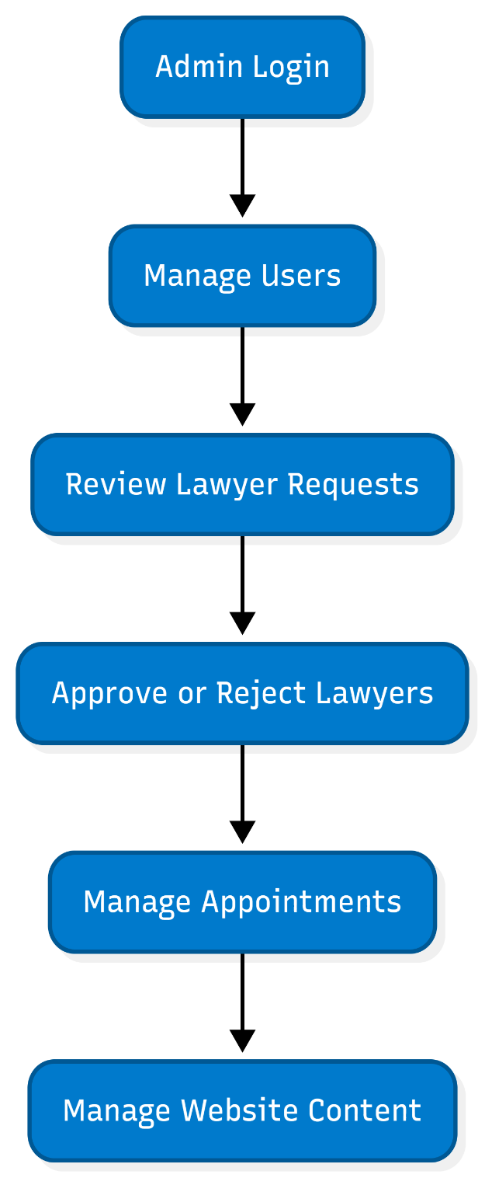
8.3 Admin Flow

9. Technology Stack

Technology | Purpose
PHP | Backend development
MySQL | Database
HTML5 | Structure
CSS3 | Styling
JavaScript | Client-side validation
Bootstrap / Material Dashboard | UI Design
SweetAlert2 | Alert messages
Apache / XAMPP | Local server

10. Hardware & Software Requirements

Category | Specification
Processor | Pentium 166 MHz or higher (Recommended: Core i3 or above)
RAM | 128 MB minimum (Recommended: 4 GB or above)
Operating System | Linux / Windows 2000 Server or higher
Web Server | Apache HTTP Server
Backend Language | PHP
Database | MySQL
Scripting | PERL (optional), JavaScript
Browser | Any modern browser (Chrome, Firefox, Edge)

11. E-R Diagrams
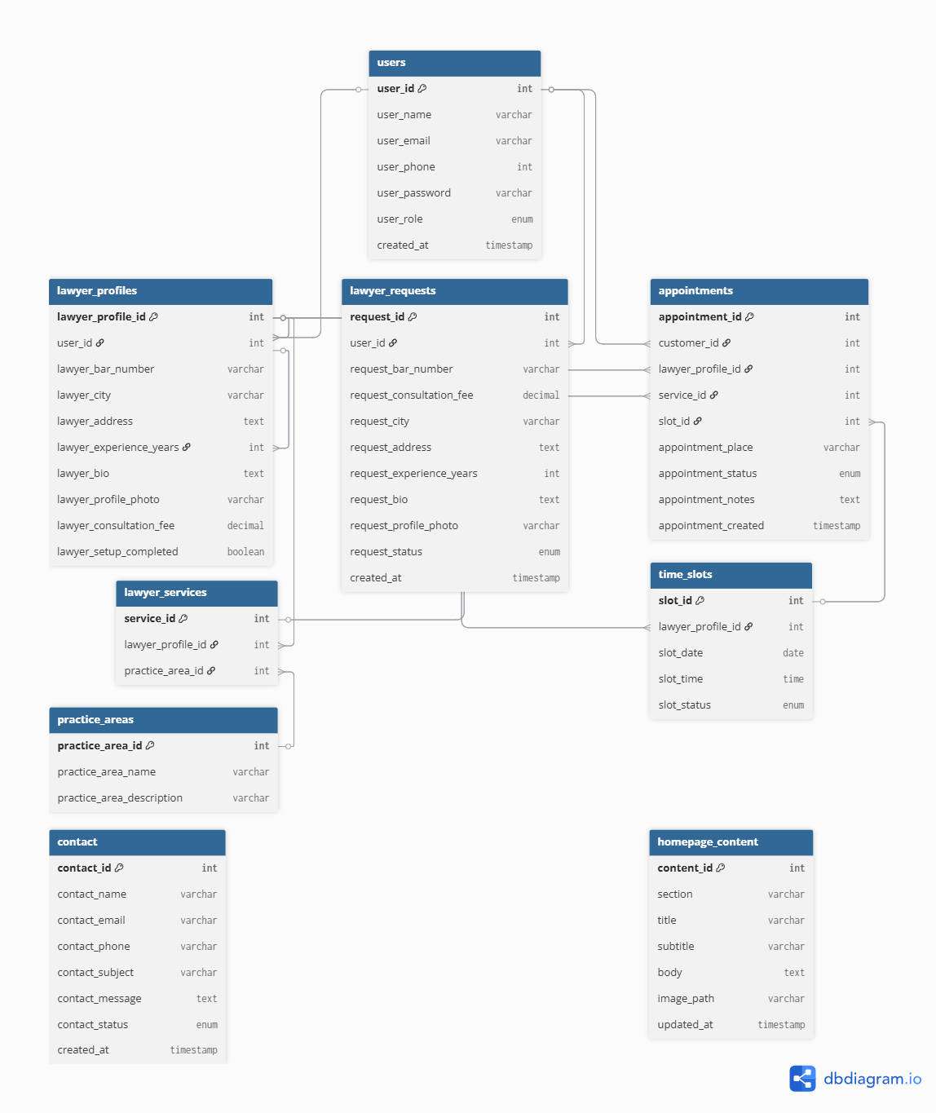

12. GUI Standards
To establish a premium, high-end digital presentation aligned with the dignity of legal systems, the client-facing and dashboard UI implementations adhere to explicit user interface parameters:
Visual Hierarchy Scaling: Headers match crisp geometric spacing targets. Large, bold accents drive focal clarity, balanced alongside a modern luxury palette composed of deep blues, charcoal typography lines, and white space layouts.
Consistent Geometric Alignment: UI panels, specialized mirror-like content cards, and control interfaces use rounded corners (border-radius: 8px to 12px) and subtle background shadow extensions to present an accessible, modern aesthetic.
Dynamic Feedback Systems: System interactions discard raw text outputs in favor of fluid, state-driven SweetAlert2 modal dialog windows to display confirmation events and error strings.
Adaptive Flow Design: Grid configurations scale through fluid Bootstrap breakpoints, shifting interfaces seamlessly from desktop multi-column monitors down to single-column cellular smartphones.

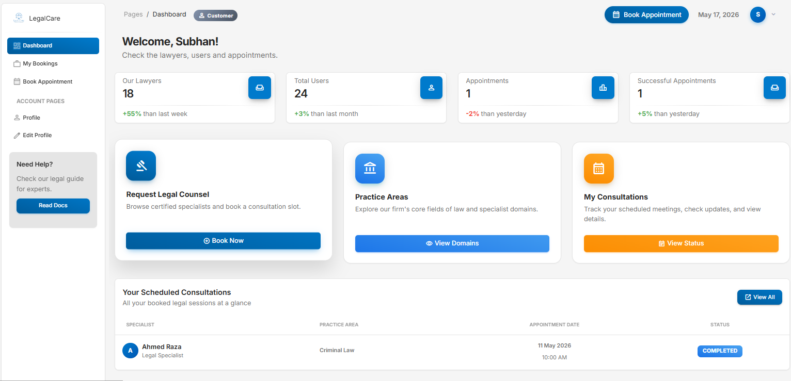

13. Interface Design
The architecture of the deployment package structures interface interaction spaces into distinct access pages:
Public Marketing Matrix: Includes the platform home page, dynamic filter grids, specialization menus, and structural biography cards for active legal practitioners.

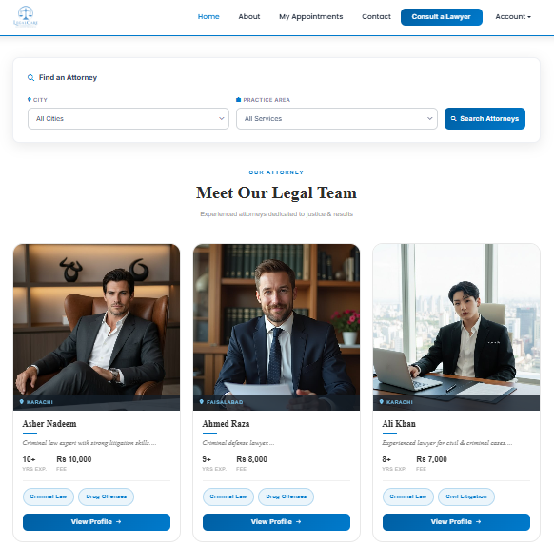

Identity Management Access Points: Specialized layout spaces accommodating standard client access portals, input verification systems, and the legal professional onboarding intake page.

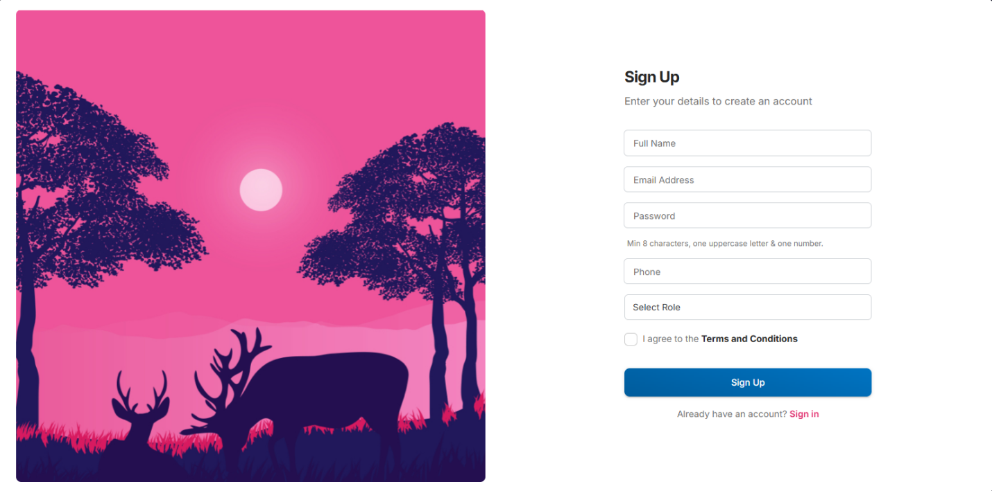

The Consumer Activity Center: Custom client dashboard interfaces displaying future scheduling records, past case entries, and location update controls.

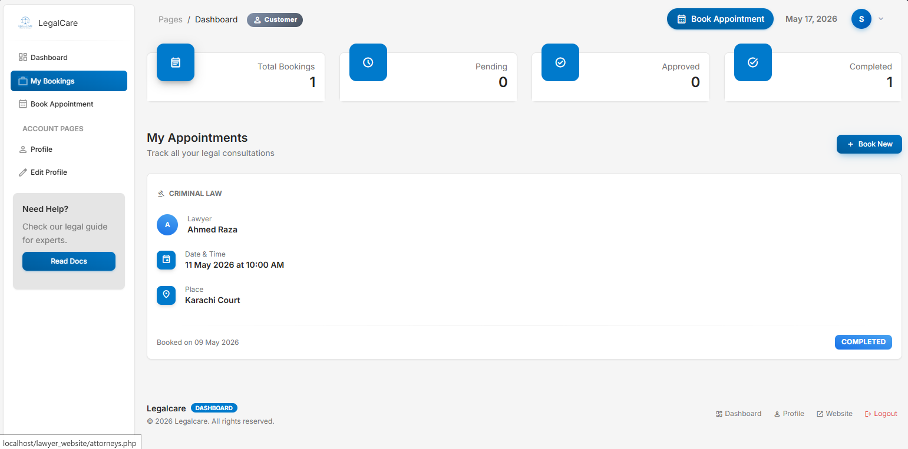

The Legal Practice Dashboard: Practitioner layout panels for tracking assigned schedules, editing services, and toggling calendar slots.

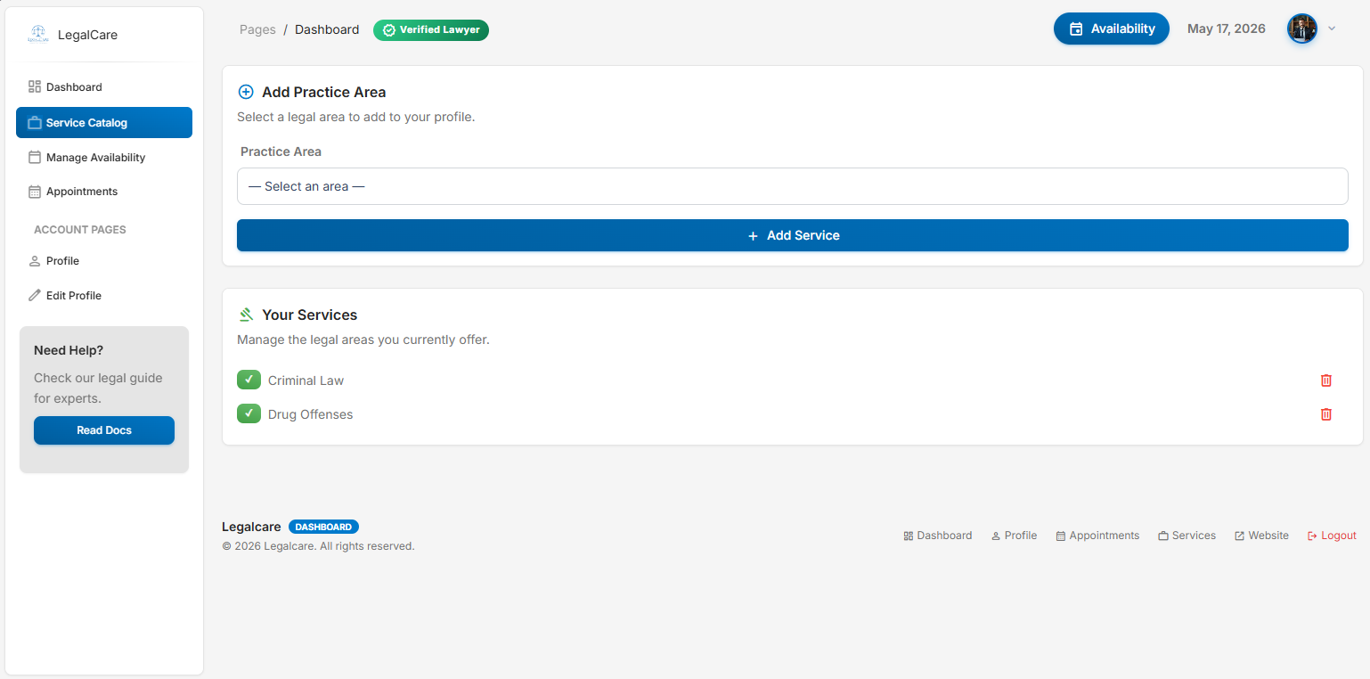

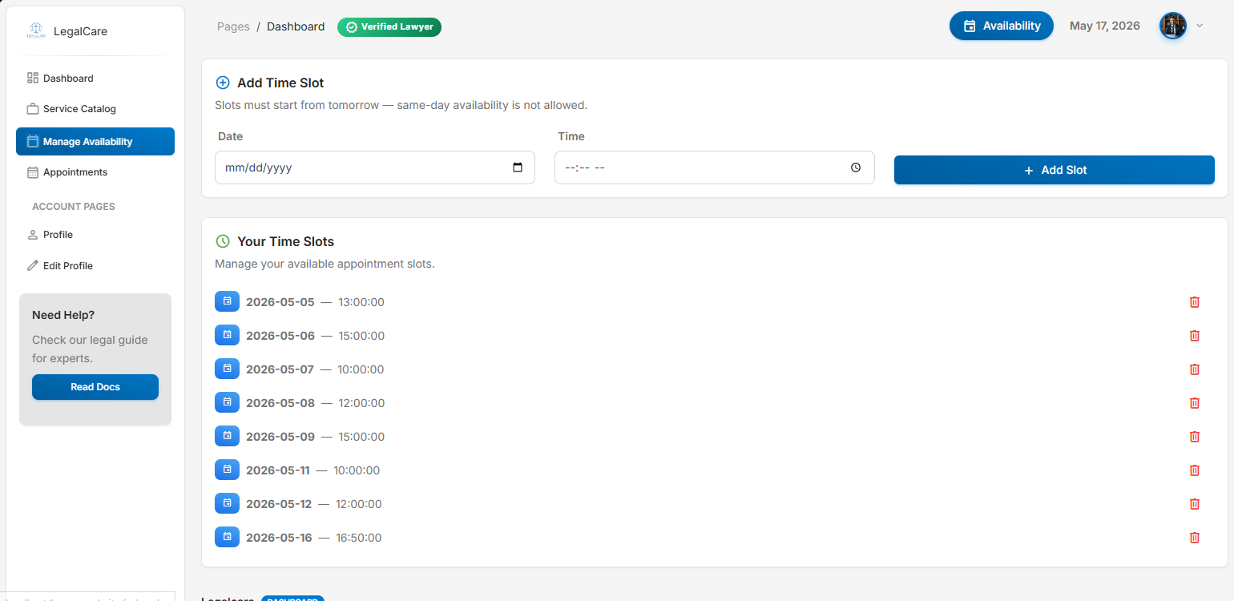

The Administrative Command Core: High-security dashboard pipelines containing verification rows for review queues, role transition controls, and global user tables.

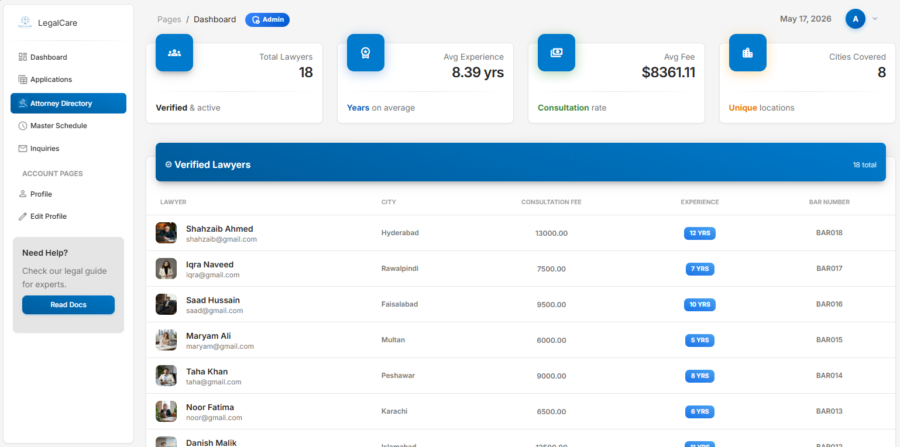

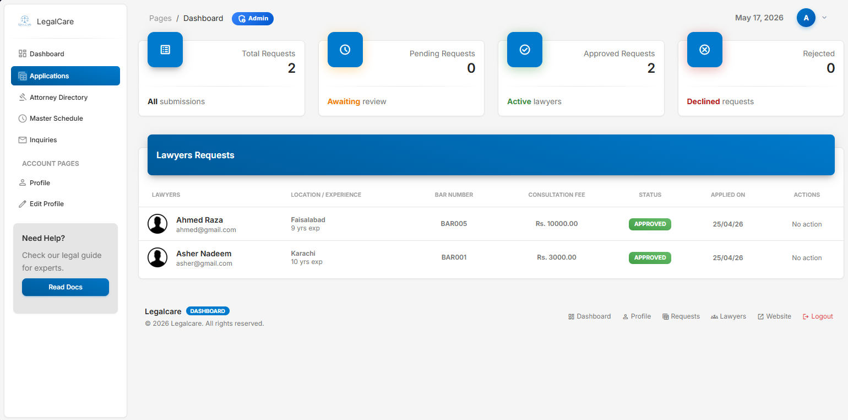

14. Testing
Processing Stage | Protection Layer | Technology Used | Technical Objective /  Vulnerability Defended
1. Data Entry & Submission | Client-Side (Immediate Feedback) | Browser HTML5 Form Attributes & PHP | Blocks empty inputs, incorrect string lengths, and malformed emails instantly before hitting the network.
2. File Asset Ingestion | Client-Side Restrictions | PHP $_File Validation & Input Handlers | Restricts file uploads exclusively to safe MIME types (image/jpeg, image/png).
3. Request Interception | Server-Side Routing Gate | PHP Session Verification & Middleware Check | Inspects current active $_SESSION tokens. Blocks unauthorized deep-linking or directory indexing and redirects anomalies back to index.php.

15. Future Enhancements
To expand the application into a commercial platform, the technical roadmap outlines several future system integrations:

Digital Consultation Frameworks:
Embedding low-latency WebRTC peer-to-peer protocols to power video consultations directly inside the dashboard panel layout.
Automated Monetary Clearing: Incorporating unified secure billing APIs (such as Stripe or PayPal) to automate client escrow processing and direct provider payouts.

Peer Evaluation Infrastructure:
Introducing verified user review and rating systems protected by verification tokens to maintain high-quality provider listings.

Automated Alert Channels:
Connecting specialized webhook drivers (such as Twilio and legal mail servers) to dispatch automated SMS and email reminders before scheduled slots.

Intelligent Case Matchmaking:
Building machine learning classifiers to analyze user case descriptions and recommend optimal legal specialists automatically based on historical success metrics.

16. Conclusion
The Online Lawyers Application Website System (LegalCare Portal) delivers an integrated, production-ready solution that addresses the historical inefficiencies of discovering and scheduling legal professionals. By building the core architecture on a structural foundation of PHP and MySQL, the application successfully automates complex business logic—including multi-tenant account handling, secure data-migration loops for provider vetting, and robust scheduling mechanisms that eliminate duplicate bookings.
The resulting platform documentation establishes a scalable framework that complies fully with modern technical specifications, secure development standards, and intuitive design workflows. The system demonstrates a practical, end-to-end implementation of secure full-stack software development principles tailored directly to the needs of modern legal practices.

