Ep-02-part-01
Episode-02 Ignite our App

Q: React Make App fast ?
A: No,
- React uses multiple package to make react App fast
Q: What is NPM ?
A: NPM is not (node package manager)
NPM is Package manager

npm init (or) npm init -y -------------------> Creates Packages.json

Q: What is package.json file
A: Configuration of NPM.
Configuration of our Project.
Q: What is dependencies ?
A Dependencies are also called Packages. It menas
packages=dependencies

A package is a collection of code and resources, while dependencies are external libraries
or modules required for a package to function properly.

npm install -D parcel

After run above command two file created
1.packages-lock.json
2.Node_modules

Q: How many type of dependecies packages have ?
A Packages have Two type of dependencies
1. Dev dependencies- required in development phase.
2. Normal dependencies- required in Production Phase.

Q what The caret symbol (^) signifies
A: package can be updated to a newer compatible version (minor update) when running
npm install in the future.
Q what The Tilde symbol(~) signifies
A: package can be update to a Patch Update When running npm install in The Future .

Q What is package-lock.json file

A: The `package-lock.json` file is a JSON file that is automatically generated when you install or update packages.

It's used to lock down the specific versions of dependencies that your project uses.

This ensures that every time you or someone else installs the project's dependencies, the exact same versions are installed, regardless of when or where they are installed.

This helps maintain consistency and prevents unintended changes in your project's behavior due to different versions of dependencies being used.

The `package-lock.json` file also includes information about the exact structure of the installed dependencies, their sub-dependencies, and their dependencies' dependencies, forming a complete and accurate dependency tree.

Q What is difference b/t package.json Vs package-lock.json file ?
A
- **package.json**: This file contains metadata about the project, including its name, version, description, dependencies, and development scripts. It's where you define the packages your project relies on and their version ranges.

- **package-lock.json**: This file is automatically generated and works alongside the `package.json`. It records the exact versions of all the dependencies (and their sub-dependencies) that are installed in your project. It ensures consistent installations across different environments and prevents unexpected changes due to version variations.

In short, `package.json` outlines what packages your project needs,
while `package-lock.json` ensures that everyone working on the project gets the same versions of those packages to maintain consistency.

Q: what is node_modules files ?
A The `node_modules` directory in a React.js project holds external packages and libraries required for the project to work.

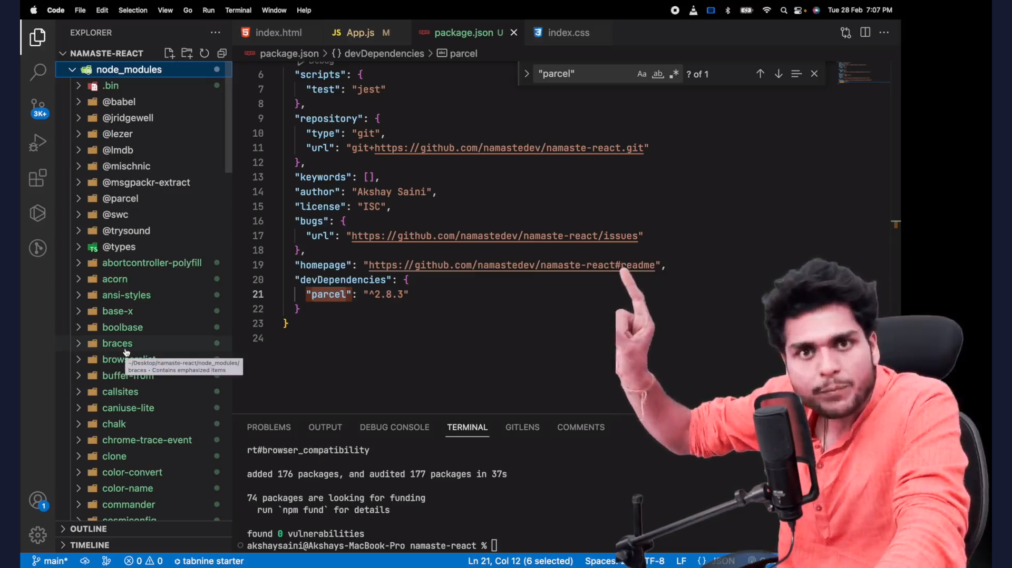
Q: I have only installed Parcel Why so much packages also present in node_modules ?
A: Because of Transitive Dependencies.

Q: What is Transitive depencencies ?
A: When we installed parcel .
Parcel depend on other package like “A” package
“A” package depend on “B” package
“B” package depend on “C” package
“C” package depend on “D” package
..........................................
.....................................................
so That many package are also present in node modules file

Q: Should I can put package.json and package-lock.json file to git
A: Yes

Q: Should I can put all the node_modules file to github or productin ready app
A: NO
Becuase we can re-create nodue_modules files using below command
npm install

Ep-02-part-02

npx parcel index.html

When run Above code then Created two files.

1- .parcel-cache
2- dist

Above two files are temp file it can generated when required by above command it’s means don’t putt These file to github!

`npx` is a command-line tool that comes with npm (Node Package Manager) and is used to execute Node.js packages that are not globally installed on your system.

It allows you to run commands from packages installed in your project's local `node_modules` directory, without the need to install them globally.

This is particularly useful for running tools, scripts, and utilities that are part of packages you use in specific projects, without cluttering your global package installations.

Install the package – npm install <name of package>
run the package - npx <name of package> <end point>

Q: what we should put in .gitignore file ?

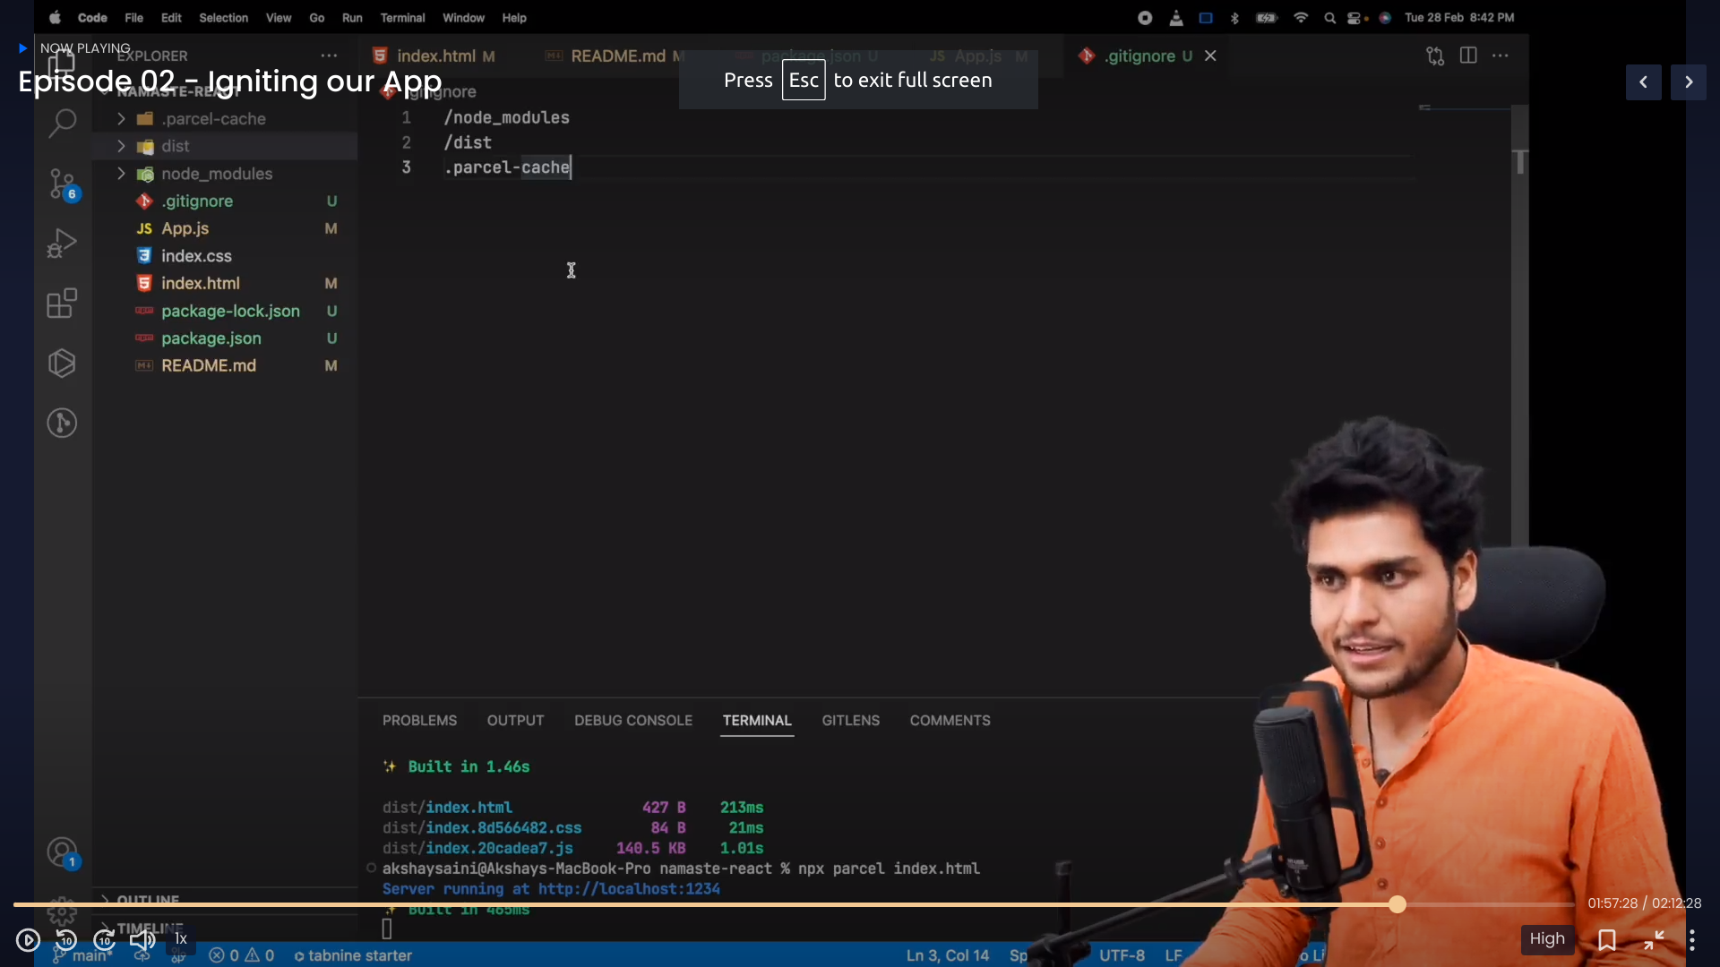
Why three files ?
Because all the file can be generated

Q: CDN is not prefered way to do bring react and react dom to a project ?
Q: why is not prefered way ?
Because package update issue
Q: What thing make react fast ?
A: Several factors contribute to making a React app fast and responsive:

1. **Virtual DOM**: React's virtual DOM efficiently updates only the necessary parts of the actual DOM, reducing the number of actual DOM manipulations and improving rendering performance.

2. **Component Reusability**: Breaking your app into reusable components allows for efficient rendering and updates, as changes in one component won't necessarily affect others.

3. **Optimized Rendering**: Using techniques like conditional rendering, lazy loading, and memoization helps minimize unnecessary rendering and ensures that components update only when needed.

4. **Code Splitting**: Splitting your app's code into smaller chunks and loading them only when necessary reduces the initial load time and allows for better resource utilization.

5. **Bundling and Minification**: Using tools like Webpack or Parcel to bundle and minify your app's code, reducing its size and improving load times.

6. **Server-Side Rendering (SSR)**: Implementing SSR can improve initial loading performance by rendering some components on the server before sending the HTML to the client.

7. **Caching**: Leveraging browser caching and optimizing HTTP requests through techniques like ETag headers and cache control can speed up subsequent visits.

8. **Optimized Images**: Using compressed and appropriately sized images, along with responsive image techniques, reduces the impact on page load times.

9. **Code Optimization**: Regularly reviewing and refactoring your codebase, removing unused code, and optimizing performance-critical parts can lead to better execution speed.

10. **Performance Profiling**: Utilizing tools like the Chrome DevTools Performance tab to identify performance bottlenecks and areas for optimization.

11. **Network Optimization**: Minimizing the number of network requests, using HTTP/2, and implementing efficient data fetching techniques like GraphQL or REST can improve data loading times.

12. **State Management**: Choosing an efficient state management solution like Redux or MobX helps manage application state effectively, avoiding unnecessary re-renders.

13. **Tree Shaking**: Leveraging tree shaking capabilities of modern bundlers to eliminate unused code from the final bundle, further reducing file size.

14. **Browser DevTools**: Utilizing browser developer tools to profile, audit, and optimize your app's performance.

By focusing on these factors and adopting best practices, you can significantly improve the speed and responsiveness of your React app.

Q: What is Parcel ?
"parcel" refers to a lightweight and fast bundler .
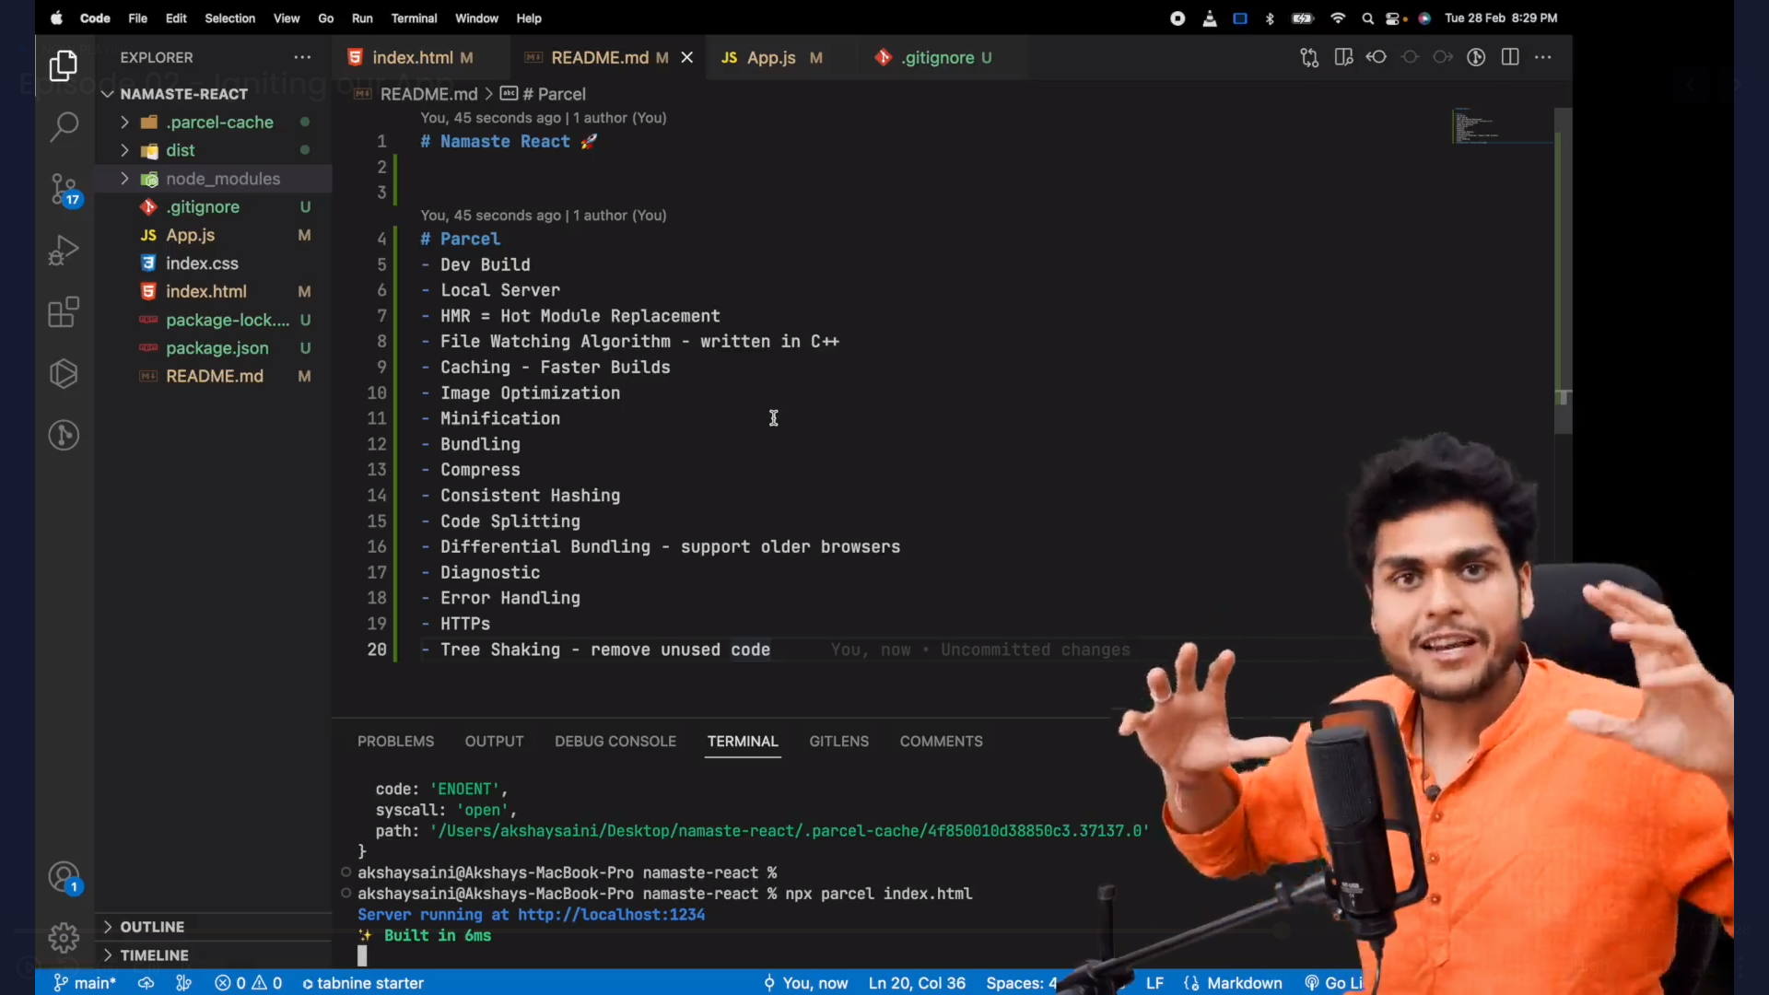
Q: How parcel is Fast ?
A Because of .parcel-cache file makes parcel fast !

Q: How we can make Production ready Build !

A npx parcel build index.html

Q: what is broswer list ?

A: Broswer list have powerfull thing todo , if we want my website works for only indian then we can configure package.json file to only works for india not for outsite india .

If We can to my website works chrome last two version we can configure as like we want .

