React Ep-1
Ep-01-part-01

Q1. What is CDN ?
Q2. What is CrossOrigin ?
Q3. At the end of the day What is React ?
A: - Javascript Library
- Piece of Javascript Code
Q4. How many Whey You can Inject React in Your Project
Q5. React CDN linkes ?
A:
<script crossorigin src="https://unpkg.com/react@18/umd/react.development.js"></script>
<script crossorigin src="https://unpkg.com/react-dom@18/umd/react-dom.development.js"></script>
Q6. Why Here Two links Why not one links ?
A: - react.development.js -> Core File of React
- react-dom.development.js -> This is react library use full for DOM operation
Q7. Why react Not combine Both file in onefile ?
A: Becuase React are not only use for web app , react Can use many places ?
Likes- React Native ... 3D Desigen ?

Ep-01-part-02
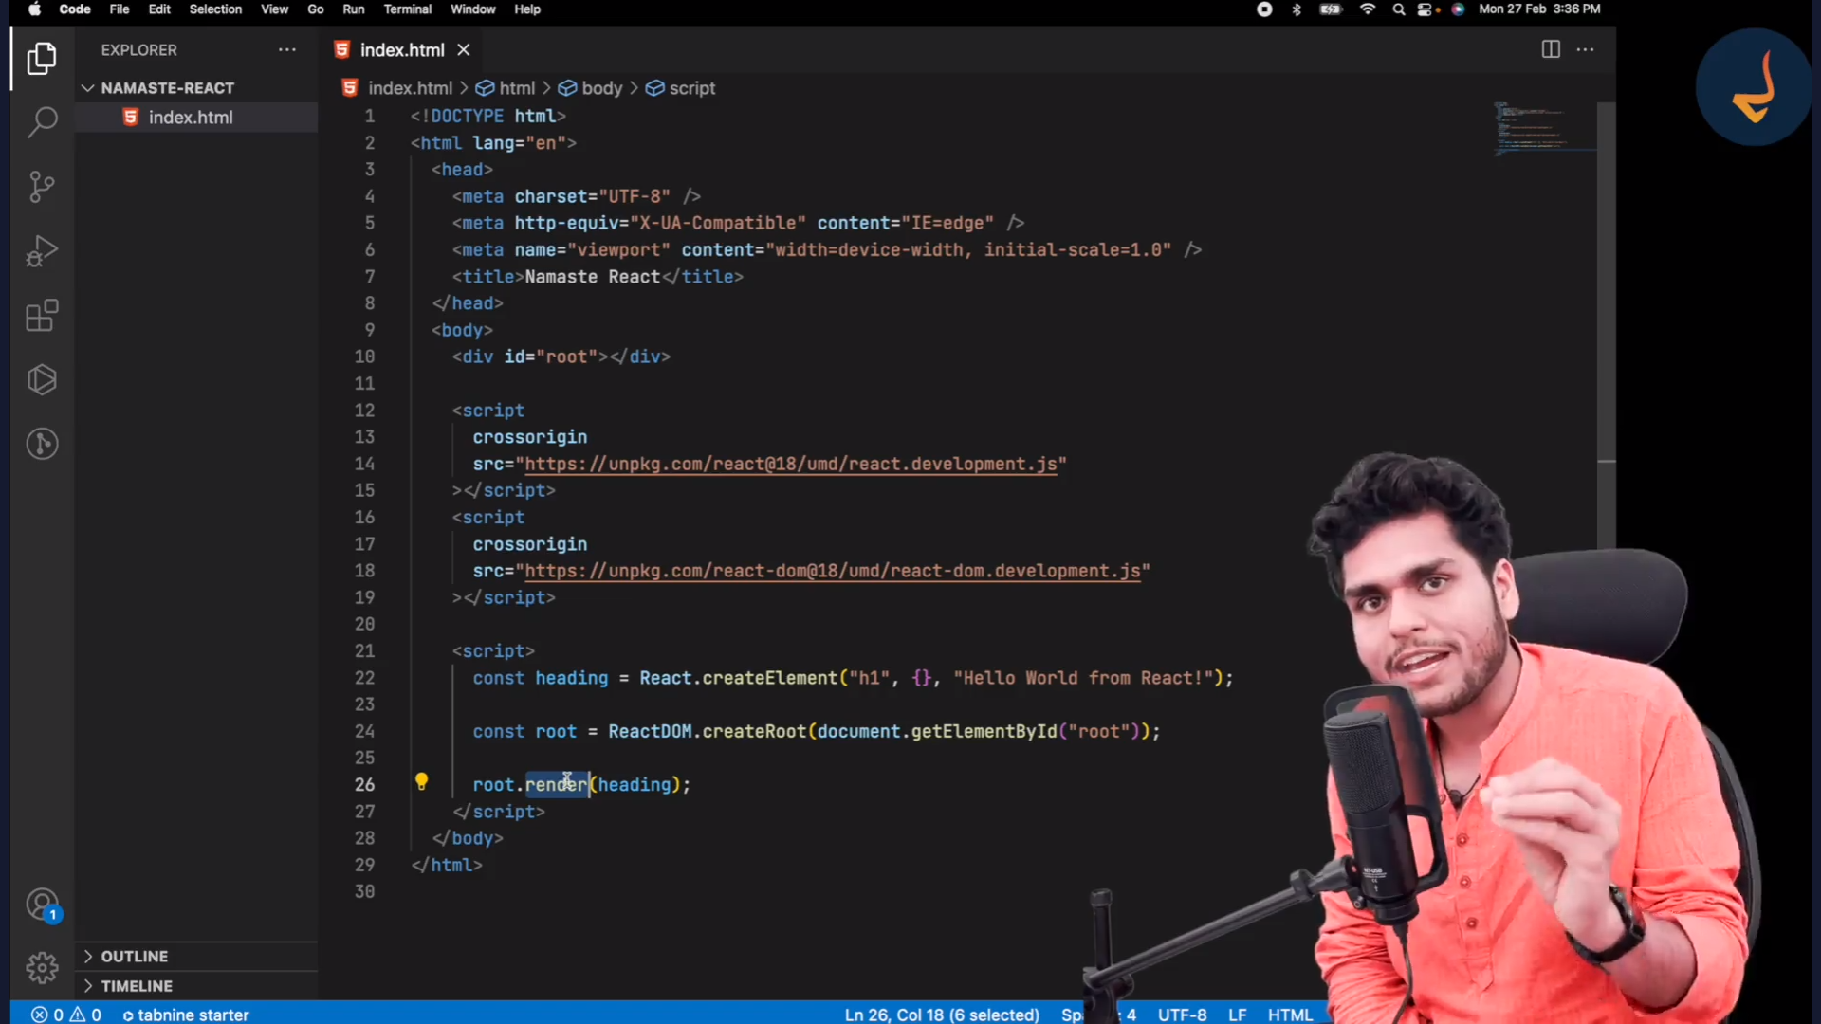

Ep-01-part-03
Q: What is Most Costly Operation is (Browser) Web page ?
A: Dom Operation
Q: What is heading End of the day ?
Const heading=React.createElement(“h1”,{},”Hello world from React!);

A- heading is Just React Element .
Q: What is React Element End of the Day ?
A- Normal Javascript Object.
Ep-01-part-04

Q: What is react.render method do ?
A: Takes react element and rendered into HTML( browser can Understand )

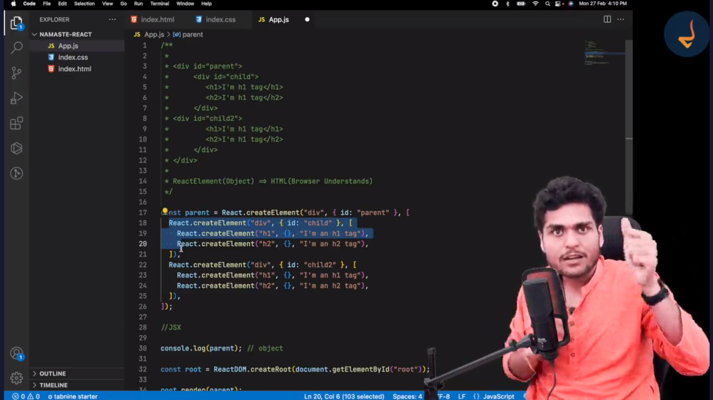
Ep-01-part-05

Q1. Order of file Important ?
A- Yes

We can not put <script src=”./App.js”></script> before CDN of ReactJS ?

Q2. What is difference b/t React.development.js VS React.production.js CDN Links ?
A- ?

Q: What is React.createElement End of the Day ?
A- Normal javascript Object

Q: What does root.render() method ?
A- root.render method takes react Element (Normal Object) and
Convert Object into HTML tags .

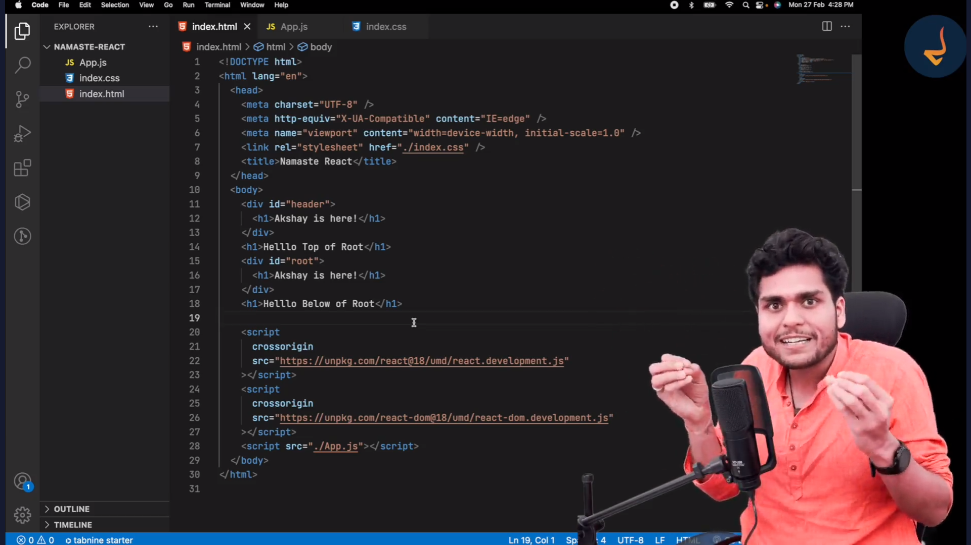
- react.render (reactElement) method replace all the tag from the root and rendered the React element further .

Q: Where You can Use React ?
A - React can be used – Entire WebApplication
- Header,Body,Footer or even we can use on only one div also .

