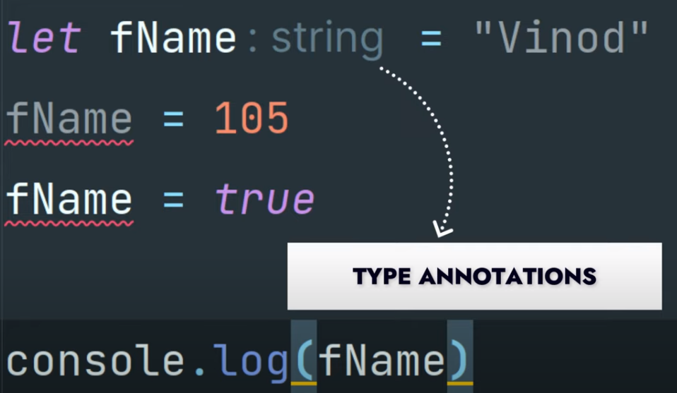
Lecture-1 Introduction to typescipt ?
TYPESCRIPT

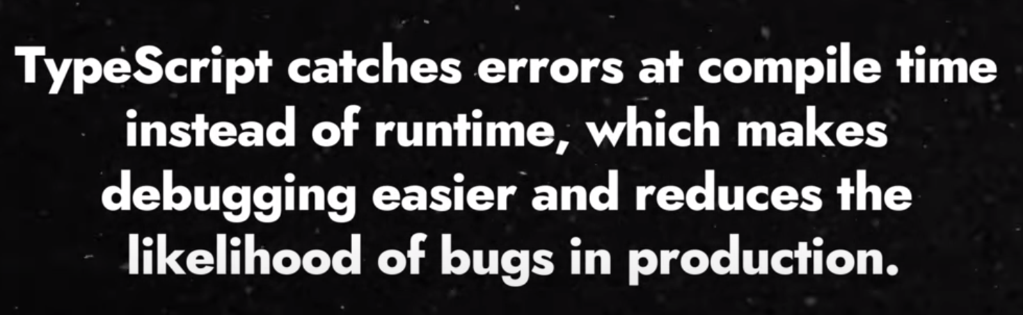

TypeScript is JavaScript with added syntax for types.
TypeScript uses compile time type checking. Which means it checks if the specified types match before running the code, not while running the code.

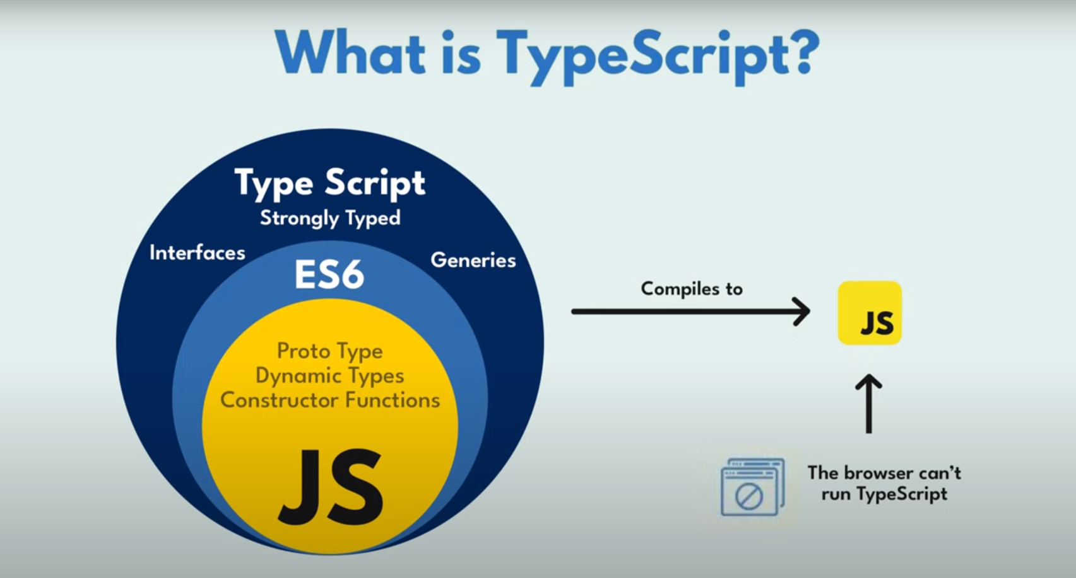

Lec-3
https://www.tutorialspoint.com/typescript/typescript_quick_guide.htm

Q] How we can compile ts code

tsc <fileName>
example >>>>>>>>>>>>tsc index.ts

Q] TS-cofiguration file ?
When error in typescript code don’t compile the code

tsc - - init [initialize tsConfiguration file]

goto tsConfig.json() and search this code an uncomment >>>>>>>>

"noEmitOnError": true /* Disable emitting files if any type checking errors are reported.

When error in ts file don’t create index.js file

tsc

Lec-4

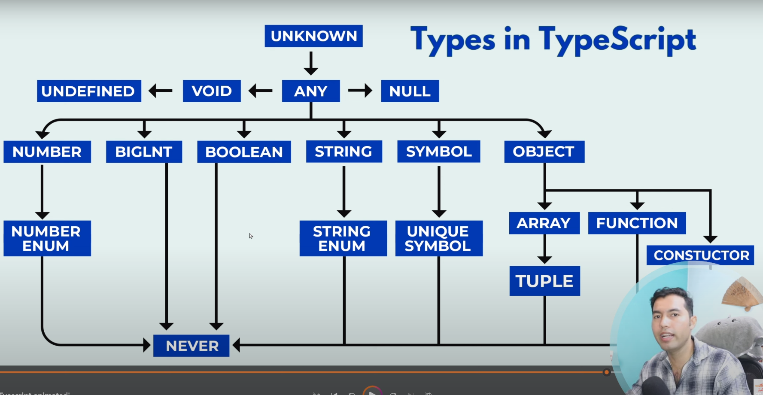

Home-Work of Lecture-4

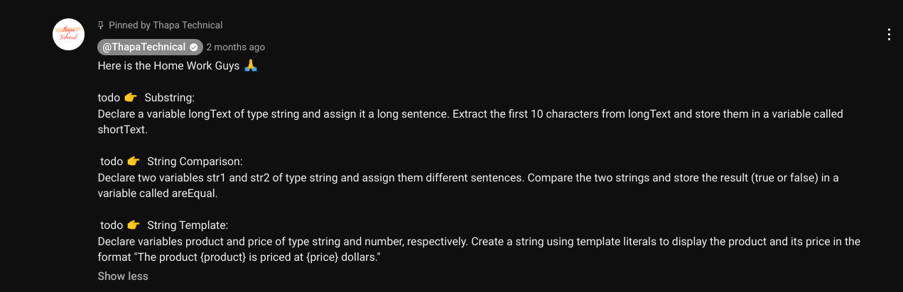

Lec-5

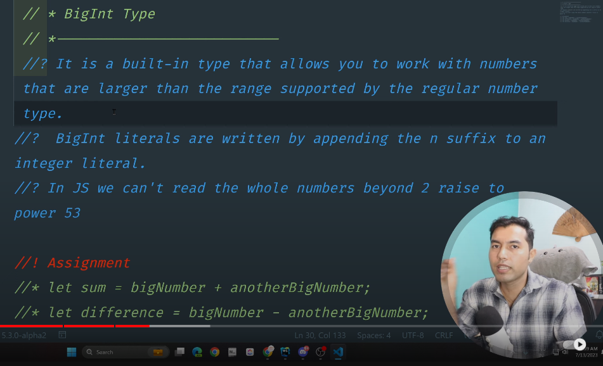

Lec-6
When you Write “any” Than you can think you use are writing code in “JS”

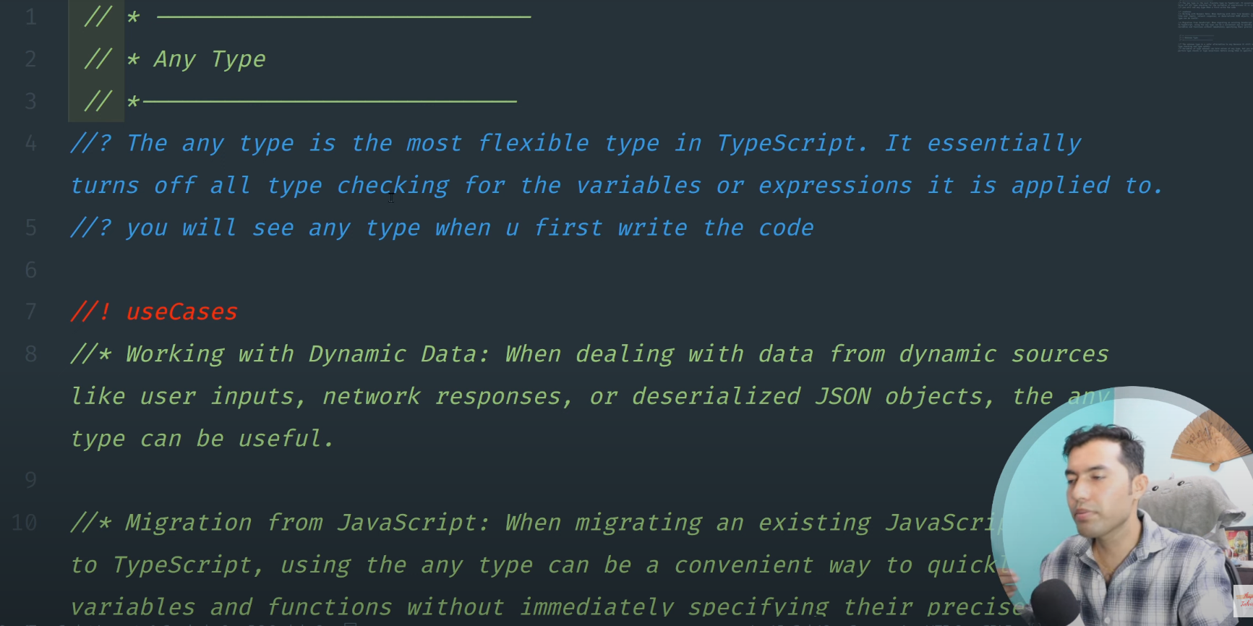

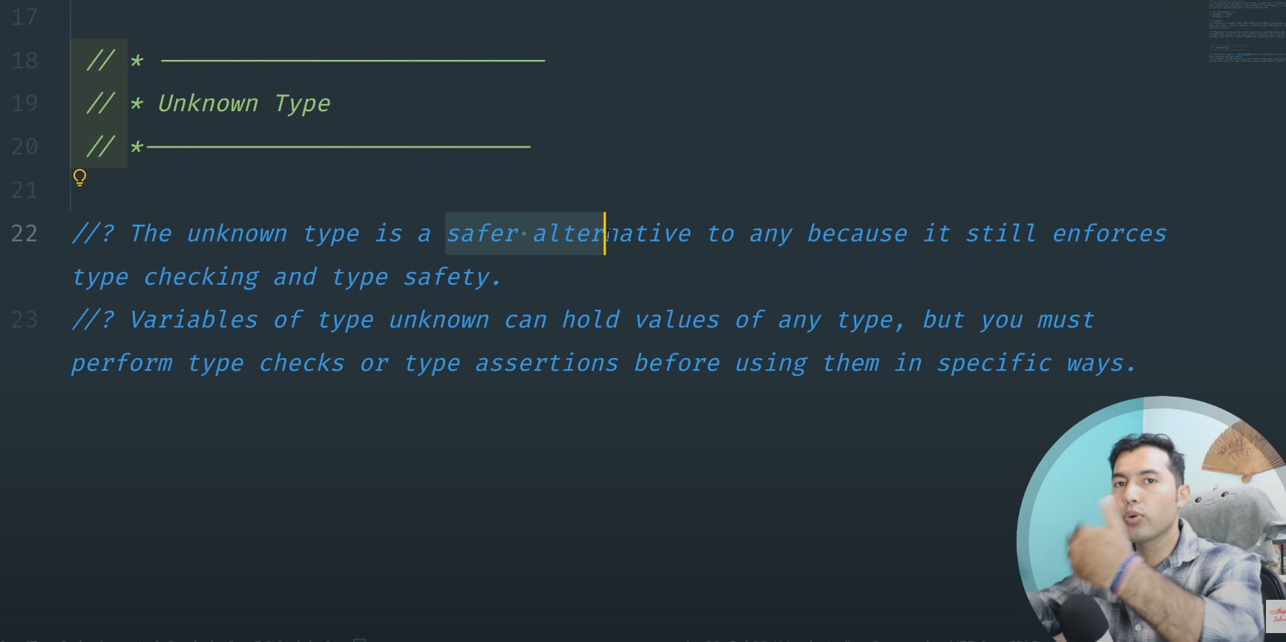
Q: What is type checkting ?
A: simple meaning of type checking when we defined type
first Number then we can not write other type of value over it
example: var myfavNum1: number=10;
myfavNum1=true
Q: What is Type safety
A: simple Meaning of Type safety is which property i can use which “myfavNum1”
myfavNum1 can be any variable names ...

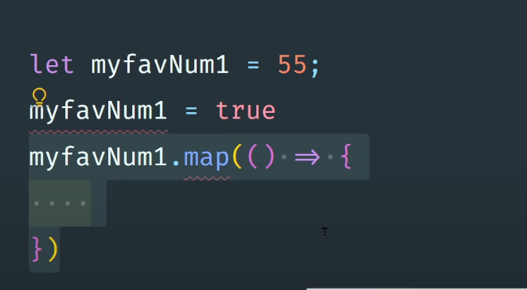

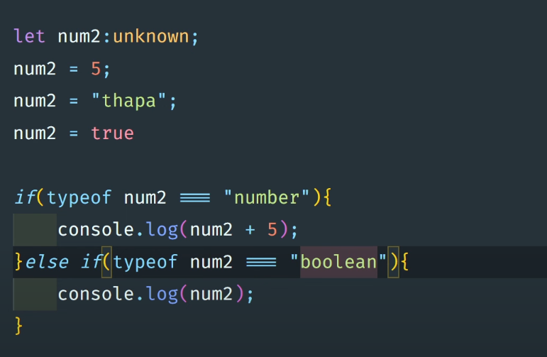

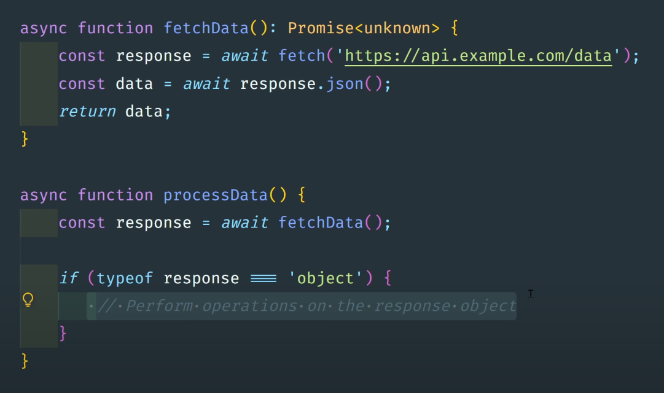
assignment-of-lec-6

Lec-7
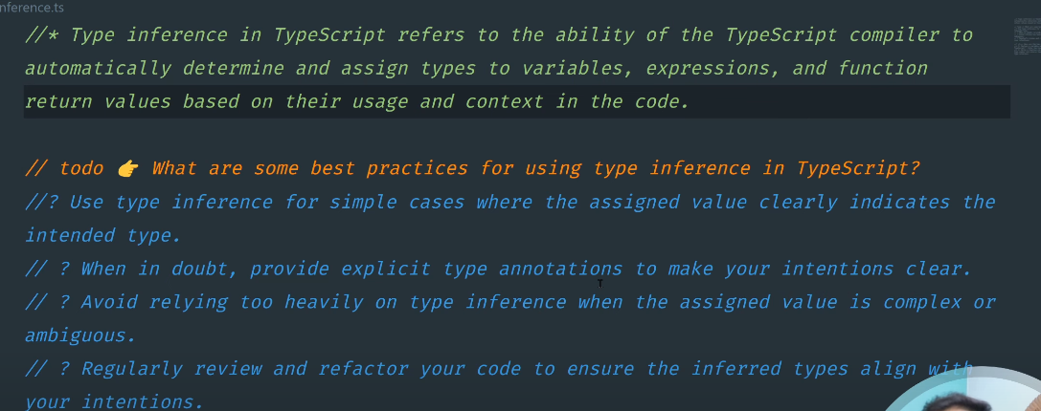
simple mearning of inference
(infer)/assume

Lec-7 assignment
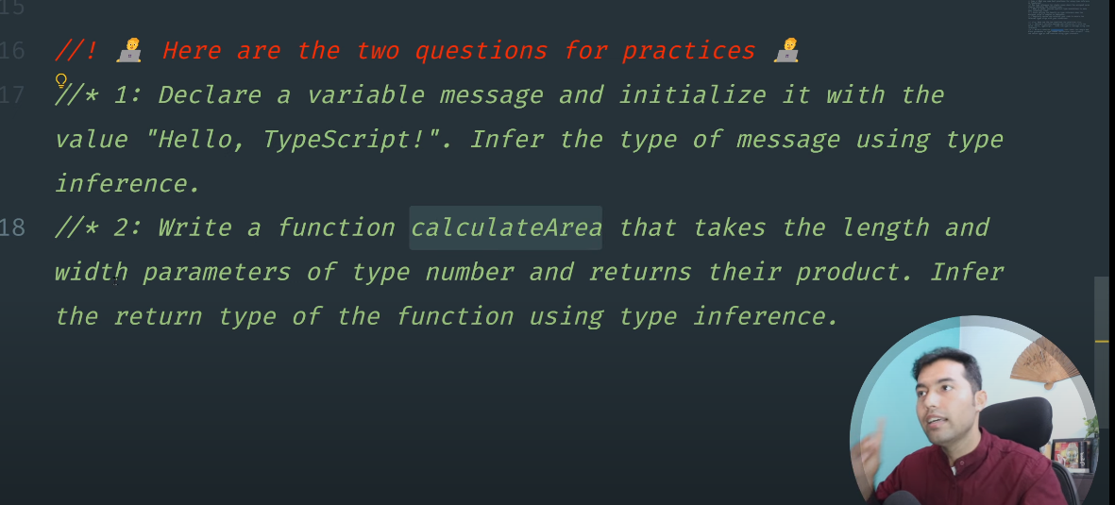

Lec-8
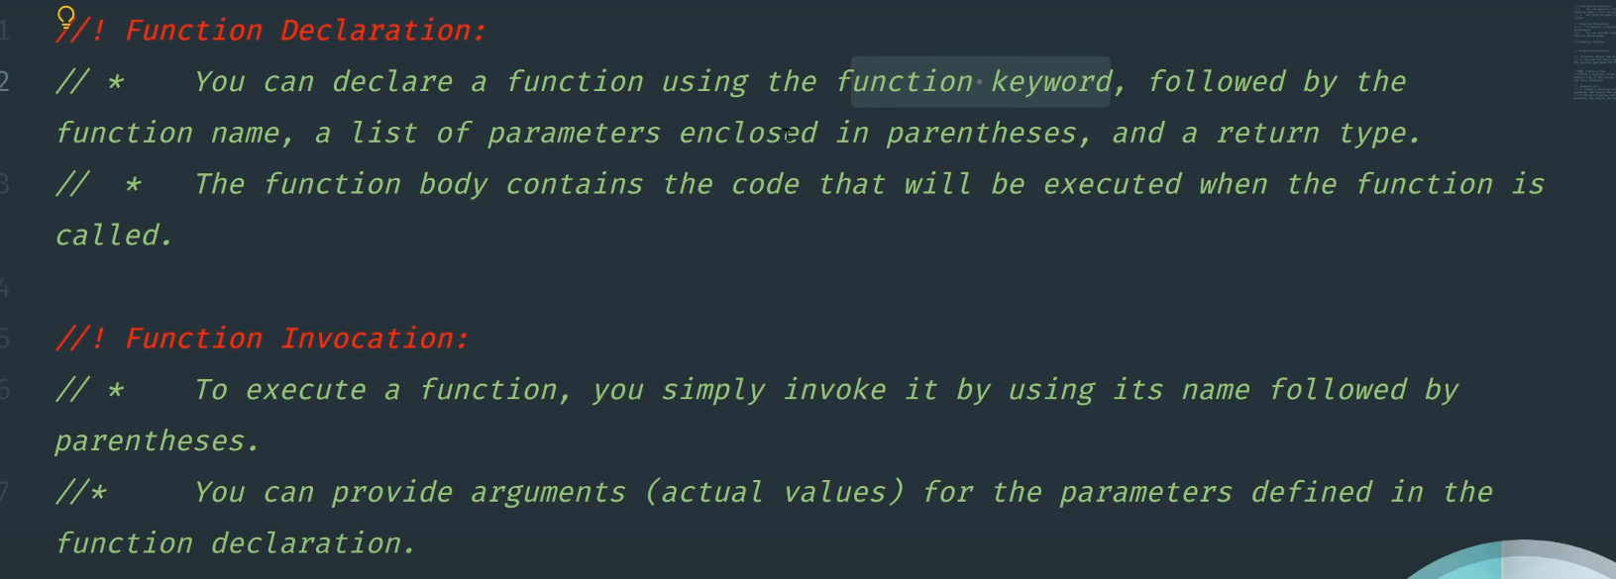

#9 Understanding Optional and Default Parameters
When In function we write “two Parameters” then it will expact “two aurguments” but but but when
gotted one augument then you write other paramerts as default parameters
function applyDiscount(price, discount = 0.05) {
return price * (1 - discount);
}
console.log(applyDiscount(100)); // 95

Optional Parameters=> ?

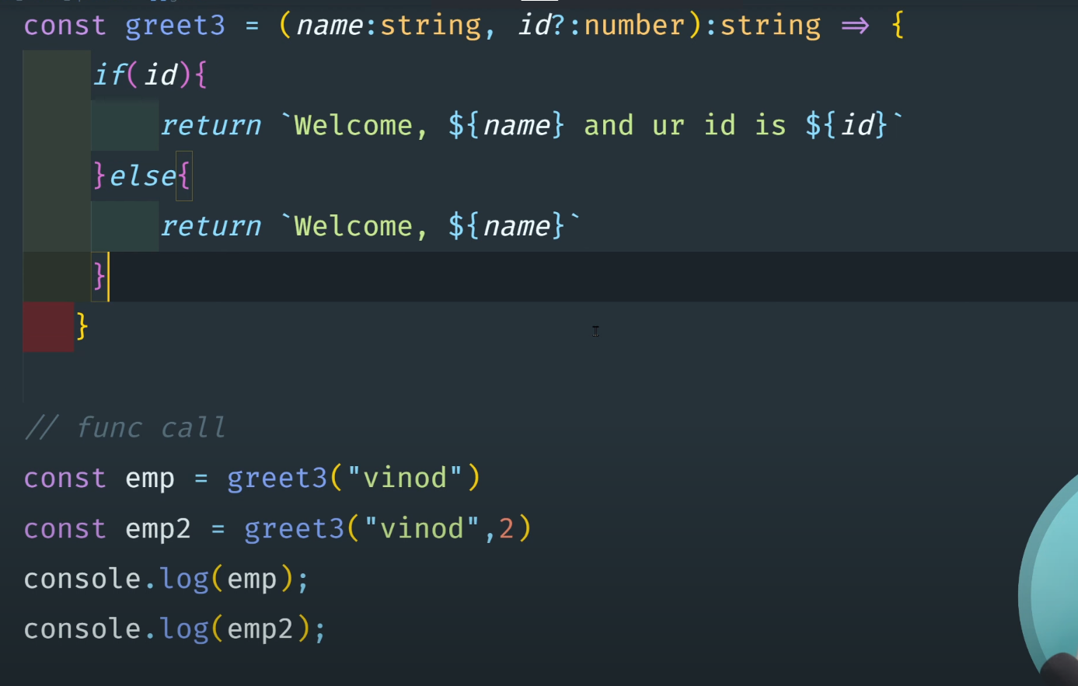

#10: Initializing, Accessing, and Checking Length of an Array
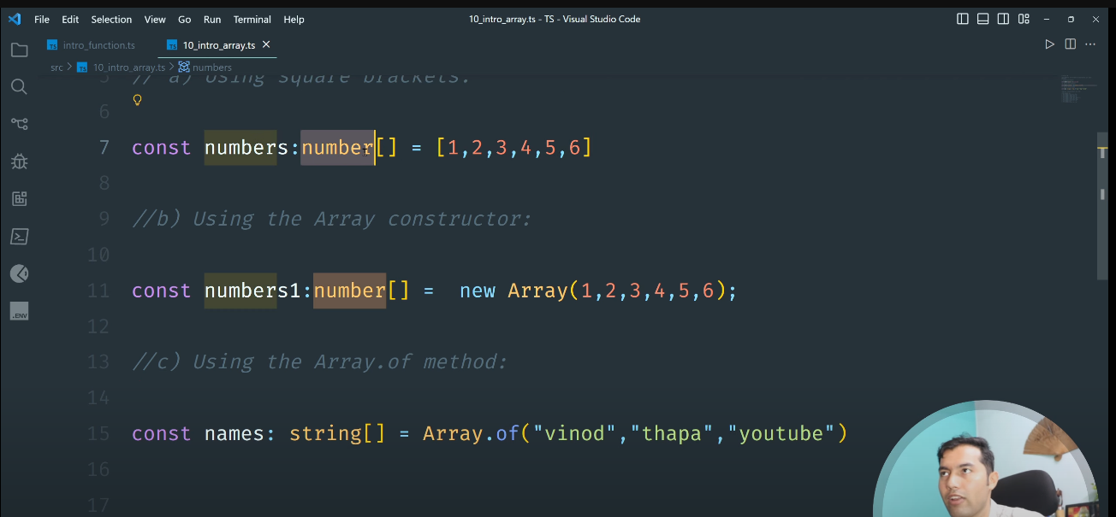

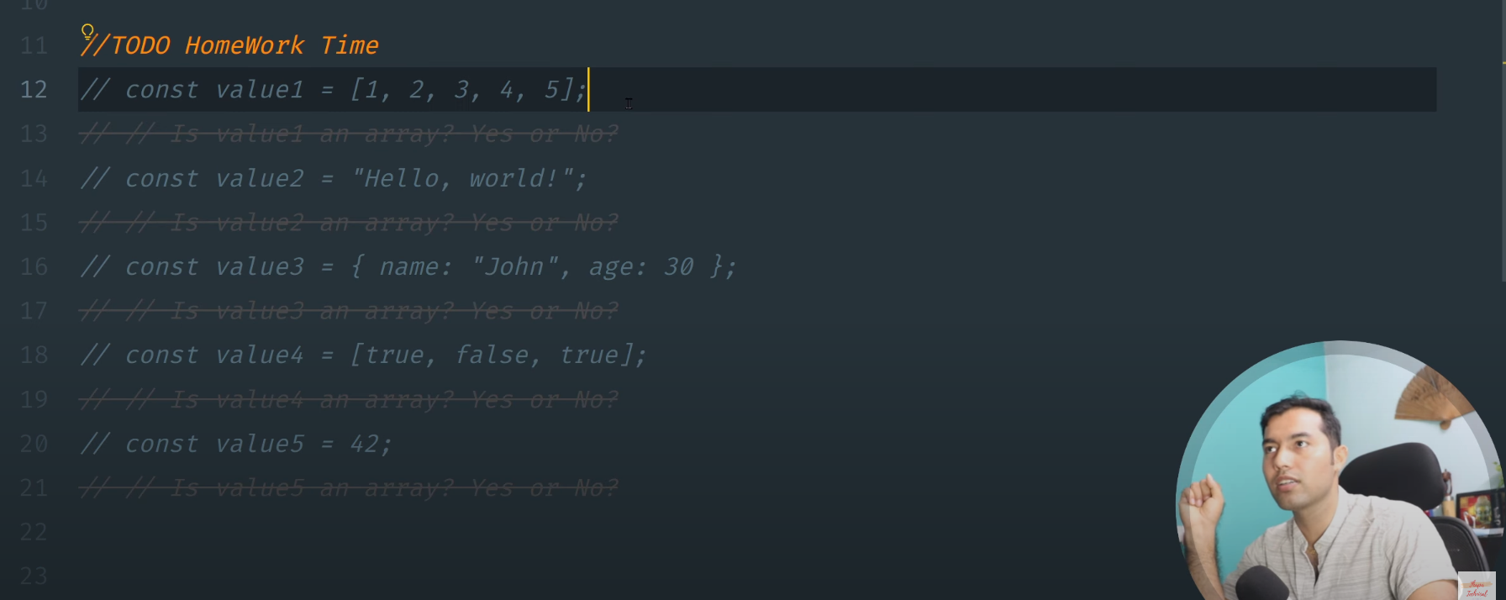
Lec-10 assignment-Questions

#11: TypeScript Arrays👉Methods and Iterations

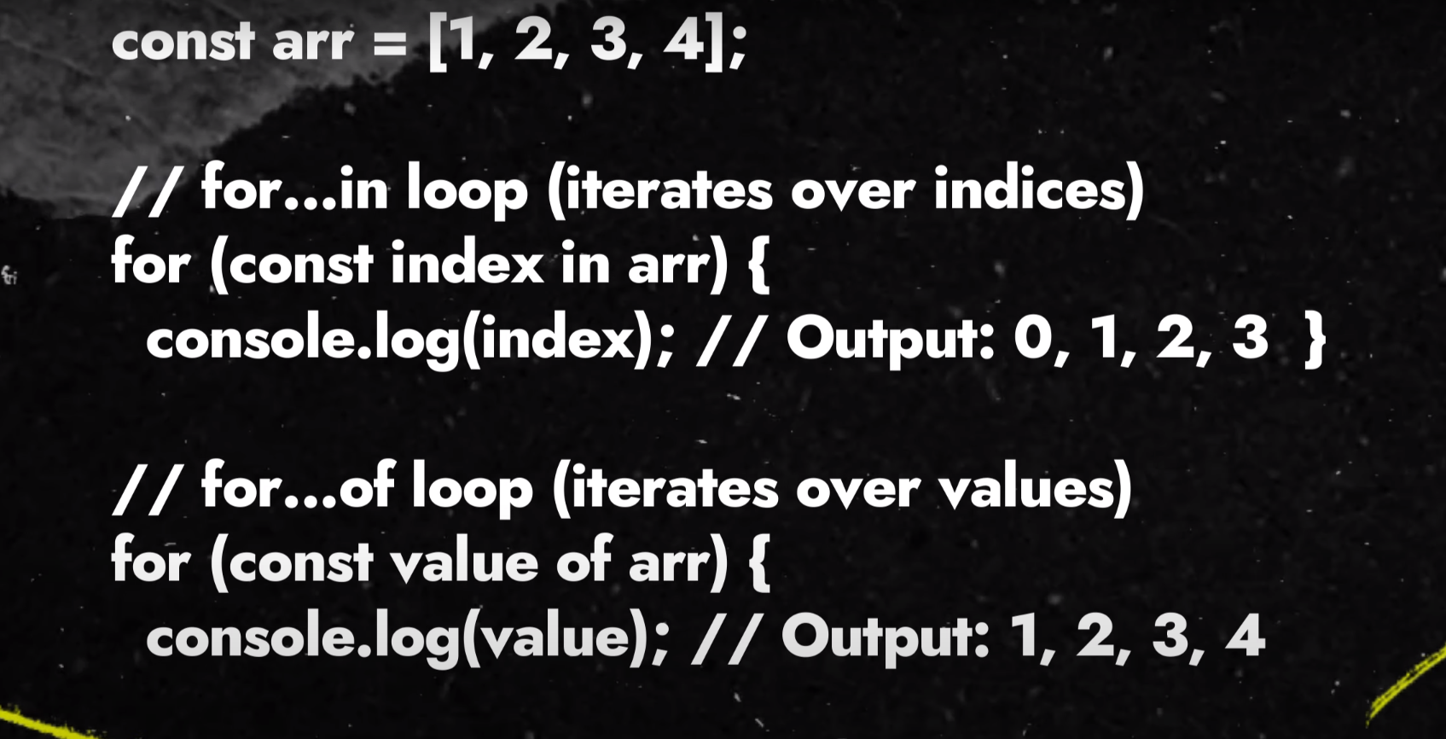

#12: TypeScript Array Map and Filter Methods

Lec-12: Assignment-Questions
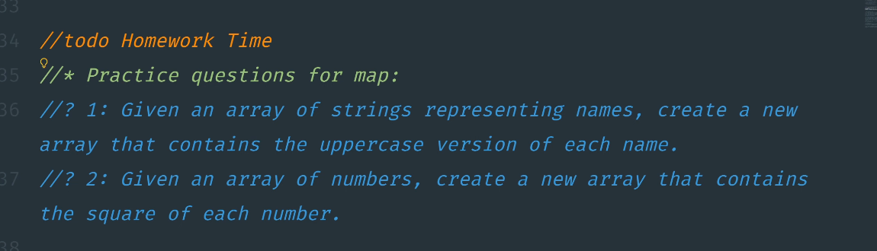

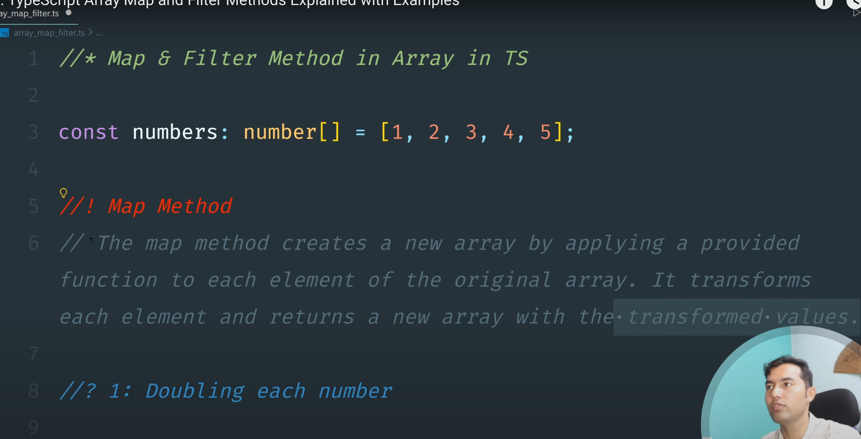
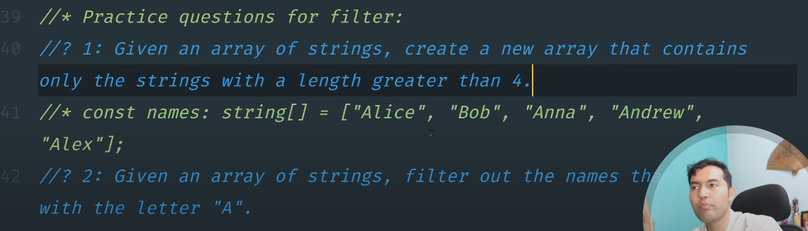

#13: TypeScript Objects Explained: Everything You Need to Know with Real Life

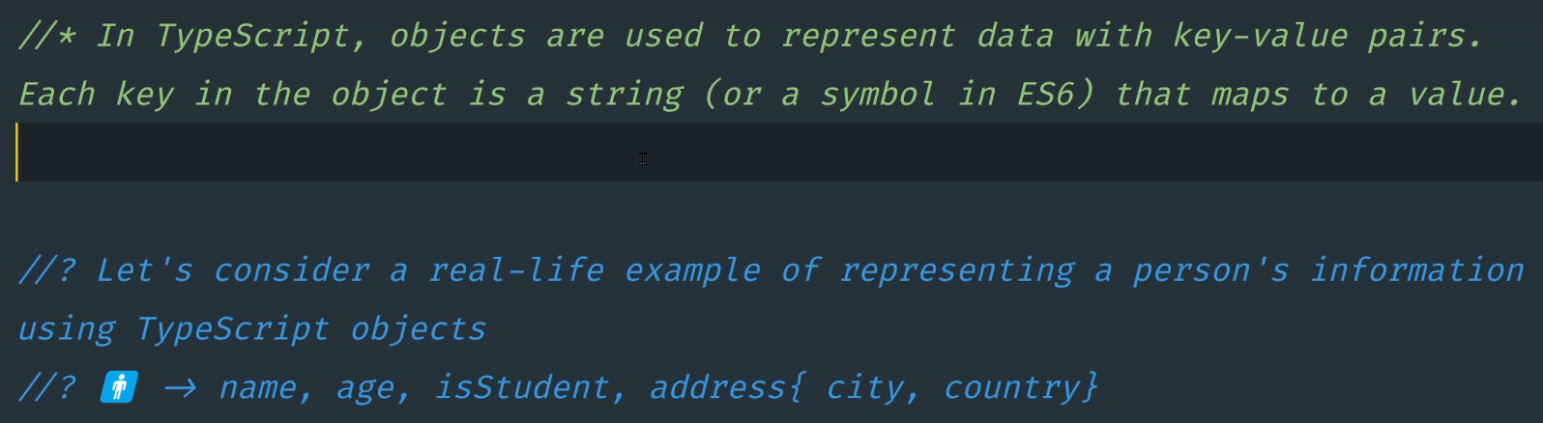
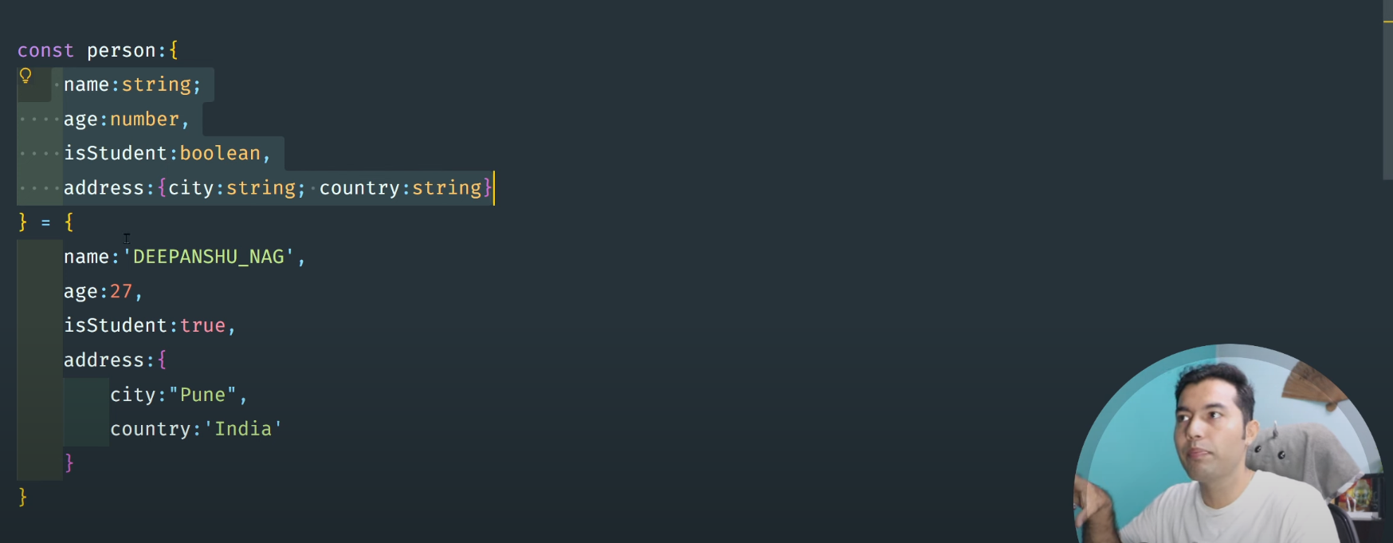
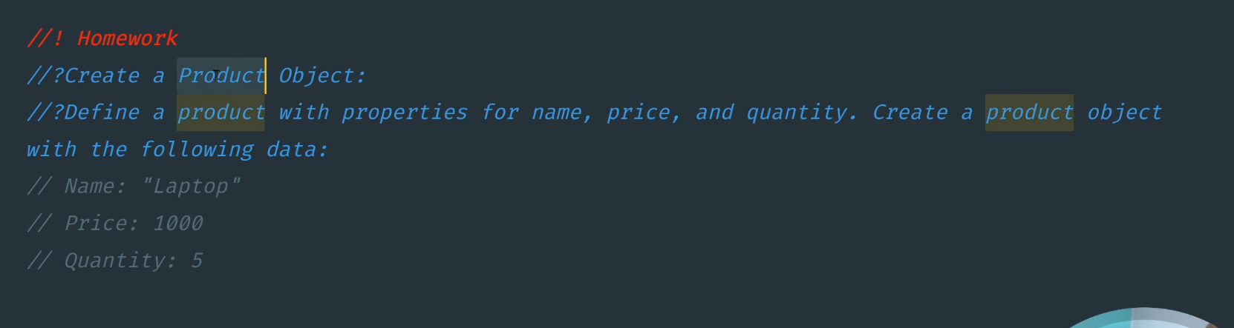
If there is 100 person then you need to type 100 times of each person type this is failed DRY concept
how we can solve this problem ?
create one Person type and used as many place you use like functions =====
using -> Type Aliases

#14: TypeScript Type Aliases: Making Your Code Easier to Read & Maintain
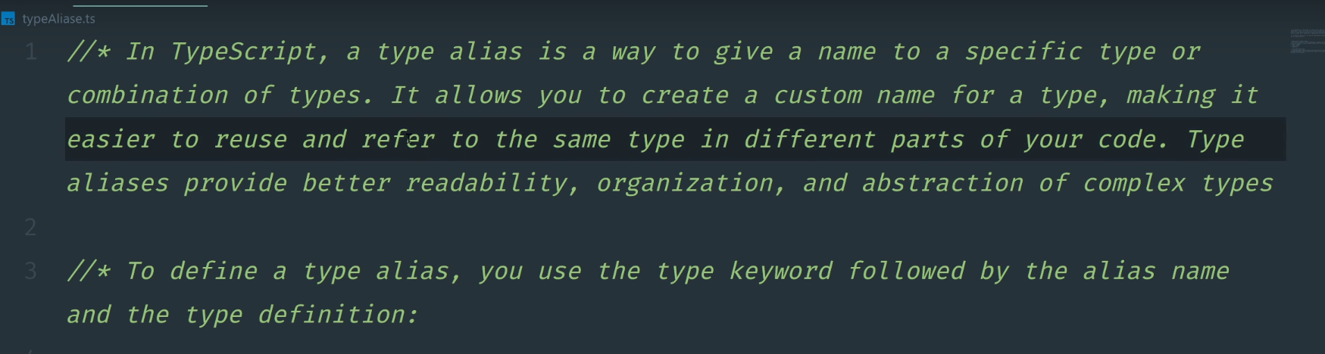
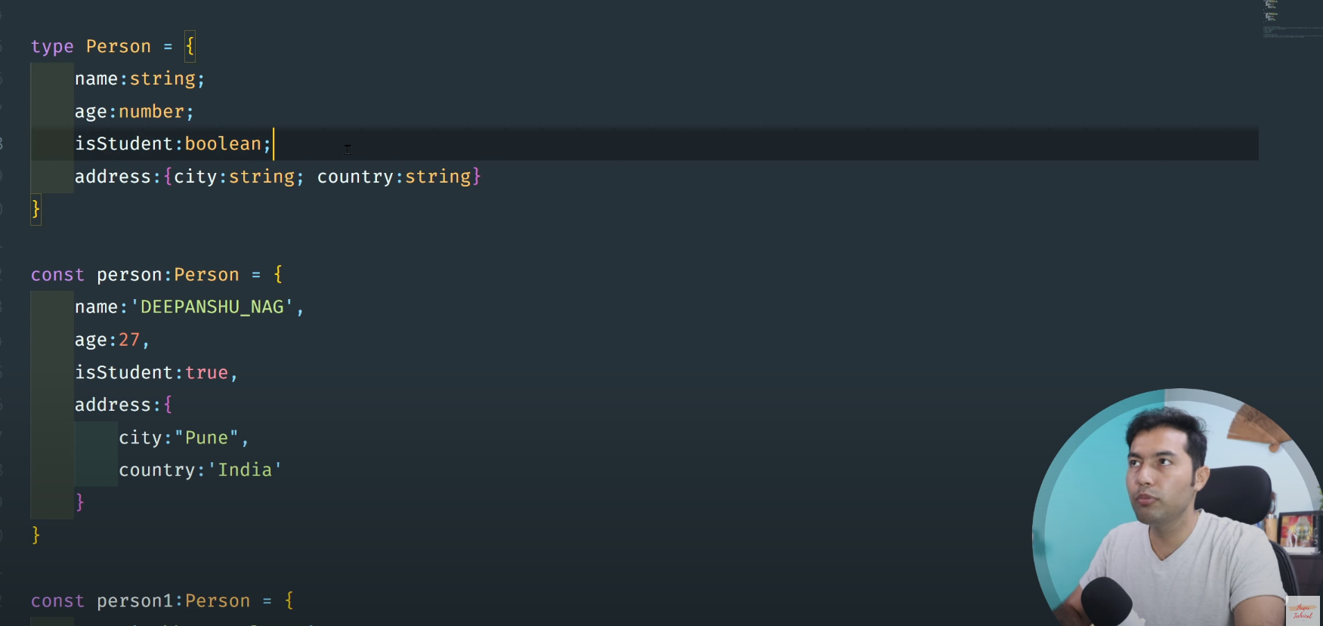

#15-Call Signatures in TypeScript with Real-life Examples & Best Practices 🧑‍💻
TypeScript is only concerned with the structure of the value we passed

#17： TypeScript Tuples🔥

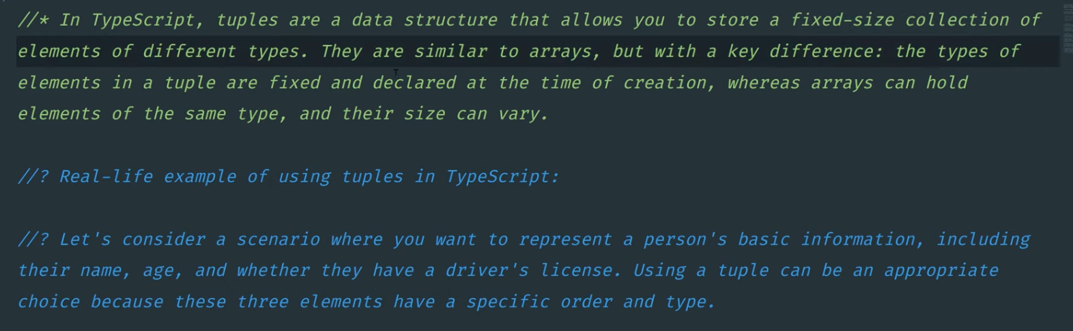

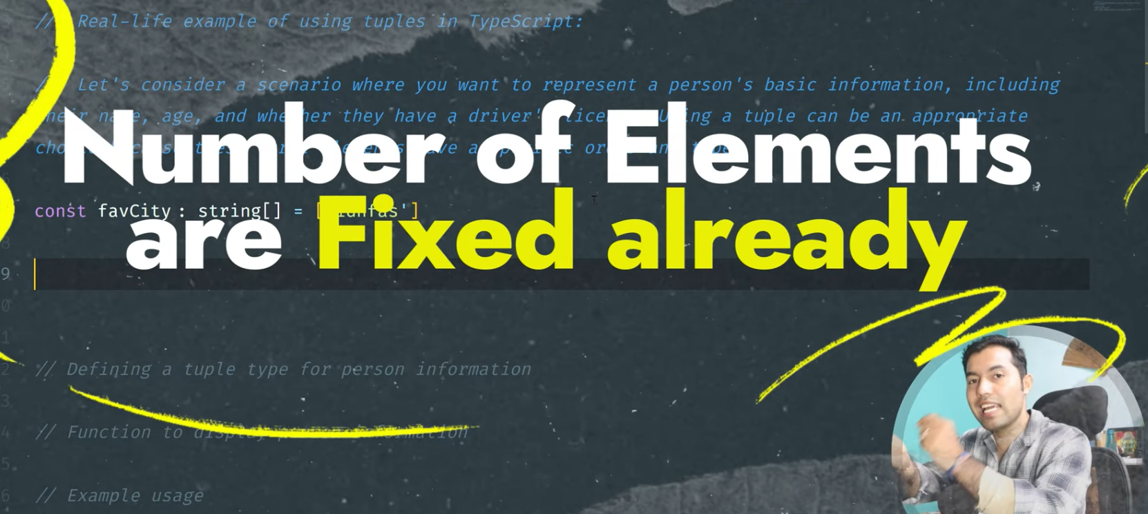
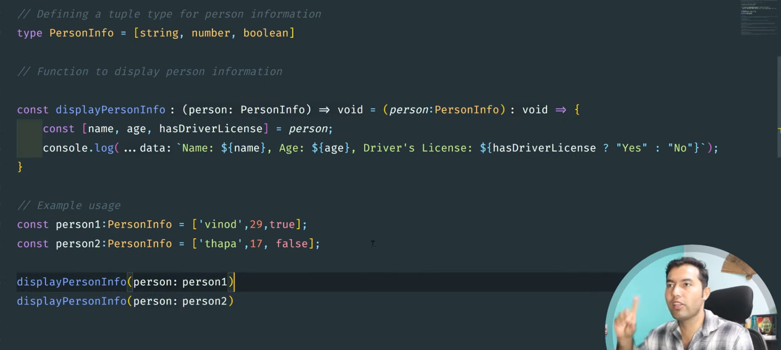

However, there are occasions when we need to keep a collection of values of various data
kinds in a single variable. Arrays do not provide this capability, but TypeScript offers a data
type called Tuple that does. A Tuple in typescript is an array that stores numerous fields
of various data kinds.

Tuples in Typescript

//! Question 1:
// You are building a simple e-commerce application and need to store product information. Define a tuple type called ProductInfo to represent each product, containing the following elements:

// Product name (string)
// Price (number)
// Quantity in stock (number)
// Create two product instances using this tuple type and display their information.

//! Question 2:
// You are creating a student management system and want to keep track of student grades for different subjects. Define a tuple type called SubjectGrade to represent a subject and its corresponding grade, containing the following elements:

// Subject name (string)
// Grade (number)
// Create an array of SubjectGrade tuples to store the grades for a student in three different subjects: Math, English, and Science. Calculate and display the average grade for the student.

//! Question 3:
// You are working on a weather application, and you need to store weather data for different cities. Define a tuple type called WeatherData to represent the weather information, containing the following elements:

// City name (string)
// Temperature in Celsius (number)
// Weather condition (string)
// Create a function called displayWeather that takes an array of WeatherData tuples as input and displays the weather information for each city in a user-friendly format.

#18: Master TypeScript Unions and Intersections 🚀

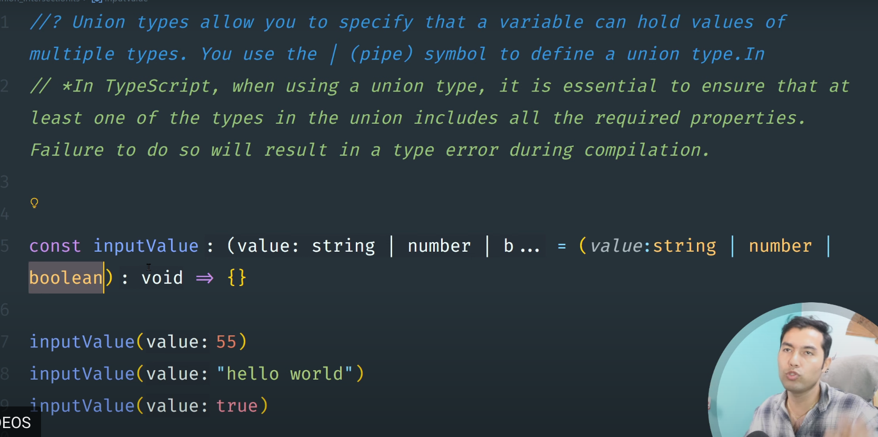
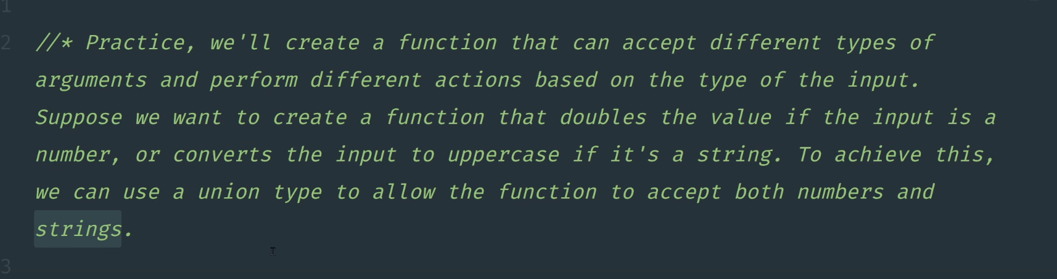
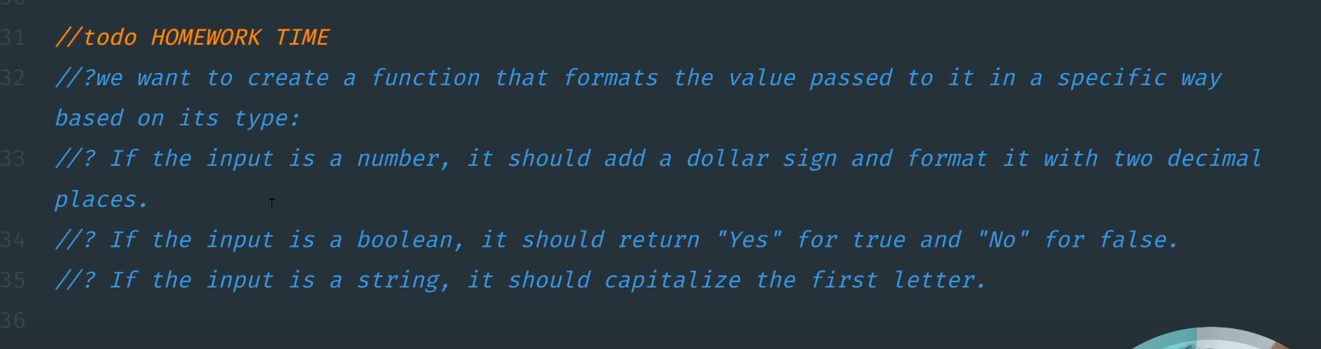

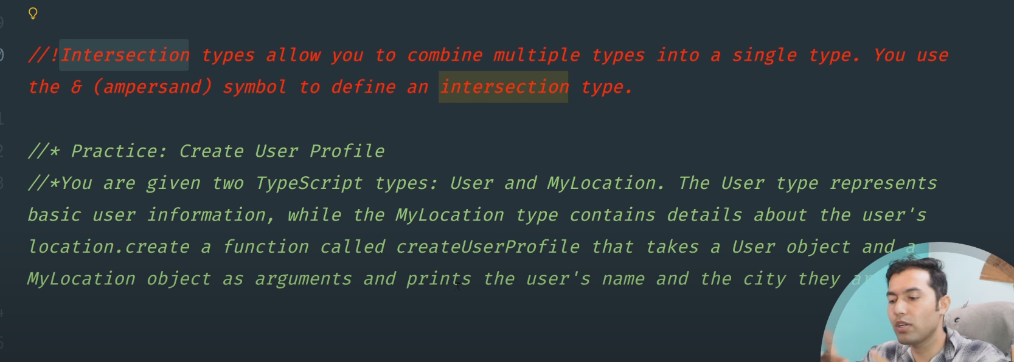
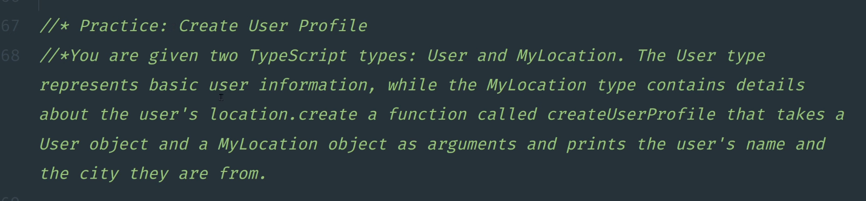
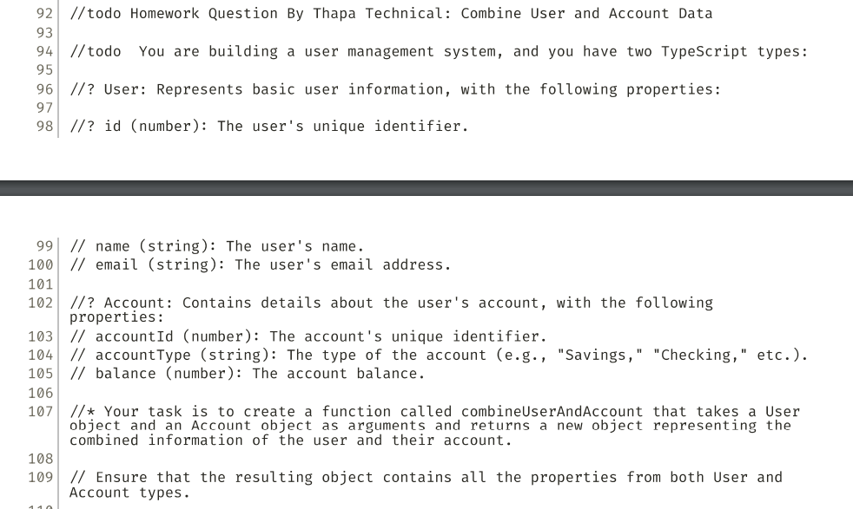

#19: Generics in Typescript 🚀 Make everything Reusable like JAVA & C#

function add<T, U>(a: T, b: U) {
console.log(typeof a);
console.log(typeof b);
console.log(`this is value of a: ${a} and value of b: ${b}`);
}
add(10, 20);
add("ashishk", "book");
add("ashishk", 20);
add("ashishk", true);
The fat arrow notation/lambda notation (=>)

#21: TypeScript Interface - Defining Contracts for Objects & Classes 📝
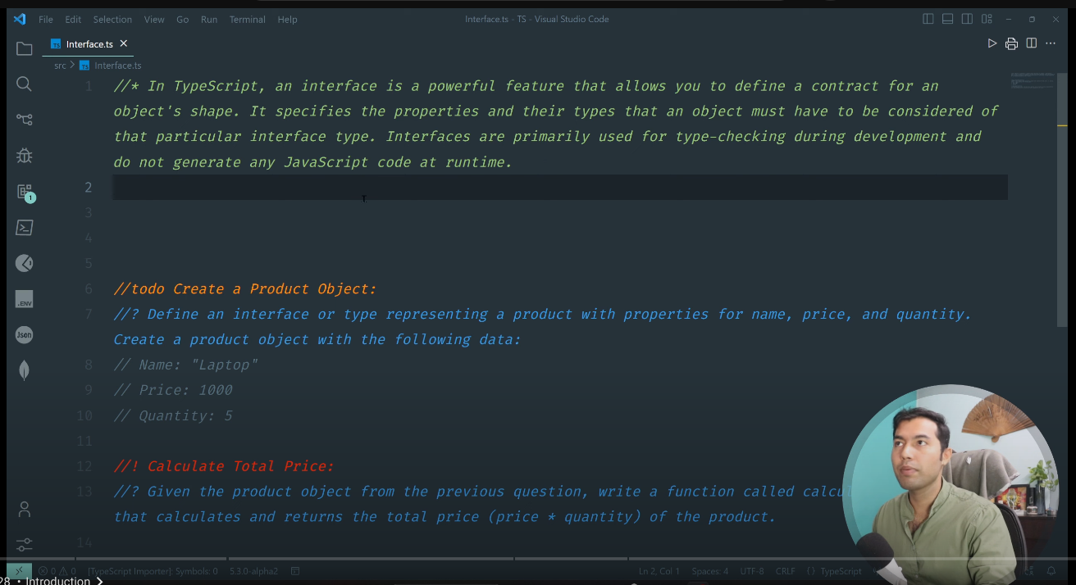

Typescript Gives Error called ==> compilation-error
JavaScript gives Error called ==> Run-time-error

When you Migration .js file to .ts file configure your tsconfig file
- make “strick” : false

when you added all the type in new .ts file then
- make “strick” : true
Const date=new Date();
- //Date() is Class
- // date is Object

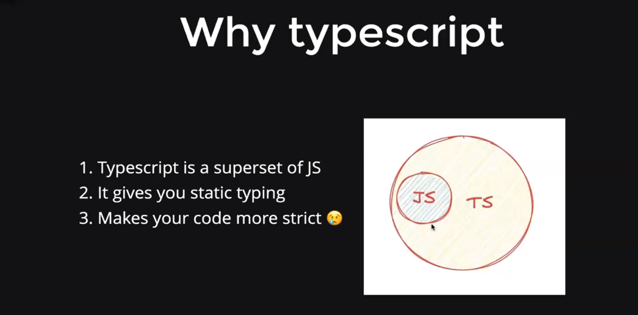
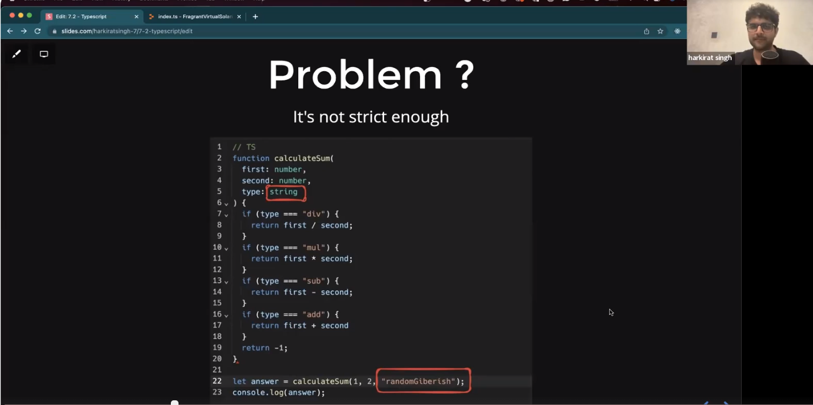
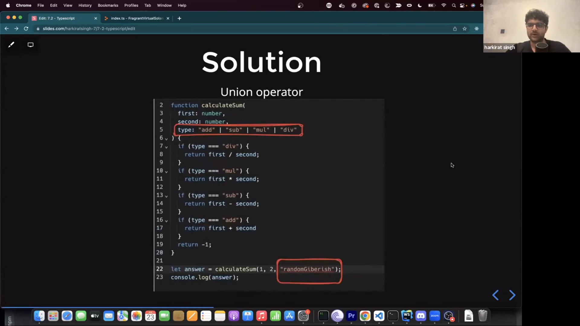
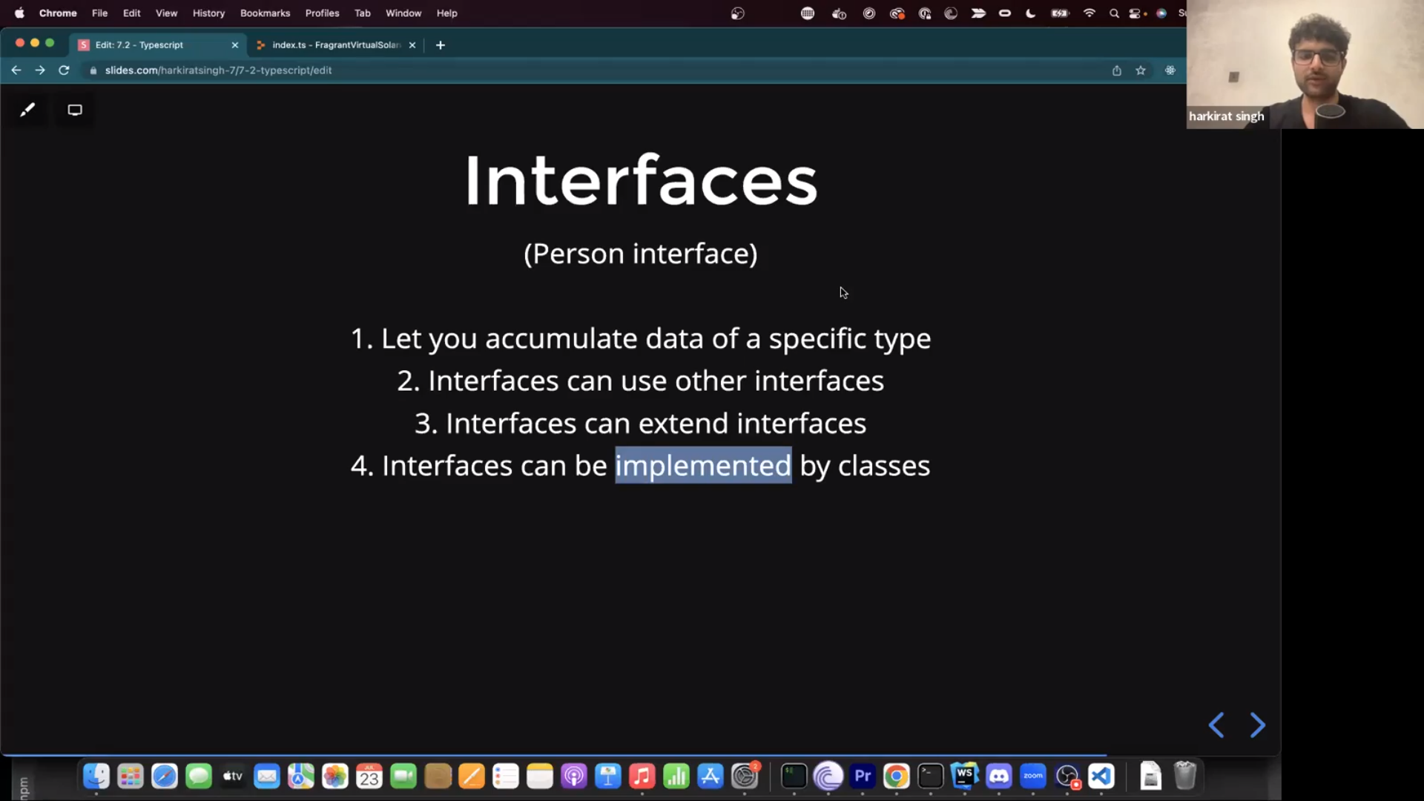
An interface declaration is another way to name an object type:

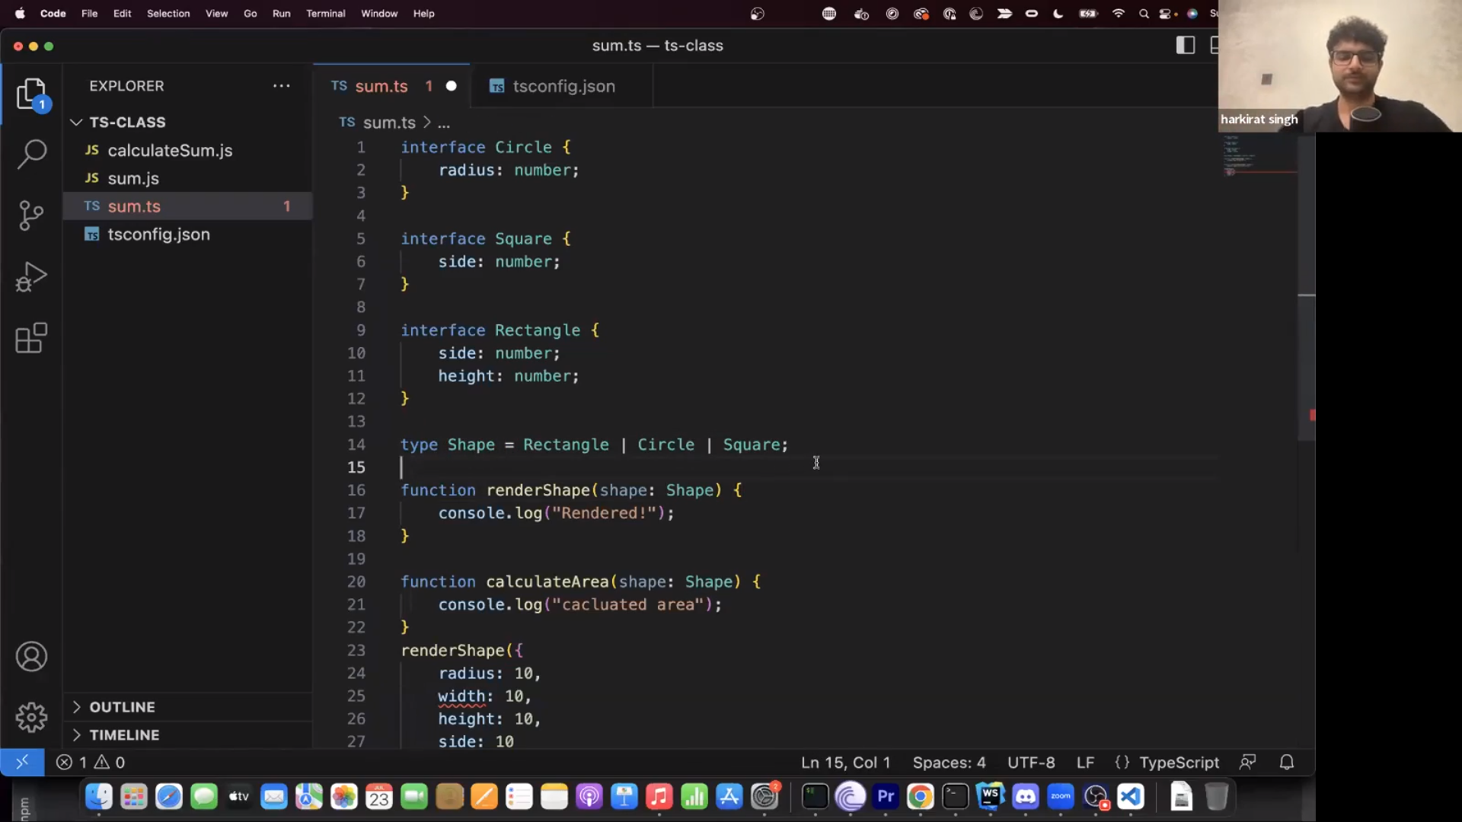

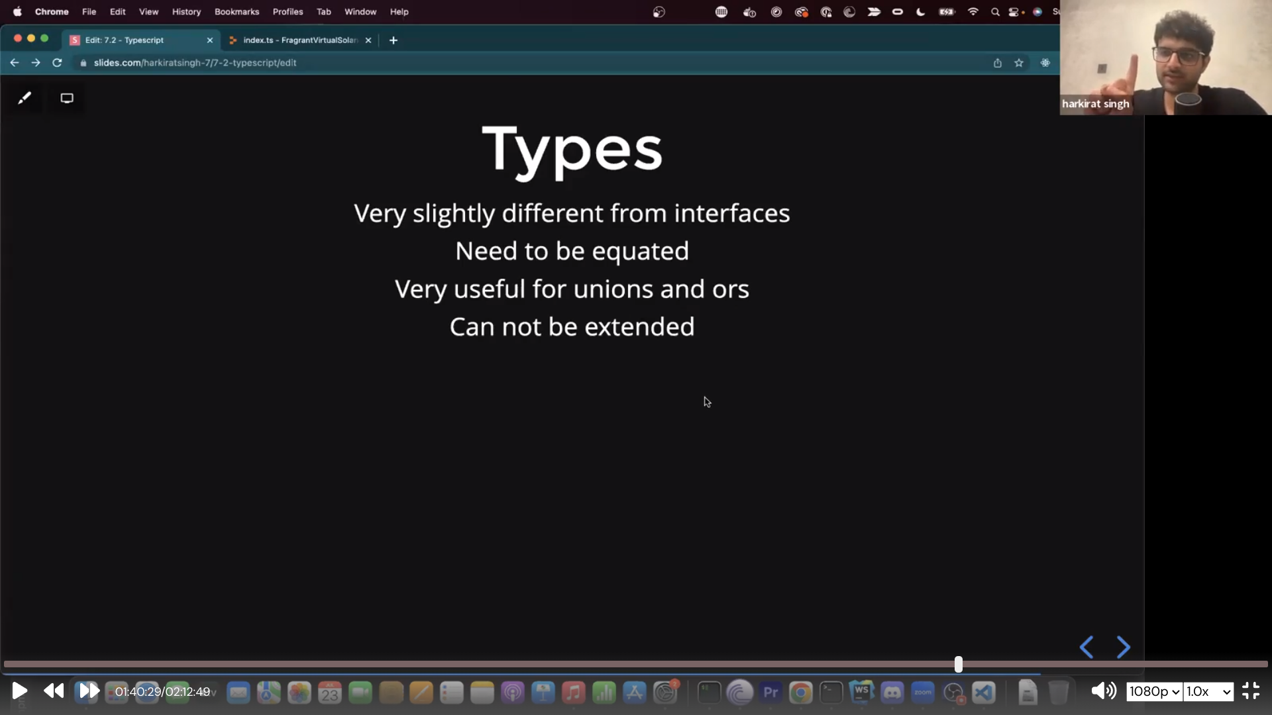
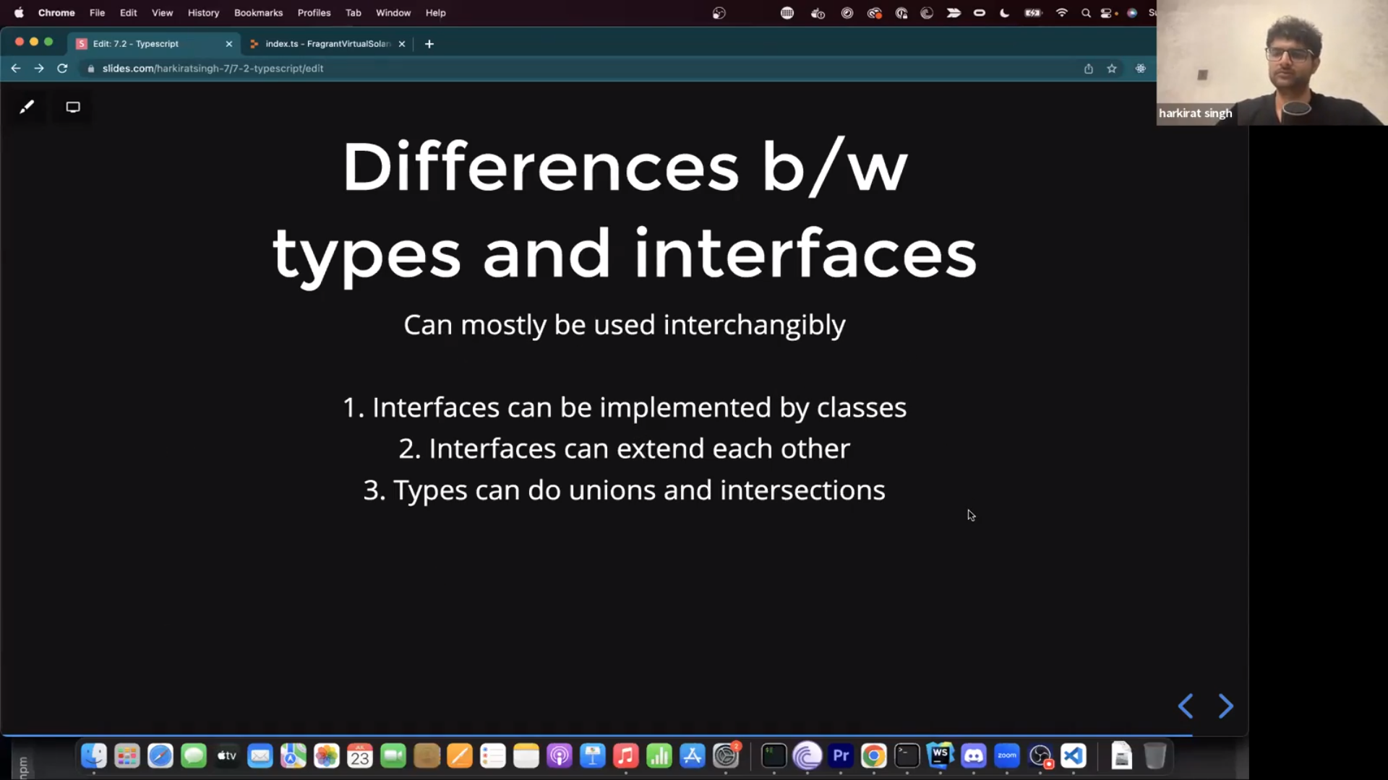

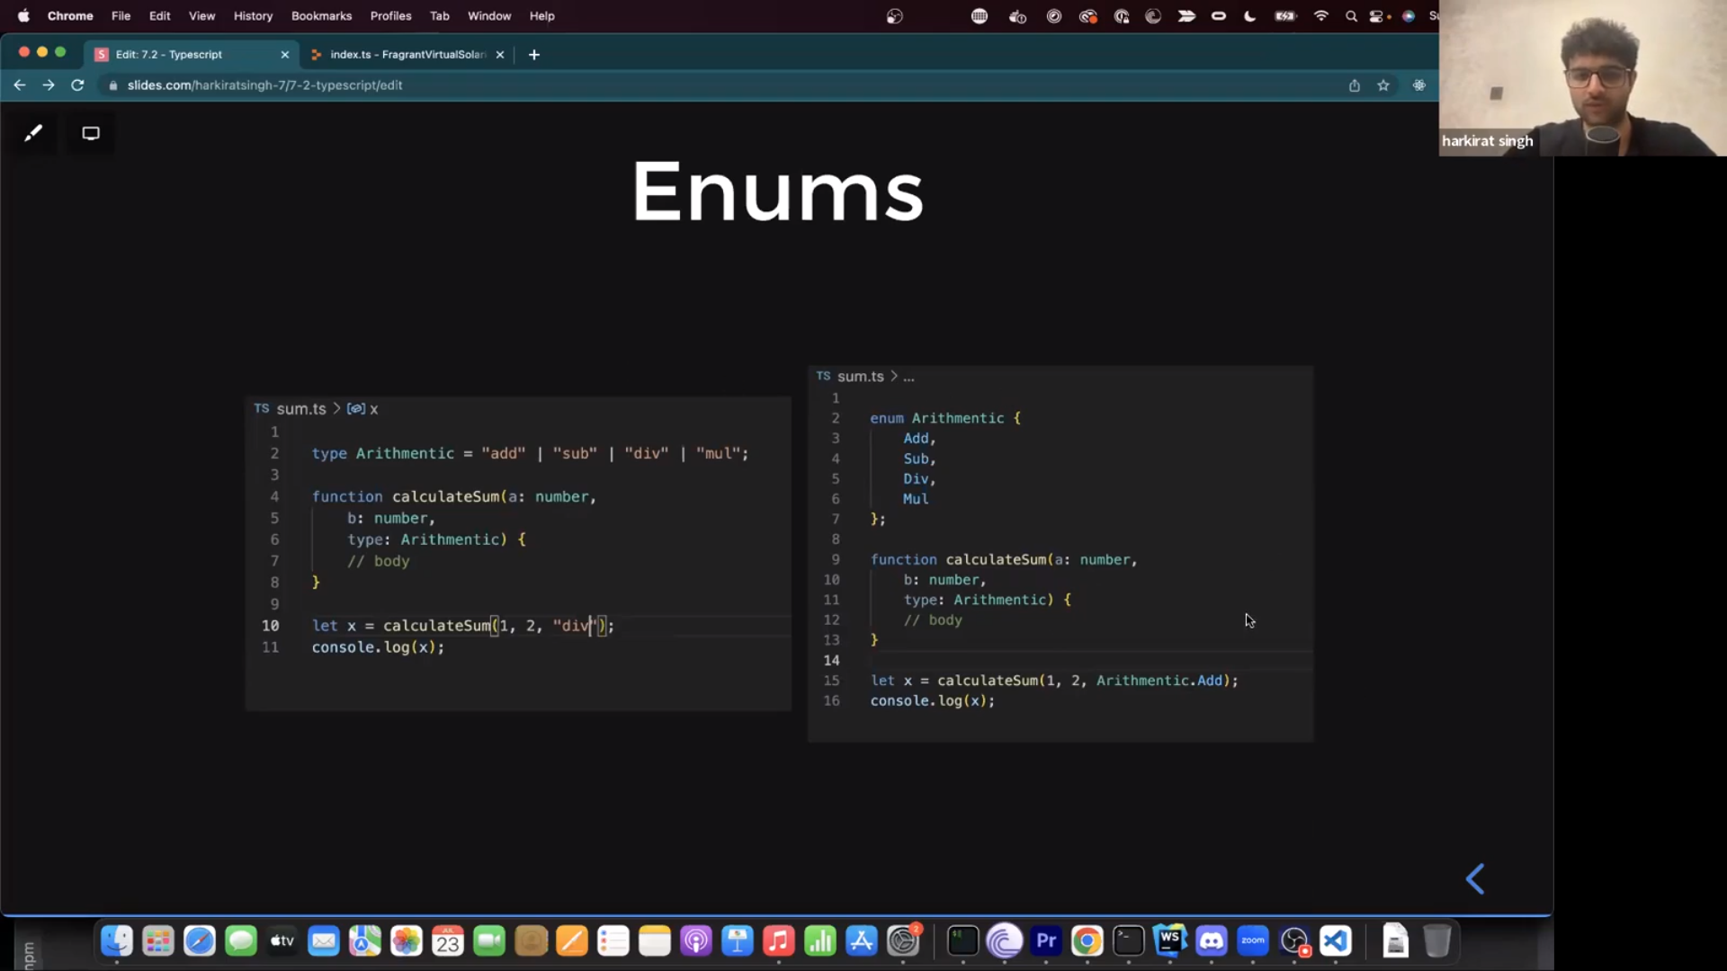

sfgsfafaf

https://youtu.be/splSB6jDjIw --------------> Typscript Challenge

