USER MANUAL
Sales Management System
Orders, field activities and reporting
Version 1.0
September 2026
Beauty Elements Ventures Inc.

Contents
PART 1 — GETTING STARTED
1 About this manual
2 Signing in
3 Finding your way around
4 Choosing your active account
5 What you can see and do
6 The dashboard
7 Controls you will meet everywhere
PART 2 — TRANSACTIONS
8 How an order flows
9 Sales Order List
10 Sales Orders for your account
11 Creating a sales order
12 Uploading several orders at once
13 Sales order templates
14 Invoices
15 Purchase Orders
16 PPU forms
17 Remittances
PART 3 — FIELD ACTIVITIES
18 The monthly cycle
19 Activity Plan
20 Schedules
21 Trips
22 Weekly Productivity Report
PART 4 — REPORTS
23 Sales order reports
24 MCP reports
25 Productivity reports
26 COE reports
PART 5 — SETUP AND ADMINISTRATION
27 How every maintenance screen works
28 Accounts and their addresses
29 Products, brands and prices
30 Geography: regions, areas and classifications
31 Commercial terms
32 The working calendar
33 People and organisation
34 Users and roles
35 Settings and logs
REFERENCE
A Status reference
B Permission reference
C Upload file formats

PART 1

Getting started
What the system is for, how to sign in, and the handful of ideas that everything else depends on.

1 About this manual
The Sales Management System — SMS — is where orders are entered, field work is planned and recorded, and both are reported on.
It sits between the field and the ERP. Sales people raise orders against a customer account; the system prices them, holds them for checking and passes them to SYSPRO. Around that sits the field side: the monthly coverage plan, branch visits, travel claims, weekly reports and the promotional funds that pay for activity in store.
WHO THIS MANUAL IS FOR
Anyone who uses the system. It is written so you can read only the part you need. Part 1 is worth reading once by everybody. After that, go to the chapter for the screen in front of you.
HOW TO READ IT
If you are | Read
A sales representative | Parts 1, 2 and 3
An area or district manager | Parts 1, 3 and 4
Finance | Parts 1 and 2, plus chapters 21 and 31
An administrator | Parts 1 and 5

CONVENTIONS
- A menu path is written like this: Transactions → Sales Orders.
- Button and field names appear exactly as they do on screen: Finalize, PO Number.
- Permission names appear in lower case, as the system stores them: sales order create.
ABOUT THE SCREENSHOTS Every screenshot in this manual is a real screen of the system, filled with made-up data. Company names such as Northpoint Supermart and the people in the examples are invented. Your own screens will show your real accounts and staff.

2 Signing in
Open the system in a browser. You will be asked for your email address and password.
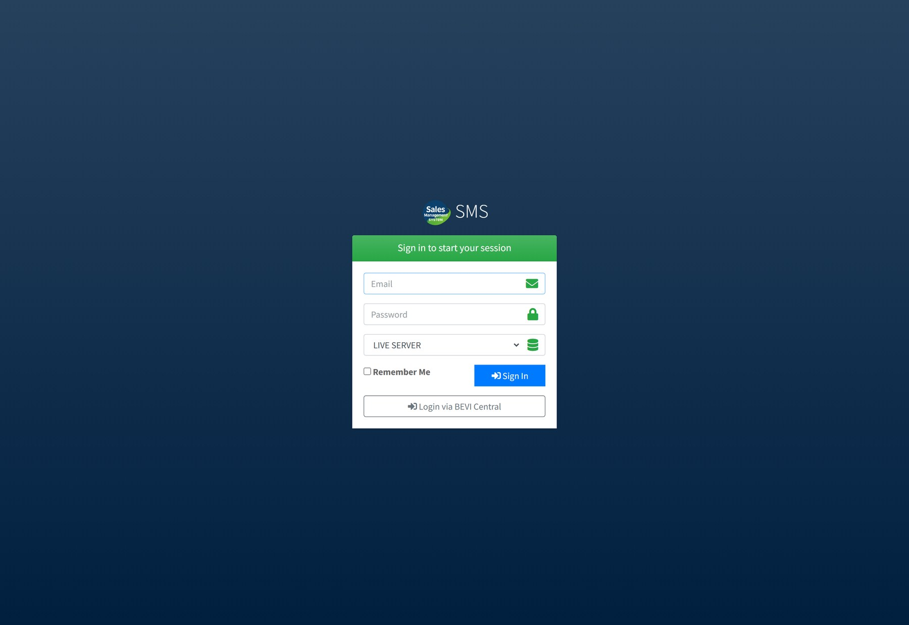
Figure 2.1 The sign-in screen. The Server setting decides which database you work in.
- Type the email address your administrator registered for you.
- Type your password.
- Leave Server on the live setting unless you have been told to use the test system. This choice decides which database everything you do is written to.
- Choose Remember Me if this is your own computer, then select Sign In.
THE SERVER SETTING MATTERS The live and test systems hold separate data. An order entered on the test server never reaches the warehouse. The bar at the top of every page shows which one you are on — check it if something you expected to find is missing.
IF YOU CANNOT SIGN IN
What you see | What to do
These credentials do not match our records | Check the email address for typing errors. If it is right, ask an administrator to reset your password.
You sign in but the menu is nearly empty | Your account has no role yet. Ask an administrator to give you one. See chapter 34.
Your account is not active | An administrator has set your status to inactive. Ask them to re-enable it.

3 Finding your way around
Every screen uses the same frame: a menu down the left, a bar across the top, and the screen itself in the middle.
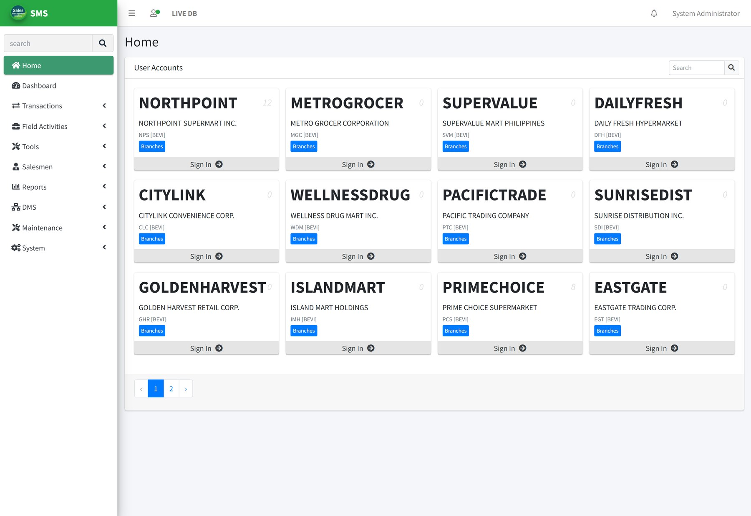
Figure 3.1 The Home screen, showing the parts of the frame that stay the same everywhere.
THE SIDEBAR
Groups every screen you are allowed to open. Selecting a group opens it; selecting it again closes it. The narrow arrow at the top of the page collapses the sidebar to icons when you need the width.
THE TOP BAR
Shows which database you are on, your name, and the account you are currently signed in to. Your name opens Profile and Log Out. The bell shows notifications waiting for you.
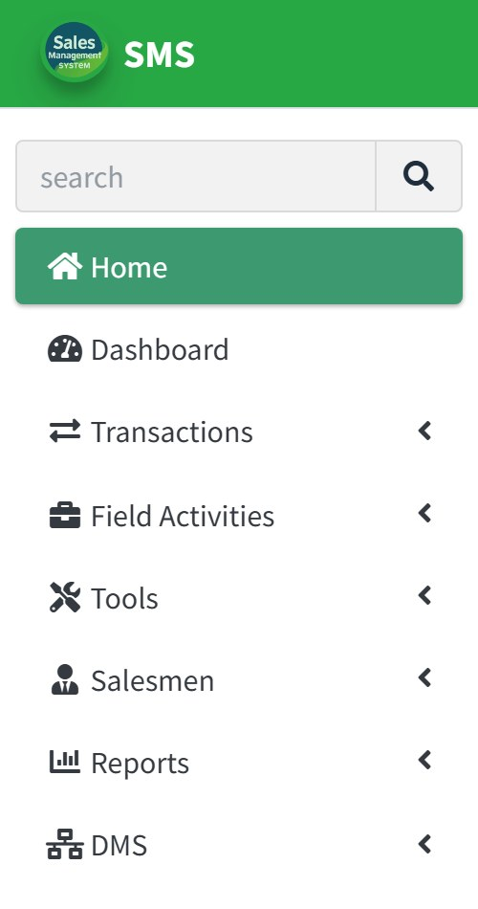
Figure 3.2 The top of the sidebar. You only see the groups your role allows.
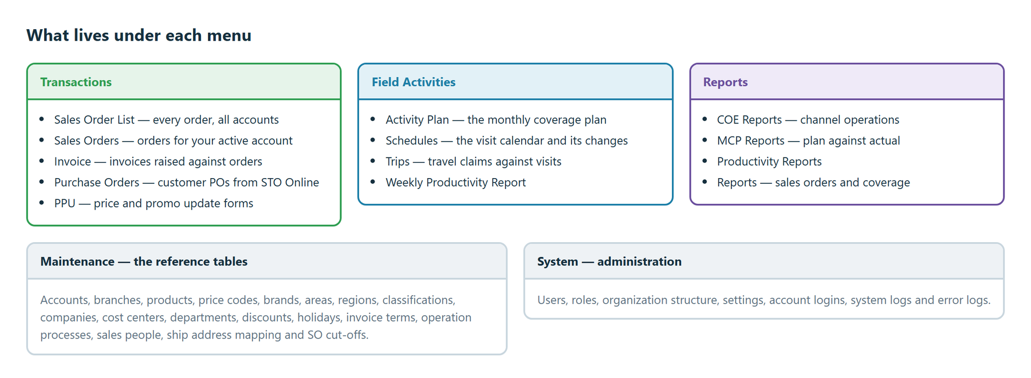
Figure 3.3 What each menu group holds.

4 Choosing your active account
This is the one idea to take away from Part 1. Before you can raise an order, a PPU form or a claim, you must be signed in to a customer account.
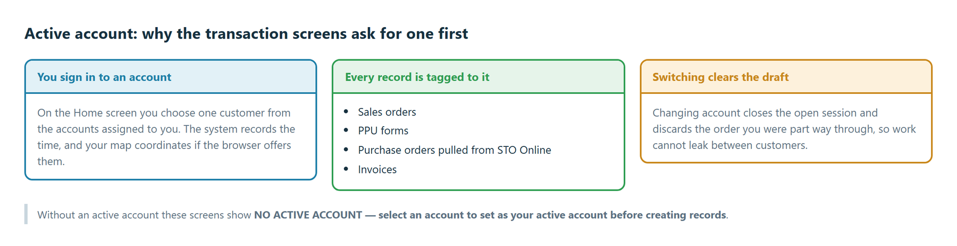
Figure 4.1 The active account tags everything you create.
The Home screen lists the accounts assigned to you, each as a card. The number in the corner of a card is how many orders you have raised for that account.
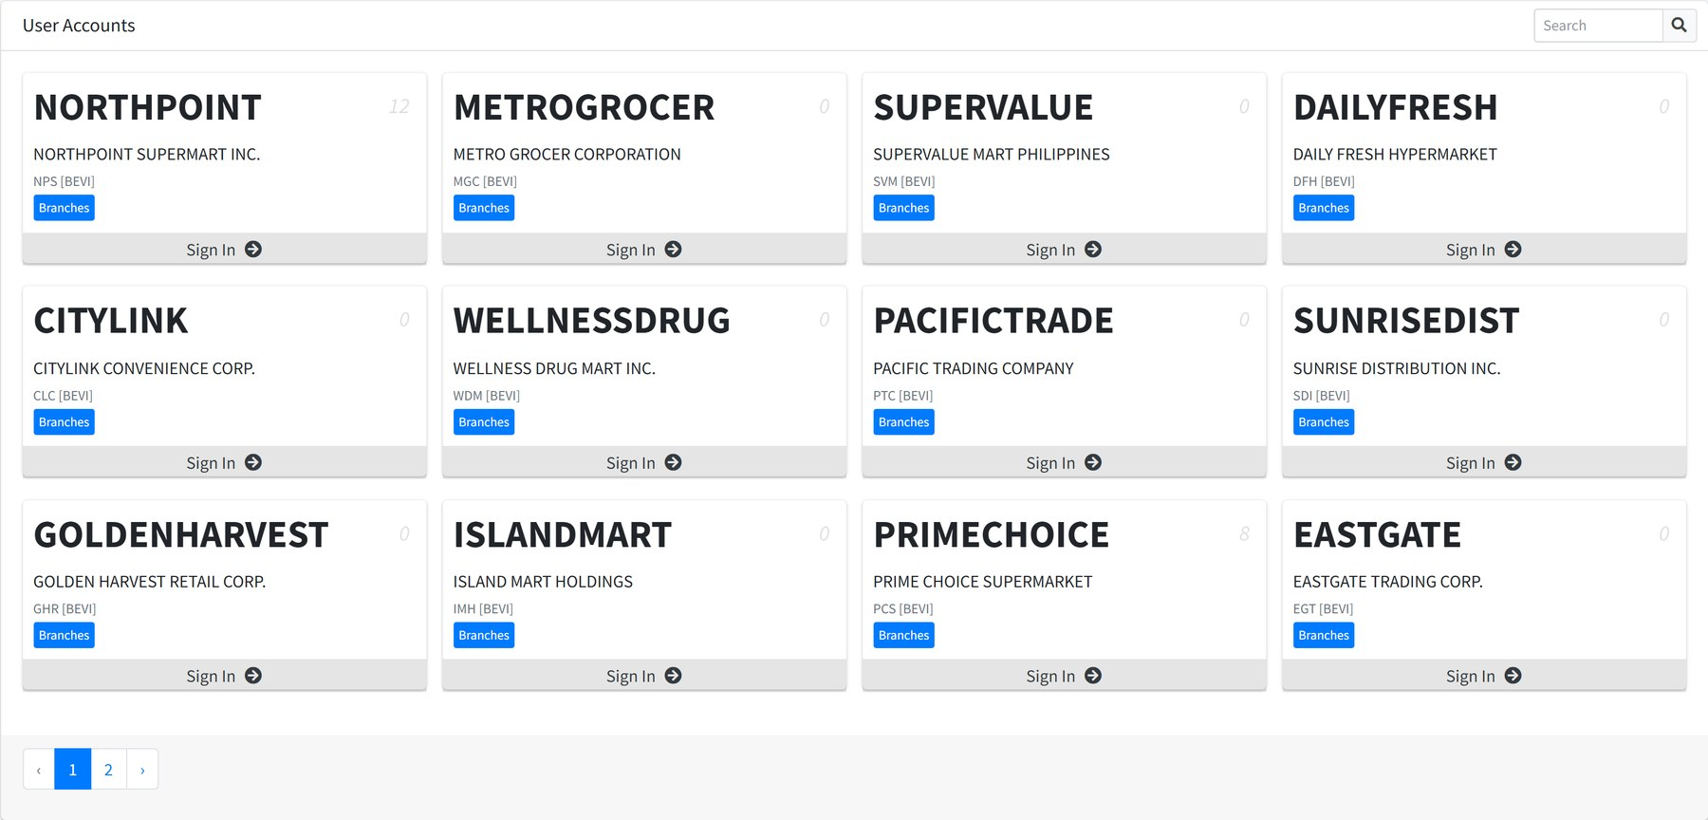
Figure 4.2 The Home screen. Sign In makes that account active; Branches lets you sign in at a particular outlet instead.
- Find the account, using the search box if the list is long.
- Choose Sign In. If the browser asks to share your location, allow it — the visit is recorded with your coordinates.
- The blue bar at the top of the transaction screens now names your active account.
Figure 4.3 The active account banner. Change Account takes you back to the list.
SWITCHING ACCOUNT DISCARDS YOUR DRAFT Changing account closes the session you had open and clears the order you were part way through. Save your work as a draft before you switch.
SIGNING IN AT A BRANCH
Field staff usually sign in at a specific outlet rather than at the account. Choose Branches on the account card, then the branch you are standing in. The system records the time and your location, which is what the coverage reports later read.

5 What you can see and do
The system hides what you are not allowed to use. If a menu entry or a button is missing, it is a permission, not a fault.
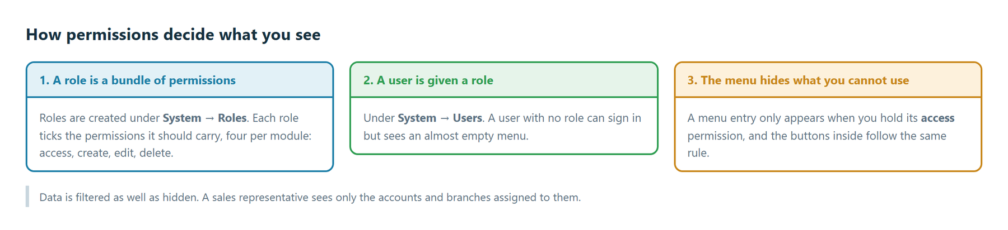
Figure 5.1 Roles carry permissions; users carry a role.
Permissions come in fours for most modules — access, create, edit and delete. account access lets you open the Accounts screen; account create adds the Add button; account edit adds the pencil on each row; account delete adds the bin.
Some permissions are not about a screen but about a step in a workflow, such as mcp approval, war approve or trip finance approver. Those decide whether the approval buttons appear on a record someone else raised.
DATA IS FILTERED TOO Permissions decide which screens you see. Your assignments decide which records are on them. A sales representative opening Accounts sees only the accounts assigned to them, not every account in the business.

6 The dashboard
The dashboard is your reminder list: things waiting for you, and things you have left unfinished.
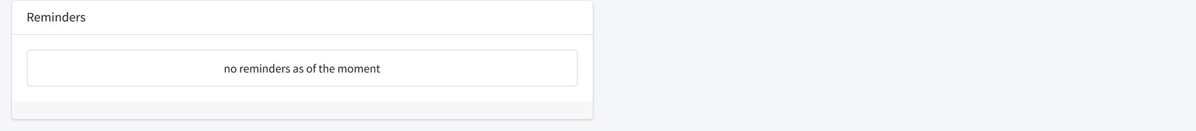
Figure 6.1 The dashboard. Each reminder links to the record it refers to.
Notifications work alongside it. The bell in the top bar counts unread items; Notifications lists them in full, with the module each came from.
Figure 6.2 Notifications, newest first.

7 Controls you will meet everywhere
The same handful of controls appear on nearly every screen. Learn them once.
Control | What it does
Search | Sits at the top right of a list. Filters the table as you type or when you press Enter. It searches the columns on screen.
Filter | Opens a panel of date ranges and drop-downs. Choose your values then select Filter. Clear puts the list back.
Paging | At the foot of a list. Lists show ten rows at a time.
Export | Downloads what is currently on screen as an Excel file, filters included.
Upload | Loads many rows from a spreadsheet instead of typing them. See below.
The eye icon | Opens the record to read it.
The pencil icon | Opens the record to change it.
The bin icon | Deletes the record, after asking you to confirm.

UPLOADING A SPREADSHEET
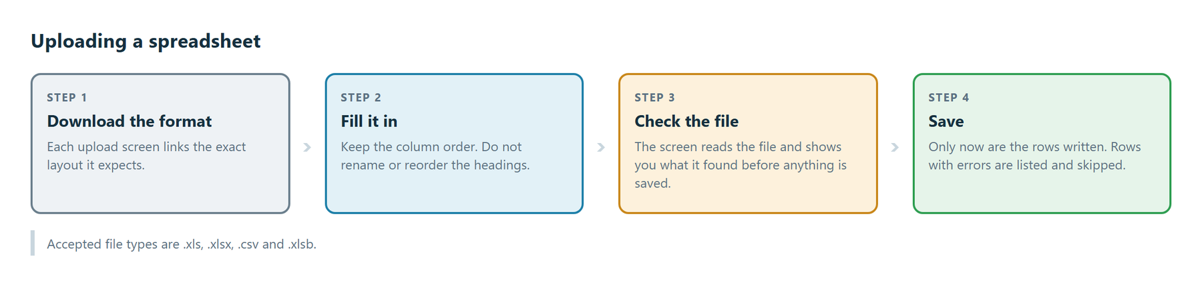
Figure 7.1 Nothing is saved until you have seen what the file contains.
CHECK BEFORE YOU SAVE Every upload screen reads the file and shows you the rows first. Use that step. Rows the system cannot read are listed and skipped rather than silently dropped.
STATUS BADGES
Coloured badges carry the same meaning throughout: grey is a draft, blue or indigo is in progress, amber needs your attention, green is done and red is refused or cancelled. Appendix A lists every status by module.
DRAFT SUBMITTED RETURNED APPROVED REJECTED

PART 2

Transactions
Everything that moves stock or money: orders, the invoices that follow them, the customer's own purchase orders, price updates and remittances.

8 How an order flows
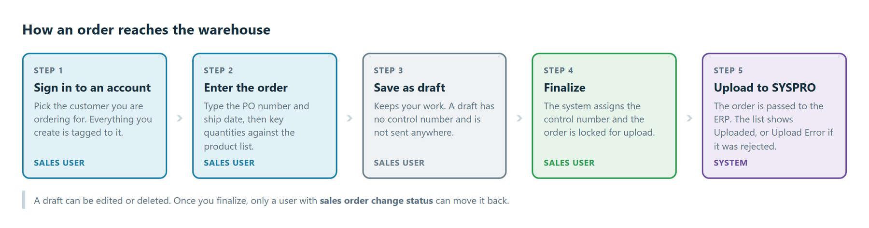
Figure 8.1 From signing in to the ERP.
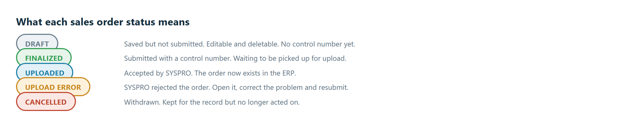
Figure 8.2 The five states an order can be in.
Two screens show orders, and they are not the same:
Screen | Shows | Used by
Sales Order List | Every order, for every account, with the account and the person who raised it | Managers, administrators
Sales Orders | Only the orders for your active account, and the button to raise a new one | Whoever is entering orders

9 Sales Order List
Where: Transactions → Sales Order List Needs: sales order list
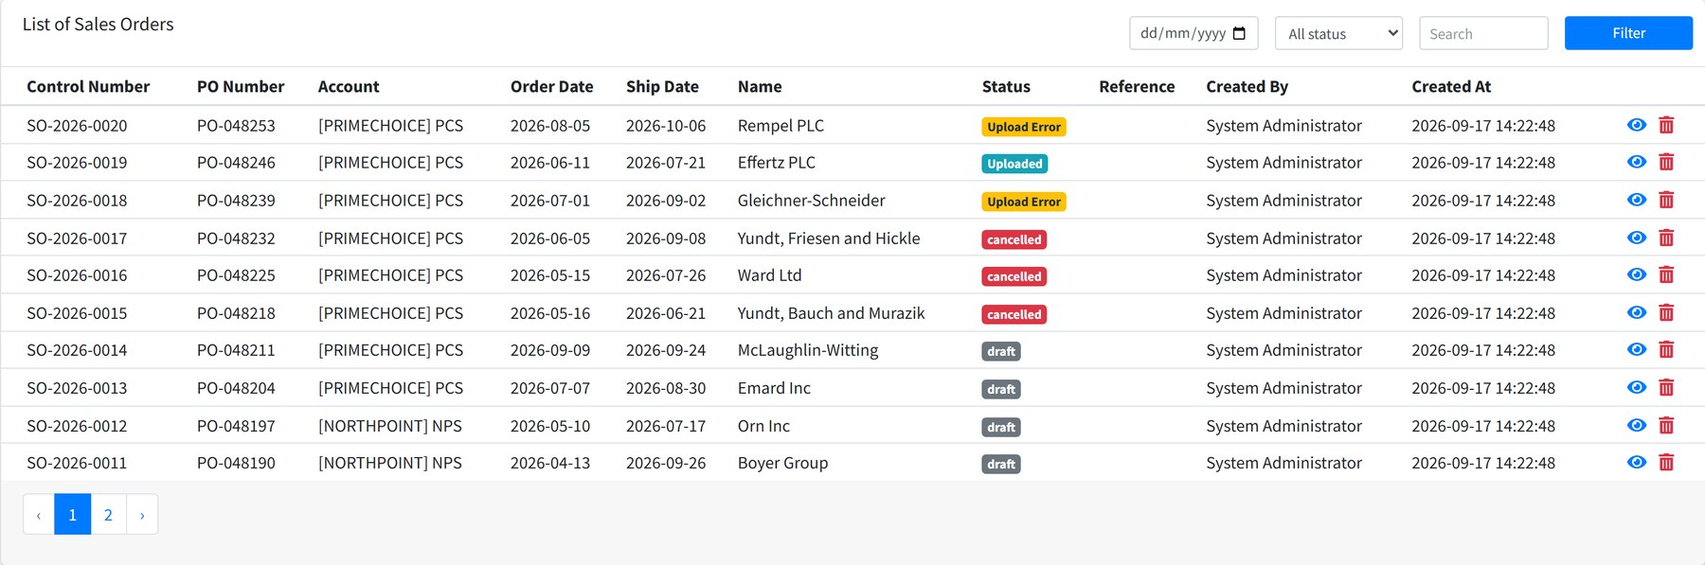
Figure 9.1 Every order in the system, newest control number first.
Column | Meaning
Control Number | The system's own reference, given when the order is finalized.
PO Number | The customer's purchase order number, typed in by whoever raised the order.
Account | The customer the order belongs to.
Order Date | The date the order was placed.
Ship Date | The date the customer expects delivery.
Name | The ship-to name on the order.
Status | Draft, finalized, cancelled, or the upload result.
Reference | Free text carried from the upload, where one was used.
Created By / Created At | Who raised it and when.

FINDING AN ORDER
Figure 9.2 Search across control number, PO number, dates, ship-to name and status; the drop-down narrows by status.
CHANGING A STATUS With sales order change status a control on each row lets you move an order back — for example returning a finalized order to draft so it can be corrected. Without that permission the control is not shown.
THE ORDER DASHBOARD
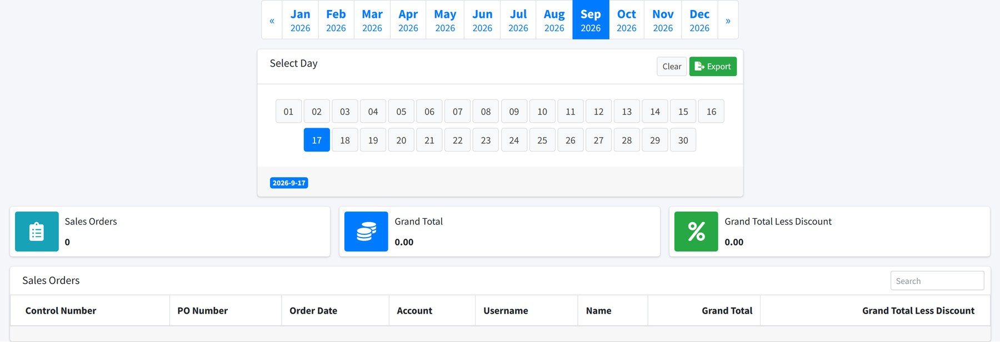
Figure 9.3 Order counts and values by month, reached from Sales Order List.

10 Sales Orders for your account
Where: Transactions → Sales Orders Needs: sales order access Requires an active account
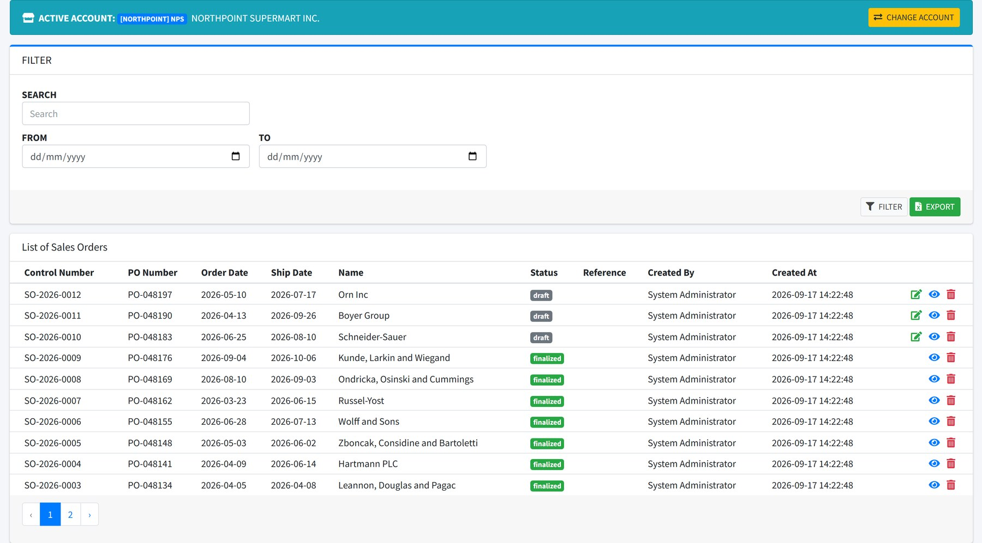
Figure 10.1 The account's own orders, with the buttons to raise a new one.
Three buttons sit at the top:
Button | What it does
Add Sales Order | Opens the order form. Chapter 11.
Upload Multiple SO | Loads several orders from one spreadsheet. Chapter 12.
Purchase Orders | Shows the customer's own POs so you can turn them into orders. Chapter 15.

NO ACTIVE ACCOUNT If this screen shows NO ACTIVE ACCOUNT, choose Select Account and sign in to a customer first. See chapter 4.

11 Creating a sales order
Where: Transactions → Sales Orders → Add Sales Order Needs: sales order create
The screen is in four parts: the header, the ship-to address, the product list, and the running summary on the right.
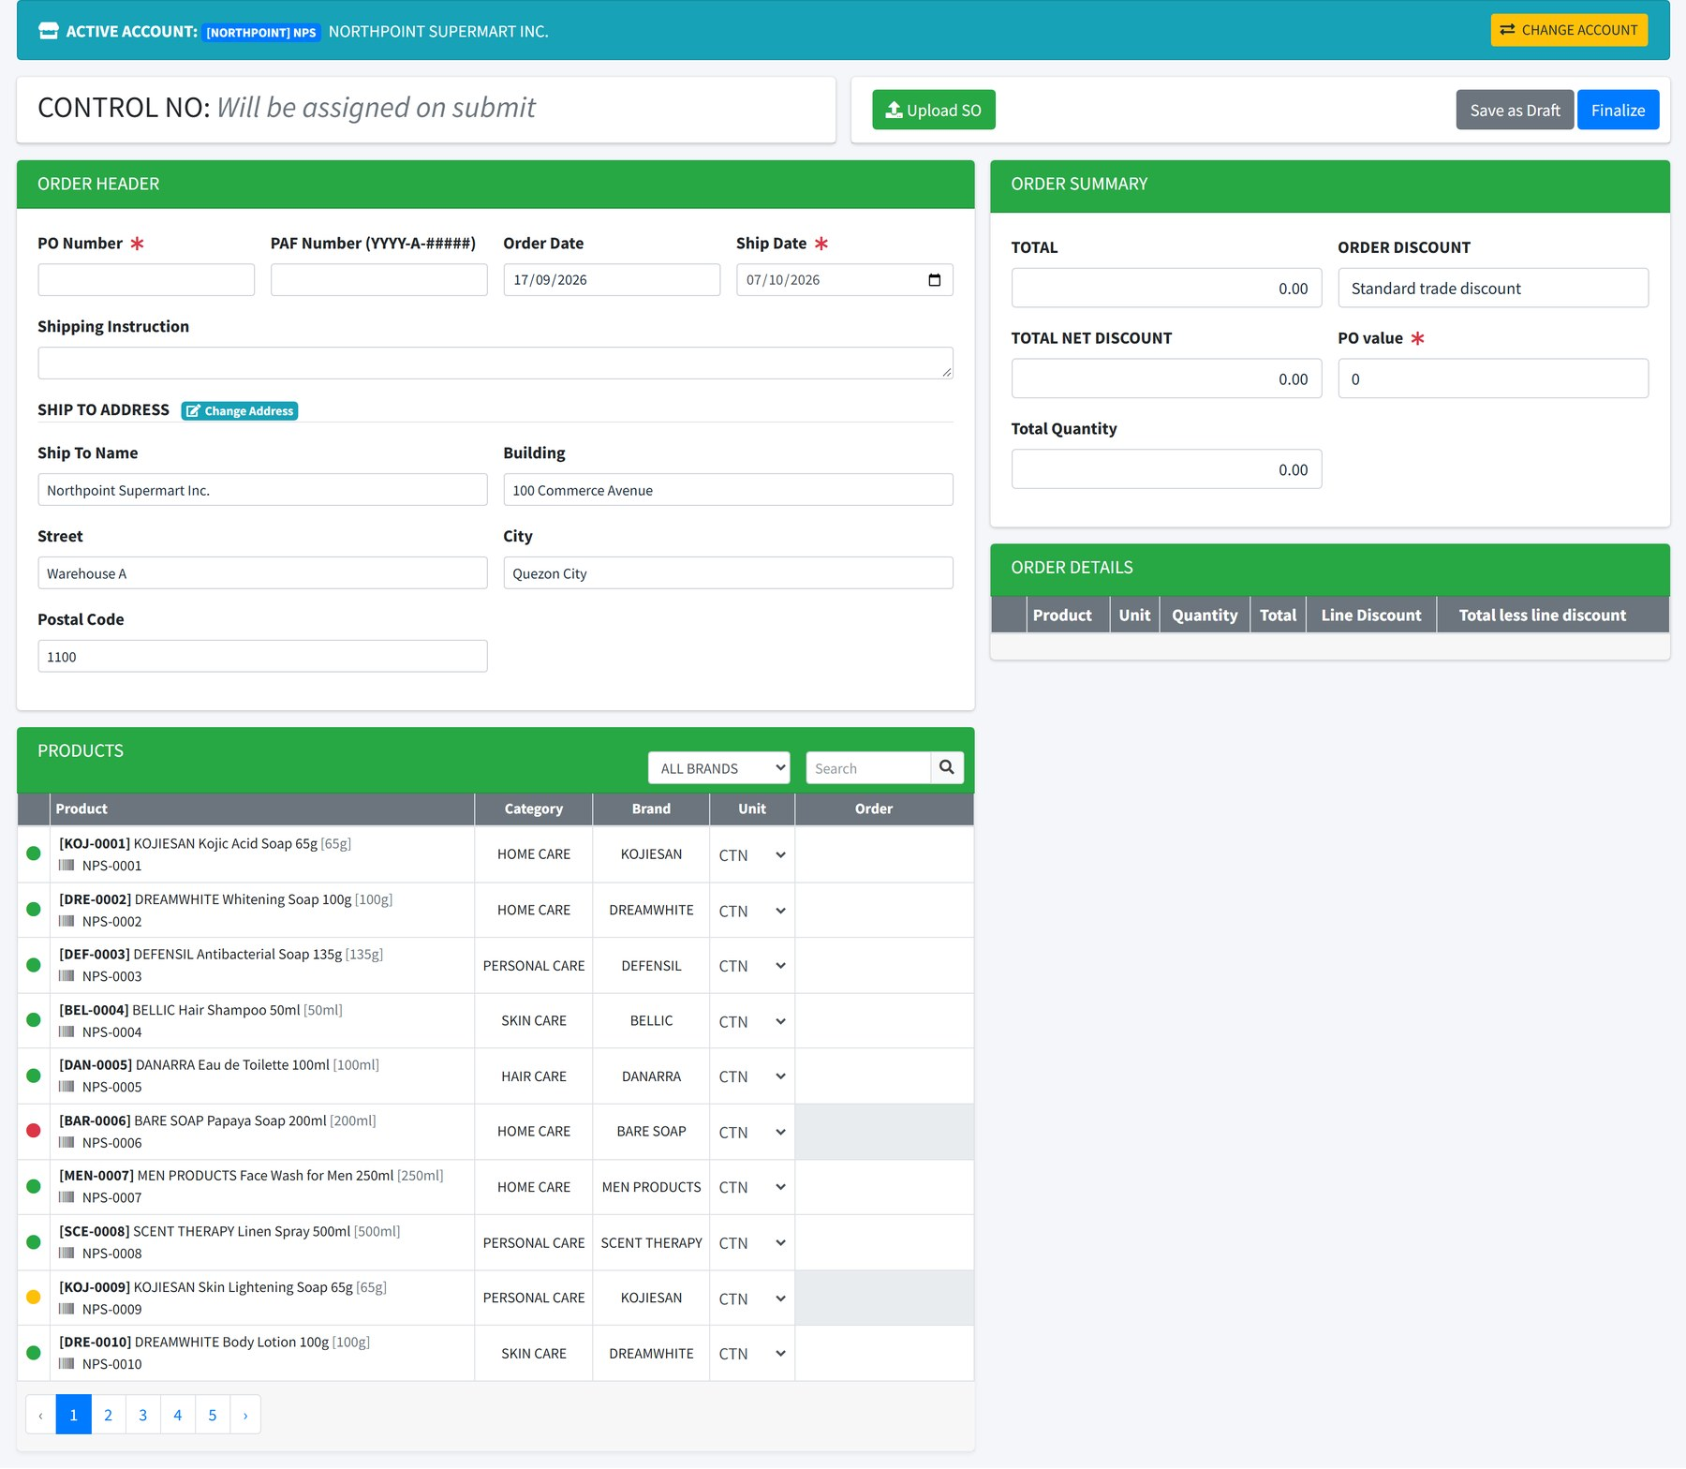
Figure 11.1 The whole order screen before anything is entered.

The order header
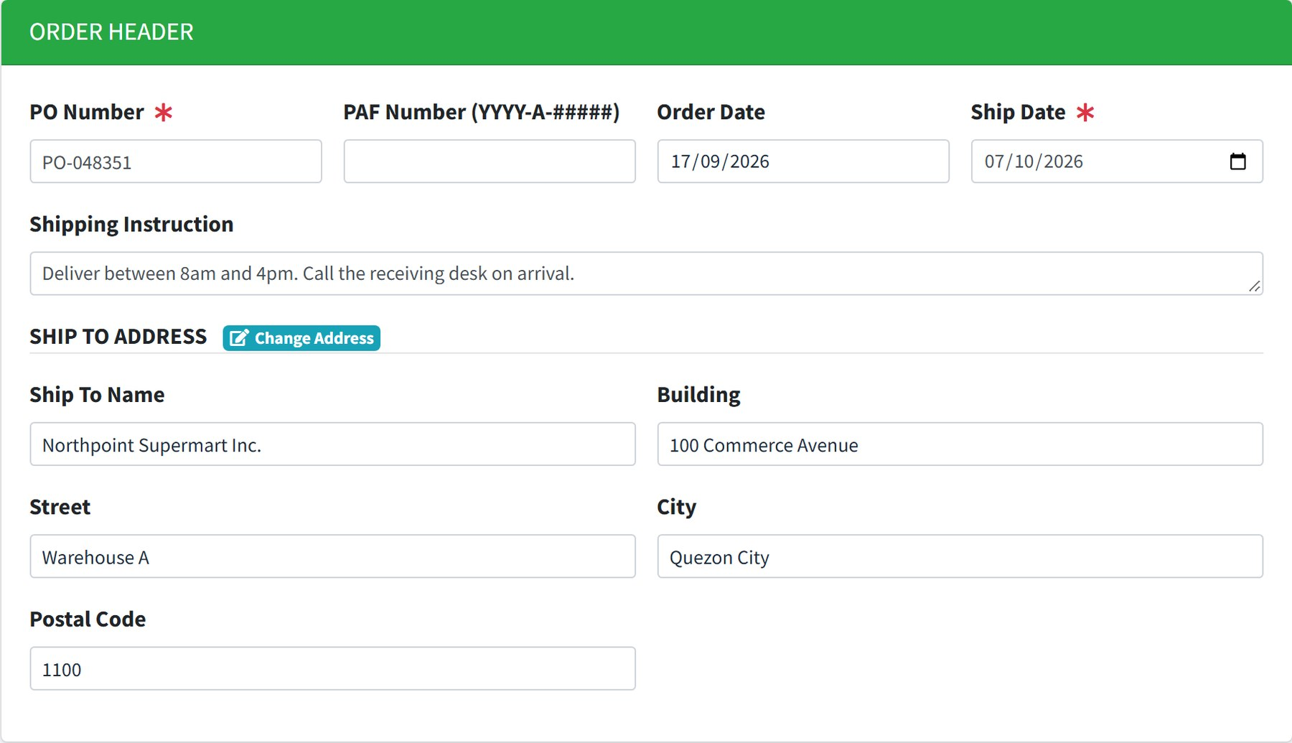
Figure 11.2 The header, with the ship-to address carried from the account.
Field | Required | Notes
PO Number | Yes | The customer's purchase order number.
PAF Number | No | In the form YYYY-A-#####. Quote it when the order is covered by an approved promotional fund. Leave it blank otherwise.
Order Date | Yes | Defaults to today.
Ship Date | Yes | When the customer expects delivery.
Shipping Instruction | No | Free text passed to the warehouse.
Ship To Name, Building, Street, City, Postal Code | Yes | Filled from the account. Change Address swaps in another registered address.

Choosing products
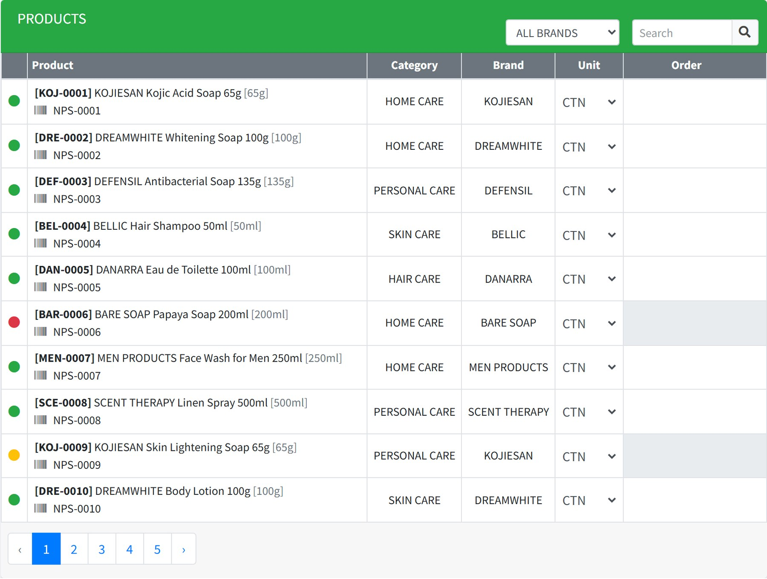
Figure 11.3 The product list. Filter by brand, or search by code, description, category or size.
Each row shows the stock code, the description, the customer's own code for that item if one is registered, the category and brand, the unit of measure, and the box where you type the quantity.
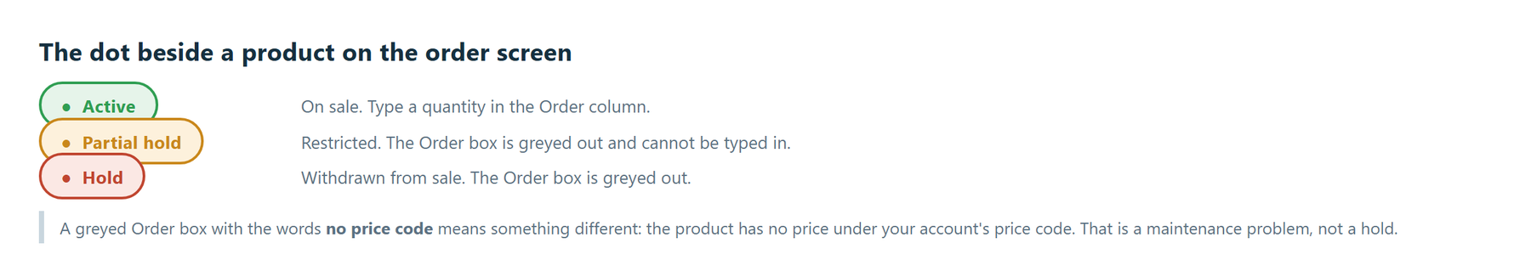
Figure 11.4 The dot in the first column.
- Narrow the list with the brand drop-down or the search box.
- Set the Unit if you are not ordering in the default unit of measure.
- Type the quantity in the Order column and move off the box.
- The summary and the order details on the right update as you go.
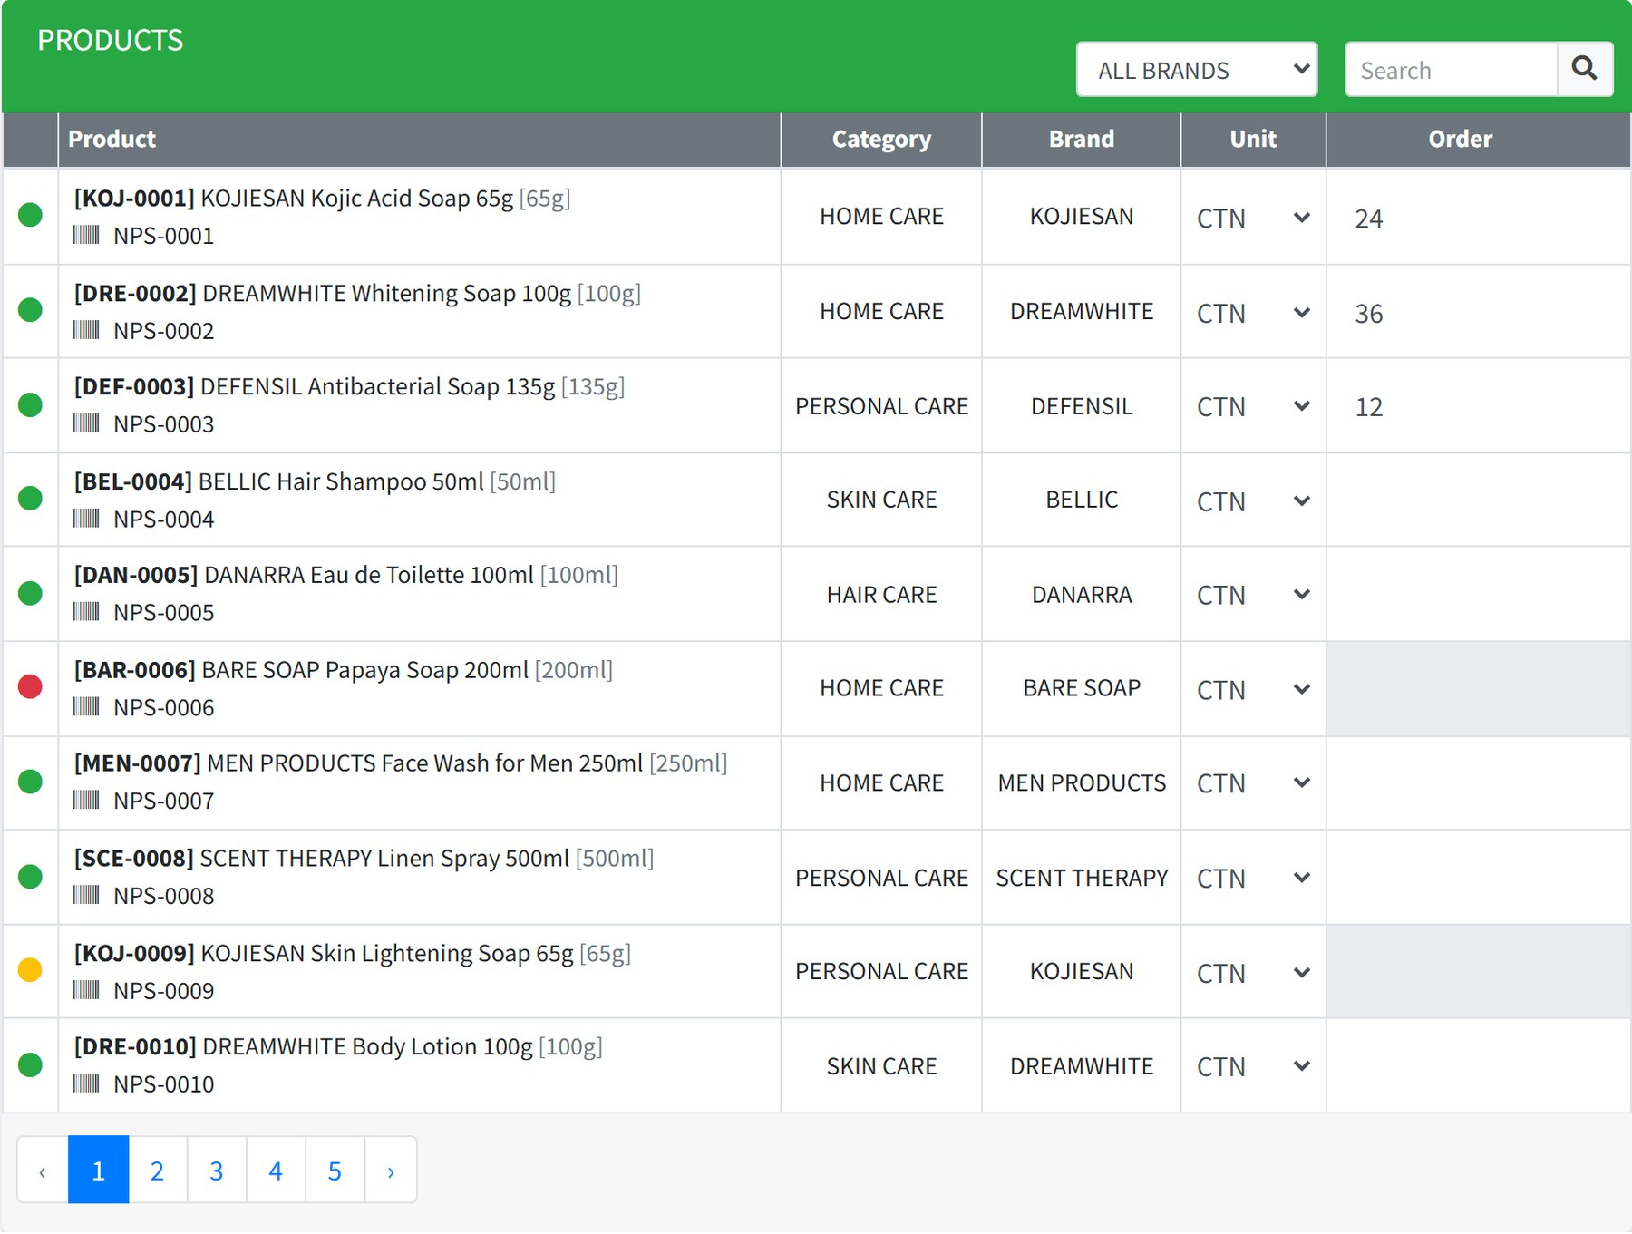
Figure 11.5 Three lines ordered. The paging at the foot keeps your quantities as you move between pages.

Watching the total
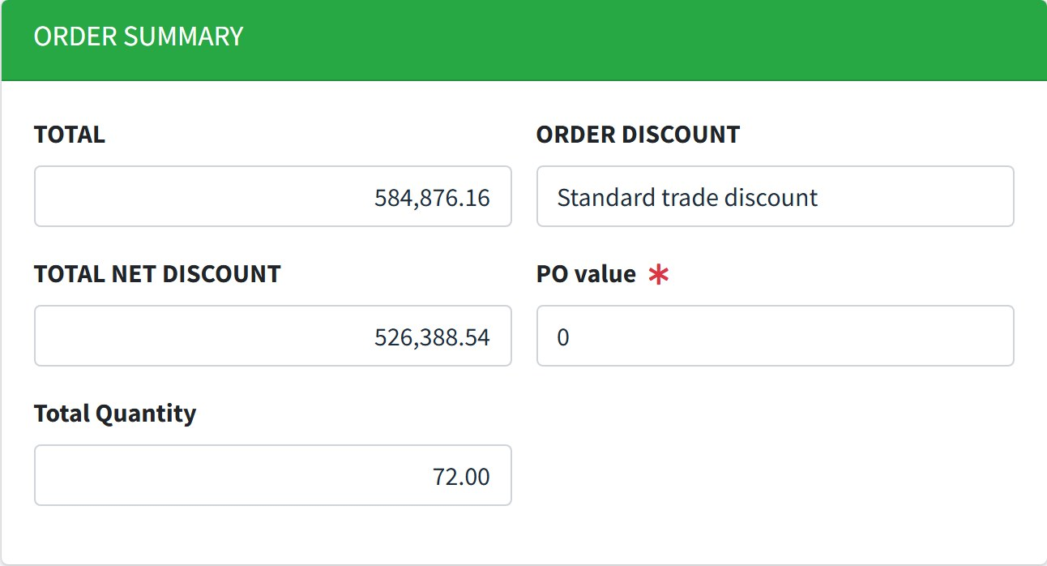
Figure 11.6 The running summary.
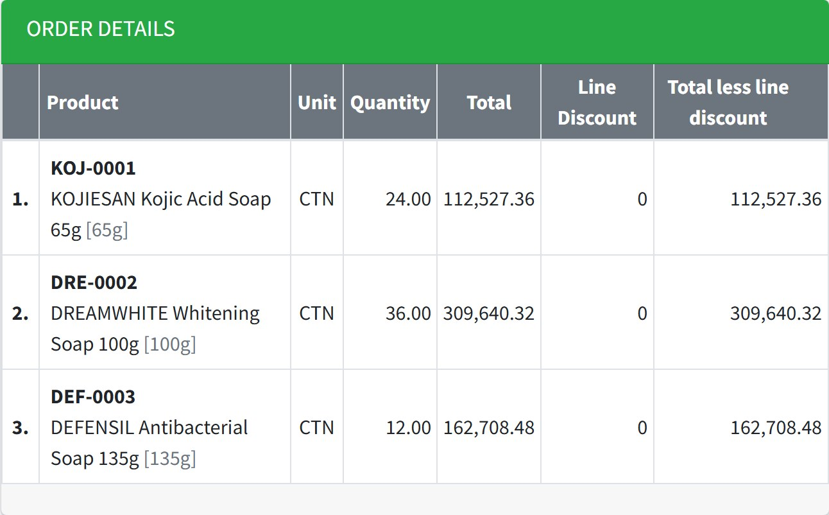
Figure 11.7 The lines you have ordered.
Field | Meaning
Total | The value of the order before discount.
Order Discount | The line discount carried from the account.
Total Net Discount | The value after that discount.
PO value | Required. The value on the customer's own purchase order, for checking against the total.
Total Quantity | Units ordered across all lines.

Saving and finalizing
Button | What happens
Save as Draft | Keeps the order without submitting it. No control number is given. You can come back, change it or delete it.
Finalize | Submits the order. The control number is assigned and the order is locked ready for upload.
Upload SO | Fills the lines from a spreadsheet instead of typing them. Chapter 12.

SAVE EARLY ON A LONG ORDER Once you have keyed more than five lines the screen prompts you to save. Take the prompt — a draft can be reopened, an abandoned screen cannot.
WATCH THE CUT-OFF If a cut-off period is running, a notice appears at the top of the order screens. Orders entered inside it are processed in the following month. See chapter 31.

Reading an order back
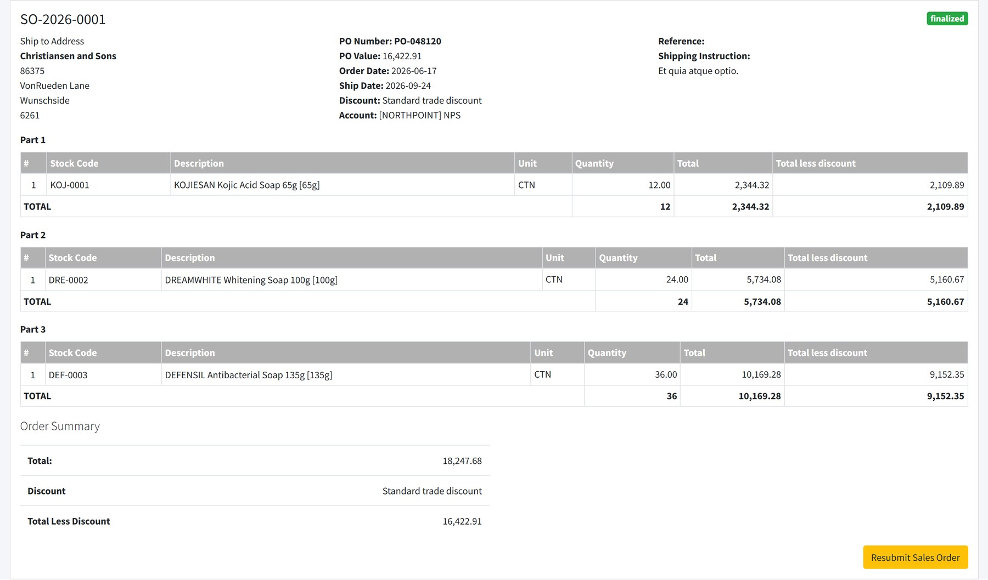
Figure 11.8 A finalized order, with its header, lines and totals.

12 Uploading several orders at once
Where: Transactions → Sales Orders → Upload Multiple SO
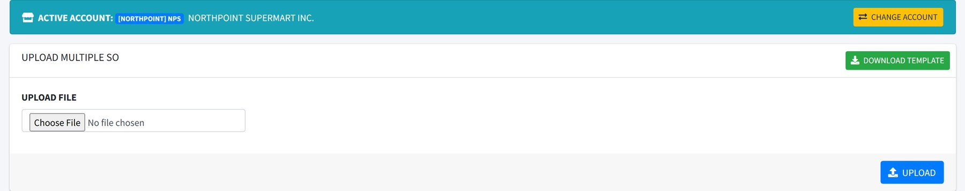
Figure 12.1 One spreadsheet, many orders.
- Download SMS Sales Order Upload Format and fill it in, one block of rows per order.
- Choose the file and select Check.
- Read the summary. Each order it found is listed with its lines and total.
- Select Save to create the orders.
CODES MUST ALREADY EXIST Stock codes must match products in the system, and the ship-to must match a registered address. Rows that do not match are reported and skipped.

13 Sales order templates
Where: Tools → SO Templates Needs: so template access
Some customers send their orders in their own layout. A template records how to read one of those files: which row the data starts on, and which column holds each field.
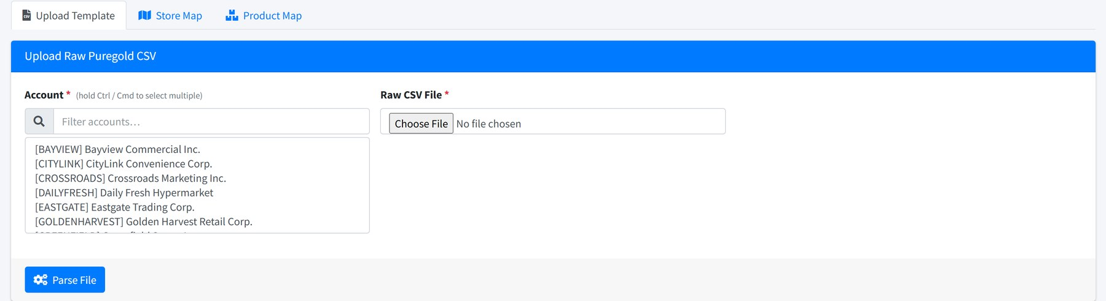
Figure 13.1 Converting a customer's own file into orders the system can read.

14 Invoices
Where: Transactions → Invoice Needs: invoice access
Invoices are raised in the ERP and shown here for reference. This screen is read-only: you look invoices up, you do not create them.
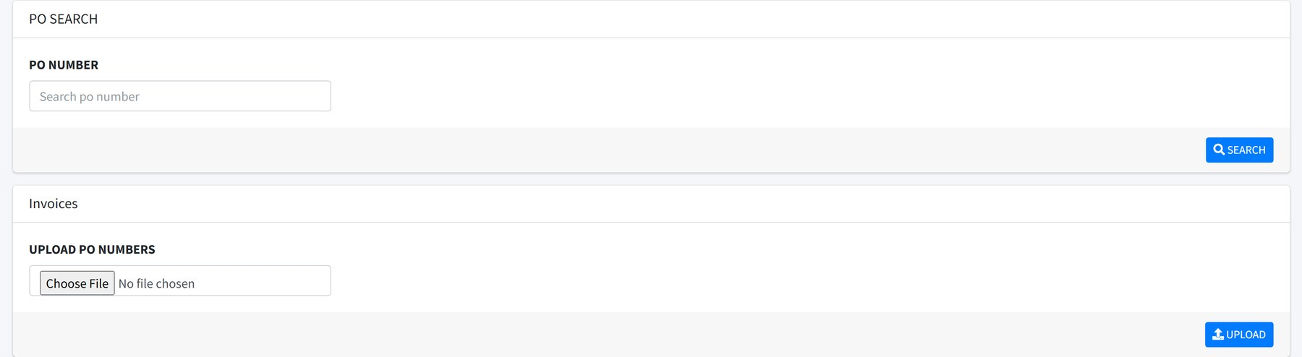
Figure 14.1 Invoices, with the order and PO they came from.
Column | Meaning
Company | The selling entity, BEVI or BEVA.
Account Code | The customer invoiced.
Invoice | The invoice number.
Sales Order | The control number of the order it covers.
PO Number | The customer's purchase order number.
Invoice Date | The date it was raised.

15 Purchase Orders
Where: Transactions → Purchase Orders Needs: purchase order access Requires an active account
These are the customer's own purchase orders, sent to us through STO Online. Rather than retyping one, you can turn it straight into a sales order.
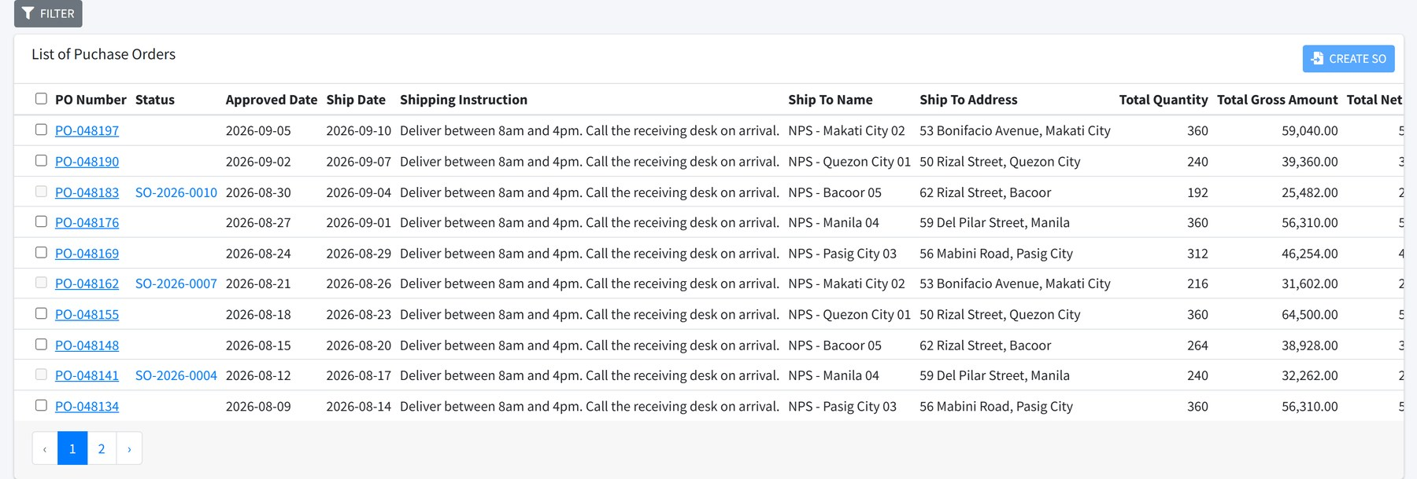
Figure 15.1 Purchase orders waiting to be converted.
Column | Meaning
PO Number | The customer's own reference.
Status | Blank until the PO has been converted. Once it has, this shows the control number of the sales order raised from it, and links to it.
Approved Date | When the customer approved the PO.
Ship Date | When they want it.
Ship To Name / Address | Where it goes.
Total Quantity | Units across all lines.
Total Gross / Net Amount | Value before and after discount.

TURNING A PURCHASE ORDER INTO A SALES ORDER
- Tick the purchase orders you want to convert. The tick box in the heading selects them all.
- Select Create SO.
- The system matches each PO line to a product and the ship-to to a registered address, and opens the order screen with the lines already filled in.
- Check the result, then Finalize as you would any other order.
MATCHING CAN FAIL If the customer's item code is not registered against a product, or the ship-to name does not match a registered address, that line cannot be matched. Set up the mapping first — see chapters 28 and 29.
The Filters panel narrows the list by approved date, ship date, and whether a PO has been converted yet.

16 PPU forms
Where: Transactions → PPU Needs: ppu form access Requires an active account
A PPU form — price and promo update — records a change to what a customer is charged for a list of items.
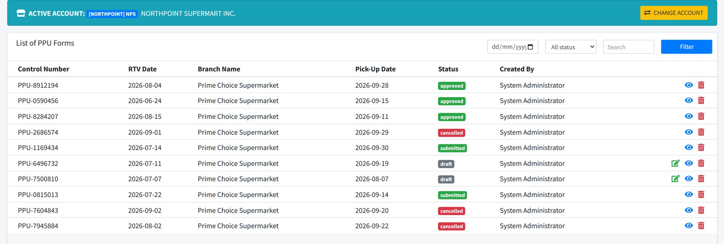
Figure 16.1 PPU forms for the active account.
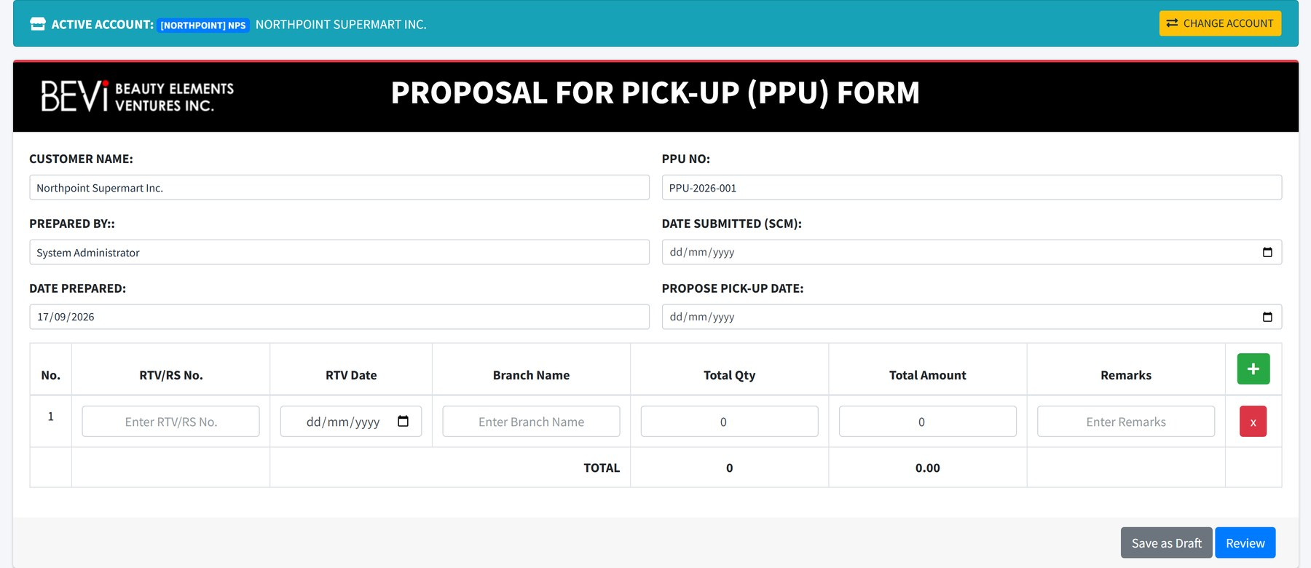
Figure 16.2 Creating a PPU form. Products are chosen the same way as on an order.
PPU forms follow the same draft-then-submit pattern as orders, and can also be loaded in bulk from a spreadsheet using the SMS PPU upload Format.
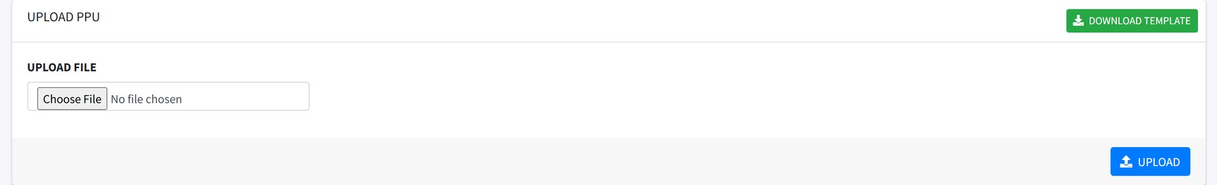
Figure 16.3 Bulk PPU upload.

17 Remittances
Where: Transactions → Remittance Needs: remittance access
Customers send a remittance advice listing what they have paid and against which invoices. This screen reads that file.
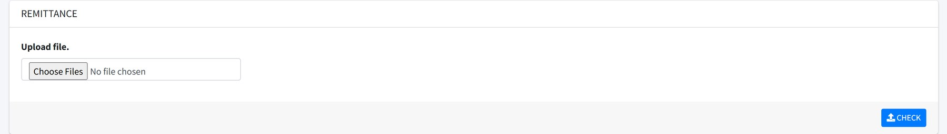
Figure 17.1 Remittance upload. Several files can be checked at once.
- Choose one or more files. Accepted types are .xls, .xlsx, .csv and .xlsb.
- Select Check. Each file is read and shown as a header and a table of lines.
- Read the lines — transaction type, reference, invoice number, amounts, EWT and VAT.
- Select Save to record the remittance.
LAYOUTS ARE PER CUSTOMER How a remittance file is read depends on the layout registered for that customer. If a file will not read, ask an administrator to check that layout before assuming the file is wrong.

PART 3

Field activities
Planning the month, recording what actually happened, and claiming the travel.

18 The monthly cycle
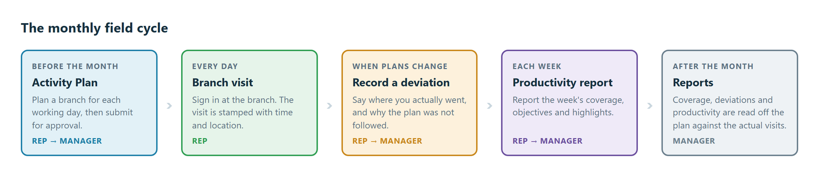
Figure 18.1 Plan, visit, adjust, report.
The plan comes first and everything else is measured against it. Coverage reports compare the branches you planned to visit with the branches you actually signed in at. A visit you made but did not plan is a deviation, and recording it is what keeps the coverage figures right.
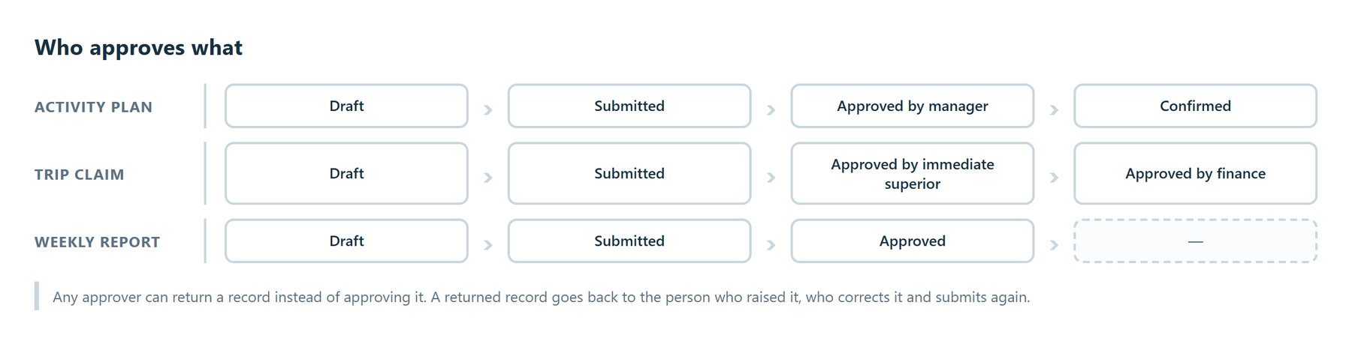
Figure 18.2 The approval route for each kind of record.

19 Activity Plan
Where: Field Activities → Activity Plan Needs: mcp access, mcp create, mcp approval
The Activity Plan — also called the MCP, the monthly coverage plan — sets out which branch you will visit on each working day of a month.
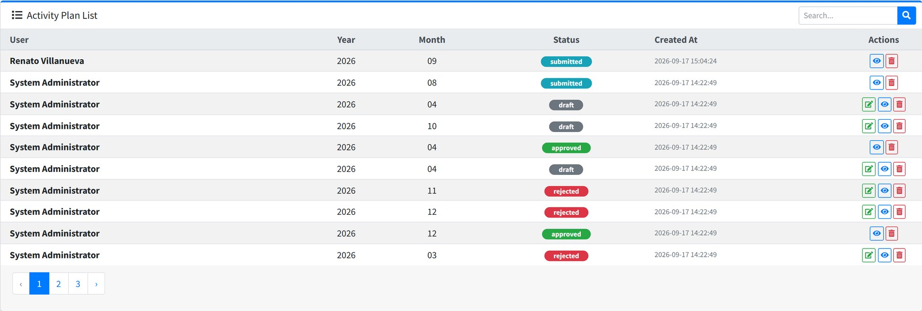
Figure 19.1 Plans by user, year and month.

Creating a plan
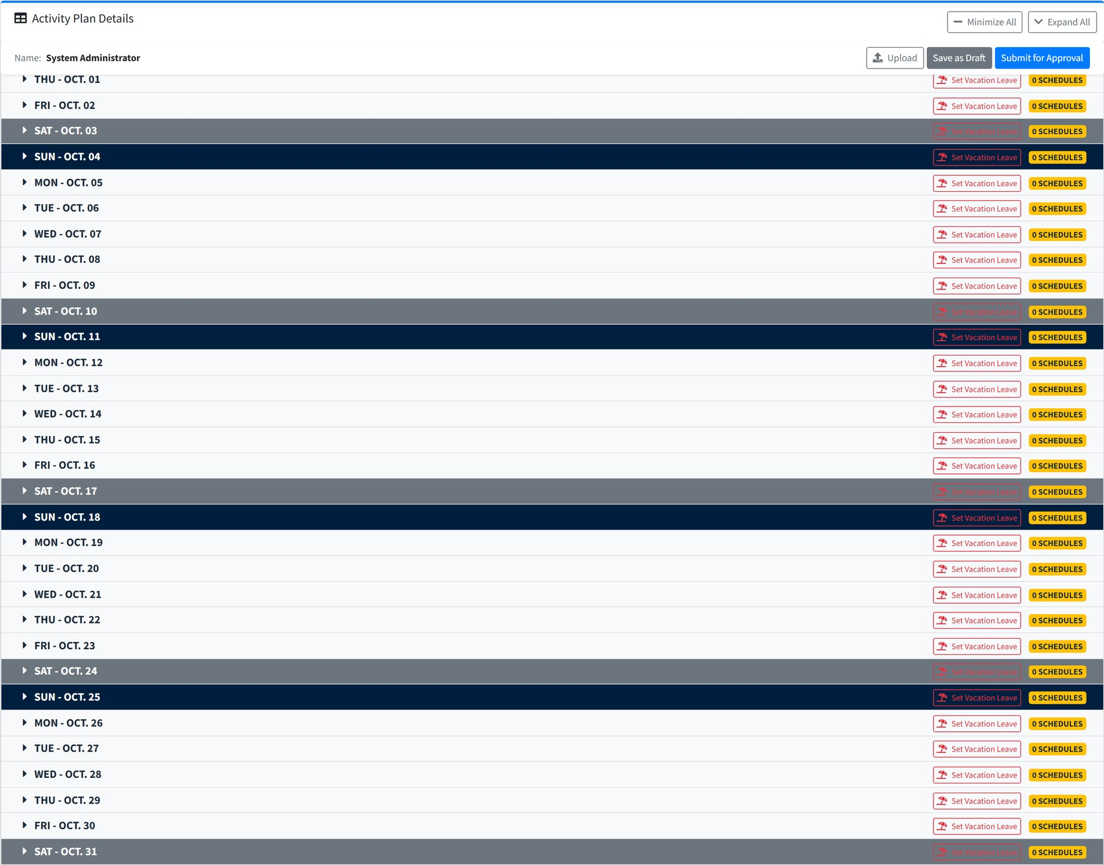
Figure 19.2 Start with the month, the year and your objectives.
- Choose the Month and Year the plan covers.
- Write your Objectives for the month — what you intend the visits to achieve.
- Work down the day list, filling in the days you will be working.
Figure 19.3 One row per day. Saturdays are shaded grey and Sundays dark. The badge on the right counts the visits planned for that day.
Select a day to open it, then add the visits for that day:
Field | What to enter
Location | Where you will be.
Account | The customer. Only accounts assigned to you appear.
Branch | The outlet, from the branches of that account.
Purpose | What the visit is for.
Work With | Who is joining you — a merchandiser, your manager, or nobody.
Trip | Add a travel claim for the journey. See chapter 21.

DAYS YOU ARE NOT WORKING
Set Vacation Leave on a day marks it as leave rather than leaving it blank, so the day is not counted against your coverage. Add a remark saying what the leave is for.
FILLING THE PLAN FASTER
- Upload loads the whole month from a spreadsheet — the SMS Activity Plan Upload Format.
- Expand All and Minimize All open or close every day at once.

Submitting and approving
Status | Meaning
DRAFT | Yours. Nobody else sees it.
SUBMITTED | Waiting for your manager.
RETURNED | Sent back for changes.
APPROVED | Agreed by your manager.
CONFIRMED | Final. The plan the reports measure against.
REJECTED | Refused.

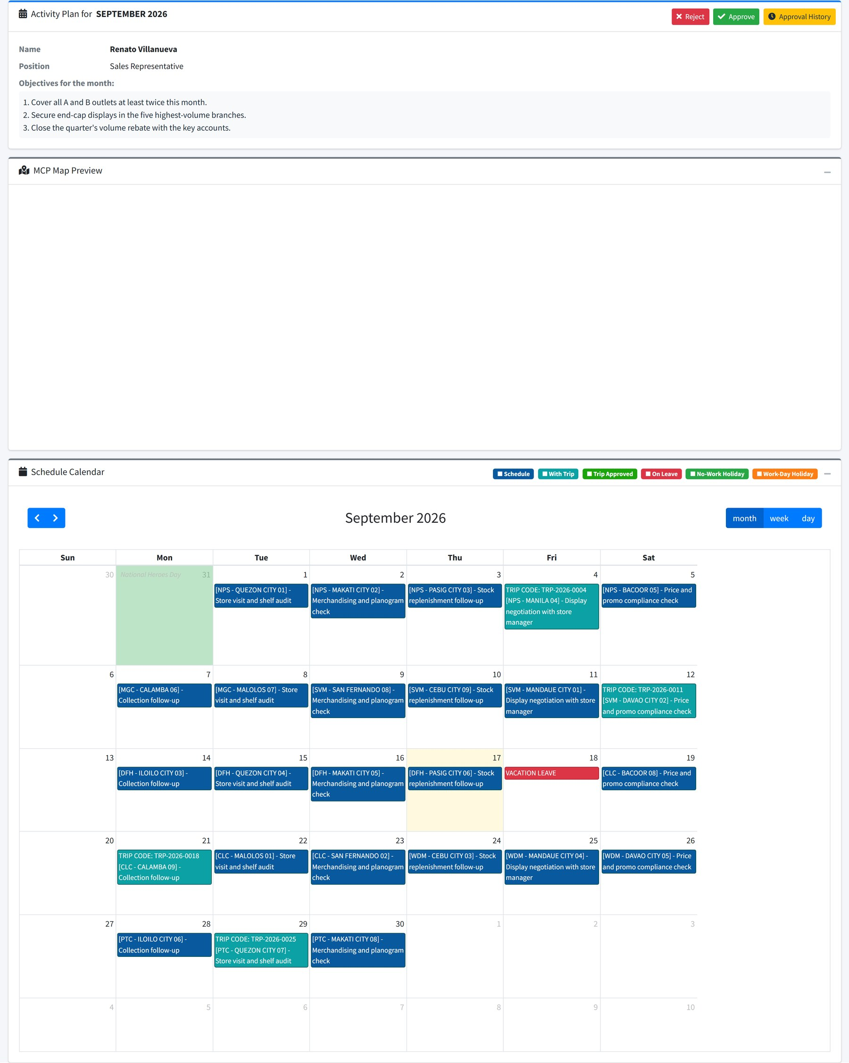
Figure 19.4 A submitted plan, with its objectives, the planned visits and the approval trail.
FOR APPROVERS With mcp approval you see plans submitted by the people who report to you, and can approve or return each one. mcp confirmation adds the final confirmation step.

20 Schedules
Where: Field Activities → Schedules Needs: schedule access
The schedule is the approved Activity Plan seen as a calendar, together with the deviations recorded against it.
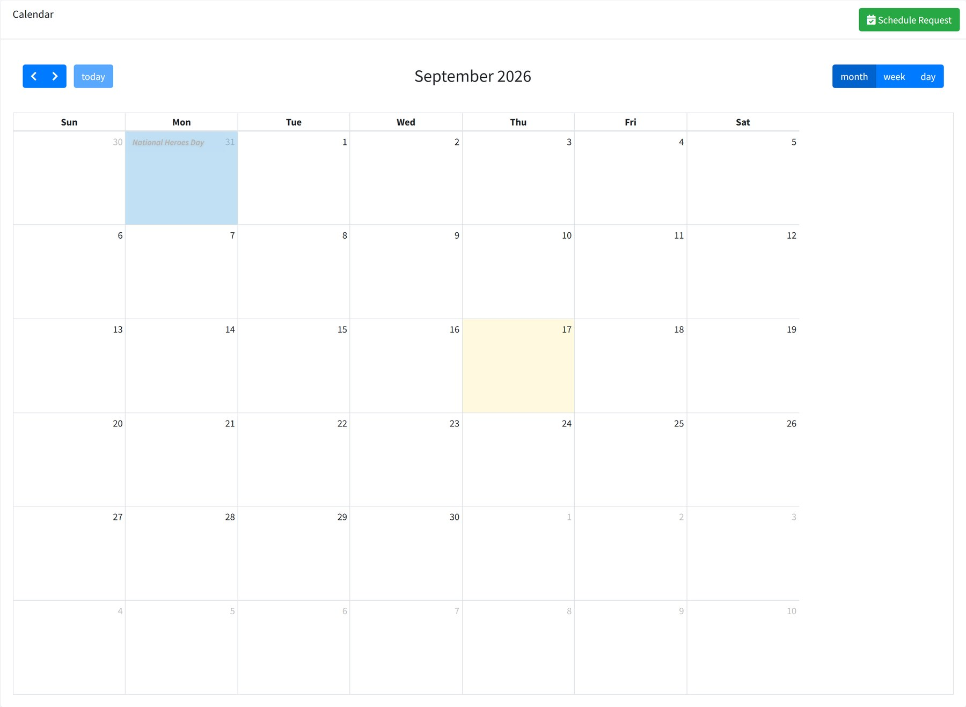
Figure 20.1 The month at a glance. Holidays are named on the day.
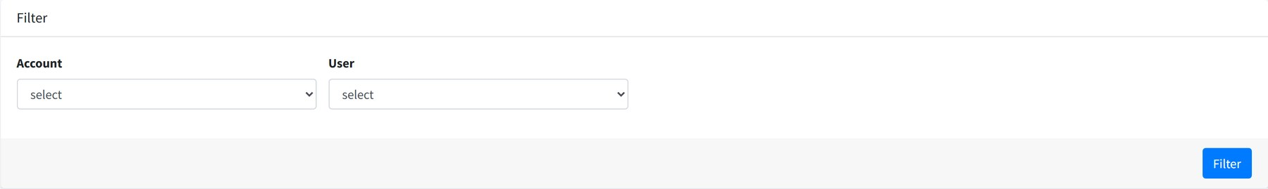
Figure 20.2 Filter by user and account.
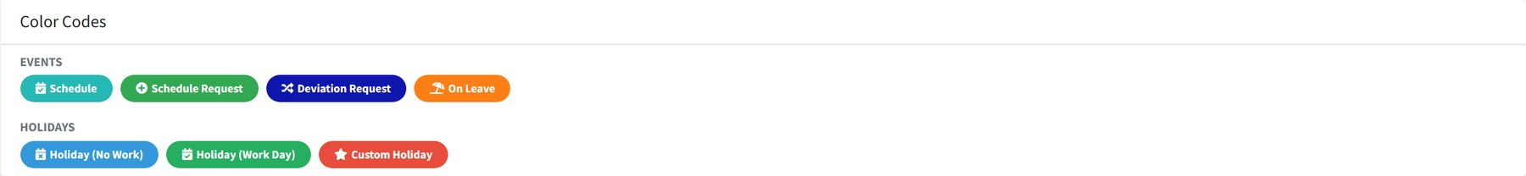
Figure 20.3 The colour key.

When the day did not go to plan
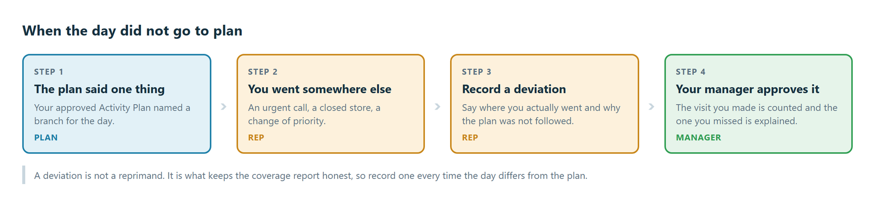
Figure 20.4 What to do when the day differs from the plan.
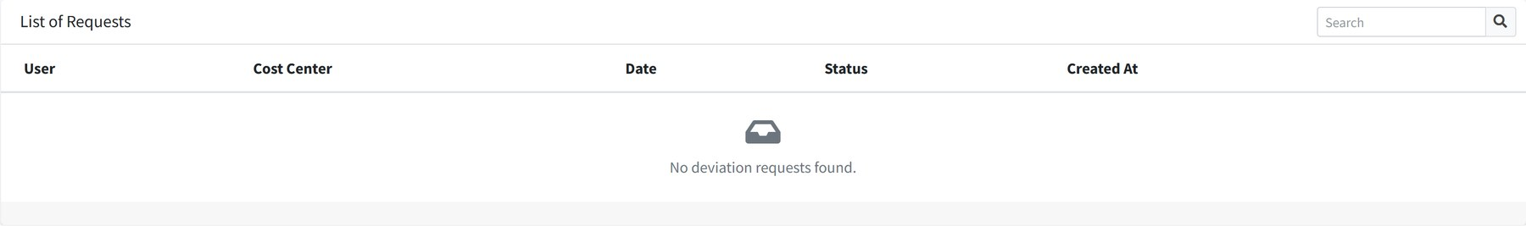
Figure 20.5 Deviation forms, each with the reason the plan was not followed.
Record a deviation whenever you visit somewhere other than the branch your plan named. Say where you actually went and why. Approvers need schedule approve deviation to accept it.
WHY DEVIATIONS MATTER A deviation is not a reprimand. Recording one keeps the coverage report honest: the visit you actually made is counted, and the one you missed is explained.

21 Trips
Where: Field Activities → Trips Needs: trip access, trip create, trip finance approver
A trip is a travel claim. Most trips hang off a planned visit, so the journey is tied to the reason for making it.
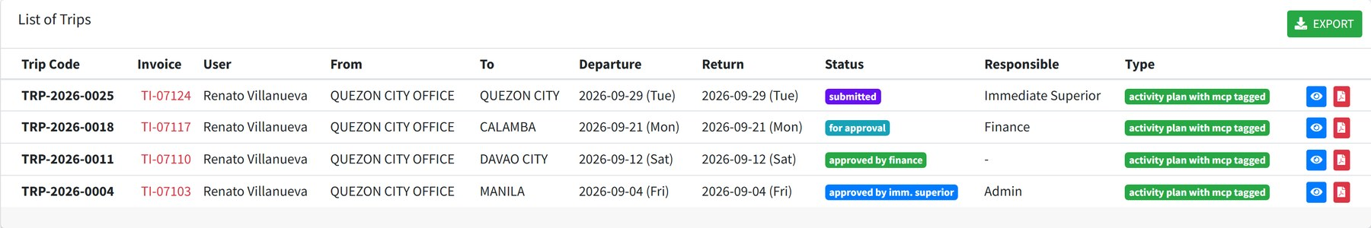
Figure 21.1 Trips with their route, dates and status.
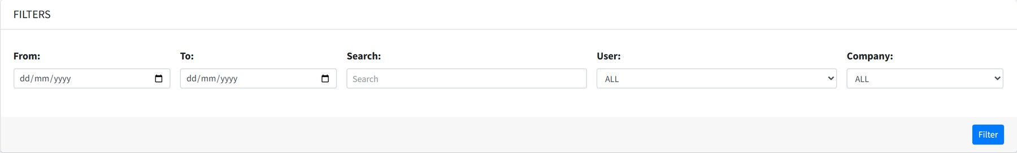
Figure 21.2 Filter by user, company and date.

Claiming a trip
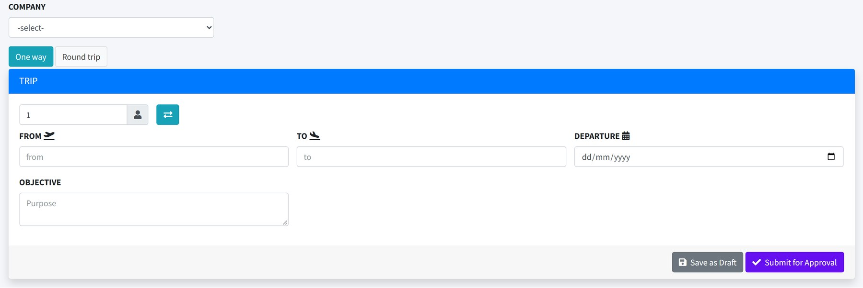
Figure 21.3 The trip form. One way and Round trip change which dates are asked for.
- Choose the Company the cost belongs to.
- Choose One way or Round trip.
- Set the number of passengers. The arrows swap From and To around.
- Enter From, To and the Departure date, and the return date for a round trip.
- Write the Objective — why the journey was needed.
- Save as Draft, or Submit for Approval.
RECEIPTS
With trip attachment you can attach the ticket or receipt to the claim. With trip invoice the invoice number and supplier can be recorded, which is what finance reconciles against.

Approval
Status | Meaning
DRAFT | Being prepared.
SUBMITTED | Sent to your immediate superior.
FOR REVISION | Sent back for changes.
APPROVED BY IMM. SUPERIOR | Passed on to finance.
FOR APPROVAL | With finance.
APPROVED BY FINANCE | Approved for payment.
REJECTED BY FINANCE | Refused.
CANCELLED | Withdrawn by the claimant.

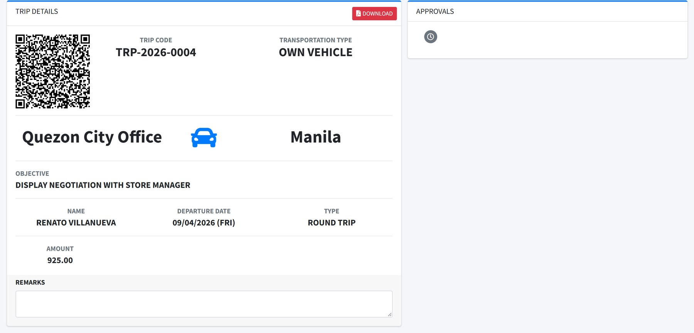
Figure 21.4 A trip in detail, with its approval trail.
Export downloads the filtered list for payroll or reimbursement. With trip print a single claim can be printed as a PDF.

22 Weekly Productivity Report
Where: Field Activities → Weekly Productivity Report Needs: war access, war create, war approve
Each week, field staff report where they went, what they set out to achieve and what came of it.
Figure 22.1 Reports grouped by person. Choose View to open someone's reports.
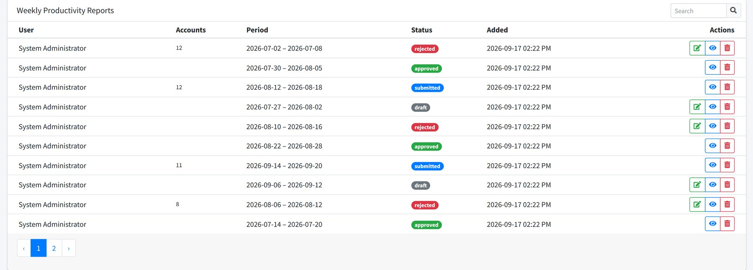
Figure 22.2 One person's reports, week by week.

Writing a report
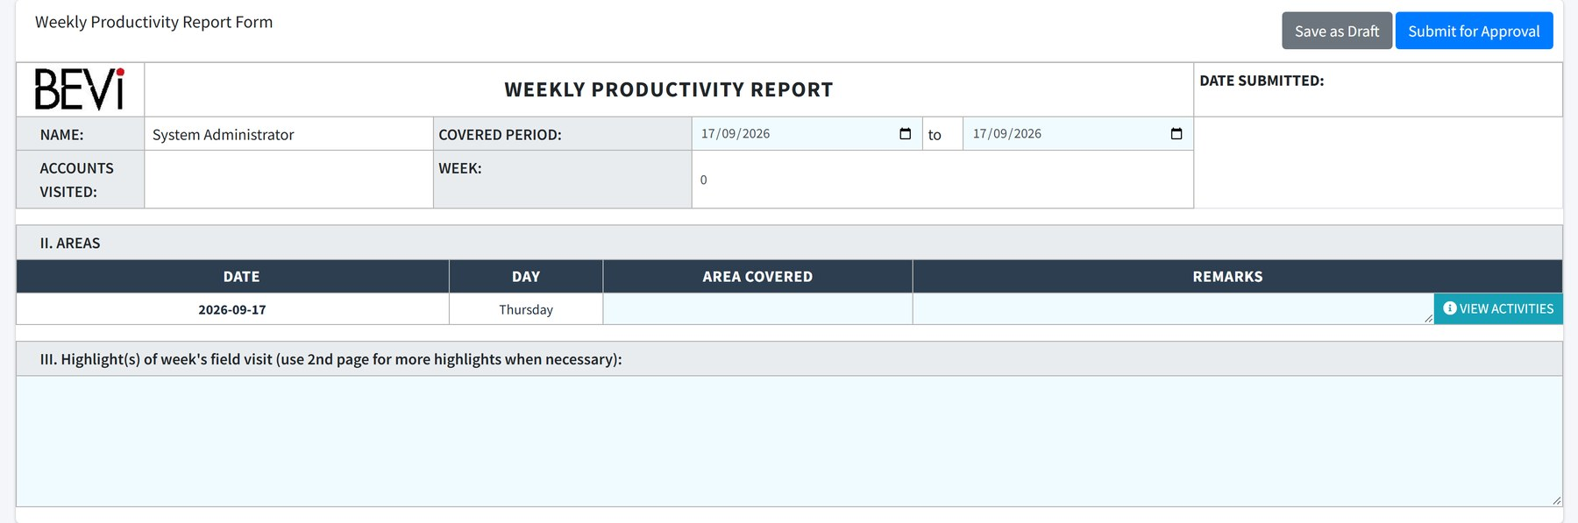
Figure 22.3 The weekly report form.
Field | What to enter
Week number | The week of the year the report covers.
Date From / Date To | The week's start and end.
Area | The area worked.
Accounts visited | The customers covered during the week.
Objectives | What you set out to achieve.
Highlights | What came of it, and anything worth passing on.
Branches | The outlets visited, each marked visited, not visited or a deviation.
Attachments | Photographs of displays and any supporting papers.

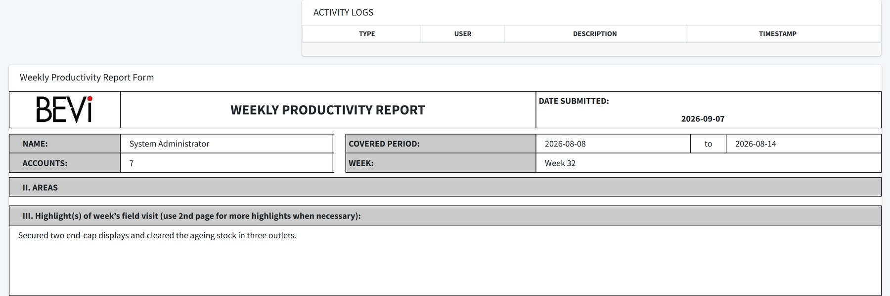
Figure 22.4 A completed report.
Reports move from DRAFT to SUBMITTED , then APPROVED or REJECTED . With war approve the approval buttons appear on reports from the people who report to you. A report can be printed as a PDF.

PART 4

Reports
Reading back what the transactions and the field work produced.

23 Sales order reports
Where: Reports → Reports Needs: report access, report export
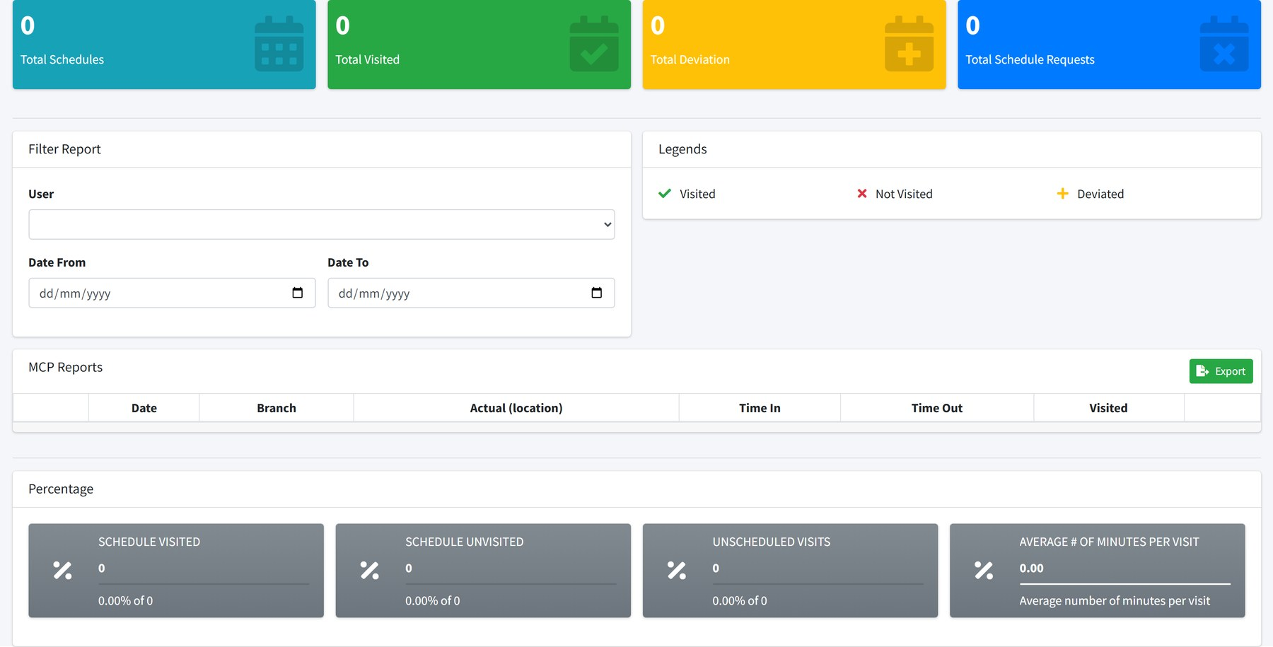
Figure 23.1 Orders and coverage side by side, with the filter panel at the top.
- Set the date range and any other filters.
- Select Filter.
- Read the figures, or select Export to take them into Excel.
RESTRICTED REPORTING The permission report restricted narrows what a user can see in the reports. It is a restriction rather than a capability, so it is not given out by default — it is added deliberately to roles that should see less.

24 MCP reports
Where: Reports → MCP Reports Needs: report access
This is the combined view of a person's month: the plan they submitted, the weekly reports they filed, and the deviations they recorded.
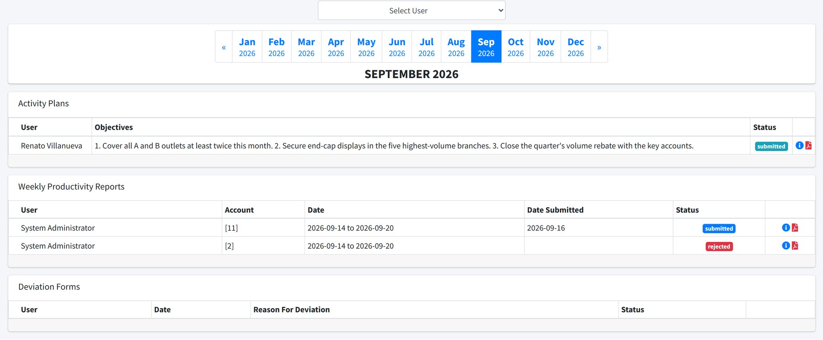
Figure 24.1 Choose a person and a month. The three panels below show their activity plan, weekly reports and deviation forms.
Panel | Shows
Activity Plans | The plan for the month, with its objectives and status.
Weekly Productivity Reports | Each week's report, the accounts visited and whether it was approved.
Deviation Forms | Days the plan was not followed, and the reason given.

The month buttons across the top move between months. A month can be printed as a PDF for a review meeting.

25 Productivity reports
Where: Reports → Productivity Reports Needs: productivity report access, productivity report upload
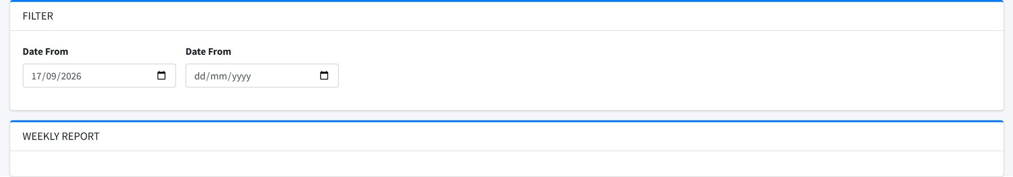
Figure 25.1 Weekly productivity, filtered by period.
Productivity figures are loaded from a spreadsheet rather than typed. With productivity report upload the Upload button takes the week's file and adds it to the report.

26 COE reports
Where: Reports → COE Reports Needs: channel operation report, channel operation list
COE — channel operations — is what merchandisers record on a store visit: what was on display, what competitors were doing, whether a trade marketing activity actually ran.
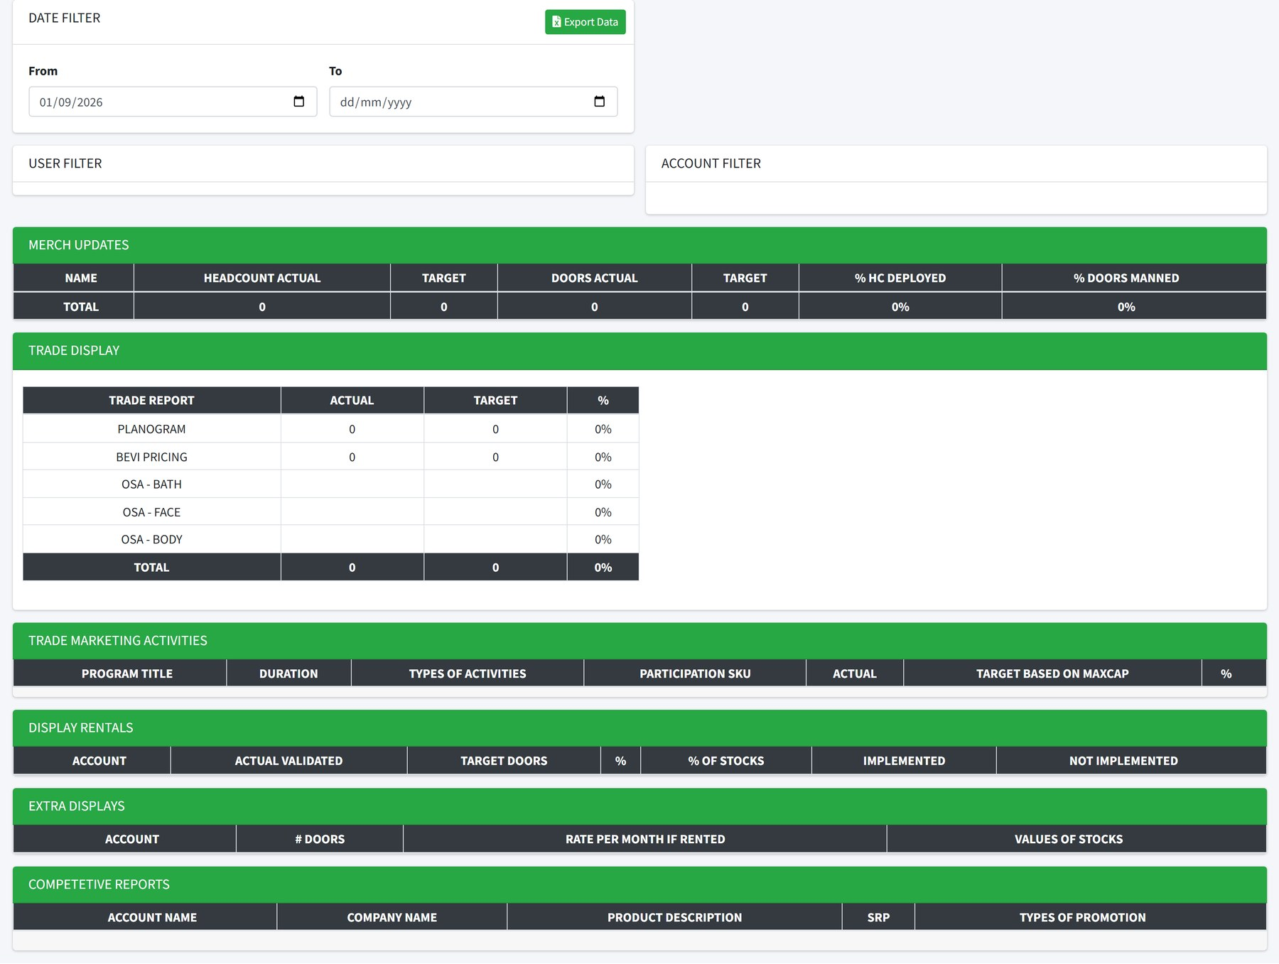
Figure 26.1 Channel operations findings, gathered from branch visits.
Section | Records
Trade marketing activity | Whether a funded activity ran, and the actual against the target for each SKU.
Trade display | The displays in place on the day.
Extra display | Additional facings beyond the agreed planogram.
Display rental | Paid display space and what it cost.
Merchandising update | Shelf condition, stock and pricing.
Competitive report | What competitors were running in the same store.

A single visit's findings can be printed with channel operation print.

PART 5

Setup and administration
The reference tables everything else draws on, and the screens that control who can do what.

27 How every maintenance screen works
There are around twenty maintenance screens and they all behave the same way. Learn the pattern once and the rest of this part is just a field list.
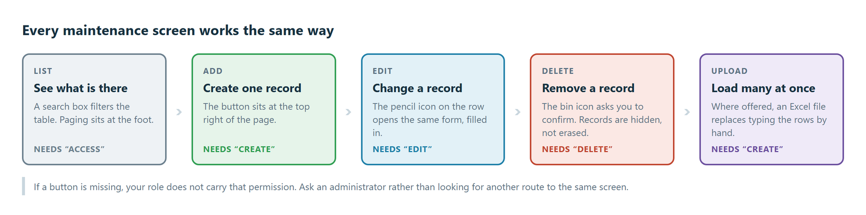
Figure 27.1 The five things every maintenance screen lets you do.
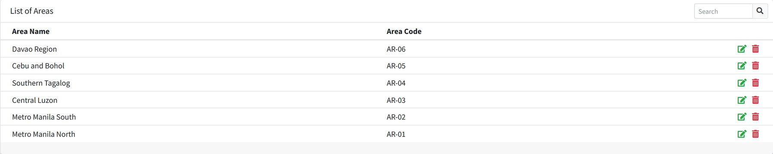
Figure 27.2 A typical maintenance screen. Search at the top right, Add above it, edit and delete icons on each row.
DELETING
Deleting hides a record rather than erasing it. Anything already referring to it — an old order, a past plan — keeps working. The record simply stops appearing in drop-downs and lists.
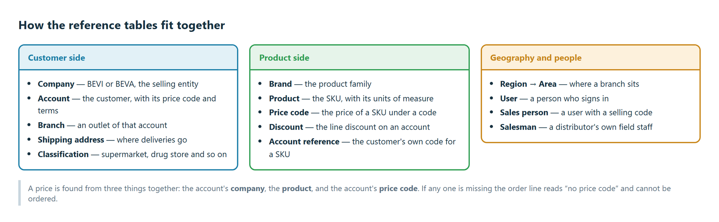
Figure 27.3 How the reference tables relate.

28 Accounts and their addresses

Accounts
Where: Maintenance → Accounts Needs: account access
An account is a customer. It carries the commercial terms every order for that customer inherits.
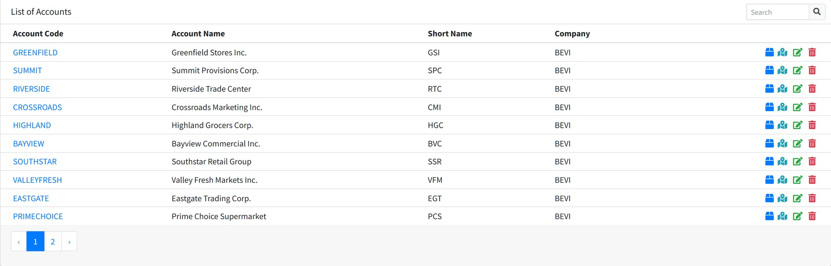
Figure 28.1 Accounts with their code, name and selling company.
Field | Meaning
Account Code | The unique code. Used on uploads and in the ERP.
Account Name | The registered trading name.
Short Name | The abbreviation shown on cards and banners.
Company | The selling entity, BEVI or BEVA.
Price Code | Which price list applies. Decides what every product costs this customer.
Line Discount Code | The discount applied to each order line.
Invoice Term | Payment terms.
Sales Order UOM | The unit of measure orders are placed in.
PO Process Date | The day of the month the customer's POs are processed.
On Hold | Stops new orders being raised for this customer.
Ship To Address | The default delivery address.

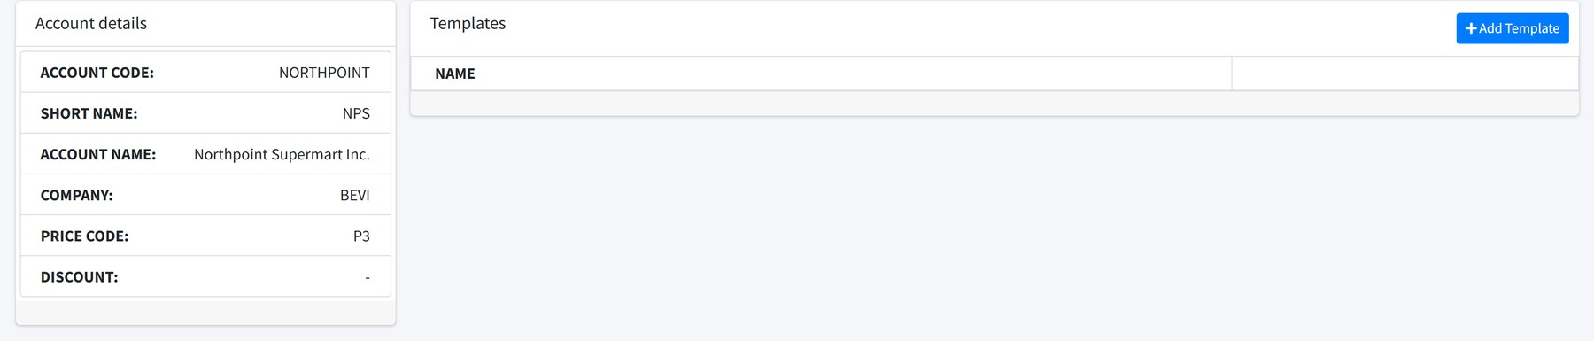
Figure 28.2 An account in detail.
PRICE CODE AND COMPANY GO TOGETHER A product is only orderable when a price exists for the account's company, that product and the account's price code. Get one of the three wrong and the order screen shows no price code against every line.

Branches
Where: Maintenance → Branches Needs: branch access
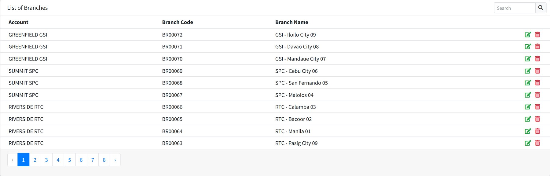
Figure 28.3 Branches, each belonging to one account.
A branch is an outlet of an account. It carries a code, a name, its province, city and barangay, and the region, area and classification it belongs to. Those three are what the coverage reports group by.
Merge folds a duplicate branch into another, moving its history across.

Branch addresses
Where: Maintenance → Branch Address Needs: branch address access
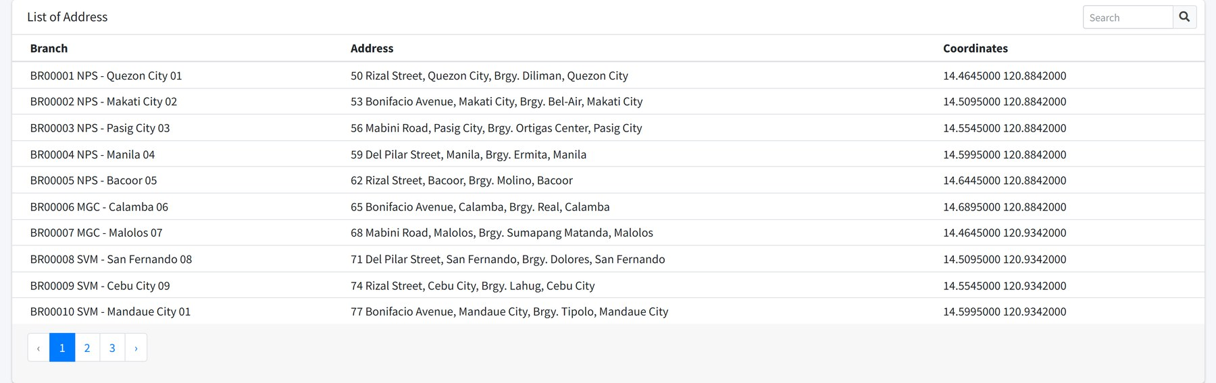
Figure 28.4 Branch addresses with their coordinates.
This is where a branch gets its map position. Without coordinates the distance checks made when someone signs in at the branch cannot work.

Shipping addresses
Where: reached from an account Needs: shipping address access
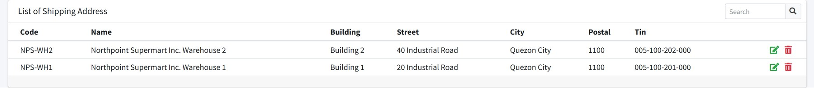
Figure 28.5 The registered delivery addresses for one account.
Each address has a code, a ship-to name, building, street, city, postal code, a TIN and a warehouse. The Change Address button on an order chooses between these.

Ship address mapping
Where: Maintenance → Ship Address Mapping Needs: ship address mapping access
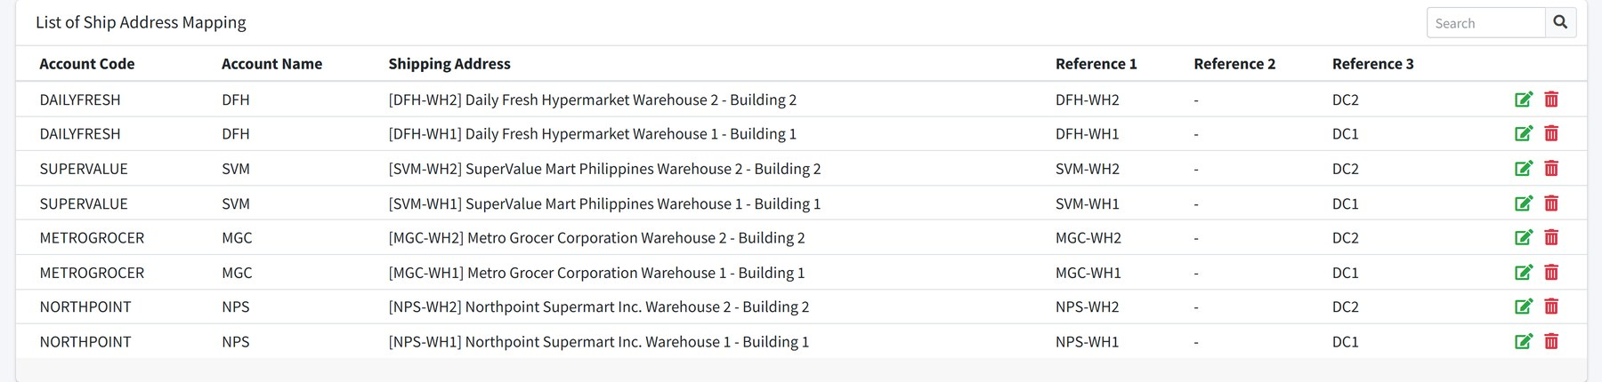
Figure 28.6 The customer's own names for a delivery point, matched to ours.
Customers write their own store names on a purchase order. This table maps up to three of their references onto one of our shipping addresses, so an uploaded PO can be matched automatically.

Account product references
Where: Maintenance → Account Reference Needs: account reference access
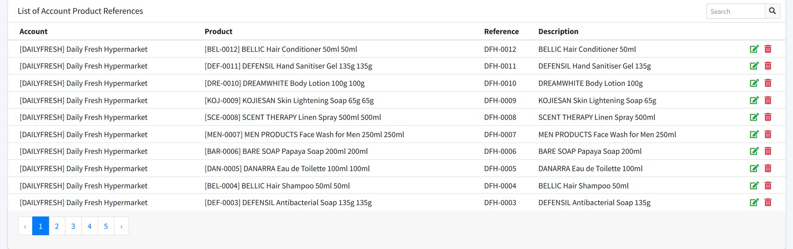
Figure 28.7 The customer's own code for each of our SKUs.
The same idea for products. Once registered, the customer's code appears under the product description on the order screen, and their purchase orders can be matched to our SKUs.

29 Products, brands and prices

Products
Where: Maintenance → Products Needs: product access
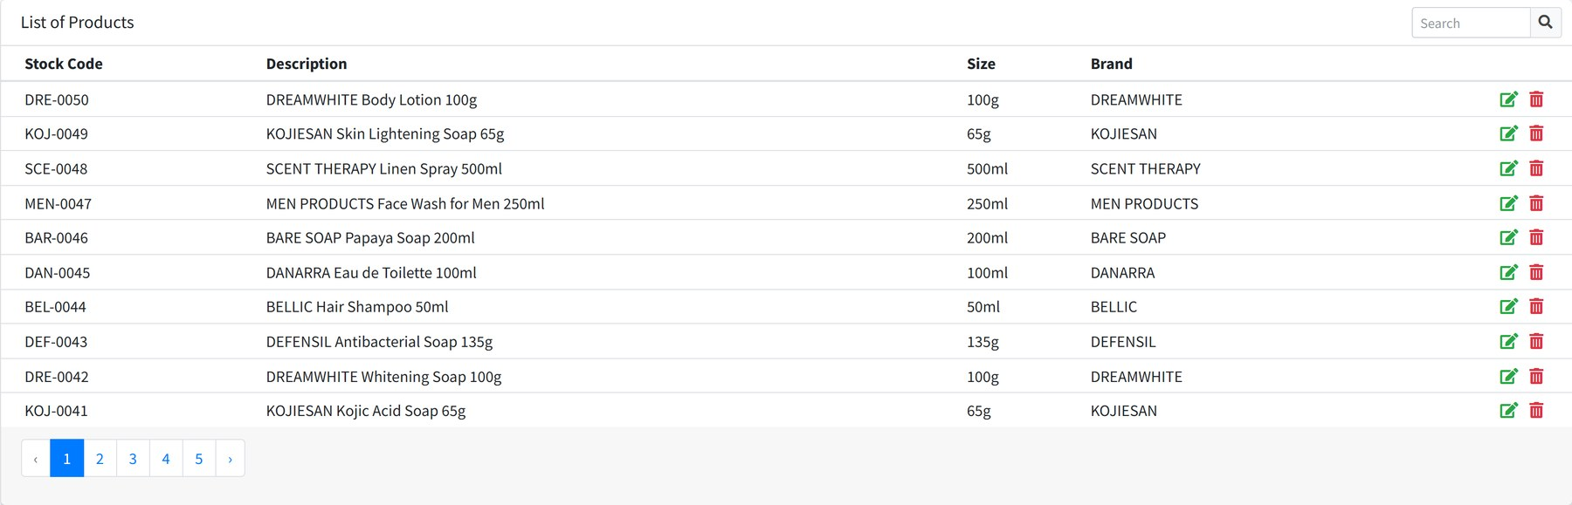
Figure 29.1 Products by stock code.
Field | Meaning
Stock Code | The SKU code, unique and used everywhere.
Description | The product name as it appears on orders.
Size | Pack size.
Brand | The brand it belongs to.
Category / Product Class / Core Group | How it is grouped for reporting.
Stock UOM | The base unit the warehouse counts in.
Order UOM | The unit orders are normally placed in, usually a carton.
Other UOM | A third unit, such as a pack.
UOM conversion and operator | How many base units make one of the larger unit, and whether to multiply or divide.
Status | Blank means on sale. A value here puts the product on hold and stops it being ordered.
Bar Code | Used by the barcode display on the order screen.
Warehouse | Where it ships from.

THE CONVERSION OPERATOR IS NOT DECORATIVE The operator must be M to multiply or D to divide. Any other value and the line prices at zero, because neither rule matches.

Brands
Where: Maintenance → Brands
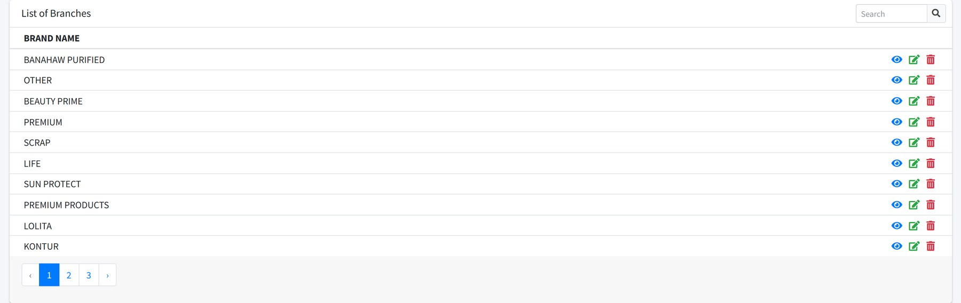
Figure 29.2 Brands. The order screen's brand filter reads this list.

Price codes
Where: Maintenance → Price Codes Needs: price code access
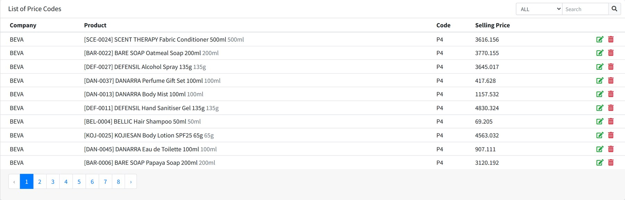
Figure 29.3 The price list: one row per company, product and code.
Field | Meaning
Company | The selling entity the price belongs to.
Product | The SKU.
Code | The price code, P1 to P4. An account is set to one of these.
Selling Price | The price per unit.
Price Basis | Which unit the price is quoted in: stock, order or other.

The filter at the top narrows to one code, which is the quickest way to check a whole price list before it goes live.

30 Geography: regions, areas and classifications
Three small tables that decide how branches are grouped in every report.
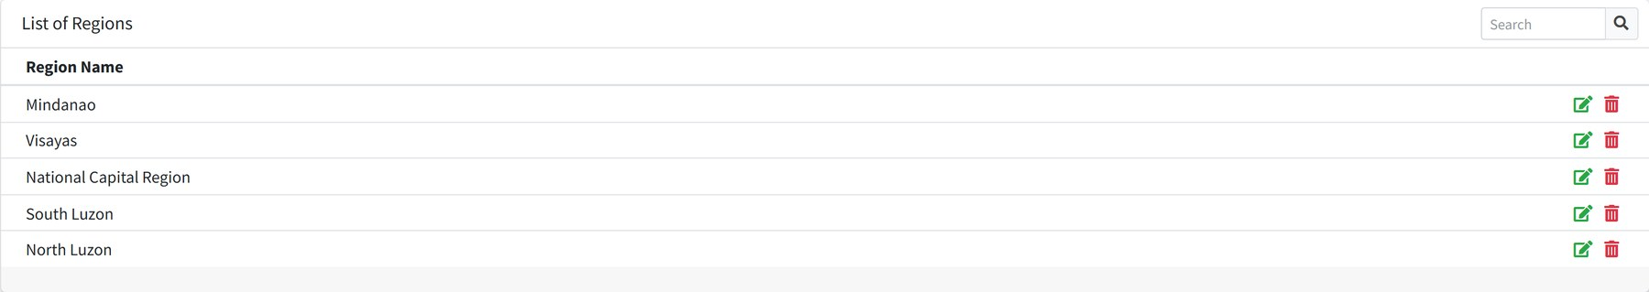
Figure 30.1 Regions.
Figure 30.2 Areas.
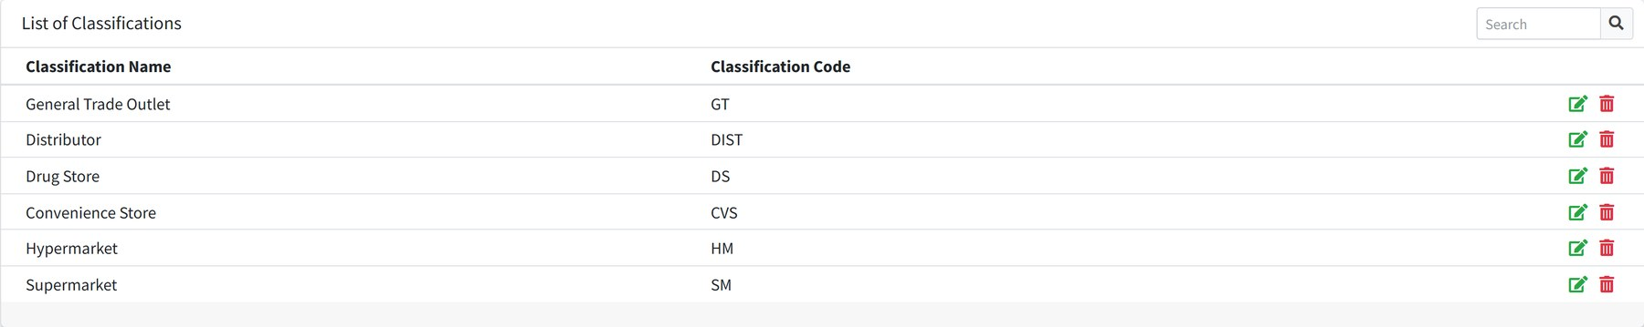
Figure 30.3 Classifications — the kind of outlet a branch is.
Table | Fields | Used by
Regions | Region Name | Grouping branches in reports
Areas | Area Code, Area Name | Weekly reports and coverage
Classifications | Classification Code, Classification Name | Splitting results by channel

31 Commercial terms

Companies
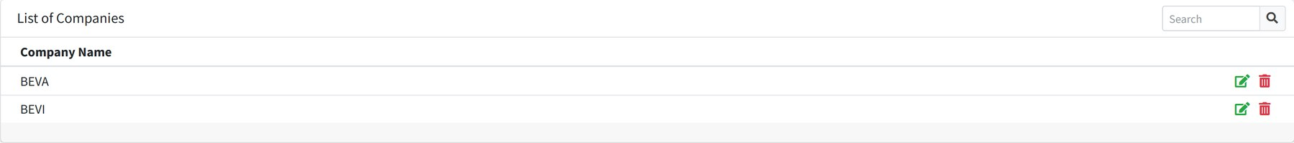
Figure 31.1 The two selling entities.
Each company carries an Order Limit, the ceiling on a single order's value.

Invoice terms
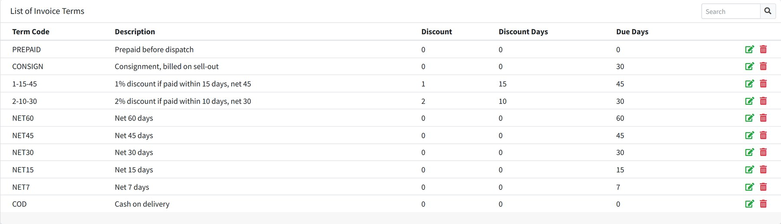
Figure 31.2 Payment terms.
Field | Meaning
Term Code | The short code, such as NET30.
Description | The terms in words.
Discount | The early settlement discount, as a percentage.
Discount Days | How quickly they must pay to earn it.
Due Days | When payment falls due.

Discounts
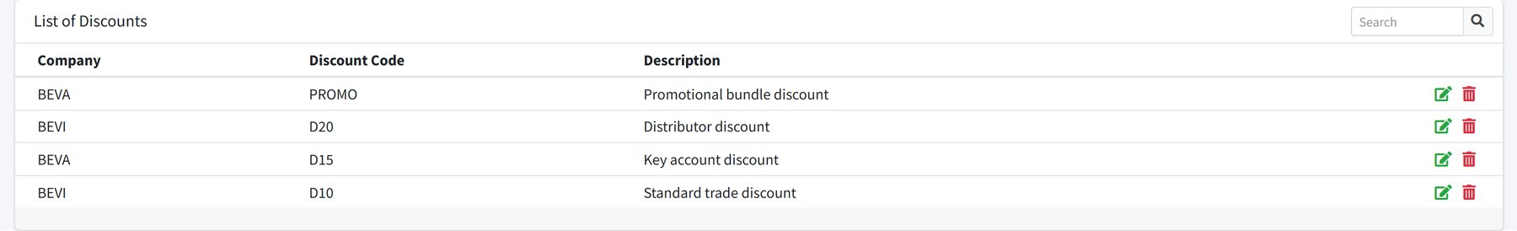
Figure 31.3 Line discounts.
A discount carries a code, a description, a company and up to three percentages applied in turn. An account is set to one discount code, which becomes the order discount on every order for that customer.

Operation processes
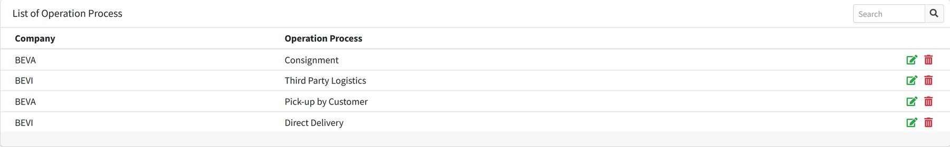
Figure 31.4 How goods reach the customer.

Sales order cut-offs
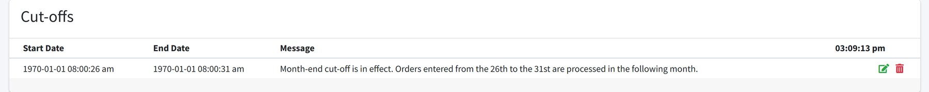
Figure 31.5 The month-end cut-off window.
A cut-off is a range of days in the month and the message shown while it runs. During a cut-off, a notice appears on the order screens telling users their orders will be processed in the following month.

Cost centers
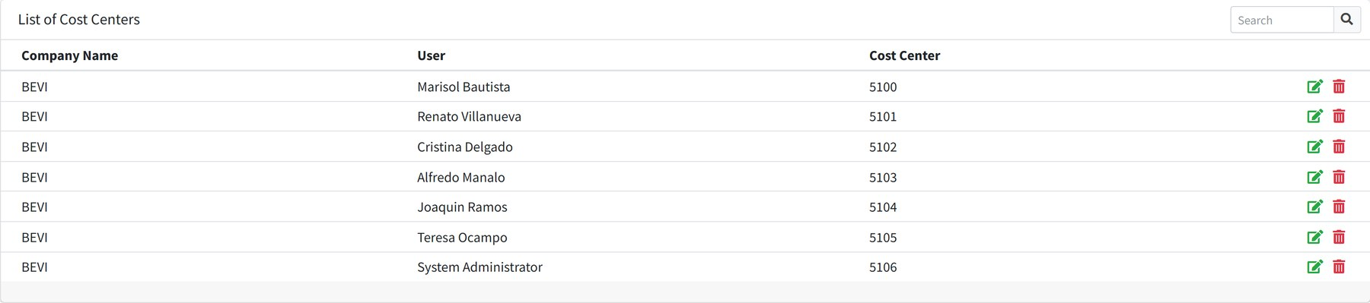
Figure 31.6 The cost center a person's expenses are booked to.

32 The working calendar
Where: Maintenance → Holidays Needs: holiday access
Holidays appear on the schedule calendar and are excluded from coverage expectations.
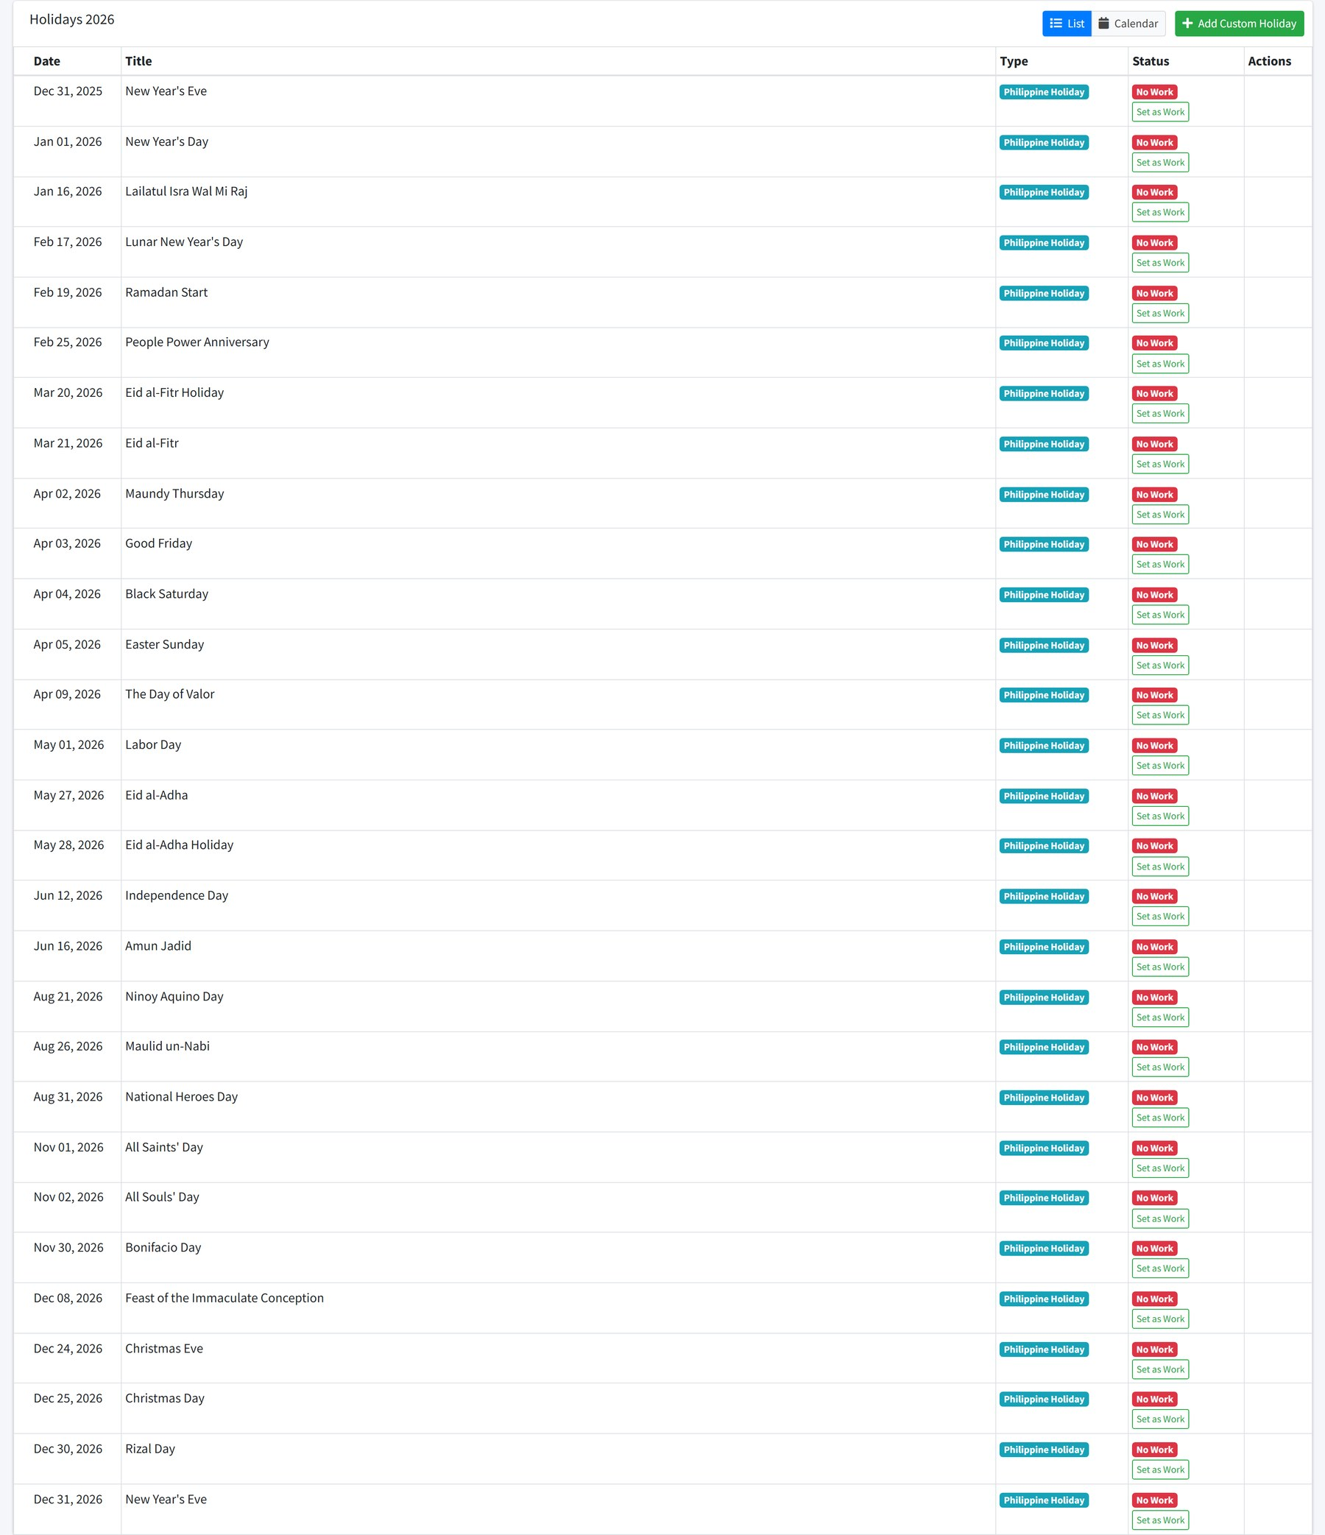
Figure 32.1 The year's holidays. Set as Work turns a holiday into a working day where the business is trading.
Field | Meaning
Date | Day and month. A holiday can repeat every year or apply to one year only.
Title | The name of the holiday.
Type | Where it came from — a proclamation, or added by hand.
Status | No Work or Work. Set as Work switches it.

33 People and organisation

Departments
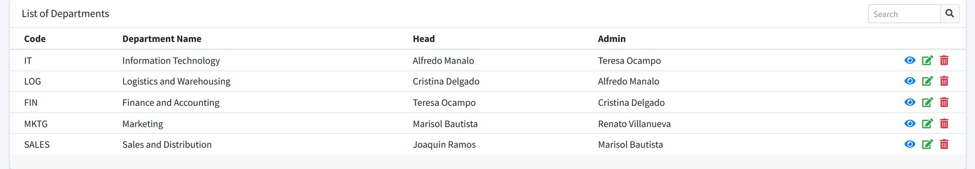
Figure 33.1 Departments with their head and administrator.
ALWAYS NAME A HEAD AND AN ADMINISTRATOR The department list expects both. A department left without them will not display.

Organization structure
Where: System → Organization Structure Needs: organizational structure access
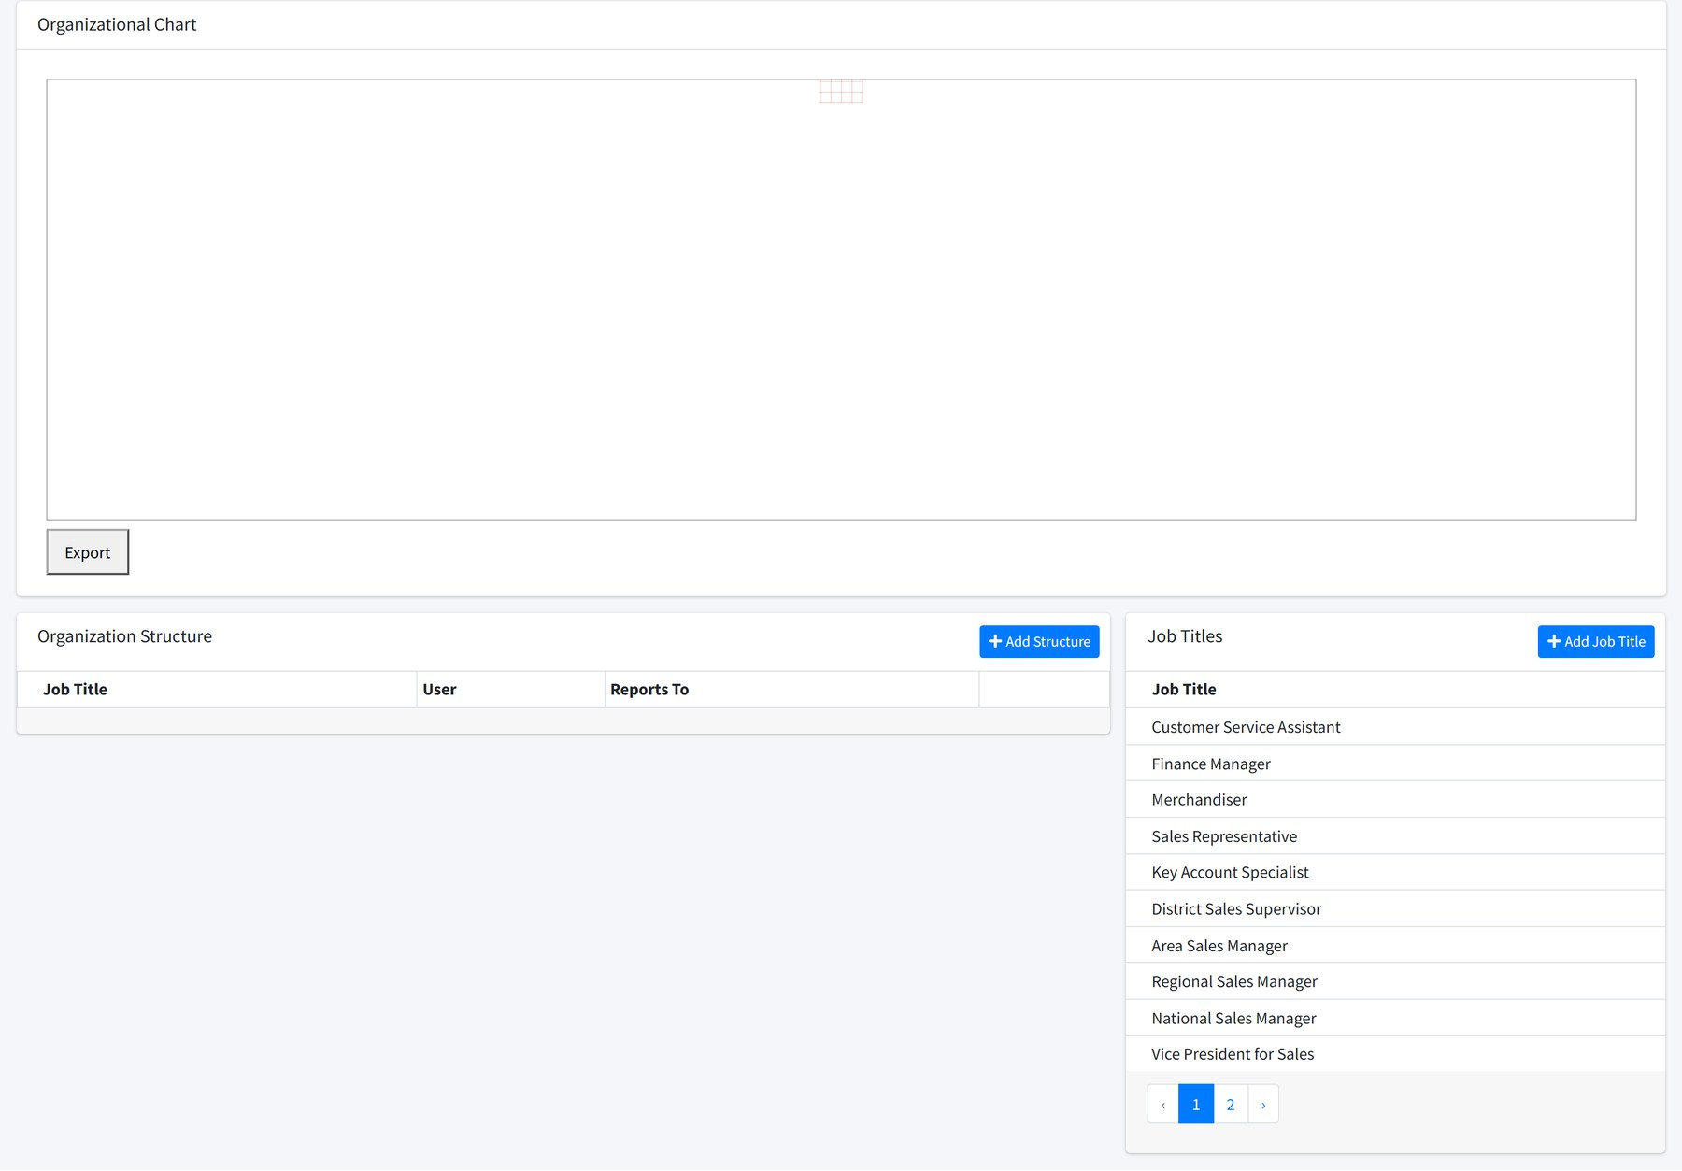
Figure 33.2 The reporting chart, the structure table and the job titles behind it.
This screen decides who approves whose work. Each person is given a job title and the person they report to; the approval steps in Part 3 follow those lines.
IF APPROVALS ARE NOT REACHING THE RIGHT PERSON Check the reporting line here before looking anywhere else. An approval goes to whoever is recorded as the submitter's immediate superior.

Sales people
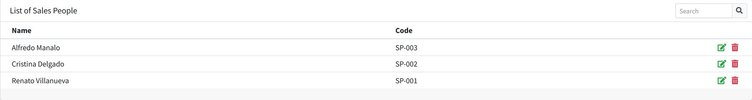
Figure 33.3 Users with a selling code.
A sales person is a user with a selling code attached. Accounts can be assigned to a sales person as well as to a user, and both count when working out which accounts someone may raise orders for.

Salesmen and their locations
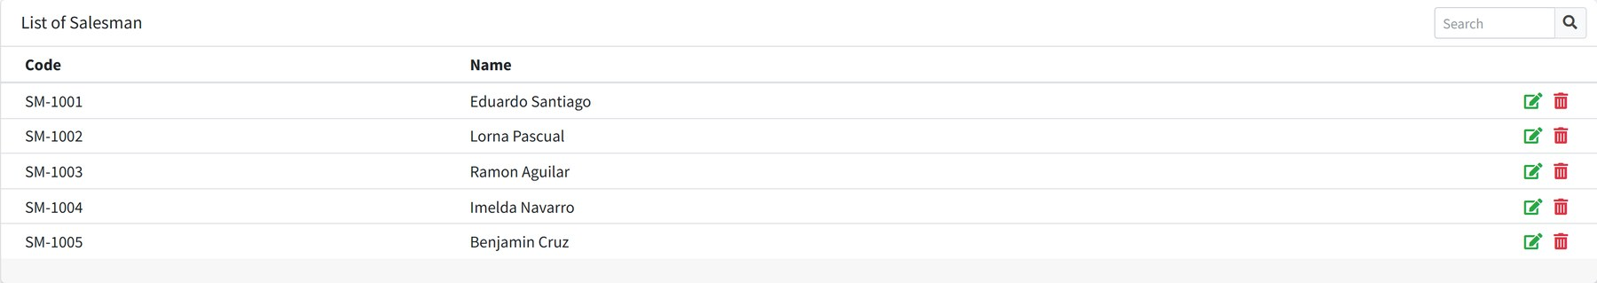
Figure 33.4 Distributor salesmen.
Salesmen are a distributor's own field staff rather than our employees. They have a name and a code, and Salesmen → Salesman Locations records the province and city each one covers.

34 Users and roles

Users
Where: System → Users Needs: user access, user create, user change password
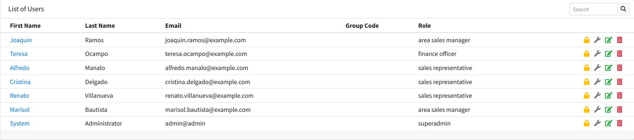
Figure 34.1 Users with their role.
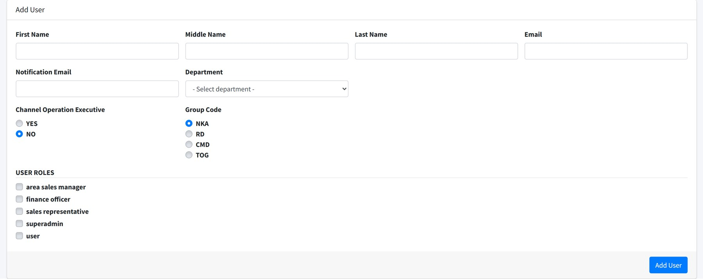
Figure 34.2 Adding a user.
Field | Notes
First / Middle / Last Name | As they should appear on approvals and reports.
Email | The sign-in name. Must be unique.
Notify Email | Where notifications are sent. Usually the same address.
Password | Set here, changed later by the user under Profile.
Department | Which department they belong to.
Role | What they are allowed to do. See below.
Status | Inactive stops them signing in without deleting the account.
COE | Marks a user as a merchandiser, which changes what they see on a branch sign-in.
Accounts / Branches | Which customers and outlets they may work with.

- Add the user with their name, email and department.
- Give them a role.
- Assign the accounts and branches they cover.
- Place them in the organization structure, with a job title and the person they report to.
ALL FOUR STEPS MATTER A user with a role but no accounts sees empty screens. A user with accounts but no place in the organization structure cannot have their work approved.
Upload adds users in bulk with user upload.

Roles
Where: System → Roles Needs: role access, role create
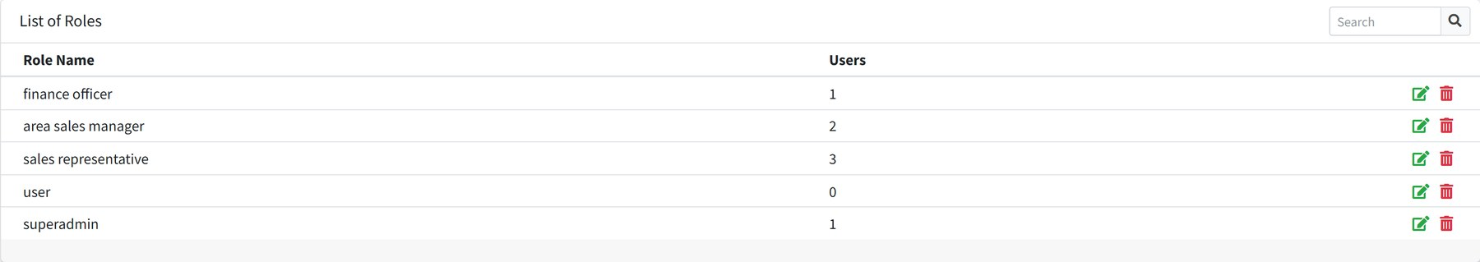
Figure 34.3 Roles and how many users hold each.
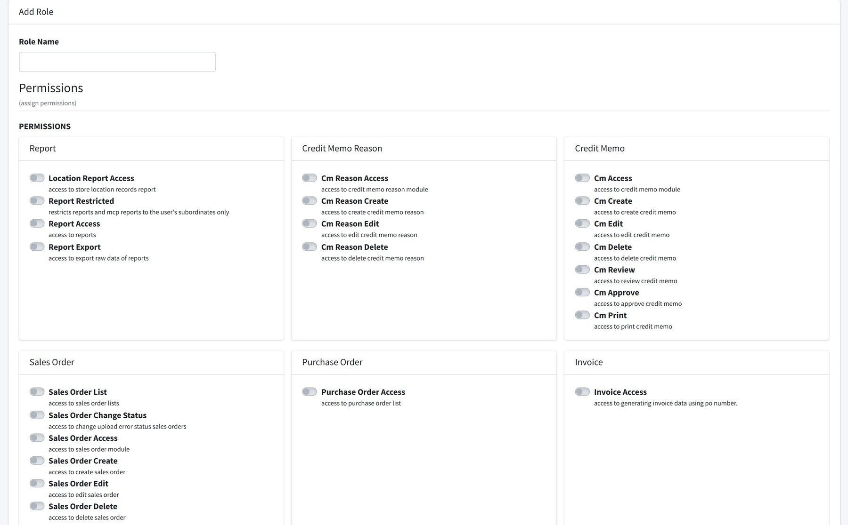
Figure 34.4 Creating a role. The permission list continues below the part shown here, grouped by module.
Give the role a name, then tick the permissions it should carry. Appendix B lists them all.
BUILD ROLES AROUND JOBS Make a role for each job — sales representative, area manager, finance officer — rather than one per person. Changing a job then means changing one role instead of a dozen user records.

Account logins
Where: System → Account Logins Needs: account login access
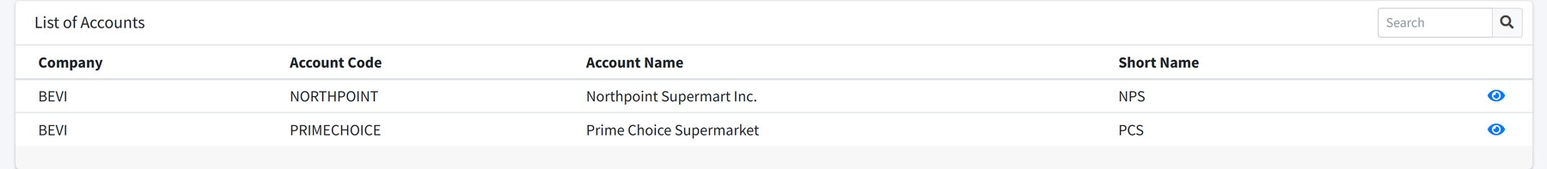
Figure 34.5 Who signed in to which account, and when.
Each sign-in records the user, the account or branch, the time in and out, and the coordinates captured. This is the raw record behind the coverage reports, and the first place to look when a visit is disputed. Export downloads it with account login export.

35 Settings and logs

Settings
Where: System → Settings Needs: settings
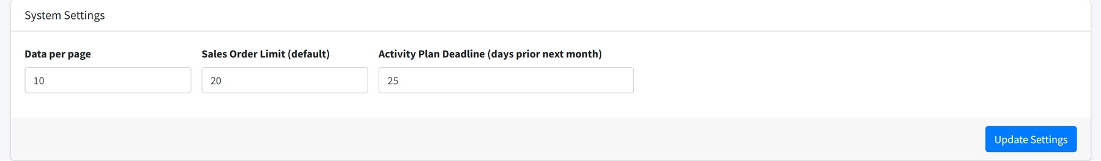
Figure 35.1 System-wide settings.
These apply to everybody. Change them deliberately and tell people when you do.

System logs
Where: System → System Logs Needs: system logs
Figure 35.2 Who changed what, and what the value was before.
Every change to a record is logged with the action, the user, a message and the time. Opening an entry shows the old and new value of each field that changed.
System → Error Logs is different: it holds technical errors for whoever supports the system, not a record of user activity.

Your own profile
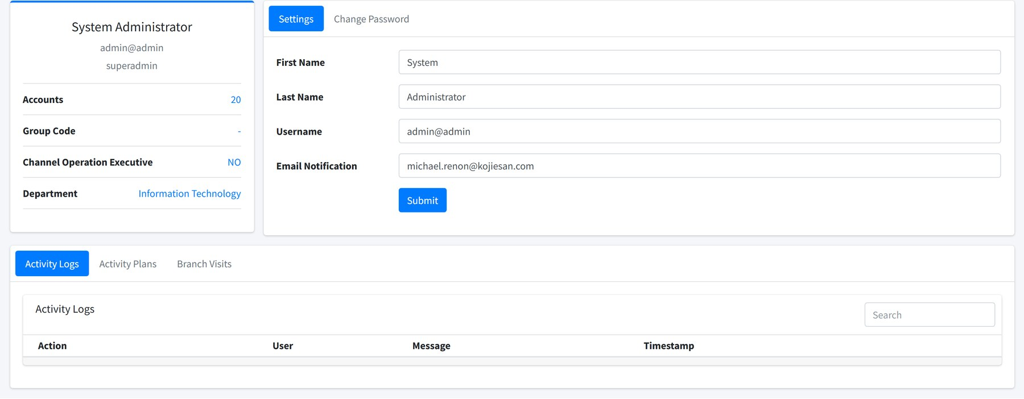
Figure 35.3 Your profile, with your own activity log, plans and branch visits.
Reached from your name in the top bar. Change your password here, and review what you have done and where you have been.

APPENDICES

Reference
Statuses, permissions and upload formats, for looking up rather than reading.

A Status reference
SALES ORDER
DRAFT FINALIZED UPLOADED UPLOAD ERROR CANCELLED
ACTIVITY PLAN
DRAFT SUBMITTED RETURNED APPROVED CONFIRMED REJECTED
TRIP
DRAFT SUBMITTED FOR REVISION APPROVED BY IMM. SUPERIOR RETURNED FOR APPROVAL APPROVED BY FINANCE REJECTED BY FINANCE CANCELLED
WEEKLY PRODUCTIVITY REPORT
DRAFT SUBMITTED APPROVED REJECTED
BRANCH VISIT, ON A WEEKLY REPORT
VISITED NOT VISITED DEVIATION

B Permission reference
Most modules carry four permissions. A few carry extras for the steps in a workflow.
Module | Permissions
Sales orders | sales order access, create, edit, delete, sales order list, sales order change status
Invoices | invoice access
Purchase orders | purchase order access
PPU forms | ppu form access, create, edit, delete
Remittances | remittance access
Activity plan | mcp access, create, edit, delete, mcp approval, mcp confirmation
Schedules | schedule access, create, schedule list, approve deviation
Trips | trip access, create, edit, trip attachment, trip invoice, trip print, trip finance approver
Weekly reports | war access, create, edit, delete, war approve
Reports | report access, report export, report restricted, sales dashboard, productivity report access, productivity report upload, channel operation report, channel operation list, channel operation print
Maintenance tables | Each has access, create, edit, delete — account, area, branch, branch address, brand, classification, company, cost center, department, discount, holiday, invoice term, operation process, price code, product, region, shipping address, ship address mapping and so cut-off
System | user access, create, edit, delete, user upload, user change password, role access, create, edit, delete, settings, system logs, account login access, account login export, organizational structure access and its three companions

C Upload file formats
Four formats ship with the system. Download the current file from the screen you are uploading to rather than reusing an old copy.
Format | Used on
SMS Sales Order Upload Format | Sales Orders → Upload Multiple SO, and Upload SO on the order form
SMS Multiple PO upload Format | Loading customer purchase orders
SMS PPU upload Format | PPU bulk upload
SMS Activity Plan Upload Format | Activity Plan → Upload

RULES THAT APPLY TO EVERY UPLOAD
- Keep the column order. The file is read by position, not by heading.
- Do not add or remove columns, and do not rename the headings.
- Codes must already exist in the system — stock codes, account codes, branch codes, ship-to names.
- Accepted file types are .xls, .xlsx, .csv and .xlsb.
- Always use Check before Save, and read what it reports.
CUSTOMER LAYOUTS Where a customer sends their own layout, ask an administrator to register it against their account instead of asking the customer to change their file.

