

Hello,

I am an interior designer. I want to create my own business.

My mission is to provide interior design and architectural services online.

My online services would be for the general public on any continent.

My goal is to "turn over" my services and create extra value for my clients. This could be the key to developing the latest innovations, efficiency, and quality. I am looking for a company like you who would like to work with me. I like what you have to offer. As you understood, this would be a collaboration with me when I needed it.

I believe that combining creative ideas and new technologies to create interactive visualization solutions results in highly specialized solutions for augmented and virtual reality, virtual tours, interactive applications and more.

My services will focus on:

1. For real estate developers
2. Construction companies
3. For Architects
4. For designers
5. For marketing agencies
6. Individuals

My service (*for architects, designers, real estate developers, and marketing agencies):*

1. Architectural
2. Landscape
3. Interior design
4. 3D architectural visualizations
5. Interactive + VR/AR

I am interested in *(I will provide a 3D image, 3D video, 360, floor plans and etc.):*

1. **Live Interactive Architecture Experience + VR**

<https://www.youtube.com/watch?time_continue=180&v=xke1M4tyfuM>

**Game platform:** *You can try a real game platform. The file is safe, just send on:*

<https://drive.google.com/uc?id=1mgX1YSM2oz-4Jv9jMU5M848dZdO3oa5C&export=download>

1. **360 virtual tours + VR**

<http://renderingofarchitecture.com/virtualtour/alella/alella.html>

**VR headset:** *Here are the different option of VR headset that they let to choose.*

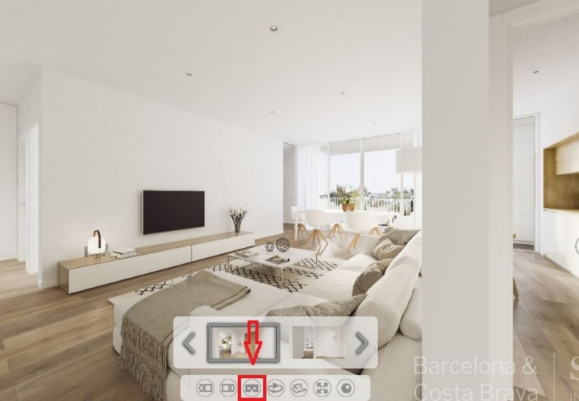

About VR: <https://webvr.info/>

<https://www.nvidia.in/object/vr-system-requirements-in.html>

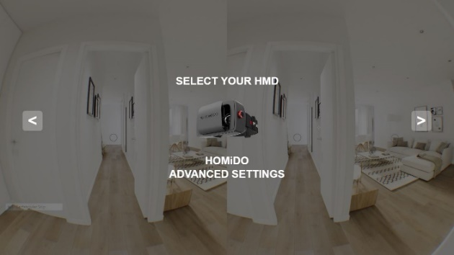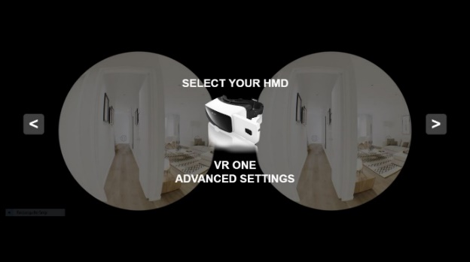

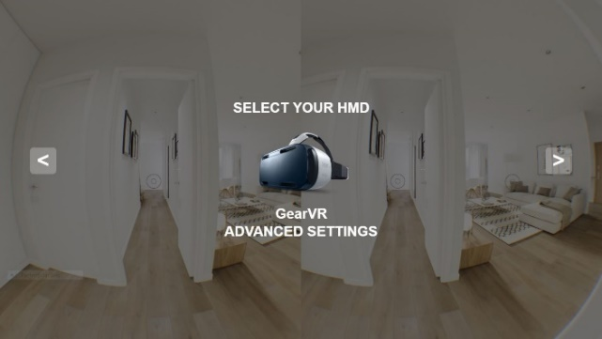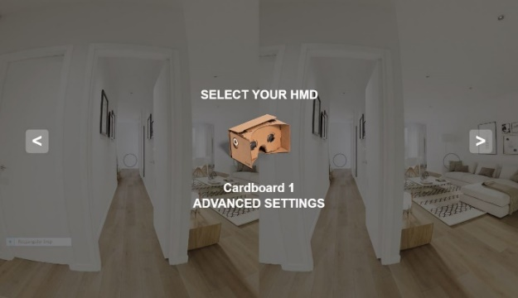

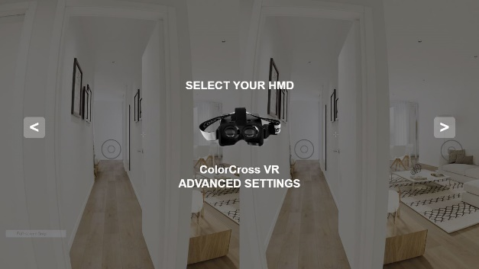

1. **Design photographic configurator or 360 virtual tours interior architecture configurator**

<http://edesign-unicom.derwid.net/Configure/?lang=en&templateId=1767>

<https://www.wrenkitchens.com/kitchen-design/online-planner/configure/vogue/modern/0C0F17AF14170A170303080E>

1. **Complete Project Marketing**

<https://desarrollobahia.hauzd.com/skyline> Using PC

<https://play.google.com/store/apps/details?id=com.archimesa.Skyline> Using App

1. **Interior designing experience with AR App**

*My idea is for the customer to scan the furniture they want from the store catalog and see if it will fit in their home.*

<https://www.youtube.com/watch?v=uNUcVPjnysE>

1. **AR Floor Plan app - customers can view their home configurations in augmented reality**

<https://www.youtube.com/watch?v=7cU2d5Pt9To>

--------------------------------------------------------------------------------------------------------------------

Like you saw, some services are based on Augmented reality, Some are based on Virtual reality and few are based on PC Visual Arch technology.

So, I am looking for an AR, VR and visual interaction for PC.

What you see in the examples is what I need.

I have analyzed everything and understand what I want and how I cannot explain it because I am not professionals on this.

I just need you to create all of these things without design.

I will present all the design files myself.

It would only be an additional service to our clients if they wanted to see their designs differently. Then when I receive the order I create the design and you will do the rest. I hope clear.

I need to know everything about each service and what I will get.

Therefore, if you are talking about all the options, I do not need a web platform.

I know that the web platform it can bring ease for me that I don't need to download exe. and send it to my clients, I can create designs and a person can see the design on the web no tension of sending exe. file it helps, but this is completely unviable due to the high cost for platform development.

For a start-up business, you really do not need it, as the design will only be created if there is an order, and if they are not, it will be a support cost every month that nobody will cover.

Later, as the business accelerates, we can think about it for the convenience of us and our customers.

But first and foremost, I need to come up with examples of services for my clients on my page. The ones I send to you I can't publicize, because it's other people's work - that's illegal. I need to create my own examples, but I know I need to that Optimization of Images Size as per the Standard to Load in Minimum Time. So, how do you recommend to show my service examples on my website?

My questions:

1. Deliverables
2. What files you are need
3. Estimated cost:

* *Per Interaction / Scene*
* *Support*

1. Time Requirement
2. Client Usage
3. What you provide
4. Extra note

**Please answer in this file.**

Thanks,

Dovile