**LAB 1**

**QUESTION 1:**

using System;

namespace Ques1

{

class Program

{

static void Main(string[] args)

{

Console.WriteLine("Enter the operation you want to perform \n");

Console.WriteLine("Enter 1 for Addition \n");

Console.WriteLine("Enter 2 for Subtraction \n");

Console.WriteLine("Enter 3 for Multiplication \n");

Console.WriteLine("Enter 4 for Division \n");

int op = Convert.ToInt32(Console.ReadLine());

Console.WriteLine("Enter your first number");

int a = Convert.ToInt32(Console.ReadLine());

Console.WriteLine("Enter your second number");

int b = Convert.ToInt32(Console.ReadLine());

int result = 0;

switch(op)

{

case 1:

{

result = a + b;

break;

}

case 2:

{

result = a - b;

break;

}

case 3:

{

result = a * b;

break;

}

case 4:

{

result = a / b;

break;

}

default:

{

Console.WriteLine("Please Input a valid operation!!!");

break;

}

}

Console.WriteLine("The answer is {0}",result);

Console.Read();

}

}

}

**INPUT/OUTPUT**

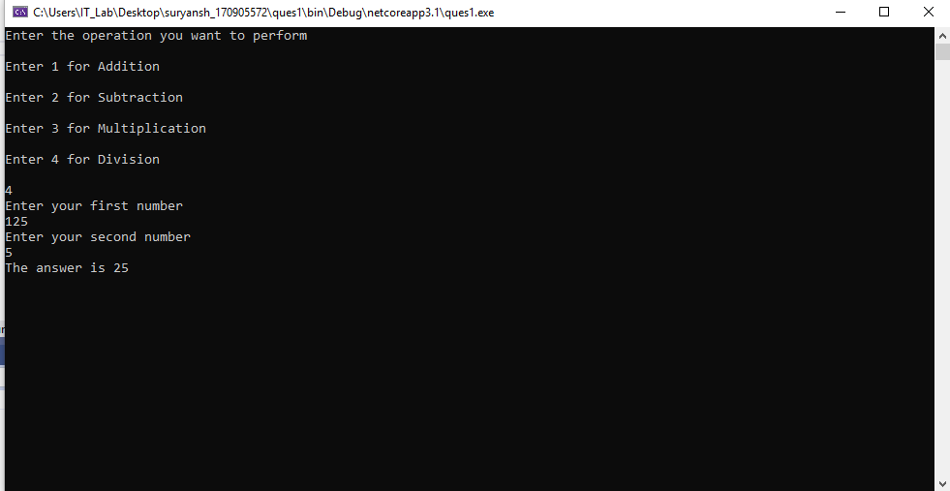

**QUESTION 2**

using System;

namespace q2

{

class Program

{

static void Main(string[] args)

{

Console.WriteLine("Enter the date in DD:MM:YY:HH:MM:SS format\n");

string date = Console.ReadLine();

string[] s = date.Split(":");

int day, month, year, hour, min, sec;

int days_in_feb;

int.TryParse(s[0], out day);

int.TryParse(s[1], out month);

int.TryParse(s[2], out year);

int.TryParse(s[3], out hour);

int.TryParse(s[4], out min);

int.TryParse(s[5], out sec);

long tick;

Console.WriteLine("Enter the no of ticks ranging from 10000000 to 999999999999\n");

string t = Console.ReadLine();

long.TryParse(t, out tick);

double second = tick * Math.Pow(10, -7);

Console.WriteLine("Ticks in seconds:\n" + second);

sec += (int)second;

while (sec >= 60)

{

int temp = sec / 60;

sec = sec % 60;

min += temp;

}

while (min >= 60)

{

int temp = min / 60;

min = min % 60;

hour += temp;

}

while (hour >= 24)

{

int temp = hour / 24;

hour = hour % 24;

day += temp;

}

if (year % 4 == 0 && year % 100 != 0 || year % 400 == 0)

{

days_in_feb = 29;

}

else

{

days_in_feb = 28;

}

int[] no_of_days = { 31,days_in_feb, 31, 30, 31, 30, 31, 31, 30, 31, 30, 31 };

if (day > no_of_days[month - 1])

{

day -= no_of_days[month - 1];

month += 1;

}

if (month > 12)

{

month = 1;

year += 1;

}

Console.WriteLine("the result date is {0}:{1}:{2}:{3}:{4}:{5}", day, month, year, hour, min, sec);

}

}

}

**INPUT/OUTPUT**

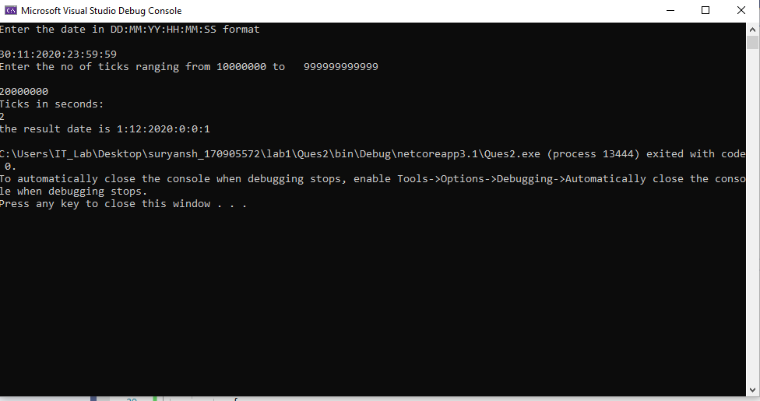

**QUESTION 3**

using System;

using System.Collections.Generic;

using System.ComponentModel;

using System.Data;

using System.Drawing;

using System.Linq;

using System.Text;

using System.Threading.Tasks;

using System.Windows.Forms;

namespace Ques3

{

public partial class Form1 : Form

{

public Form1()

{

InitializeComponent();

}

private void button1_Click(object sender, EventArgs e)

{

double bonus = 0.0;

double sal = 0.0;

double.TryParse(textBox1.Text, out sal);

if(comboBox1.SelectedItem.ToString()=="LEVEL 1")

{

bonus = 0.1 * sal;

}

else if(comboBox1.SelectedItem.ToString()=="LEVEL 2" || comboBox1.SelectedItem.ToString()=="LEVEL 3" || comboBox1.SelectedItem.ToString()=="LEVEL 4")

{

bonus = 0.09 * sal;

}

else if(comboBox1.SelectedItem.ToString()=="LEVEL 5" || comboBox1.SelectedItem.ToString()=="LEVEL 6" || comboBox1.SelectedItem.ToString()=="LEVEL 7")

{

bonus = 0.07 * sal;

}

else if(comboBox1.SelectedItem.ToString()=="LEVEL 8" || comboBox1.SelectedItem.ToString()=="LEVEL 9" || comboBox1.SelectedItem.ToString()=="LEVEL 10")

{

bonus = 0.05 * sal;

}

textBox2.Text = bonus.ToString();

}

private void button2_Click(object sender, EventArgs e)

{

textBox1.Text = textBox2.Text = "";

comboBox1.Text = "";

}

}

}

**INPUT/OUTPUT**

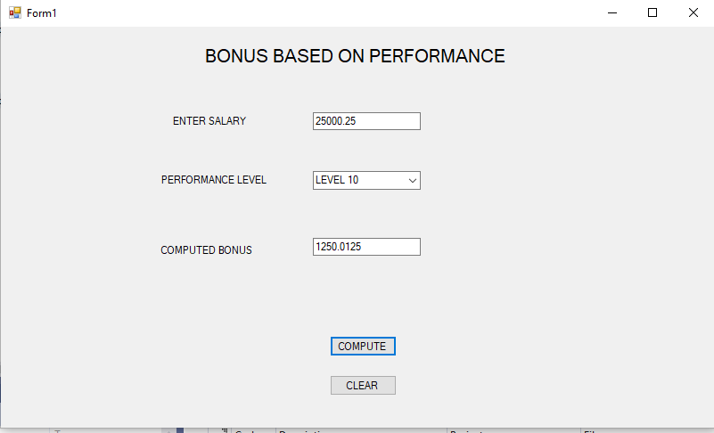

**QUESTION 4**

using System;

using System.Collections.Generic;

using System.ComponentModel;

using System.Data;

using System.Drawing;

using System.Linq;

using System.Text;

using System.Threading.Tasks;

using System.Windows.Forms;

namespace Ques4

{

public partial class Form1 : Form

{

public Form1()

{

InitializeComponent();

}

private void button1_Click(object sender, EventArgs e)

{

if (comboBox1.SelectedItem.ToString() != null || comboBox2.SelectedItem.ToString() != null)

{

MessageBox.Show("Thankyou for purchasing from us");

}

else

{

MessageBox.Show("Please select both model and colour of the car");

}

}

private void button2_Click(object sender, EventArgs e)

{

comboBox1.Text = "";

comboBox2.Text = "";

}

}

}

**INPUT/OUTPUT**

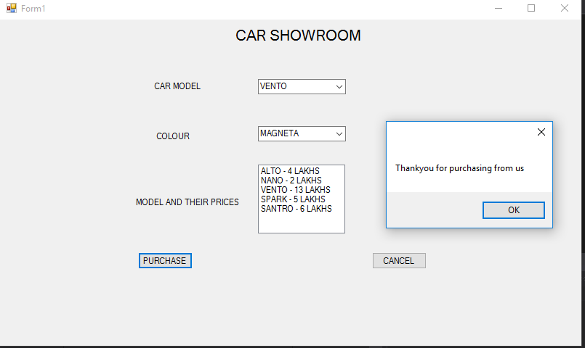

**LAB 2**

**Question 1**

using System;

namespace Ques1

{

class Item

{

private string name;

private int price;

public delegate void PriceChangeHandler();

public event PriceChangeHandler PriceChanged;

public string Name

{

get

{

return name;

}

set

{

name = value;

}

}

public int Price

{

get

{

return price;

}

set

{

price = value;

if(PriceChanged!=null)

{

PriceChanged();

}

}

}

public void ChangeHappened()

{

Console.WriteLine("Event Handler is Invoked now\nNow The price for {0} is {1}", name, price);

}

}

class Program

{

static void Main(string[] args)

{

Item i = new Item();

int cost;

i.PriceChanged += i.ChangeHappened;

Console.WriteLine("Enter the name of the item and its price");

i.Name = Console.ReadLine();

int.TryParse(Console.ReadLine(), out cost);

i.Price = cost;

}

}

}

**Input/Output**

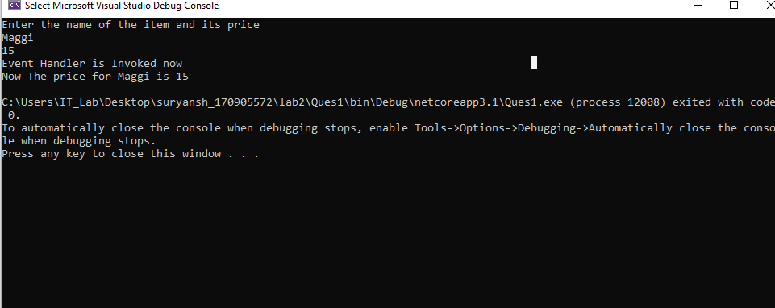

**Question 2**

using System;

namespace Ques2

{

class Item

{

string name;

static double price = -1.0;

public string Name

{

get;

set;

}

public double Price

{

get

{

return price;

}

set

{

if (value > 0)

{

price = value;

}

else

{

Console.WriteLine("Please Enter positive price value only\n");

}

}

}

public double CalcGST()

{

return 0.08 * price;

}

static void Main(string[] args)

{

//Console.WriteLine("Hello World!");

double cost = 0.0;

Item i = new Item();

Console.WriteLine("Enter the name of the item and its base price\n");

string name = Console.ReadLine();

double.TryParse(Console.ReadLine(), out cost);

i.Price = cost;

if(i.Price!=-1.0)

{

double ans = i.CalcGST();

Console.WriteLine("The GST charged on {0} will be {1}\n", name, ans);

}

}

}

}

INPUT/OUTPUT

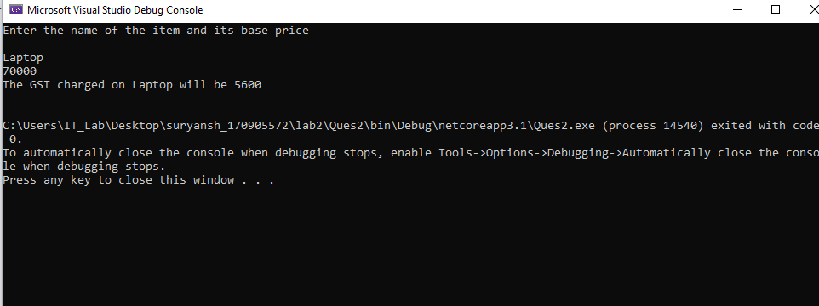

QUESTION 3

using System;

namespace Ques3

{

public delegate void TrafficDel();

class TrafficSignal

{

public void Red()

{

Console.WriteLine("RED MEANS STOP!!");

}

public void Yellow()

{

Console.WriteLine("YELLOW MEANS WAIT!!");

}

public void Green()

{

Console.WriteLine("GREEN MEANS GO!!");

}

static void Main(string[] args)

{

TrafficSignal ts = new TrafficSignal();

TrafficDel td;

td = ts.Red;

td();

td = ts.Yellow;

td();

td = ts.Green;

td();

//Console.WriteLine("Hello World!");

}

}

}

**INPUT/OUTPUT**

