**LAB 2**

**Question 1**

using System;

namespace Ques1

{

class Item

{

private string name;

private int price;

public delegate void PriceChangeHandler();

public event PriceChangeHandler PriceChanged;

public string Name

{

get

{

return name;

}

set

{

name = value;

}

}

public int Price

{

get

{

return price;

}

set

{

price = value;

if(PriceChanged!=null)

{

PriceChanged();

}

}

}

public void ChangeHappened()

{

Console.WriteLine("Event Handler is Invoked now\nNow The price for {0} is {1}", name, price);

}

}

class Program

{

static void Main(string[] args)

{

Item i = new Item();

int cost;

i.PriceChanged += i.ChangeHappened;

Console.WriteLine("Enter the name of the item and its price");

i.Name = Console.ReadLine();

int.TryParse(Console.ReadLine(), out cost);

i.Price = cost;

}

}

}

**Input/Output**

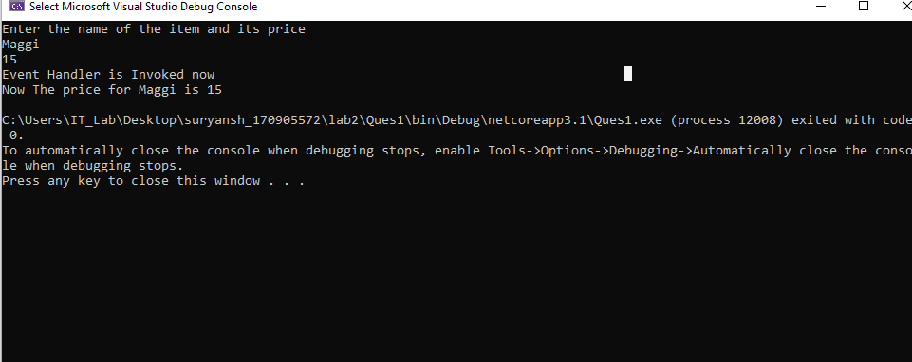

**Question 2**

using System;

namespace Ques2

{

class Item

{

string name;

static double price = -1.0;

public string Name

{

get;

set;

}

public double Price

{

get

{

return price;

}

set

{

if (value > 0)

{

price = value;

}

else

{

Console.WriteLine("Please Enter positive price value only\n");

}

}

}

public double CalcGST()

{

return 0.08 * price;

}

static void Main(string[] args)

{

//Console.WriteLine("Hello World!");

double cost = 0.0;

Item i = new Item();

Console.WriteLine("Enter the name of the item and its base price\n");

string name = Console.ReadLine();

double.TryParse(Console.ReadLine(), out cost);

i.Price = cost;

if(i.Price!=-1.0)

{

double ans = i.CalcGST();

Console.WriteLine("The GST charged on {0} will be {1}\n", name, ans);

}

}

}

}

INPUT/OUTPUT

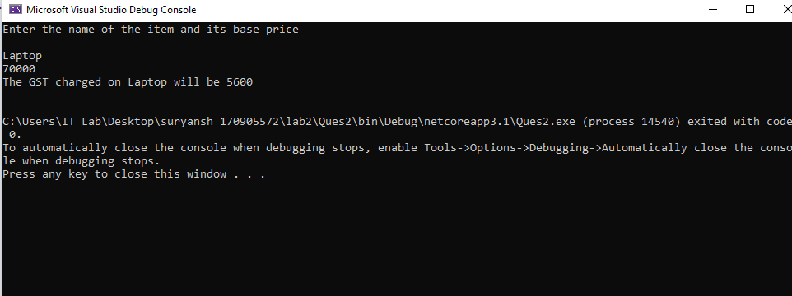

QUESTION 3

using System;

namespace Ques3

{

public delegate void TrafficDel();

class TrafficSignal

{

public void Red()

{

Console.WriteLine("RED MEANS STOP!!");

}

public void Yellow()

{

Console.WriteLine("YELLOW MEANS WAIT!!");

}

public void Green()

{

Console.WriteLine("GREEN MEANS GO!!");

}

static void Main(string[] args)

{

TrafficSignal ts = new TrafficSignal();

TrafficDel td;

td = ts.Red;

td();

td = ts.Yellow;

td();

td = ts.Green;

td();

//Console.WriteLine("Hello World!");

}

}

}

**INPUT/OUTPUT**

