Page : users-administration.php

For favorite icon, excel sheet tab : User Administration , row : 232,233

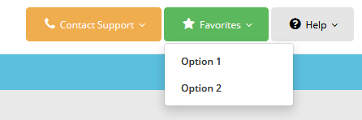

When clicked on Favorit (Star) can we add on the above favorites list ? If it is yes then we need table structure for this favorites.

Page : access-management-roles.php



What is the functionality of the above button and textboxes.

Date : 5 September 2017

Tab : Access Management

assign-app-adminstrator.php page please differentiate work of the button “Assign” and “Update Selected”

Tab : Create new Subscribr Popup

Row no.: 69 CXS_USERS table

From this subscriber popup insert only user name,start date and end date data only. Isn’t it? Actually here we have not data for password or resource name and others fields which are required for the table CXS_USERS.

Row no. 17: MIDDLE_INITIAL field has no link to store data.

Row no. : 68,70 which data is stored in table CXS_APPLICATION_ASSIGMENTS from Add New Subscribers

Row no. 77 still I think its pending but can we store this data in table? If yes in which field?

What is the work of “View SLA” button.

Tab : Subscriber Administration Data

Row no. : 39 we have not CXS_APPLICATIONS table instead of it we have SYS_APPLICATIONS which is structured in tab : Access Management row no. 145. Please elaborate this combo box functionality.

Row no. 51 : Please Explain design style of update functionality. As the row no. 48 says all fields are editable. Can we edit subscriber name and username from here too.