Complex Web Page

ICAWEB502A & ICAWEB505A

Nolan Ryan

2014

Table of Contents

Task 1 2

Task 2 3

Task 3 3

# Task 1

This is a brief report on how the requirements for the website such as paragraphs, navigation, image maps and layout are achieved. For folder the structure I used folders such as css, images, js and php and for naming convention I used lowercase, no spaces and for Hypertext Mark-up Language files I used .html.  
  
Folder Layout  
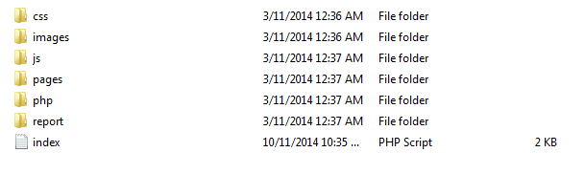

Site Layout  
The layout was achieved by using division tag and giving them specific names such as wrapper, headerwrapper, leftheader, rightheader, navbar, contentwrapper, mainbar, sidebar and footer. Then gave them specific settings in the css.  
  
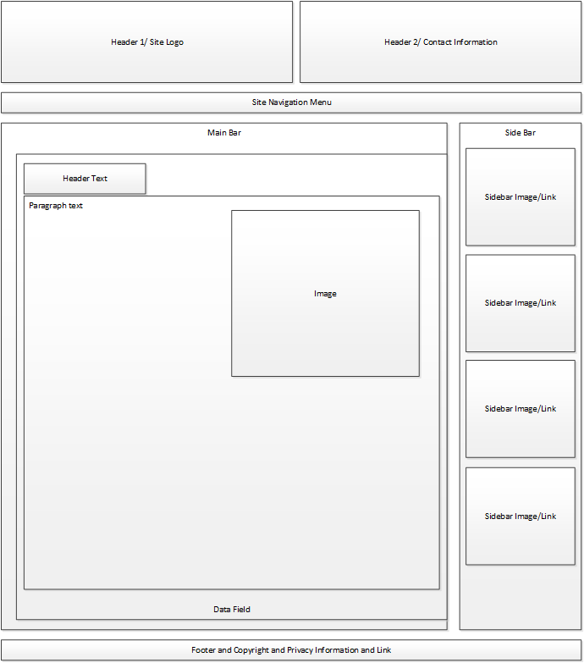

# Task 2

For Paragraph I added the settings to set the font to Verdana, Arial, Helvetica or sans-serif. I set the font size to 0.8em and the colour to black.

For Header1 I set the font to Verdana, Arial, Helvetica or sans-serif and set the font size to 1emFor letter spacing I set it to -2px and set the font colour to #b40c00. I set the font to be Bold and underlined. For Header 2 I did the same as Header 1 except for the font size was 0.9em and I did not use underline. For Header 3 same again except with smaller font at 0.9em different colour #e86600 and font style italic.

For navigation I used unordered lists and anchors and was able to achieve look I desired. This was achieved by using unordered lists and placing anchors in a li. And in the CSS I placed setup font to the usual ones and set the height to 25px as required and set width to 100% to make it fill the screen.

The layout was achieved by using division tag and giving them specific names such as wrapper, header and navbar each div would have settings for each one such as height, width, padding and margin. For my site I used a wrapper and in the wrapper I have a header that contains right and left headers for the company logo and contact information. In my navbar it contains the links for all the html pages. For my main content and sidebar I placed them in a content container so I can control their heights. And lastly I placed my footer outside the wrapper after have a lot of problems with it.  
  
For the image map i was able to create image maps using division tab, image, unordered list, anchors and span tag. By loading the image I wanted into an img tag in the division tab and putting the unordered list’s <li> on a specific part of the division tab (i.e. top: 60% and left 20%) and whenever the mouse hovers over it would show the span’s text in tool tip.

# Task 3

I tested the website on Chrome, Firefox, Safari and Internet Explorer and all worked well.

Chrome:  
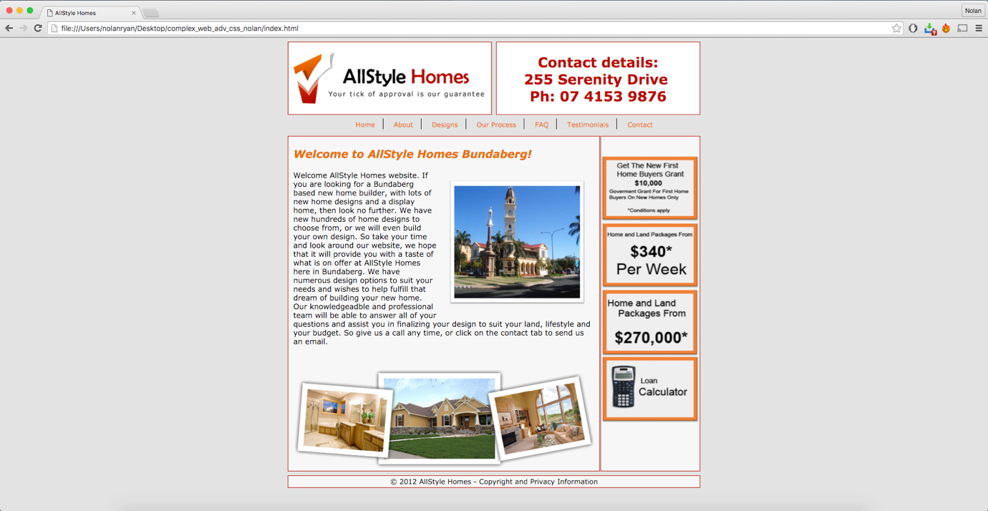

Firefox:  
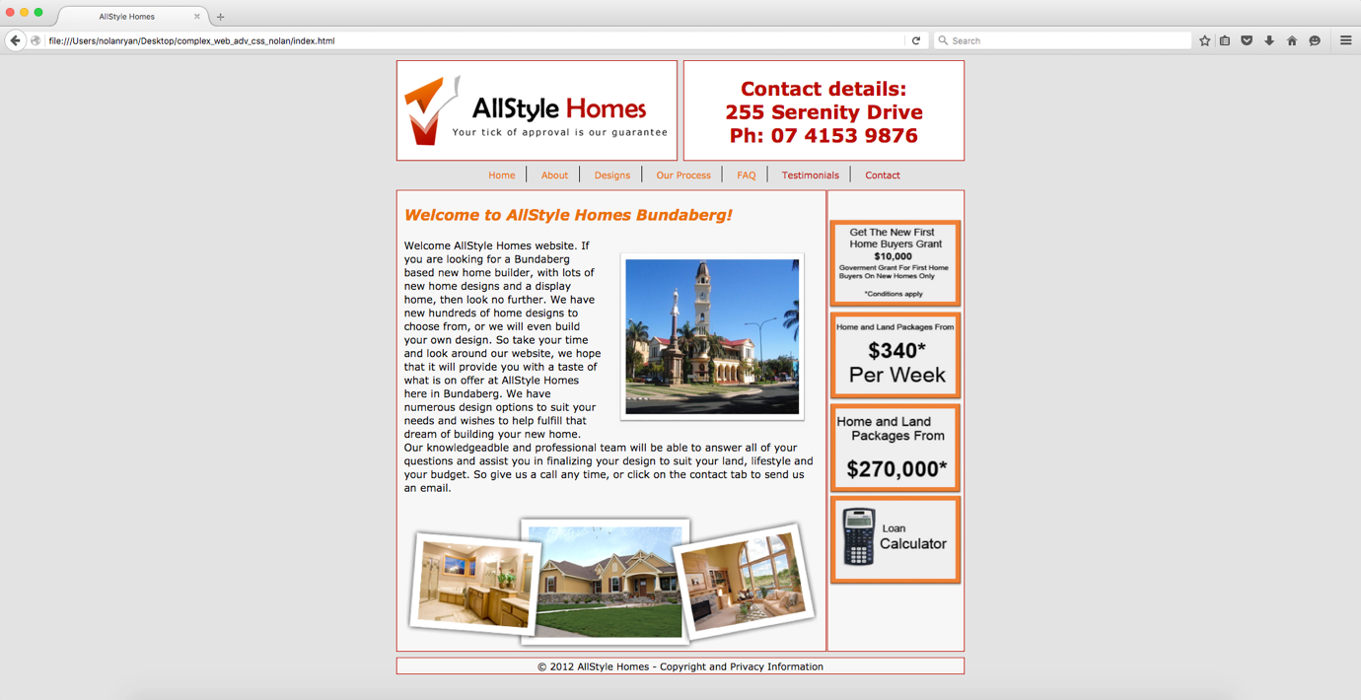

Safari:  
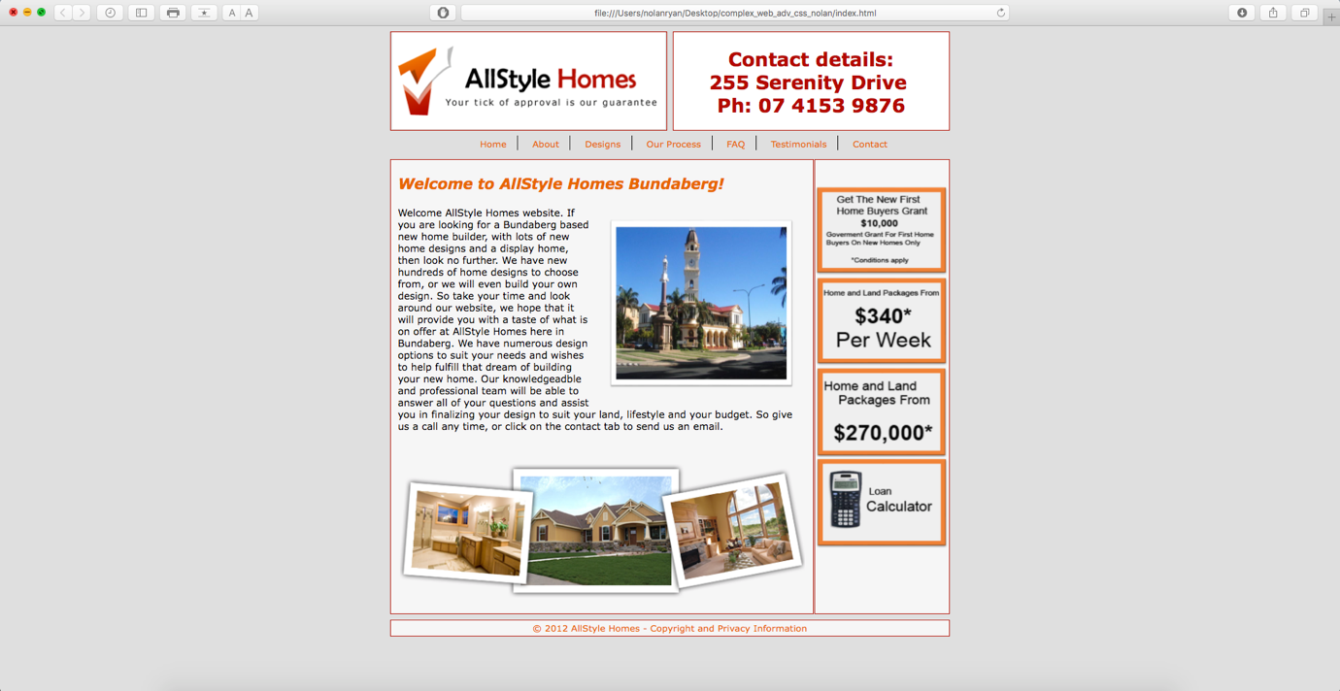

Internet Explorer:  
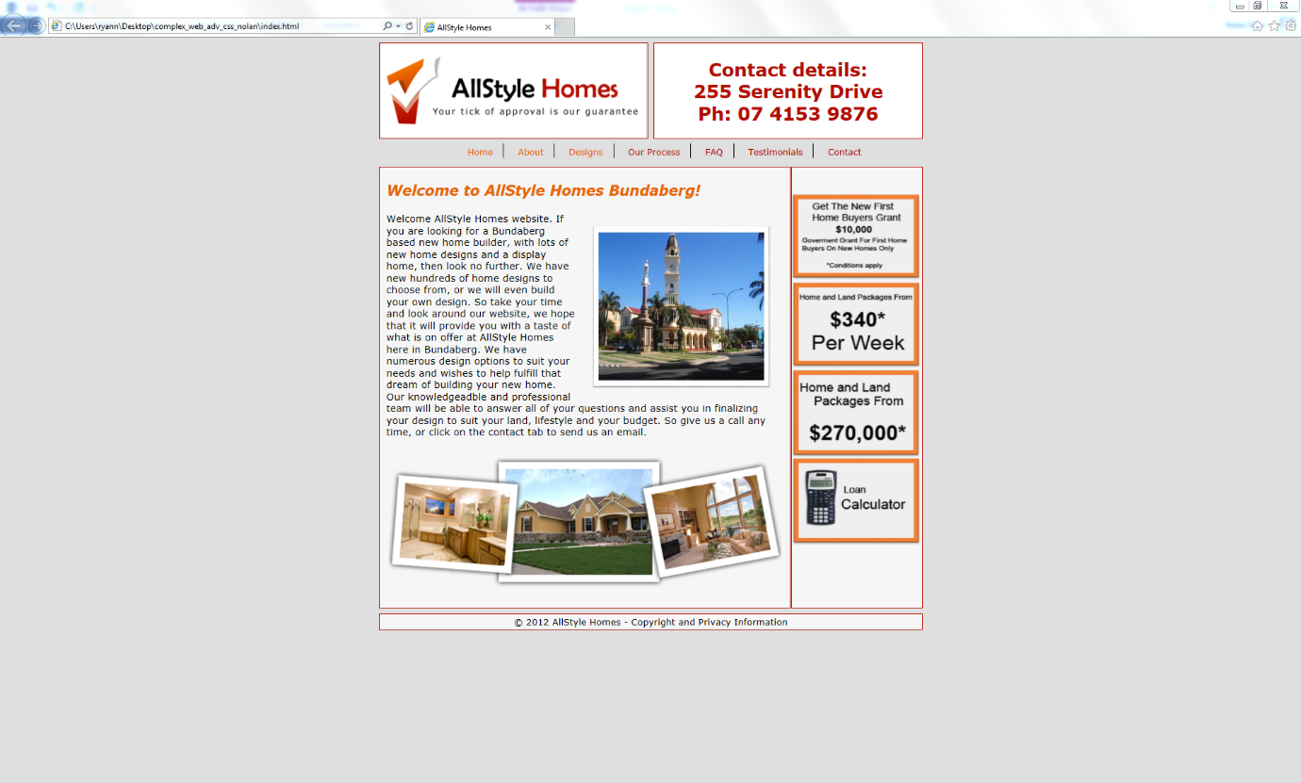

Safari on iPhone 6s:  
 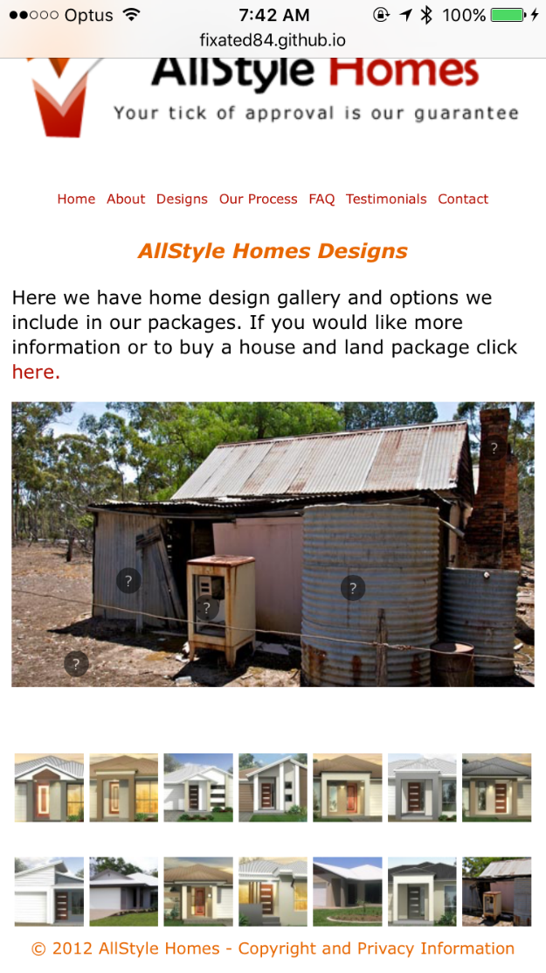

I was able to successfully validate all my pages and css.

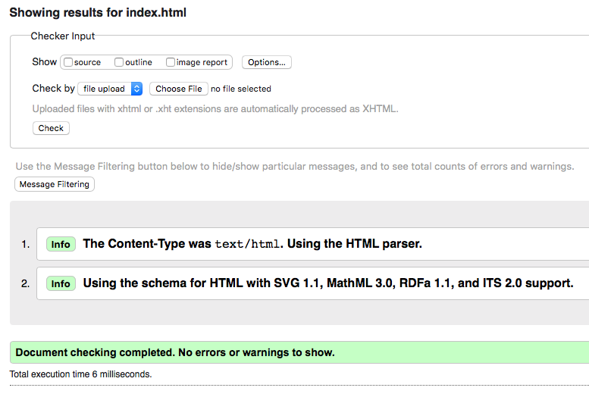

I have been getting CSS errors but from what I was able to find out online it could be a bug in the validator.

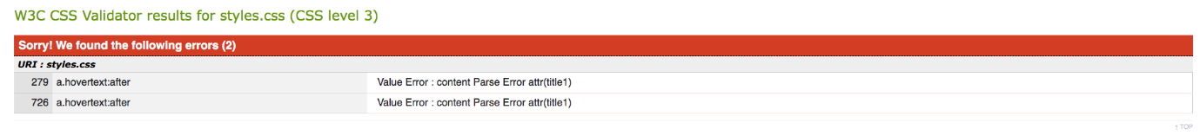

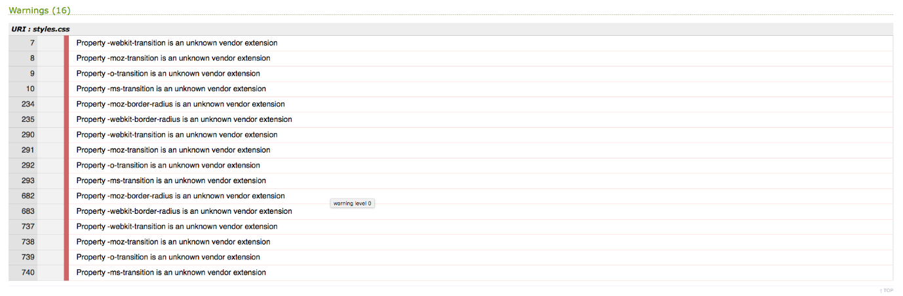

## Issues with website

I had a few minor issues with the website such as:

1. mailto link causing validate errors
2. Issues with image map on mobile screens

## Check List

1. Site works on all browsers – Yes
2. Does the site meet the technical specification criteria – Yes
3. Does the site meet the style guide criteria – Yes
4. Validate the site and css – Yes
5. Test site for accessibility standards – Yes
6. Identify any issues and fix them – Yes
7. Re-test site – Yes

## Recommendations and rectifications to issues

I was able to fix the mailto error by using Unicode to replace certain symbols such as for = with &#61;. For image map I was able to fix the issue I had by using percentage instead of pixels.

## 2 x recommendations for additional or changes to design features

The first recommendation is to remove the image map from mobile because it is too complex to adjust it for every screen. The second recommendation is to use bootstrap to improve the mobile and tablet experience.