**Final Frontier**

**Team "Snoopy"**

* **Team name and list of team members (including usernames from the student system)**

|  |  |  |  |
| --- | --- | --- | --- |
| **№** | **FULL NAME** | **NAME IN TELERIK ACADEMY SYSTEM** | **NAME IN CODEPLEX** |
| 1 | Dimo Pertov | dimo.petrof | webdude21 |
| 2 | Deyan Yanakiev | lostm1nd | lostm1nd |
| 3 | David Gacev | david.gacev | DavidGacevGit |
| 4 | Ivo Yontchev | Ivo.Iontchev |  |
| 5 | Svilen Valkanov | SvilenVal |  |
| 6 | Kristiyan Marinov | koko_9898 |  |

* **Project explanation – describe your game**

Final Frontier is shooter game, developed and published by “Snoopy team” URL GitHub: <https://github.com/webdude21/FinalFrontier>, in June 2014, as part of a team project of "JavaScript UI & DOM 2014 - online" by the Telerik Academy.

The name of the game is Final Frontier, because our ship is final frontier to overcome for aliens to conquer our Mother Planet. The alien ships on 6th light speed and show up near our planet and try to conquer and enslave all people.

The player controls a starfighter that can fire, and move in round with mouse aim and fly with left/right/up/down arrows in space near our planet. The objective of Final Frontier is to score as many points as possible by destroying enemy aliens.

**How to start the game?**

1.Start Up Screen:



2.Start Game:

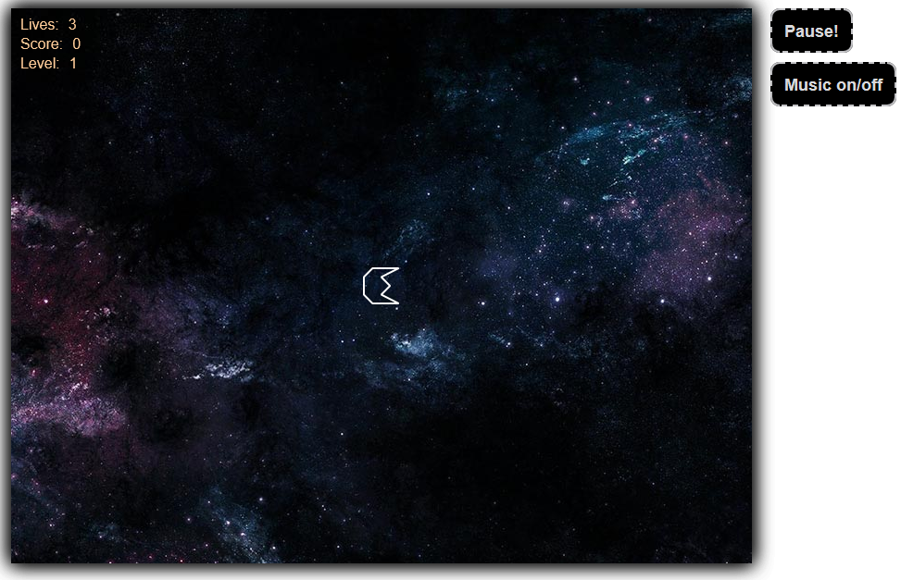

3.Screen during gameplay:

* Start play screen:



* Game play screen:

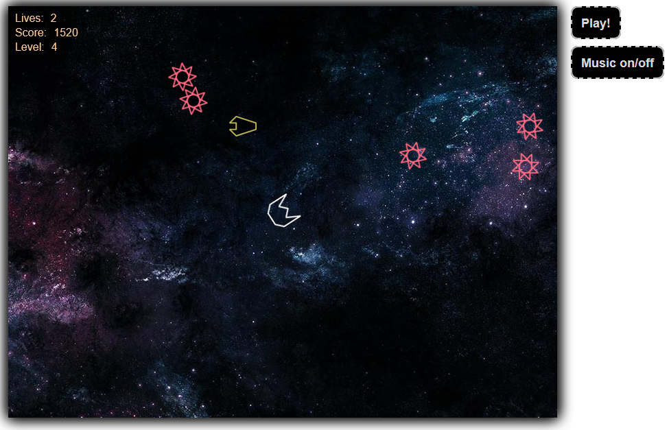

* Killing our ship:

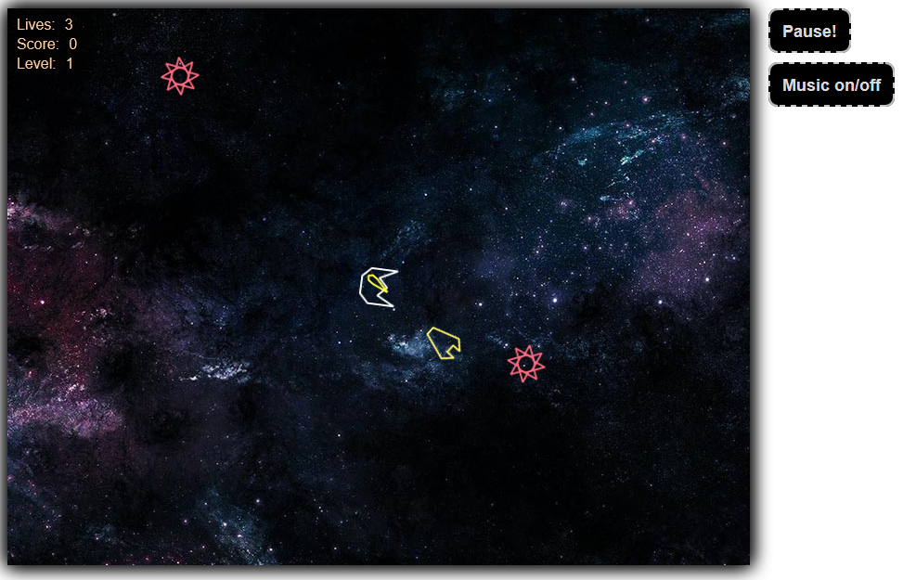

* Game Over screen:

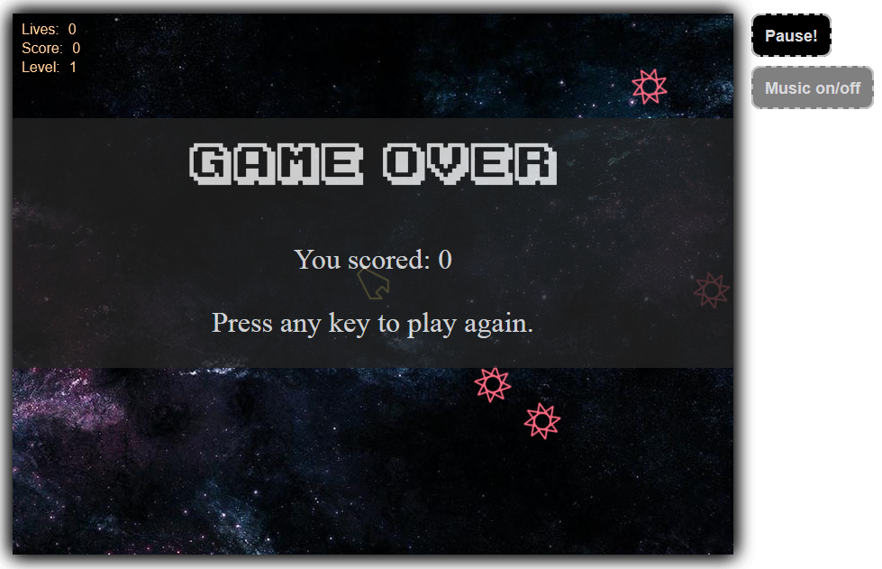

**Meet the requirements:**

1. We use Canvas framework KineticJS
2. Picked Canvas framework KineticJS over SVG, because of the advantage in performance of Canvas in raster drawings of large amount of objects..
3. Created animations for Canvas.
4. The application works in the latest version of the browsers – Google Chrome, Mozzilla Firefox, IE 10/11, Opera and Safari.
5. Followed the best practices for producing high-quality code: correct naming, data encapsulation, strong cohesion and loose coupling.
6. Used GitHub as a source control system.
7. Used DOM manipolations.

* **The URL of your TFS repository**

<https://github.com/webdude21/FinalFrontier>