**FIFO**

module para_fifo #(

parameter DEPTH = 32,

parameter DATA_W = 8)

(

input wire clk,

input wire reset,

input wire w_en,

input wire r_en,

input wire [DATA_W-1:0]data_in,

output wire [DATA_W-1:0]data_out,

output wire empty,

output wire full

);

logic [DEPTH-1:0][DATA_W-1:0]fifo_mem;

parameter PTR_W = $clog2(DEPTH);

logic [PTR_W-1:0]wr_ptr;

logic [PTR_W-1:0]rd_ptr;

logic [DATA_W-1:0] fifo_pop_data;

always_ff @(posedge clk or posedge reset)

begin

if(reset)begin

rd_ptr <= {PTR_W+1{1'b0}};

wr_ptr <= {PTR_W+1{1'b0}};

fifo_pop_data <={DATA_W+1{1'b0}};

for(int i=0; i<32; i++) begin

fifo_mem[i] <= {DATA_W+1{1'b0}};

end

end

else

begin

if((w_en == 1'b1) && (full == 1'b0))

begin

fifo_mem[wr_ptr]<=data_in;

wr_ptr <= wr_ptr + 1'b1;

end

if((r_en == 1'b1) && (empty == 1'b0))

begin

fifo_pop_data <= fifo_mem[rd_ptr];

rd_ptr <= rd_ptr + 1'b1;

end

end

end

assign data_out = fifo_pop_data;

assign empty = ((wr_ptr - rd_ptr) == 0)? 1'b1:1'b0;

assign full = ((wr_ptr - rd_ptr) == 31)? 1'b1:1'b0;

endmodule

**Test Bench Code**

module tb_para_fifo();

parameter DATA_W = 8;

parameter DEPTH = 32;

logic clk;

logic reset;

logic w_en;

logic[DATA_W-1:0] data_in;

logic r_en;

logic[DATA_W-1:0] data_out;

logic full;

logic empty;

// Instantiate the RTL

para_fifo #(.DEPTH(DEPTH), .DATA_W(DATA_W)) Day19(.*);

always begin

clk = 1'b0;

#5;

clk = 1'b1;

#5;

end

initial begin

reset = 1'b1;

w_en = 1'b0;

r_en = 1'b0;

@(posedge clk);

reset = 1'b0;

@(posedge clk);

@(posedge clk);

for (int i =0; i<DEPTH; i++)begin

w_en = 1'b1;

data_in = $urandom_range(0,2**DATA_W-1);

@(posedge clk);

end

w_en = 1'b0;

@(posedge clk);

@(posedge clk);

for (int i =0; i<DEPTH; i++)begin

r_en = 1'b1;

@(posedge clk);

end

r_en <= 1'b0;

@(posedge clk);

@(posedge clk);

w_en <= 1'b1;

data_in <= $urandom_range(0, 2**DATA_W-1);

@(posedge clk);

w_en <= 1'b0;

// Push and pop both

for (int i=0; i<DEPTH; i++) begin

w_en <= 1'b1;

r_en <= 1'b1;

data_in <= $urandom_range(0, 2**DATA_W-1);

@(posedge clk);

end

w_en <= 1'b0;

r_en <= 1'b0;

@(posedge clk);

@(posedge clk);

$finish();

end

// Dump vcd

initial begin

$dumpfile("day19.vcd");

$dumpvars(0, tb_para_fifo);

end

endmodule

**Simulation**

**W_en**

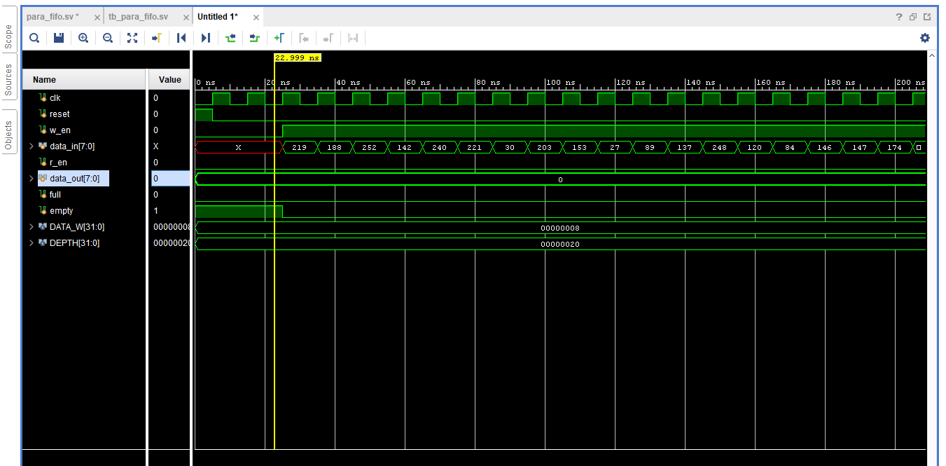

r_en

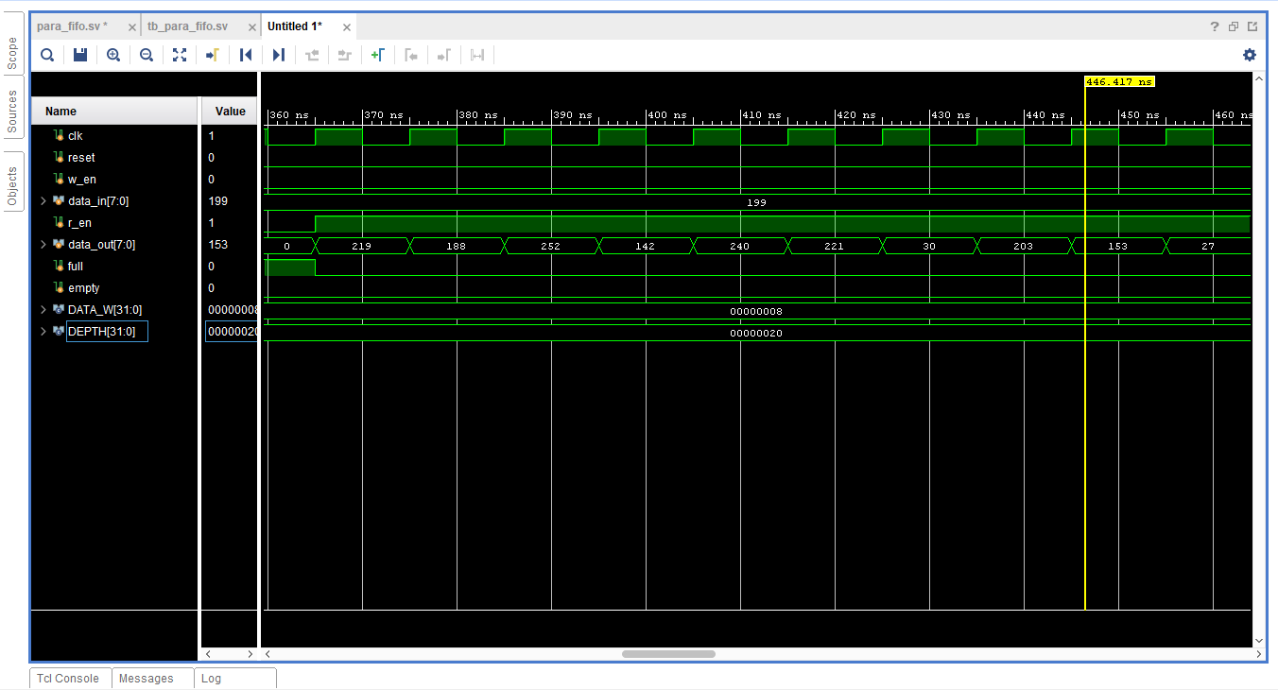

Both w_en and r_en