**Vivado Experiment on Generate Statements**

**Experiment 01:**

1. Set the generic value on the top level to 2 and synthesis the code. After the synthesis open the schematic and explain what you see?

**Explanation**:

Generic Value set to 2 will instantiate two debouncer circuits for 2 switches. It will instantiate as much debouncer modules as we will set a value of count according to our switches.

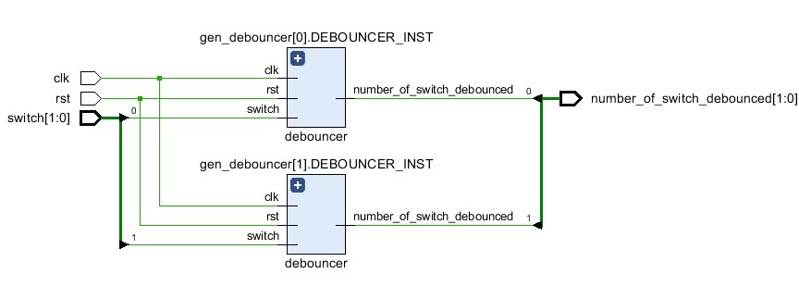

1. Set the generic value on the top level to 4 and synthesis the code. After the synthesis open the schematic and explain what you see?

Explanation:

Generic Value set to 4 will instantiate four debouncer circuits for 4 switches. It will instantiate as much debouncer modules as we will set a value of count according to our switches.

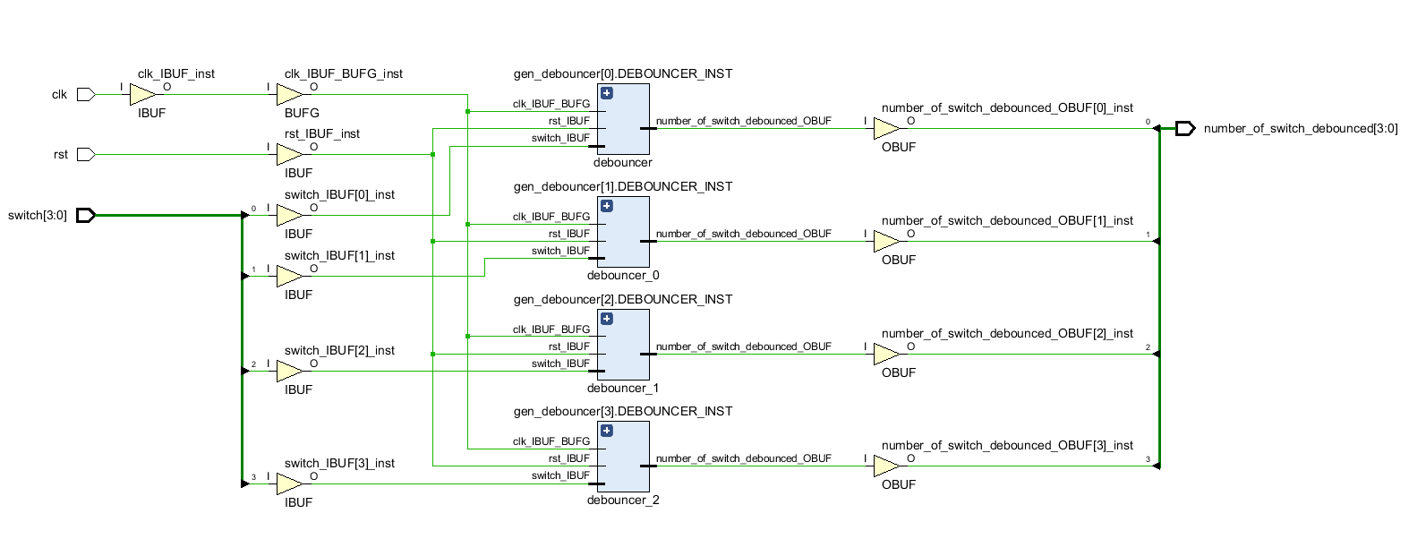

**Experiment 02:**

1. Replace the architecture in the top level with the architecture below and set the generic value count to 0 and run the synthesis and explain what you see.

Explanation:

Generic Value for generate_module set to 0 will instantiate only 1 debouncer circuit for 1 switch iff generate_module value set to 0, if there is a value other than 0, it will not generate or instantiate a debouncer module.

