1.配置根目录www

DocumentRoot

<Directory俩个地方

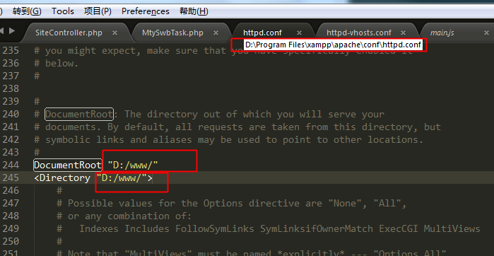

2.打开虚拟主机

# Virtual hosts

Include conf/extra/httpd-vhosts.conf

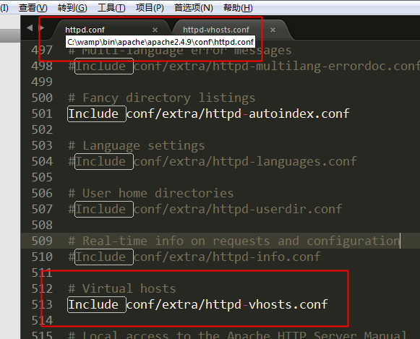

3.配置虚拟主机

ThinkPhp配置到项目目录

<VirtualHost *:80>

DocumentRoot "d:/www/mycsm2"

ServerName www.mycsm.com

ErrorLog "logs/www.mycsm.com-error.log"

CustomLog "logs/www.mycsm.com-access.log" common

</VirtualHost>

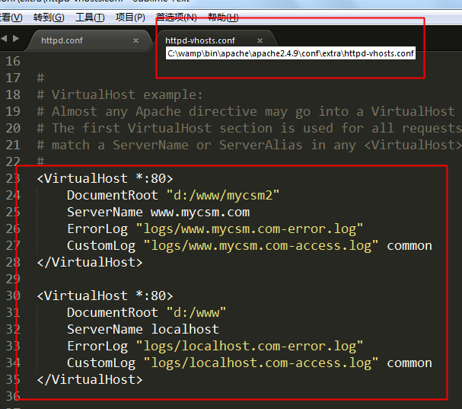

Yii配置到web目录  
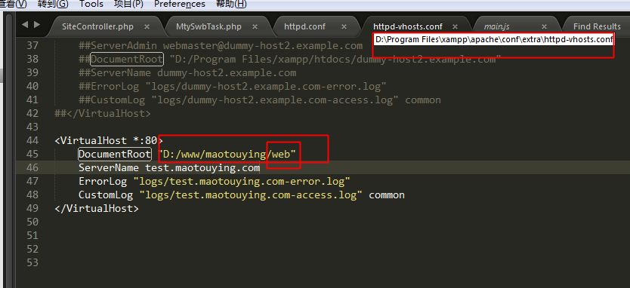

4.配置hosts

127.0.0.1 www.mycsm.com

127.0.0.1 localhost

