参考：<https://github.com/felixrieseberg/npm-windows-upgrade>

npm install --global --production npm-windows-upgrade

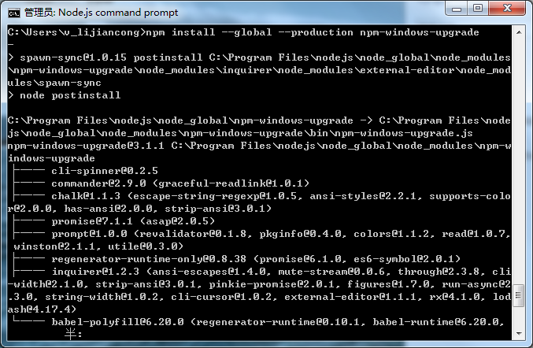

报错

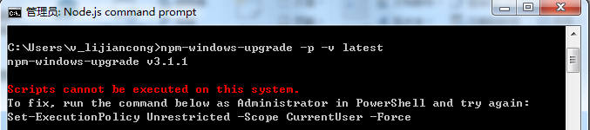

powershell Set-ExecutionPolicy RemoteSigned



npm-windows-upgrade -p -v latest

