1. 用斜单引号包裹代替字符串拼接  
   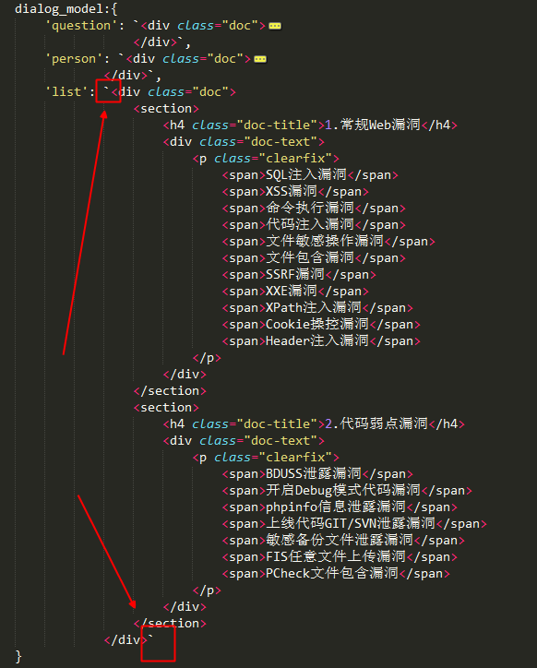
2. 传参匹配

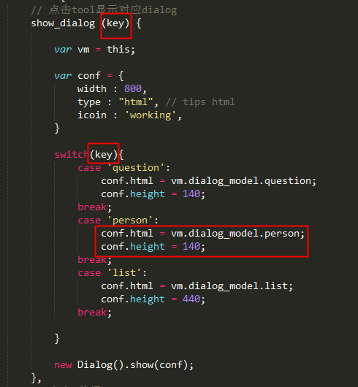

1. IE SCRIPT5022: [vuex] vuex requires a Promise polyfill in this browser.
2. 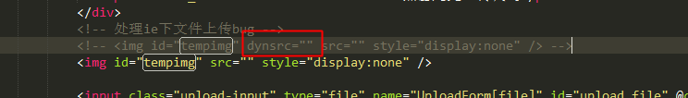
3. 当表单中只有一个input输入元素时，点击enter键，form表单会自动提交。

1 <form onsubmit="return false">

2 <input type="text" name="test"/>

3 </form>

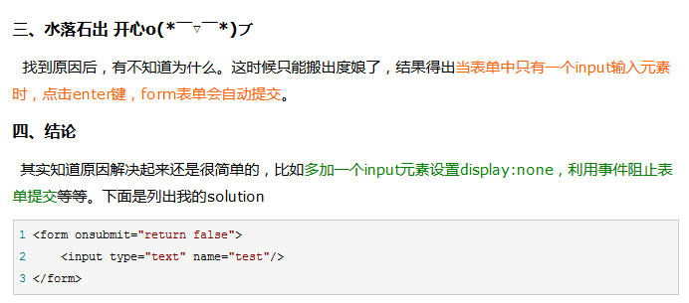

// 千分位

to_thousands(num) {

var num = (num || 0).toString(), result = '';

while (num.length > 3) {

result = ',' + num.slice(-3) + result;

num = num.slice(0, num.length - 3);

}

if (num) { result = num + result; }

return result;

},