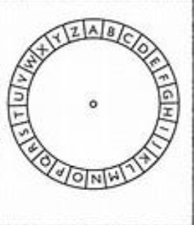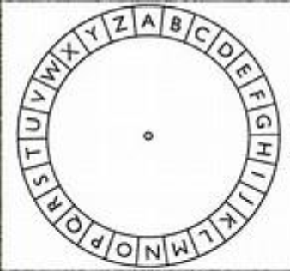

1.1

a) ﻿Plain Text: A page of history is worth a volume of logic

Cypher: K ZKQO YP RSCDYBI SC GYBDR K FYVEWO YP LYQSM

b) ﻿Cypher: AOLYLHYLUVZLJYLAZILAA LYAOHUAOLZLJYLALZAOHALCLYFIVKFNBLZZLZ.

Rotation: 7

Plain text: THERE ARE NO SECRETS BETTER THAN THE SECRETES THAT EVERYBODY GUESSES.

C) ﻿XJHRFTNZHMZGAHIUETXZJNBWNUTRHEPOMDNBJMAUGORFAOIZOCC =

WHEN ANGRY COUNT TEN BEFORE YOU SPEAK IF VERY ANGRY AN HUIRRED

1.2

a) ﻿ Cypher: ﻿LWKLQNWKDWLVKDOOQHYHUVHHDELOOERDUGORYHOBDVDWUHH

Shift: 3

Plain text: I THINK THAT I SHALL NEVER SEE A BILLBOARD LOVELY AS A TREE

b) ﻿Cypher: UXEN RBWX CUXENFQRLQJUCNABFQNWRCJUCNAJCRXWORWMB

Shift: 9

Plain text: LOVE IS NOT LOVE WHICH ALTERS WHEN IT ALTERATION FINDS

c) Cypher: ﻿BGUTBMBGZTFHNLXMKTIPBMAVAXXLXTEPTRLEXTOXKHHFYHKMAXFHNLX

Shift: 19

Plain text: IN BAITING A MOUSE TRAP WITH CHEESE ALWAYS LEAVE ROOM FOR THE MOUSE

1.3

a) IBXFEPAQLBQAAXWQWIBXFSVAXW

b) ciphertext alphabet: SCJAXUFBQKTPRWEZHVLIGYDNMO

plain text alphabet: ABCDEFGHIJKLMNOPQRSTUVWXYZ

c) cipher text: THE SECRET PASSWORD IS SWORDFISH

1.4)

a.