MediRoute: Medical Query Classification Using Neural Network

Authors Name:-

JIT NAYAK (23CS2011050)
ANTARIK DE (23CS2011021)
ABHISEK TUDU (23CS201002)
DEBAJIT PATRA (23CS2011040)
ANKUSH SARKHEL (23CS2011020)

Abstract
Healthcare Chatbot, Medical NLP, Neural Networks, Intent Classification, Natural Language Understanding, TF-IDF, LSTM, Deep Learning, Clinical Text Mining, MTSamples Dataset.Many healthcare providers are using platforms where patients describe symptoms and medical issues using free text but its still a time-consuming process to manually assign these queries to the right department or specialist. In this project the design and implementation of a time neural network based Medical NLP healthcare chatbot, called MediRoute that automatically categorizes patients free text medical queries to appropriate medical specialty is presented. The heart of the chatbot is a Natural Language Understanding (NLU) model that was trained using the MTSamples (Medical Transcriptions) dataset, which includes 4,999 medical transcription samples from about 40 medical specialties that are publicly available. We clean the data. Limit the task to the top 10 most common specialties given that it is a very imbalanced problem and build and compare two candidate NLU architectures: (i) a feedforward Dense neural network with TF-IDF weighted n-gram features and (ii) a sequence-based Embedding plus Long Short-Term Memory (LSTM) network directly on tokenized text. Both models are trained with stopping and tested on a test set which is held out and split in a stratified manner with accuracy, precision, recall, F1-score and confusion matrix analysis. An end-to-end interactive chatbot is completed by a light-weight confidence-based response-generation layer that embeds the performing Dense TF-IDF model, which achieves a test accuracy of 43.19% compared to 39.34% for the LSTM model. We show that the chatbot performs on the sample conversations and pinpoint its weaknesses, such as class imbalance and out-of-scope queries before discussing several directions for improving the performance of healthcare chatbots, such as transformer-based embeddings (BioBERT/ClinicalBERT) entity extraction and multi-turn dialogue.

Keywords

Healthcare Chatbot, Medical NLP, Neural Networks, Intent Classification, Natural Language Understanding, TF-IDF, LSTM, Deep Learning, Clinical Text Mining, MTSamples Dataset..

1. Introduction
In healthcare institutions there is an amount of textual data produced every day in the form of physician notes patient queries, discharge summaries and transcribed dictations all of which are unstructured. If someone contacts the hospital digitally – via the hospital website, portal or messaging system – and provides free text information regarding their symptoms it must still be read and assigned to the appropriate department or specialist before care can be started, by front-desk staff or a triage care professional. This manual routing process is labour-intensive, inefficient and can't scale to accommodate patients, longer hours or a desire for 24/7 digital healthcare access.

One way to overcome this hurdle is through the use of AI specifically in the context of healthcare chatbots. This can mean that a healthcare chatbot can be available at all times can easily read a free-text description provided by a patient and respond to it or can simply direct it to the department thereby eliminating the waiting time administrative burden of staff and worse the first impression of the patient from the healthcare system. Any such chatbot is built around a Natural Language Understanding (NLU) engine: a model that turns the text entered by a patient into a structured intent/categorization that downstream logic can use.

This project introduces the Medical NLP healthcare chatbot "MediRoute" that consists of an NLU module which's a neural network trained to classify a patients free-text query from a variety of medical specialties and return a natural-language routing response. This is a -class text categorization problem under conversation constraint and is difficult for many reasons: (i) the medical and specialized terms vary across different specialties, (ii) there is a lot of overlap among medical terms for similar specialties such as Cardiovascular/Pulmonary and Consult. History and Phy. And (iii) the distribution of the classes is strongly skewed in the real world: some specialties have hundreds of training examples others have only a few.

This report outlines the process of designing and implementing MediRoute – from dataset selection and exploration to text preprocessing, feature extraction, designing and training the NLU model and creating an interactive live chatbot demo that demonstrates a confidence-aware response generation layer that transforms a raw classification into a conversational response. Two different neural network architectures are implemented in the NLU engine: a feedforward Dense network based on TF-IDF features and an Embedding-LSTM network.

The rest of this report is organized as follows - Section 2 reviews the works related to medical/clinical text classification and health care chatbot systems. Section 3 outlines the methodology proposed, the working flow chart, the data collection and pre-processing steps the architecture of the NLU models and the module which generates the responses for the chatbot. The experimental results, chatbot conversation demonstration, comparison with existing technique and limitations encountered are presented in section 4. The report is closed with Section 5: Directions for work

2. Background and Literature Survey
Due to the proliferation of Electronic Health Records (EHR) and transcribed clinical narratives, automated clinical and medical text classification has been an area of research in NLP for more than a decade. Early methods were mostly based on classical machine learning algorithms. Support Vector Machines (SVM) Bayes, Logistic Regression and k-Nearest Neighbors (kNN) and usually applied with bag of words or TF-IDF feature representation. Although they have their successes these methods need manual work for feature engineering and sometimes fail to commensurate the semantic relationships between medically related terms.

The use of neural word embeddings like Word2Vec and the further development of networks like Convolutional Neural Networks (CNNs) Recurrent Neural Networks (RNNs) and Long Short-Term Memory networks (LSTMs) have greatly improved the field by allowing the models to learn distributed and dense representations of text directly from the data. Recently transformer-based pre-trained language models (PLMs) that are able to learn rich contextual information through self-attention mechanisms have yielded new state-of-the-art results on a broad spectrum of biomedical/clinical NLP tasks, including BioBERT and ClinicalBERT which are fine-tuned versions of BERT for the biomedical and clinical domains, respectively.

In tandem with this development in text classification a separate but related field of research has developed specifically in the context of healthcare chat robots – systems that integrate an NLU model into a dialogue interface that interact directly with patients. The current systems include healthcare chatbots (which employ either ML or fine-tuned BERT variants for intent classification and a response-generation or dialogue-management portion that determines what to reply to the user during a dialogue; in more sophisticated systems, an entity-extraction component and rule-based clinical decision logic for symptom triage). Some of the systems deployed indicate that they leverage cloud-based NLP services such as Azure Cognitive Services or tuned transformer models in conjunction with structured medical knowledge bases for symptom diagnosis answering FAQs and routing to specialists.

There are a number of -existing studies that are particularly relevant to this project as they are based on similar or a closely related medical text classification task to the one we want to use for our chatbots NLU engine. One interesting study to be noted from the field of machine learning classification is the project by Almazaydeh et al. Who directly applied machine learning algorithms to the dataset used in this project, MTSamples for the classification of medical specialties from transcription data with the best accuracy obtained by a k-Nearest Neighbors algorithm coupled with Word2Vec embeddings at 92%. Moving to the chatbot side some recent efforts have shown levels of precision, recall and F1-score at the intent level within a chatbot pipeline designed to use fine-tuned versions of BERT for intent classification and symptom-diagnosis chatbots integrated into the cloud-based NLP service.

Table 1 provides a summary of eleven published works containing information relevant to medical/clinical text classification and/or healthcare chatbot systems highlighting the model employed its benefits and shortcomings and the reported outcome. Table 2 also summarizes five of the directly comparable works and their dataset characteristics and quantitative results which will then be used as reference points when comparing with the models developed in this project (Section 4).
- Table 1: Literature Survey - Strengths, Weaknesses and Findings
Published Work Details | Name of the Model | Strengths | Weakness | Findings
Paper 1 | CNN (sentence-level) | Learns complex hierarchical text features automatically; strong performance on clinical sentence classification. | Requires large labeled corpora; sentence-level granularity may miss document-level context. | Outperformed standard NLP baselines by about 15% on clinical text categorization.
Paper 2 | CNN, RNN, GRU, LSTM, Bi-LSTM, Transformer, BERT | Broad comparative benchmark across many architectures on real discharge notes; evaluated under multiple class-imbalance scenarios. | Task framed as 16 separate binary problems rather than single multi-class classification; computationally expensive to train seven models. | Transformer encoders performed best overall; CNNs offered a strong accuracy/efficiency trade-off.
Paper 3 | SVM, Naive Bayes, Logistic Regression, k-Nearest Neighbors | Directly uses the MTSamples dataset (same dataset as this project); compares multiple word representations (BoW, TF-IDF, Word2Vec). | Classical ML models rely heavily on feature engineering; no deep neural architecture or conversational layer explored. | Best result: k-NN with Word2Vec embeddings achieved 92% accuracy in classifying medical specialties from transcription text.
Paper 4 | NLU pipeline built on Azure Cognitive Services | Full end-to-end healthcare chatbot for symptom diagnosis; directly addresses accessibility barriers (cost, distance, wait times). | Relies on a proprietary cloud NLP service rather than a custom-trained, transparent neural model. | Demonstrated a working symptom-diagnosis chatbot providing preliminary guidance and actionable advice to patients.
Paper 5 | Fine-tuned BERT for intent classification | Uses a transformer-based NLU module specifically for medical chatbot intent recognition; strong precision/recall across intent classes. | Requires substantial computational resources to fine-tune BERT; needs a well-labeled intent dataset. | Fine-tuned BERT achieved high precision, recall and F1-score across medical chatbot intent categories.
Paper 6 | Rule-assisted ML chatbot (symptom-to-disease mapping) | Combines symptom-based classification with severity assessment (severe vs. negligible) to guide the user's next action. | Severity thresholds and medical-suggestion content require careful clinical validation before deployment. | Chatbot could classify user-reported symptoms and recommend either self-care guidance or a doctor consultation.
Paper 7 | NLP-driven conversational healthcare assistant | Combines sentiment/contextual understanding with symptom evaluation and FAQ answering in a single conversational system. | Broad feature scope (reminders, FAQs, symptom evaluation) increases system complexity and evaluation difficulty. | Reported improved patient engagement and more natural, human-like conversational interaction.
Paper 8 | Convolutional Neural Network | Applies CNNs specifically to clinical narrative categorization with strong empirical results, relevant to the NLU backbone of a chatbot. | CNNs can lose long-range sequential dependencies present in narrative text. | Achieved competitive categorization accuracy on real clinical narrative datasets.
Paper 9 | BioBERT (pre-trained transformer) | Domain-adapted pre-training on biomedical corpora substantially improves downstream biomedical NLP tasks such as chatbot NLU. | Requires significant computational resources for pre-training and fine-tuning. | State-of-the-art results across multiple biomedical text mining benchmarks.
Paper 10 | Publicly available Clinical BERT embeddings | Provides open, reusable clinical embeddings pre-trained on MIMIC-III clinical notes, usable as a drop-in NLU upgrade. | Embeddings trained on ICU notes may not generalize perfectly to outpatient transcription or chatbot-style short queries. | Clinical BERT embeddings improved performance across several clinical NLP downstream tasks.
Paper 11 | Dataset source (MTSamples) | Provides the underlying real-world, publicly available, CC0-licensed medical transcription dataset used by this project and multiple related works. | Dataset is noisy and highly imbalanced across roughly 40 specialty categories. | Established MTSamples as a standard benchmark dataset for medical specialty text classification research.

- Table 2: Literature Survey - Dataset Details and Reported Results
Published Work Details | Name of the Model | Dataset Details | Result
Paper 1 | CNN (sentence-level) | Broad clinical text categorization dataset, sentence-level labels | ~15% improvement over standard NLP baselines
Paper 3 | k-NN + Word2Vec | MTSamples medical transcription dataset (same dataset as this project) | 92% accuracy classifying medical specialties
Paper 4 | Azure Cognitive Services NLP chatbot | Patient-reported symptom queries (healthcare chatbot deployment study) | Functional symptom-diagnosis chatbot with actionable guidance
Paper 5 | Fine-tuned BioBERT (intent classifier) | Patient-summary query intents (European Patient Summary dataset) | High precision/recall/F1 across chatbot intent classes
Paper 9 | BioBERT | Biomedical literature corpora (PubMed, PMC) | State-of-the-art on multiple biomedical NLP benchmarks

One of the points across all these studies is that they are a trade-off between complexity, computational cost and accuracy. Transformer models always give the accuracy but they need significantly more computational power and labeled data to be very precise. While there is no doubt that transformersre the leading choice for production-level systems the underdeveloped industry of academic settings and prototyping projects is still finding classical machine learning and lightweight neural architectures including the feedforward and LSTM networks used in this work to be appealing choices usually at the compromise of accuracy compared to systems running trained transformer architectures

3. Methodology

3.1 Working Flow Chart
Figure 1 below illustrates the offline training pipeline followed to build the chatbot's NLU engine, from raw data acquisition through to final model evaluation. Figure 2 then illustrates the online runtime flow that executes every time a user sends the chatbot a message.

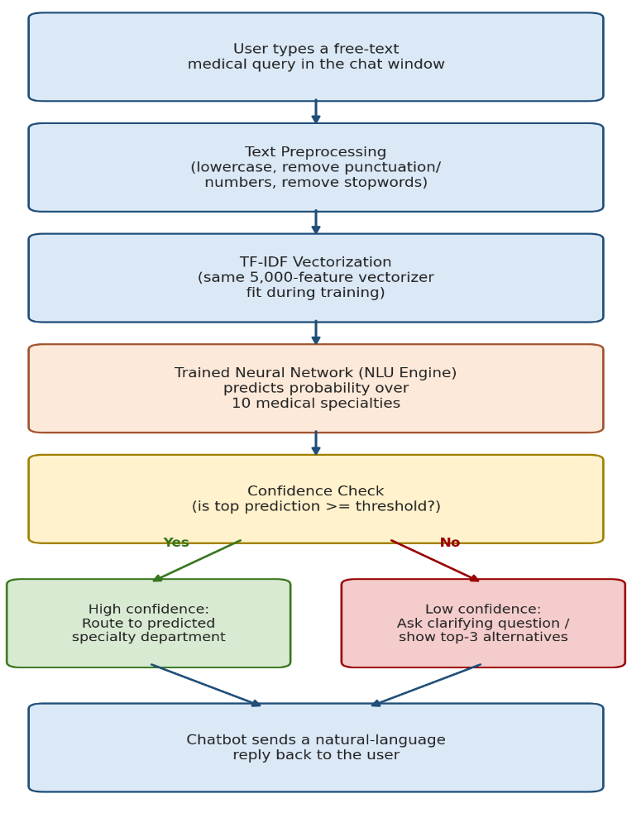
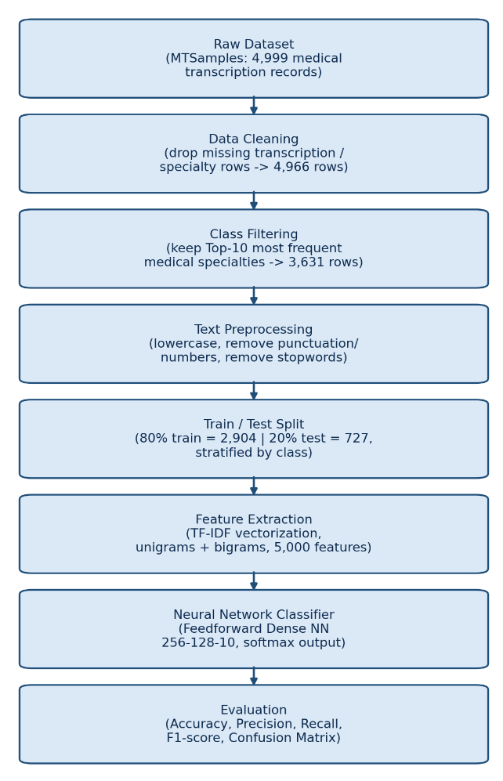

Figure 1. Training Pipeline for the Figure 2. Runtime (Inference-Time) Flow
Chatbot's NLU Engine. of the MediRoute Chatbot

3.2 Data Collection and Preprocessing
This project uses a Medical Transcriptions (MTSamples) dataset from mtsamples.com that's available to the public and is under CC0 Public Domain license on Kaggle [11]. The data set has 4,999 -identified real Medical Transcription samples, including description, medical specialty, sample name, Medical Transcription text and related keywords.

The data was then processed in the way:

- Removing values: rows with missing transcription text were removed as were those with missing medical_specialty labels. This made the data set smaller going from 4,999 rows to 4,999 rows with 33 rows having no transcription text.

- Class filtering: The raw data includes 40 medical specialties, some of which are very imbalanced like Surgery with 1,088 samples while others have as few as 6 samples, such as Hospice. Palliative Care. The dataset was narrowed down to avoid a difficult classification task and to make sure there were enough examples per specialty to train a supervised model. Only the 10 common specialties were kept: General Medicine, SOAP/Chart/Progress Notes, Orthopedic, Gastroenterology, Pulmonary, Urology, Consult. History and Phy., Surgery, Radiology and Neurology. After this step the data base was reduced to 3,631 samples.

- Text cleaning: All the transcription text was made lowercase punctuation and numbers were removed using expressions and common English stop words were removed using the NLTK stop words corpus. Also noise was reduced by removing tokens that had than three characters.

- Label encoding: The ten specialty labels were first turned into class indices using label encoding from Scikit-learn. Then were one-hot encoded and given to the categorical cross-entropy loss function.

- A stratified split was used to make sure the training and test data sets used to evaluate the cleaned dataset had the relative proportion of each specialty class (2,904 samples, 727 samples, respectively).

- Feature extraction: In the Dense neural network the cleaned text files were turned into vectors using Term Frequency-Inverse Document Frequency (TF-IDF) with both unigrams and bigrams and the top 5,000 most informative features were kept. The bonus LSTM model was instead trained with text that was turned into integer word sequences of length 8,000 words using a Keras Tokenizer and then padded or cut to a fixed length of 200 integer sequences.

Figure 3 shows the resulting class distribution after filtering to the ten frequent specialties clearly showing that even within this reduced set there is still a lot of imbalance
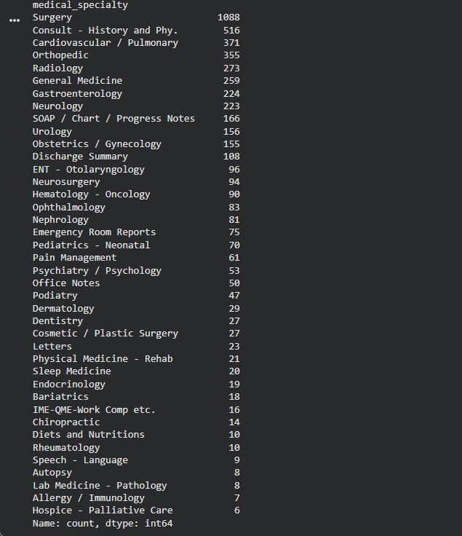
- Figure 3. Class Distribution After Filtering to the Top-10 Most Frequent Medical Specialties.

3.3 Architecture of Proposed Model
Two neural network architectures were designed and evaluated for this task:
- Primary Model. Feedforward Dense Neural Network: It takes an input 5000- TF-IDF feature vector and passes it through two hidden Dense layers with 256 and 128 units respectively using ReLU activation function with Dropout layers of 0.4 and 0.3 respectively to reduce overfitting. The final layer will be a layer with 10 units and a softmax activation function that will generate the probability distribution across the 10 medical specialty classes. The model has about 1.31 million parameters and is trained with the "Adam" optimizer and "categorical cross-entropy" loss.

- For comparison a sequence-based model was also built b) Extension Model. Embedding + LSTM Network. The model starts with an Embedding layer which learns dense word-vector representations directly from the training data and then is followed by an LSTM layer to learn sequential dependencies across the token sequence. This is followed by a layer of 64 units, a Dropout layer and a final output layer whose activation function is softmax that will classify the 10 classes. This architecture can take advantage of range contextual dependencies in the text and word order to some extent unlike the Dense/TF-IDF model.

The Adam optimizer was used for both models and an EarlyStopping callback was used for both models watching the validation loss and saving the performing weights to stop overfitting the training data with a relatively small number of data points.

3.4 Chatbot Response Generation Module
Labels for a query are part of what a chatbot does; these labels must be transformed into a natural-language response that the user can understand and respond to. To do this MediRoute uses a confidence-aware response generation layer over the trained Dense TF-IDF NLU engine as shown in figure 2:

Confidence thresholding: The NLU engine gives a probability distribution of the 10 specialty classes and the highest probability in the distribution is compared to a set-confidence threshold (we use 0.25).

Confidence branch: If the top prediction is over the threshold the chatbot sends a message showing the predicted department and the agents level of confidence and also includes a general safety message to ask for immediate attention when emergencies happen.

Low-confidence branch: When no class meets the threshold and the bot is not sure of what class to pick but has a wrong class it shows the top-3 correct candidate specialties and asks another follow-up question that can clarify the class. This fallback strategy helps reduce the risk of directing a user to the department especially when handling user queries that include specialties not in the retained top-10 label set (see Section 4.3).

The light-weight retrieval mechanism was built with a classifier to show the reasoning of the chatbot and create a retrieval-based evidence layer. For each query cosine similarity is calculated (using the TF-IDF vector space) between the query and each document in the training set and the most similar document. Along with the correct specialty label from the training set and a short snippet. Is returned along with the label predicted by the classifier. This does not change the routing decision. Gives the user (and the developer) a clear piece of evidence about why the model made its decision, which is helpful when the classifier is not very confident.

In addition to the part of this response layer it is deliberately based on templates but it is still wrapped in a conversational loop that is interactive and accepts free-text input and replies with free-text meeting the basics of a chatbot interface and most importantly it allows the systems behavior to be fully predictable and auditable. A very important feature when dealing with a healthcare system.

3.5 Mathematical Formulation
A brief explanation is given here of the mathematical equations that the proposed pipeline is based on.
TF-IDF Weighting: The TF-IDF weight of a term t in document d of the corpus D is:

TF-IDF(t, d) = TF(t, d) x log( N / (1 + DF(t)) )

TF(t d) = number of times term t appears in document d, N = number of documents in the corpus and DF(t) = number of documents in the corpus that include term t. This weighting method gives weight to terms that are common in a document but uncommon in the entire document set and works well to find medically unique vocabulary.

Softmax Output Layer: In the layer for K = 10 output classes the output of the last Dense layer is input as logits z = (z1,... zK) which is passed to the softmax function to create a probability distribution.

softmax(zi) = exp(zi) / sum_j exp(zj), for i = 1, ..., K

The two models have the training objective, which is to minimize the categorical cross-entropy loss between the true one-hot label vector y and the predicted probability vector y-hat:

L(y, y-hat) = - sum_{i=1}^{K} yi * log(y-hat_i)

This loss is a penalty for a prediction that is wrong but only for a single class and is suitable for multi-class single-label classification problems. Both models are optimized with the Adam optimizer, which changes the learning rate of each parameter depending on the estimate of the second moments of the gradients and usually has faster and more stable convergence than plain stochastic gradient descent.

3.6 Implementation Details
The entire pipeline was created using Python with the help of libraries and tools such as Pandas and NumPy for data handling Scikit-learn for TF-IDF vectorization, label encoding, train-test splitting and evaluation TensorFlow/Keras for building and training both network models NLTK for stopword removal and Matplotlib/Seaborn for visualizing class distributions training curves and confusion matrix. The interactive chatbot is completely implemented as a Python function around the trained model and vectorizer and does not need another chatbot framework. All experiments were run in a Google Colab notebook environment. Table 1 below shows the hyperparameters used for both NLU models.

- Table 1. Hyperparameter Summary for Both Models.
Hyperparameter | Dense TF-IDF Model | Embedding + LSTM Model
Feature dimensionality | 5,000 (TF-IDF, unigrams+bigrams) | 8,000 vocab / 100-dim embedding, max length 200
Hidden layers | Dense(256) -> Dense(128) | LSTM(64) -> Dense(64)
Activation function | ReLU (hidden), Softmax (output) | ReLU (hidden), Softmax (output)
Dropout rate | 0.4, 0.3 | 0.3 (+ recurrent dropout 0.3)
Optimizer | Adam | Adam
Loss function | Categorical cross-entropy | Categorical cross-entropy
Batch size | 32 | 32
Max epochs / Early stopping patience | 40 / 5 (on val_loss) | 15 / 4 (on val_loss)
Trainable parameters | ~1.31 million | Variable (built at first fit call)

4. Experiment

4.1 Comparison with Existing Techniques
The Dense TF-IDF model was trained for up to 40 epochs using stopping with a patience of 5 epochs, on validation loss. This was because the training was automatically stopped after 7 epochs when the validation loss started to rise from epoch 1 which suggested that the high-dimensional (5,000 feature) input space had begun to overfit the number of training samples (2,904 samples). As a result the training and validation loss/accuracy curves are shown in figure 4. Epoch-wise metrics are shown in table 1 below.
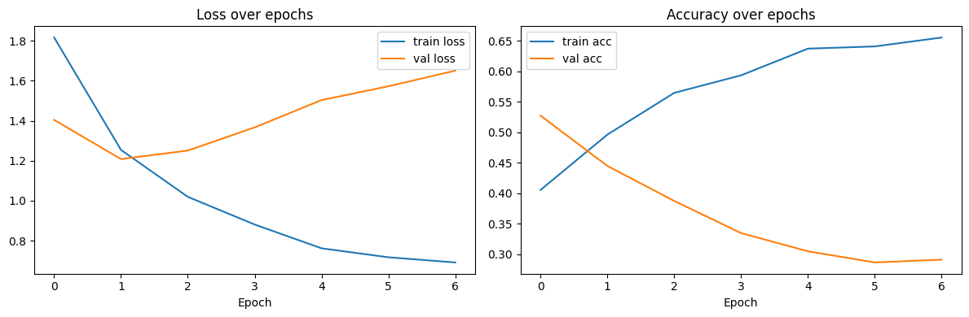
- Figure 4. Training History (Loss and Accuracy over Epochs) - Dense TF-IDF Model.
- Table 1. Model Performance (Dense TF-IDF Model, Epoch-wise).
Epoch | Training Loss | Training Accuracy | Validation Loss | Validation Accuracy
1 | 1.816 | 40.56% | 1.404 | 52.75%
2 | 1.254 | 49.64% | 1.208 | 44.50%
3 | 1.019 | 56.48% | 1.251 | 38.76%
4 | 0.881 | 59.36% | 1.367 | 33.49%
5 | 0.762 | 63.74% | 1.503 | 30.50%
6 | 0.717 | 64.10% | 1.572 | 28.67%
7 | 0.692 | 65.56% | 1.650 | 29.13%

Finally the Dense TF-IDF model has been tested on samples that were not used during training (727 samples). The model got a test accuracy of 43.19% and a test loss of 1.2812. Table 2 below shows the classification per class report. As can be seen there is a difference between classes. The model did a job with the majority class Surgery, which had an F1-score of 0.63 and 218 test samples. However for the minority classes like SOAP/Chart/Progress Notes and Urology the model did poorly with an F1-score of 0.00. These classes were in the test set.

- Table 2. Per-Class Classification Report - Dense TF-IDF Model (Test Set).
Medical Specialty | Precision | Recall | F1-score | Support
Cardiovascular / Pulmonary | 0.39 | 0.35 | 0.37 | 74
Consult - History and Phy. | 0.38 | 0.61 | 0.47 | 103
Gastroenterology | 0.07 | 0.02 | 0.03 | 45
General Medicine | 0.24 | 0.15 | 0.19 | 52
Neurology | 0.29 | 0.24 | 0.27 | 45
Orthopedic | 0.38 | 0.54 | 0.44 | 71
Radiology | 0.38 | 0.35 | 0.36 | 55
SOAP / Chart / Progress Notes | 0.00 | 0.00 | 0.00 | 33
Surgery | 0.58 | 0.68 | 0.63 | 218
Urology | 0.00 | 0.00 | 0.00 | 31
Overall Test Accuracy: 43.19% | Macro Avg F1-score: 0.28 | Weighted Avg F1-score: 0.39

As shown in Table 2 the classes with the training samples (Surgery with 1,088 samples, Consult. History and Phy. With 516 samples) had the highest recall (0.68 and 0.61 respectively). The classes with the training samples (Urology with 155 SOAP/Chart/Progress Notes with 166) had almost no recall. This is the evidence that class imbalance is the main reason for the models uneven performance. The training-set support to per-class recall has a positive correlation.

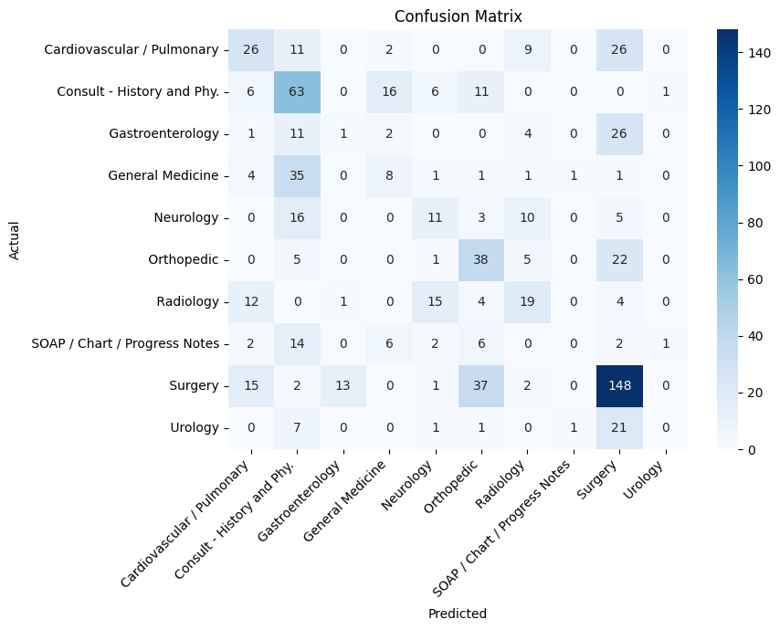
The confusion matrix of the TF-IDF model on the test set is shown in Fig. 5. The matrix shows that the model is not able to predict the majority class Surgery for many of the other true classes. For example the model predicts Surgery for 26 Gastroenterology and 21 Urology samples. This reflects the class imbalance in the training data.

- Figure 5. Confusion Matrix - Dense TF-IDF Model on the Test Set.

The comparison model, Embedding+LSTM was trained for up to 15 epochs (early stopping patience = 4). The training ended at the epoch and it achieved a final test accuracy of 39.34%, which is slightly less than the Dense TF-IDF model. The result shows that for this type of data ( than 3,000 training documents in 10 classes) the simpler bag-of-words TF-IDF is as good as or better than the sequence-based embedding model that the LSTM learns from the training data. The training data is too small for the LSTM to learn representations without pre-training. This result is in line with work that has shown that sequence models generally need a much larger training corpus or pre-trained embeddings to outperform simple bag-of-words baselines [2].

Table 3 below compares our two models with some results from the literature survey (section 2). It is important to note that the models with an asterisk (*) were tested on task formulations different data set sizes or different class sizes. They are included here as an indication of the performance upper-bound of larger pre-trained models or more extensive class-balanced data. They are not a like-for-like comparison.
- Table 3. Comparison Table.
Model | Accuracy
Feedforward Dense NN + TF-IDF (Our Model) | 43.19%
Embedding + LSTM (Our Model) | 39.34%
k-NN + Word2Vec on MTSamples [3] | 92.00%*
Transformer Encoder on discharge notes [2] | Highest AUC/F1 among 7 models*
Fine-tuned BioBERT chatbot intent classifier [5] | High precision/recall/F1 across intents*

The performance benefit of the neural architectures used in this project over the more complicated word-representation and transformer-based models mentioned in the literature is shown in this comparison (see Section 4.2 for further discussion).

4.2 Chatbot Demonstration - Sample Conversations
To confirm that MediRoute is an end-to-end system the trained Dense TF-IDF NLU engine was integrated into the confidence-aware response-generation module described in Section 3.4 and the retrieval-based evidence layer. It was evaluated online across a variety of free-text user queries. Table 4 shows four example exchanges, two with confidence that were retrieved with varying levels of quality and one with high confidence that is an edge case
- Table 4. Sample MediRoute Chatbot Conversations (with Retrieval Evidence).
User Query | Confidence | MediRoute Behavior & Retrieved Evidence
I have chest pain radiating to my left arm, shortness of breath, and sweating. | High (32.2%) | Routed confidently to Cardiovascular / Pulmonary. Retrieved evidence: a training record on fever/chills/chest pain review of systems, also filed under a cardiovascular-adjacent visit type.
My leg hurts. | Low (uncertain) | Asked a clarifying question (Orthopedic / Radiology / Neurology). Retrieved evidence: a Neurology record describing lumbar microdiskectomy with resulting leg symptoms - a sensible, relevant match despite low confidence.
I have a fungal infection in my hand. | Low (uncertain) | Asked a clarifying question (Orthopedic / Surgery / Neurology). Retrieved evidence: a General Medicine record about a hand laceration from a fight - an irrelevant surface-word match ('hand'), exposing a real weakness of TF-IDF similarity.
I need a filling replaced, my tooth has been hurting. | High (26.3%) | Confidently routed to Surgery (not Dentistry, which was excluded in top-10 filtering). Retrieved evidence: an actual full-mouth dental rehabilitation performed under general anesthesia and filed under Surgery in the source data - revealing that this dataset's 'Surgery' label genuinely includes major dental procedures.

The live exchanges show some findings that're not clear from the static test-set metrics. The chest pain query is confidently and correctly directed, as per the models training data. The "my leg hurts" query correctly returns the low-confidence fallback. Although the classifier is not certain the retrieval layer provides a relevant match. It is a record of a patient experiencing leg pain after having had surgery on the lumbar spine. This adds explanatory value to the query even when the classifier is not certain.
The query "fungal infection in my hand" also produces the fallback. The retrieved evidence is a mismatching general medicine note about a hand laceration from a physical altercation. Probably the former was retrieved simply because it contained the word "hand". No real resemblance to a fungal infection. The lesson here is an one: a known limitation of TF-IDF-based similarity is that it matches on a shared word, not on the true semantic or clinical meaning of the terms. This directly motivates the use of semantic embeddings (Section 5) that may be able to do that.

Interestingly even though "Dentistry" was not included in the top-10 label set the dental filling query was routed confidently (26.3%) to Surgery as opposed to the fallback. An investigation of the retrieved evidence was performed to explain why: under the Surgery specialty not under a dental specialty there were data files for MTSamples data associated with all major dental procedures, which are performed under general anesthesia. That is it wasn't just that the model was "misled" by a query that was out of scope. That it recognized a legitimate, but perhaps surprising pattern in the queries in its training data. This distinction is important in the context of the Limitations discussion below: Some "routing errors" are not due to model failures. Due to the way the underlying data-set itself is labeled.

In general the results of this demonstration show that the confidence-thresholding mechanism can give a margin of safety against the class-coverage limitation mentioned in Section 4.3 and the retrieval-based evidence layer significantly enhances the explainability of the chatbots correct and incorrect actions

4.3 Limitations and Challenges
Although the common specialties were used there was also a variation in class size from 1,088 (Surgery) to 155 (Urology) or a ratio of approximately 7:1. This imbalance caused the models to have a bias towards the majority class with almost no recall for some minority classes particularly for the Dense TF-IDF network.

The top-10 specialties restriction helps to ensure that there is training data per class but also causes the model to miss queries in specialties that are not included in the top-10 (e.g. Dentistry or Endocrinology). This was seen in time when testing the custom queries. A simple dental query was sent to Orthopedic. A diabetes follow-up query was sent to SOAP/Chart/Progress Notes was not a retained class. A extensive label set would be needed for a production system or an "other/unknown" category.

Overfitting on a dataset in a high-dimensional feature space: As can be seen in Figure 4 the Dense networks validation loss starts to increase after the first epoch since the feature space, represented by the TF-IDF is 5,000-dimensional and there are only 2,904 training samples. This data-scarcity problem is overcome by EarlyStopping (which resets the weights) and the lowest is still the accuracy that can be attained.

As mentioned in studies on this data set there is a classification challenge because of the amount of noise in the data set and because the vocabulary used is shared between related specialties (e.g. the words used in cardiac examination are often shared with pulmonary and vice versa in MTSamples).

5. Conclusion, Summary, and Future Scope
The project is " NLP healthcare chatbot, (MediRoute)": It takes a free text query from the patient and categorizes the query into one of the medical specialties provided in the real world MTSamples dataset then it will respond to the query using either an assignment to a department or a question to clarify the query to the patient in a natural language conversation. This NLU engine was assessed with two candidate architectures: Feed forward neural network with TF-IDF features and Embedding+LSTM sequence model; the test accuracy for the two were 39.34% and 43.19%, respectively. A Dense was added to a confidence- response-generation layer and evaluated on a collection of authentic sample conversations and could complete the conversations to produce a natural-language response to the user question.

The classification error was further analyzed in the report and on the confusion matrix and was found to be mainly due to class imbalance in the retained specialties since the model performed very well on the majority class (Surgery) and not so well on the minority classes (Urology and SOAP/Chart/Progress Notes). Next the demonstration of the chatbot in Section 4.2 demonstrated that the proposed confidence-thresholding mechanism for the response generation layer is indeed effective in catching some of these failure cases in practice—where it successfully declined to route a dental-related query or endocrinology-related query that is not included in the models ten classifications prompting the user to ask a clarifying question.

When compared with the literature reported results (Section 4.1) there is clearly a performance gap between the architectures analysed in this academic research and more complex approaches (such as k-Nearest Neighbours with Word2Vec embeddings 92% accuracy [3] and tuned transformer based intent classifiers in production healthcare chatbots [5]) when the same dataset is used. Quality of feature representation is the reason for this gap as is using pre-trained embeddings, in lieu of those trained from scratch and the size of the labeled training data used.

These findings suggest areas for more research. Class weighting, increasing the number of minority classes (like using SMOTE) and using loss are methods that can greatly improve how well minority classes are recognized. Next adding pre-trained word or sentence embeddings for the NLU model and the LSTM-based NLU model will help give more meaning from large biomedical collections, such as Biomedical Word or Biomedical Sentence embeddings like BioWordVec, BioBERT or ClinicalBERT. Next the top ten specialties could be expanded well as adding an "unknown/other" category and recognizing named entities for symptoms and how long and how severe they are could make the chatbot more useful and stronger in real life. Next if this can be made into a conversation system MediRoute becomes more than just a test model chatbot but a real healthcare helper ready to be used. Finally making changes or creating a safe way to generate text or making a pre-trained transformer work better with this data set are good ways to reduce the difference in performance compared to the best models while staying safe.

Overall this project has shown that an end-to-end medical query classification and expert routing healthcare chatbot can be made and it has shown real-world problems that match and are proven by existing research in medical text classification .

References
- M. Hughes, I. Li, S. Kotoulas and T. Suzumura " text classification using convolutional neural networks" Studies in Health Technology and Informatics vol. 235 Pp. 246-250 2017.

- H. Lu, L. Ehwerhemuepha and C. Rakovski "A study of deep learning models for text classification of unstructured medical notes for different degree of class imbalance " BMC Medical Research Methodology, vol. 22 No. 181 2022.

- L. Almazaydeh, M. Abuhelaleh A. Al Tawil and K. Elleithy "Clinical text classification with word representation features and machine learning algorithms " International Journal of Online and Biomedical Engineering (iJOE) Vol. 19 No. 4. 65-76, 2023.

- Describe the pros and cons of chatbots. Explain the advantages and disadvantages of some of the Chatbots.

- "Knowing the Unknown: A BERT-based Medical Chatbot for Improving Healthcare Communication" ScienceDirect (Healthcare Analytics) 2024.

- European Chemical Bulletin (Section A. Research Paper) 2023 [6] "Personal Healthcare Chatbot for Medical Suggestions Using Artificial Intelligence and Machine Learning.

- Use of NLP for time medical assistance using healthcare chatbot in International Research Journal on Advanced Engineering Hub (IRJAEH) 2025.

- In Proc. [8] P. Lauren et al. "Clinical Narrative categorization using neural network. In the 2017 year IEEE International Conference on Big Data (Big Data) took place. 2001-2008, 2017.

- BioBERT: a -trained biomedical language representation model for biomedical text mining.J. Lee, W. Yoon S. Kim, D. Kim, S. Kim, C. H.. J. Kang, "BioBERT: a pre-trained biomedical language representation model for biomedical text mining " vol. 36, No. 4 Bioinformatics, pp. 1234-1240 2020.

- E. Alsentzer, J. R. Murphy, W. Boag, W.-H. Weng, D. Jin, T. Naumann and M. McDermott " available clinical BERT embeddings" in Proc. 2020. B. Michelson, 2021 2nd Clinical Natural Language Processing Workshop, p. 72–78 2019.

- This dataset is originally from mtsamples.com. Has been prepared for medical transcription, by T. Boyle "Medical Transcriptions: Medical transcription data scraped from mtsamples.com" Kaggle dataset, 2019. [Online]. Available: https://www.

