**Color Report**

**By, William B Weber**

Color combinations can be used to create emotional reactions to affect a person in many ways. Cultures such as the Chinese and Egyptians have been using colors for thousands of years for healing purposes or therapy. Today many designers whether home, commercial, or web designers have been using colors to evoke a feeling or reaction about the rooms, buildings, and sites they create.

These designers are skilled in knowing whether to use warm or cool colors to evoke an array of feelings. Warm colors would include oranges, reds, and yellows. Warm colors can make people feel joy, passion, excitement, love, playfulness, and other stimulating emotions. Cool colors such as blues, greens, and purples. Cool colors can make people feel calm, relaxed, and refreshed.

Here is a list of how colors make people feel in our culture and around the world.

* Red
  + Considered the most intense color.
  + Associated with love, passion, intensity, warmth, and comfort.
  + In other cultures, it can be perceived differently
    - In Japan it represents Life, Anger, or Danger (empower-yourself)
    - In South Africa it is a color of mourning
    - In India it is used for wedding ceremonies.
* Blue
  + Considered the safest color
  + Associated with peace, calm, trust, authority, sadness, and depression.
  + In other cultures, it can be perceived differently
    - In China it represents immortality
    - In Korea it represents mourning
    - In Egypt it represents virtue
* Green
  + Considered as nature’s color
  + Associated with tranquility, luck, health, spring, and new birth.
  + In other cultures, it can be perceived differently
    - In Thailand it is the color for Wednesday
    - In Japan it represents youthfulness
    - In North Africa it represents corruption
    - In South America it represents death.
* Purple
  + Considered the color of Royalty
  + Associated with wealth, fame, honor, royalty, and spirituality.
  + In other cultures, it can be perceived differently
    - In Brazil it represents death and mourning
    - In India it represents sorrow and comforting
    - In Japan it represents privilege
* White
  + Considered to represent purity and innocence
  + Associated with peace, cleanliness, brides, and weddings.
  + In other cultures, it can be perceived differently
    - In the Middle East it represents mourning and purity
    - In Japan a White carnation symbolizes death
    - In India it represents unhappiness and sorrow.
* Black
  + Considered the color of mourning, death, and evil.
  + Associated with power, control, intimidation, and rebellion
    - In Japan it represents mystery and the night
    - In Africa it represents Age and wisdom
    - In Judaism it represents Unhappiness
    - In China it is the color for young boys.

Colors can mean different things to different people and cultures. Using the right colors for the right audience being targeted is a very important thing to consider.

Color Design artists use multiple colors in rooms and websites to evoke multiple feelings and reactions at the same time. Analogous colors used together can enforce the warmth or coolness of a room and emphasize the feeling the designer is trying to evoke. A monochromatic look can “create a unified, cohesive look” (Smartbug). A complimentary can “draw attention when you use the opposite color on the button or headline elements” (Smartbug). Triadic Colors can create visual interest and draw attention, but can also create a chaotic feeling if used incorrectly. So, whether you are trying to make a room or website stand out and pop or enforce an emotion. How you use color is up to what your intent is with your audience!

Here are some images that will be related to my project (Unless of course my client/father in-law wants to flip the color scheme).

1. Lakeside
   1. This makes me feel relaxed and at peace.

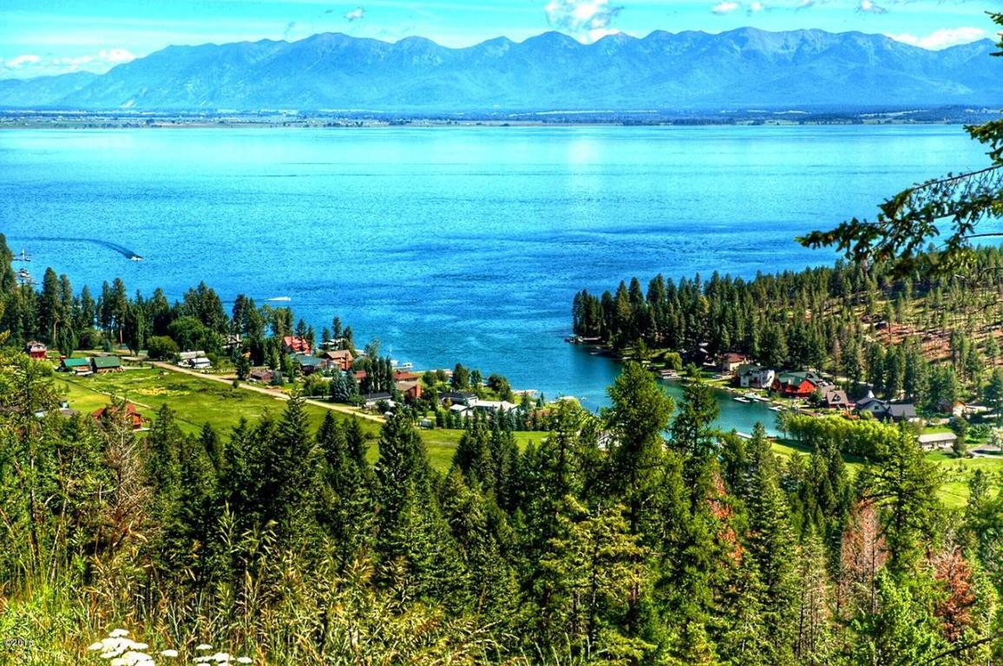

* 1. Color Pallet (#3CACF1/#45C0F2/#4DD2F4/#73F1F3/#D1D935)



1. Anvil
   1. This makes me feel power and strength



* 1. Color Pallett (#7980A3/#72686B/#FEFFFF/#101510/#1B1616)



1. Tamarack Brewery
   1. This makes me feel comfort, rest, and warmth.

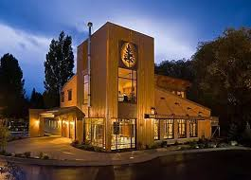

* 1. Color Palette (#7C98D9/#356EBF/#EF9B38/#8C4B13/#5B2400)



**SOURCES**

1. Color Moods
   1. Websites Visited
      1. <https://freshome.com/room-color-and-how-it-affects-your-mood/>
      2. <https://www.verywellmind.com/color-psychology-2795824>
2. Colors in Cultures
   1. Websites Visited
      1. <http://www.empower-yourself-with-color-psychology.com/cultural-color.html>
3. Warm vs Cool Colors
   1. Websites Visited
      1. <https://www.thespruce.com/understanding-warm-and-cool-colors-1976480>