Domain Name Report

Domain names are used so that instead of a long IP address, we can use a name to reference the location of the of the IP address. So instead of 151.410.261.919 we can use easytoremember.com. Domain name are important because it is easier to remember a name easier than it is to remember a 12-digit number. Also, represents who you are. People will be able to find your site if you have an easy to remember name. Otherwise they would be lost in cyberspace, not able to locate you. Domain names need to be unique to differentiate you from someone else. They separate you from the crowd and can enforce your brand or make your brand memorable. It is easy to check if a domain name that you want is available. There are many domain registrars. A few that come up to the top of a search are GoDaddy, Google, and Wix. To register a domain all you need to do is search for your desired domain and if it is available, purchase the rights through one of the registrars.

I decided to price the domain ironbirdforge.com and I was given a range of options on pricing for other top-level domains. Most domains can be purchased for increments of 1 year to ten years. It depends on the registrar. For my google example below, I was only given the initial option of 1 year. Whatever option you choose, you will need to make sure to remember when your domain is running out to renew. On average you can register your domain for around $12. If you want to do more years you can multiply 12 by the years you want. Some people advise against going for more than a couple years at a time. They say that if you go out of business, you are paying for something you are not using. However, contrary to that claim, some say that you want to lock it up for 10 years because then you have a sellable asset in case you go out of business.

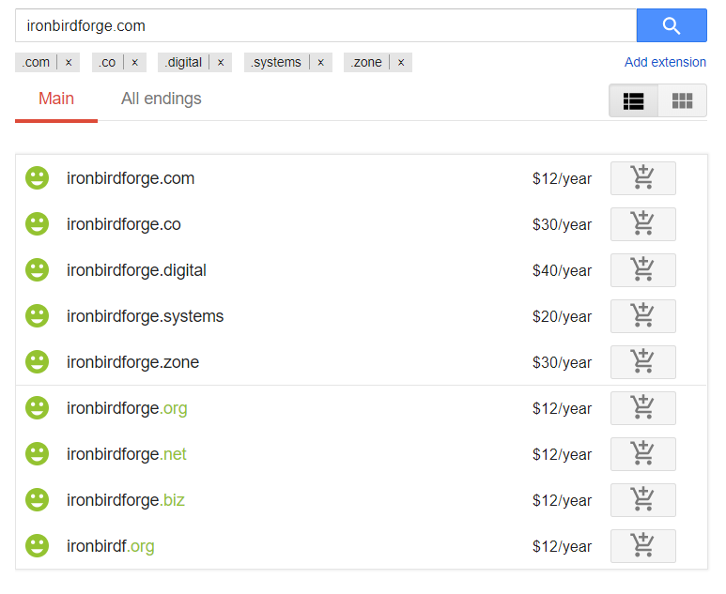

If ironbirdforge.com was not available, I would have used the .co, .org, or .net depending on how much the client wanted to pay and how important the specific top-level domain was to them. Or if I really wanted the .com I could place a certified offer to the current owner of the site. Another option is to place a backorder on the site and wait for it to expire.

However you look to get a domain name. The options are plentiful!

Sources

1. <https://www.lifewire.com/what-is-a-domain-name-2483189>
2. <https://www.allbusiness.com/why-domain-names-are-so-important-681-1.html>
3. <https://domains.google.com/registrar>
4. <http://www.networksolutions.com/support/get-the-domain-name-you-want/>