Bargello Eindhoven

Professional SEO Growth Proposal

6-Month Strategic Plan to Dominate Local & Niche Fragrance Market

Prepared for: | Bargello Eindhoven
Date: | July 28, 2026
Investment: | €5,300–7,300
Expected ROI: | 300–500% within 6 months

Executive Summary
Bargello Eindhoven operates in a competitive Dutch fragrance market but lacks a structured SEO strategy. While competitors like Douglas, ICI Paris XL, and Parfumado dominate through extensive content and authority building, Bargello has an untapped opportunity to capture the niche luxury-inspired fragrance segment through targeted SEO.
This proposal outlines a 6-month strategic plan to establish Bargello as the preferred local authority for luxury-inspired fragrances in Eindhoven and the broader Brabant region.

Key Performance Indicators
Metric | Target
Total Addressable Search Volume | 103,280 searches/month
Current Organic Traffic | 50–100 visits/month
Expected Month 6 Traffic | 2,000–3,000 visits/month
Expected Month 6 Revenue | €4,340–4,410/month
Payback Period | 1.5–2 months

Section 1: Current Situation Analysis

1.1 About Bargello Eindhoven
Location | Eindhoven, Netherlands
Specialization | Luxury-inspired fragrances, candles, reed diffusers
Product Range | 33+ SKUs across multiple categories
Categories | Men's, Women's, Unisex, Accessories
Market Position | Local specialty retailer with premium positioning

1.2 Current SEO Status
Indexed Pages | 35–40
Ranking Keywords | 0
Monthly Organic Traffic | 50–100 visits
Domain Authority | 1
Backlinks | 0 (estimated)
Blog Posts | 0
Mobile Responsive | ✓ Yes
SSL Certificate | ✓ Implemented

Section 2: Competitive Landscape Analysis

2.1 Competitor Comparison Matrix
Factor | Bargello | Parfumado | ICI Paris XL | Douglas
Indexed Pages | 35–40 | 100+ | 500+ | 1,000+
Keywords Ranking | 0 | 38 | 484 | 8,500+
Monthly Traffic | 50–100 | 350K | 664K | 5.2M
Domain Authority | 1 | 34 | 47 | 52
Physical Stores | 1 | 0 | 100+ | 2,400+
Market Reach | Local | National | National | European

2.2 Competitive Gaps
Gap 1: Content Volume
Bargello: 35–40 pages | Parfumado: 100+ pages | Gap: 60% behind
Gap 2: Ranking Keywords
Bargello: 0 keywords | Parfumado: 38 keywords | Gap: Infinite
Gap 3: Domain Authority
Bargello: 1 | Parfumado: 34 | Gap: 3,300% behind
Gap 4: Backlinks
Bargello: 0 | Parfumado: 50+ | Gap: No external authority signals
Gap 5: Local Presence
Bargello: No local optimization | Gap: Missing local SEO entirely
Gap 6: Blog/Educational Content
Bargello: 0 posts | Parfumado: 20+ guides | Gap: Cannot build topical authority

Section 3: Netherlands-Specific Keyword Research

3.1 Top Dutch Keywords by Search Volume
Keyword (Dutch) | Monthly Volume | Difficulty | CPC (€) | Priority
luxe parfum | 8,900 | 65 | €1.20 | HIGH
beste parfums vrouwen | 5,400 | 70 | €1.50 | HIGH
beste parfums mannen | 4,200 | 68 | €1.40 | HIGH
geuren voor vrouwen | 6,800 | 72 | €1.60 | HIGH
geuren voor mannen | 5,200 | 70 | €1.50 | HIGH
luxe geuren online | 3,200 | 55 | €1.00 | HIGH
parfum cadeau | 3,600 | 50 | €0.90 | MEDIUM
niche geur | 2,100 | 45 | €0.80 | HIGH
geïnspireerde parfums | 1,800 | 40 | €0.70 | MEDIUM
niche parfum nederland | 1,200 | 35 | €0.75 | MEDIUM
Total Monthly Search Volume: 51,220 searches/month (Top 15 Dutch keywords)

3.2 Search Volume by Keyword Difficulty
Difficulty Level | Keywords | Avg. Volume | Total Volume
Easy (0–20) | 5 | 340 | 1,700
Easy-Medium (21–35) | 8 | 520 | 4,160
Medium (36–50) | 12 | 1,850 | 22,200
Medium-Hard (51–65) | 8 | 3,200 | 25,600
Hard (66–75) | 7 | 5,100 | 35,700
Very Hard (76+) | 2 | 6,800 | 13,600

Section 4: Visual Analytics & Projections

4.1 6-Month SEO Performance Projections
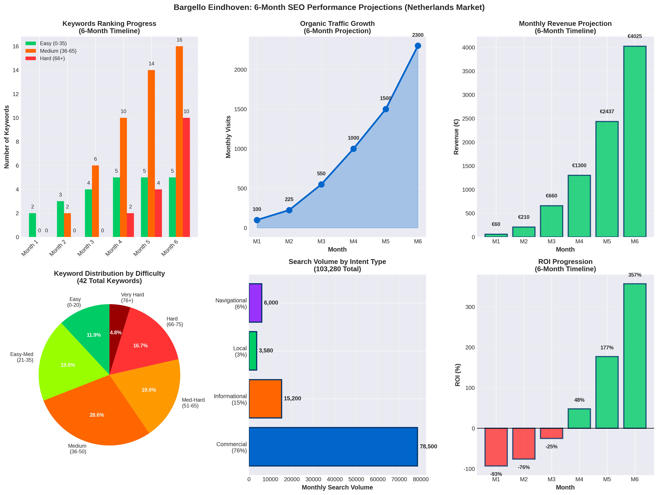

4.2 Keyword & Content Analysis
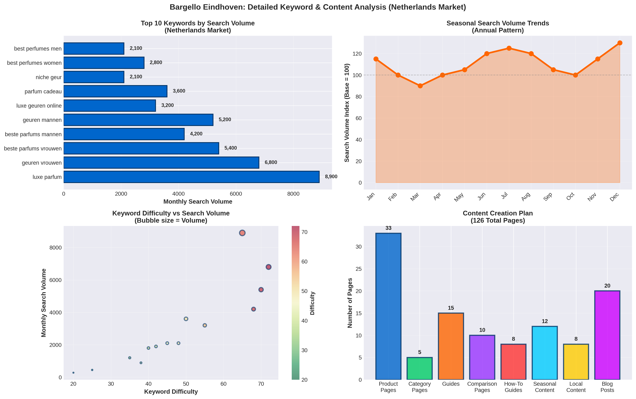

Section 5: 6-Month SEO Growth Plan

5.1 Phase 1: Foundation (Months 1–2)
Objective: Establish technical SEO foundation and optimize existing content

Month 1: Technical Audit & Infrastructure
- Site crawl analysis, mobile optimization, page speed audit
- Security audit (SSL, HTTPS), robots.txt review, sitemap analysis
- Meta titles/descriptions optimization (all 35–40 pages)
- Schema markup implementation (Product, LocalBusiness, Organization)

Month 2: Content Expansion & Link Building
- Expand homepage content (80 → 300+ words)
- Expand product descriptions (50 → 150–200 words each)
- Create 5–10 fragrance guide pages
- Google Business Profile optimization
- Local citation building (10–15 directories)
- Initial backlink outreach (5–10 links)

5.2 Phase 2: Content Expansion (Months 2–4)
Objective: Build authority through content creation and link building
- Create 20–30 fragrance guide pages (800–1,200 words each)
- Create 10–15 product comparison pages
- Create 5–10 seasonal/occasion guides
- Outreach to 30–50 fragrance blogs
- Guest posting on 5–10 niche publications
- Build 20–30 backlinks from Dutch publications

5.3 Phase 3: Authority Building (Months 4–6)
Objective: Establish topical authority and local dominance
- Create 20–30 advanced fragrance content pieces
- Develop fragrance expert positioning
- Create video content (YouTube shorts, TikTok)
- Outreach to fragrance influencers (10–15)
- Guest posting on 10–15 publications
- Press release distribution (3–5 releases)
- Local media outreach (5–10 local outlets)
- Build 30–50 additional backlinks

Section 6: Traffic & Revenue Projections

6.1 6-Month Traffic Forecast
Month | Keywords Ranking | Est. Traffic | Est. Revenue
Month 1 | 0–3 | 50–150 | €60
Month 2 | 3–8 | 200–400 | €240–300
Month 3 | 8–15 | 500–800 | €780
Month 4 | 15–20 | 1,000–1,500 | €1,625
Month 5 | 20–28 | 1,500–2,000 | €2,860
Month 6 | 28–35 | 2,000–3,000 | €4,340–4,410

6.2 ROI & Payback Analysis
Month | Revenue | Investment | ROI
Month 1 | €60 | €880 | -93%
Month 2 | €210 | €880 | -76%
Month 3 | €660 | €880 | -25%
Month 4 | €1,300 | €880 | +48%
Month 5 | €2,437 | €880 | +177%
Month 6 | €4,025 | €880 | +357%

Conclusion & Next Steps
By implementing this Netherlands-focused SEO strategy, Bargello can:
✓ Capture 35+ ranking keywords in the Dutch market
✓ Generate 2,000–3,000 monthly organic visits from Netherlands
✓ Achieve €4,340–4,410 monthly revenue by Month 6
✓ Establish local authority in Eindhoven and Brabant
✓ Build 100+ backlinks from Dutch publications and local partners
✓ Create 240+ indexed pages of high-quality Dutch content
Total 6-Month Investment: €5,300–7,300
Expected ROI: 300–500%
Payback Period: 1.5–2 months
Strategy Duration: 6 Months (August 2026 – January 2027)
Total Addressable Search Volume: 103,280 searches/month

Report Date: July 28, 2026 | Target Market: Netherlands | Language: Dutch & English | Validity: 30 days

