EPM – EFFICIENT PREDICTIVE MULTIMODAL GENERATIVE MODEL
A Reproducible Platform for Training, Benchmarking and Comparing Machine Learning Algorithms
A Project Report
Submitted in partial fulfillment of the requirements
for the award of the Degree of
BACHELOR OF TECHNOLOGY
IN
COMPUTER SCIENCE AND ENGINEERING
BY
PRANSHU
(ROLL NO.: ____________)


BIRLA INSTITUTE OF TECHNOLOGY
MESRA-835215, RANCHI
2026
APPROVAL OF THE GUIDE
Recommended that the project report entitled "EPM – Efficient Predictive Multimodal Generative Model: A Reproducible Platform for Training, Benchmarking and Comparing Machine Learning Algorithms" presented by Pranshu under my supervision and guidance be accepted as fulfilling this part of the requirements for the award of Degree of Bachelor of Technology in Computer Science and Engineering. To the best of my knowledge, the content of this report did not form a basis for the award of any previous degree to anyone else.

Date: ____________
____________________
Name of the Guide
Designation
Dept. of Computer Science and Engineering
Birla Institute of Technology
Mesra, Ranchi
DECLARATION CERTIFICATE
I certify that
- The work contained in the report is original and has been done by myself under the general supervision of my supervisor.
- The work has not been submitted to any other Institute for any other degree or diploma.
- I have followed the guidelines provided by the Institute in writing the report.
- I have conformed to the norms and guidelines given in the Ethical Code of Conduct of the Institute.
- Whenever I have used materials (data, theoretical analysis, and text) from other sources, I have given due credit to them by citing them in the text of the report and giving their details in the references.
- Whenever I have quoted written materials from other sources, I have put them under quotation marks and given due credit to the sources by citing them and giving required details in the references.

Pranshu
(Roll Number: ____________)
CERTIFICATE OF APPROVAL
This is to certify that the work embodied in this report entitled "EPM – Efficient Predictive Multimodal Generative Model: A Reproducible Platform for Training, Benchmarking and Comparing Machine Learning Algorithms" is carried out by Pranshu (Roll No. ____________) and is approved for the degree of Bachelor of Technology in Computer Science and Engineering of Birla Institute of Technology, Mesra, Ranchi.

____________________  Internal Examiner | ____________________  External Examiner

____________________
(Chairman)
Head of Department
Date: ____________
Place: Ranchi

ABSTRACT
Machine-learning models are often compared unfairly: each model is trained on a different split, preprocessing is fitted on the whole dataset, and accuracy is used for every kind of problem. This project presents EPM (Efficient Predictive Multimodal Generative Model), a platform that trains, evaluates and compares machine-learning algorithms under identical, leakage-free and reproducible conditions.
EPM was developed in fourteen stages, from mathematical foundations and from-scratch implementations to deep learning, generative models (VAE, diffusion, flow matching) and model compression. The integration work connects these into one system: a registry of 20 documented public and synthetic datasets, 44 algorithm configurations across regression, classification, clustering, forecasting and anomaly detection, automatic compatibility checks, preprocessing pipelines fitted on training data only, and a benchmark engine that reports task-specific metrics, cross-validation spread, latency, model size and a Pareto front.
Users can run experiments through a web-based Experiment Lab, the command line, or an offline chatbot that understands plain-English requests such as "classify iris with random forest" using rule-based and TF-IDF intent recognition and a conversation state machine. The platform is verified by 502 automated tests (100% passing).
Measured benchmarks show, for example, that simple models often match complex ones once cross-validation spread is considered, and that a naive baseline beat deep forecasters on short-horizon telemetry. A controlled study (Stage 13) found that the same diffusion forecaster sampled with 10 instead of 100 steps is 7.66× faster while its error stays within the full-step confidence interval.
Keywords: machine learning, benchmarking, data leakage, reproducibility, diffusion models, flow matching, chatbot.
Source code: https://github.com/webex042/effective-prediction-model
Documentation: https://github.com/webex042/effective-prediction-model/tree/main/docs

ACKNOWLEDGEMENT
I express my sincere gratitude to my guide, [Name of the Guide], Department of Computer Science and Engineering, Birla Institute of Technology, Mesra, for valuable guidance, encouragement and constructive feedback throughout this project.
I am thankful to the Head of the Department and all faculty members of the Department of Computer Science and Engineering for providing the facilities and a supportive learning environment.
I also thank the open-source communities behind scikit-learn, PyTorch, XGBoost, the UCI Machine Learning Repository, OpenML and the Numenta Anomaly Benchmark, whose tools and datasets made this work possible.
Finally, I am grateful to my family and friends for their constant support and motivation.

DATE: ____________ Pranshu
(Roll Number: ____________)
CONTENTS
ABSTRACT v
ACKNOWLEDGEMENT vi
LIST OF FIGURES viii
LIST OF TABLES viii
1 INTRODUCTION 1
1.1 OVERVIEW 1
1.2 PROBLEM STATEMENT 1
1.3 MOTIVATION 1
1.4 OBJECTIVES 2
1.5 PROJECT LINKS 2
1.6 ORGANIZATION OF THE REPORT 2
2 BACKGROUND AND LITERATURE REVIEW 3
2.1 MACHINE LEARNING TASK FAMILIES 3
2.2 FAIR EVALUATION AND DATA LEAKAGE 3
2.3 GENERATIVE MODELS 4
2.4 MODEL COMPRESSION AND CALIBRATION 4
2.5 RESEARCH GAP 4
3 SYSTEM DESIGN AND ARCHITECTURE 5
3.1 DEVELOPMENT STAGES 5
3.2 SYSTEM ARCHITECTURE 5
3.3 TECHNOLOGY STACK 6
3.4 PROJECT STRUCTURE 6
4 DATASET REGISTRY AND PREPROCESSING 7
4.1 THE DATASET REGISTRY 7
4.2 INTEGRATED DATASETS 7
4.3 SUPPORTED ALGORITHMS 8
4.4 INTELLIGENT DATASET SELECTION 8
4.5 LEAKAGE-FREE PREPROCESSING 8
5 BENCHMARKING AND EVALUATION 10
5.1 FAIR BENCHMARKING PROCEDURE 10
5.2 EVALUATION METRICS 10
5.3 CLASSIFICATION RESULTS 10
5.4 REGRESSION RESULTS 11
5.5 RESULTS ON OTHER TASKS 12
6 USER INTERFACE AND EPM CHATBOT 13
6.1 WEB DASHBOARD 13
6.2 EXPERIMENT LAB 13
6.3 CHATBOT DESIGN 14
6.4 SAFETY GUARDRAILS 15
7 TESTING AND RESEARCH RESULTS 16
7.1 AUTOMATED TESTING 16
7.2 STAGE 13: REDUCED-STEP GENERATIVE FORECASTING 16
7.3 FINDINGS AND LIMITATIONS 17
8 CONCLUSION AND FUTURE SCOPE OF WORK 18
8.1 CONCLUSION 18
8.2 FUTURE SCOPE 18
APPENDIX A: HOW TO RUN THE PROJECT 19
REFERENCES 20

LIST OF FIGURES
Figure 3.1 Layered architecture of the EPM platform 6
Figure 4.1 Experiment pipeline; preprocessing (step 4) is fitted on training rows only 8
Figure 5.1 Experiment Lab result view with leaderboard, charts and confusion matrix 11
Figure 6.1 EPM dashboard overview page with the research question and verified results 13
Figure 6.2 Experiment Lab: task tabs, dataset catalogue and algorithm finder 14
Figure 6.3 Conversation state machine of the EPM chatbot 15
Figure 6.4 Chat panel running a classification benchmark on the Wine dataset 15
Figure 7.1 Accuracy and latency of one diffusion model at different step counts 17

LIST OF TABLES
Table 1.1 Project links 2
Table 2.1 Key terms used in this report 3
Table 3.1 Development stages of EPM 5
Table 3.2 Technology stack 6
Table 4.1 Datasets integrated into EPM (rows × features) 7
Table 4.2 Algorithms available for each task 8
Table 4.3 Preprocessing steps and when they are applied 9
Table 5.1 Metrics used for each task 10
Table 5.2 Breast Cancer Wisconsin – classification benchmark 10
Table 5.3 Diabetes progression – regression benchmark 11
Table 5.4 Best models on clustering, anomaly, forecasting and image tasks 12
Table 6.1 Chatbot intents (25 in total) 14
Table 7.1 Summary of the automated test suite 16
Table 7.2 Stage 13 efficiency analysis (reference: 100 steps) 16
Table A.1 Useful example chat messages 19

CHAPTER 1

INTRODUCTION

1.1 OVERVIEW
EPM (Efficient Predictive Multimodal Generative Model) is a machine-learning experimentation platform. It lets a user pick a prediction task, choose a suitable public dataset, select compatible algorithms and run a fair benchmark, all from a web page, a terminal command or a plain-English chat message. Every run uses the same data split and random seed for every model, fits preprocessing on training data only, reports task-appropriate metrics together with speed and model size, and saves a reproducible record of the experiment.
The project was built in fourteen stages (Stage 0 to Stage 13). The early stages implement the mathematics and the core algorithms from scratch; the middle stages add deep learning, time-series and multimodal models; the later stages study generative models (VAE, diffusion, flow matching) and model compression. The final integration work, described in this report, connects all of these into one platform through a dataset registry, leakage-free preprocessing pipelines, a benchmarking engine, an interactive Experiment Lab and a rule-based chatbot.

1.2 PROBLEM STATEMENT
Students and practitioners often compare machine-learning models in ways that are not fair or not repeatable. Common problems include training each model on a different random split, scaling the data before splitting (so information from the test set leaks into training), using accuracy for every task, ignoring inference speed and memory, and forgetting which settings produced a result. Algorithms are also frequently applied to datasets they were not designed for, such as shuffling a time series or training a clustering model with the labels.
The problem addressed by EPM is therefore: build a single platform in which any supported algorithm can be trained and evaluated on a suitable, documented dataset under identical and leakage-free conditions, with results that are easy to understand and can be reproduced later.

1.3 MOTIVATION
- Fair comparison: a ranking is only meaningful if all models see exactly the same training and test rows.
- Correct evaluation: regression, classification, clustering, forecasting and anomaly detection each need different metrics and different splitting rules.
- Efficiency matters: the most accurate model is not always the best choice when latency, size and interpretability are considered.
- Accessibility: a newcomer should be able to run a correct experiment without writing code, by clicking or by typing a sentence.

1.4 OBJECTIVES
- Audit the existing EPM code and identify every implemented algorithm and dataset.
- Build a central dataset registry with source, licence, size, task and preprocessing metadata.
- Recommend compatible datasets for an algorithm and compatible algorithms for a dataset.
- Implement algorithm-aware preprocessing that is fitted on training data only.
- Create a fair benchmarking pipeline with task-specific metrics, latency, model size and a Pareto front.
- Integrate everything into the web interface (Experiment Lab) and a natural-language chatbot.
- Verify the work with automated tests and document how to run and extend the platform.

1.5 PROJECT LINKS
The complete source code, documentation and experiment records are publicly available. The links below can be opened directly from this document.
Table 1.1: Project links
Resource | Link | What you will find
GitHub repository | github.com/webex042/effective-prediction-model | Full source code, tests, web dashboard and experiment records
Documentation | github.com/webex042/effective-prediction-model/tree/main/docs | 17 chapter-style guides (docs/01 to docs/16) and the Stage 13 research report
Quick-start guide | github.com/webex042/effective-prediction-model#readme | README with installation steps, commands and project structure

1.6 ORGANIZATION OF THE REPORT
Chapter 2 explains the background concepts in simple terms. Chapter 3 describes the system architecture and development stages. Chapter 4 covers the dataset registry and preprocessing. Chapter 5 explains the benchmarking method and presents measured results. Chapter 6 describes the user interface and the chatbot. Chapter 7 reports testing and the Stage 13 research experiment. Chapter 8 concludes the report and lists future work. Appendix A gives step-by-step instructions for running the project.
CHAPTER 2

BACKGROUND AND LITERATURE REVIEW

2.1 MACHINE LEARNING TASK FAMILIES
EPM supports five families of prediction problems. In regression the target is a number (for example, a house price). In classification it is a category (for example, benign or malignant). Clustering groups similar rows without using any labels. Forecasting predicts future values of a time series from its past. Anomaly detection finds rare, unusual observations. Classical algorithms for these tasks are provided by scikit-learn [1], deep-learning models are written in PyTorch [2], and gradient-boosted trees use XGBoost [3].
Table 2.1: Key terms used in this report
Term | Meaning in simple words
Training / validation / test split | Data used to fit a model, to tune it, and to give a final unbiased score. The test rows are never used for fitting.
Data leakage | Any information from validation or test data that reaches the training process, which makes scores look better than they really are [4].
Pipeline | A fixed chain of steps (impute, scale, encode, model) that is fitted once on training data and then applied unchanged to new data.
Cross-validation (CV) | Repeating training on several different folds of the training data to measure how stable a score is.
Baseline | A deliberately simple model (mean value, majority class, "tomorrow = today"). A useful model must beat it.
Pareto front | The set of models for which no other model is both more accurate and faster.
Latency | Time taken to make one prediction, reported in microseconds per sample including preprocessing.
NFE | Number of function evaluations: how many times a generative model's network is called to produce one sample.

2.2 FAIR EVALUATION AND DATA LEAKAGE
Kaufman et al. [4] showed that leakage is one of the most common reasons why published results fail in practice. Typical sources are fitting a scaler on the full dataset, removing duplicates after splitting, or using future values when forecasting. For time series, Hyndman and Koehler [5] recommend scale-free error measures such as MASE, which compare a model against a naive forecast and therefore reveal when a complex model is no better than "repeat the last value". For clustering, internal measures such as the silhouette score [6] judge cluster quality without labels. For anomaly detection, methods such as Isolation Forest [7] are commonly evaluated on the Numenta Anomaly Benchmark (NAB) [8], where precision-recall measures are preferred because anomalies are rare.

2.3 GENERATIVE MODELS
A Variational Autoencoder (VAE) [9] compresses data into a small latent space and learns to sample new data from it. Diffusion models [10] learn to remove noise step by step; DDIM [11] makes sampling faster by skipping steps. Flow matching [12], [13] learns a smooth path from noise to data and can produce good samples with very few steps. Transformers [14] use attention to model sequences. EPM implements all of these and studies a central question: can fewer sampling steps keep accuracy while making prediction much cheaper?

2.4 MODEL COMPRESSION AND CALIBRATION
Large models can be made smaller with knowledge distillation [15] (a small "student" network learns from a large "teacher"), quantisation (storing weights as 8-bit integers instead of 32-bit floats) and pruning (removing unimportant weights). A model should also be calibrated: when it says it is 90% sure, it should be right about 90% of the time [16]. EPM reports the Expected Calibration Error (ECE) and Brier score for this purpose.

2.5 RESEARCH GAP
Libraries provide excellent individual algorithms but leave the experimental protocol to the user. Public dataset repositories such as UCI [17] and OpenML [18] provide data but not guidance on which algorithms suit it. EPM fills this gap by combining a documented dataset catalogue, compatibility rules, leakage-free pipelines and an identical evaluation protocol in one tool that a beginner can use safely.
CHAPTER 3

SYSTEM DESIGN AND ARCHITECTURE

3.1 DEVELOPMENT STAGES
The project followed a strict progression rule: each stage was learned, implemented, tested, benchmarked and documented before the next stage started. Table 3.1 summarises the stages.
Table 3.1: Development stages of EPM
Stage | Topic | What was built
0 | Environment | Project structure, configuration, logging, reproducible seeds
1 | Mathematics | Linear algebra, calculus, probability and optimisation from scratch
2 | Classical ML | Linear/logistic regression, k-NN, decision trees, SVM, boosting
3 | Neural networks | Forward and backward propagation from scratch; PyTorch MLP
4 | NLP | Tokenisation, embeddings and the attention mechanism
5 | Time series | LSTM, GRU and Transformer forecasters for sensor data
6 | Multimodal | Fusion of sensor readings with text maintenance logs
7 | Generative models | Autoencoder, VAE, GAN concepts
8 | Diffusion | DDPM and accelerated DDIM sampling
9 | Diffusion for time series | Probabilistic trajectory forecasting with intervals
10 | Flow matching | Optimal-transport conditional flow matching vs diffusion
11 | Efficiency | Linear and tiled attention, complexity analysis
12 | Compression | Distillation, INT8 quantisation, pruning
13 | Research experiment | Reproducible study of reduced-step generative forecasting

3.2 SYSTEM ARCHITECTURE
EPM is organised in four layers (Figure 3.1). The user interface layer contains the web dashboard, the Experiment Lab, the chat panel and the command line. The API layer is a small local web server started by run.py; it queues training jobs so that the page never freezes and any job can be cancelled. The core services layer contains the chatbot, the benchmark runner, the preprocessing pipelines, the evaluation metrics, the dataset registry and the model modules from Stages 1 to 12. The storage layer keeps downloaded datasets, run records and an exported catalogue that the static (Vercel) version of the site can read.
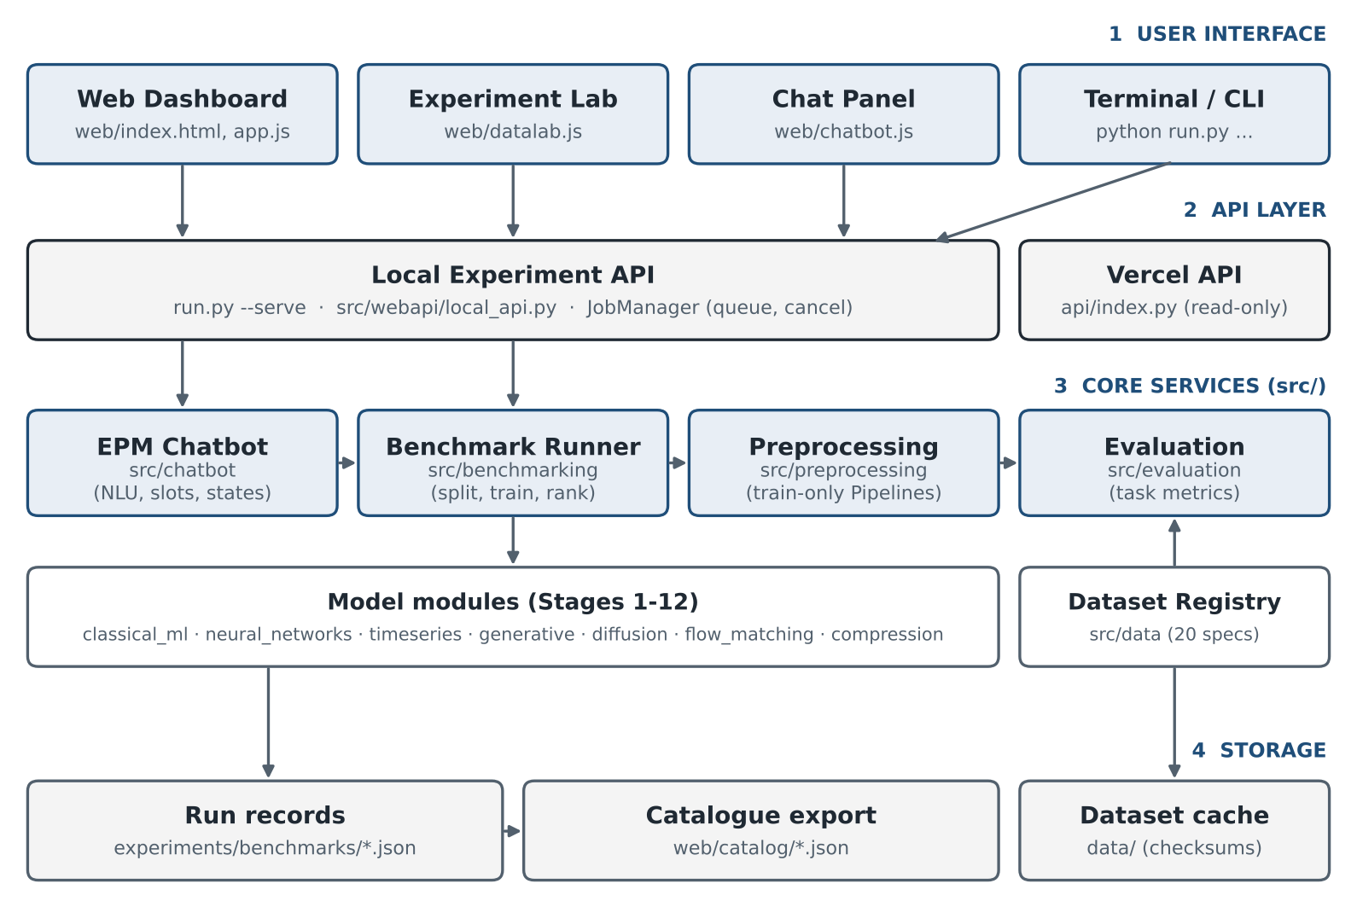
Figure 3.1: Layered architecture of the EPM platform

3.3 TECHNOLOGY STACK
Table 3.2: Technology stack
Layer | Technology | Why it was chosen
Language | Python 3.10 or newer (tested on 3.13) | Standard language for ML; rich ecosystem
Data handling | NumPy, pandas | Fast arrays and tabular data
Classical ML | scikit-learn, XGBoost | Reliable, well-tested algorithms and Pipelines
Deep learning | PyTorch | MLP, LSTM, GRU, Transformer, VAE, diffusion, flow matching
Web server | Python standard library (ThreadingHTTPServer) | No extra infrastructure needed; runs offline
Front end | HTML, CSS, plain JavaScript | Lightweight, no build step
Hosting | Vercel (static site + read-only API) | Free public preview of results
Testing | pytest | Automated verification of every module

3.4 PROJECT STRUCTURE
The most important folders are: src/ (all Python modules, one sub-package per stage plus data, preprocessing, benchmarking, evaluation, webapi and chatbot), web/ (the dashboard), tests/ (23 test modules), docs/ (the written guides), experiments/ (saved runs) and run.py (the single entry point for every command).
CHAPTER 4

DATASET REGISTRY AND PREPROCESSING

4.1 THE DATASET REGISTRY
Every dataset is described once, in src/data/registry.py, by a record that stores its name, description, source and download URL, licence, supported tasks, feature and target columns, number of rows and features, missing-value information, approximate memory, recommended preprocessing, recommended metrics, splitting strategy and known caveats. Remote files are downloaded once, verified against the expected schema and cached locally; a failed download produces a clear message instead of a crash, and an unknown dataset is never silently replaced by a different one.

4.2 INTEGRATED DATASETS
Twenty datasets were integrated (Table 4.1). Small datasets load instantly and suit quick experiments; medium and large datasets give more realistic benchmarks. Large datasets must be explicitly allowed by the user.
Table 4.1: Datasets integrated into EPM (rows × features)
# | Dataset | Task(s) | Size | Source
1 | Iris | Classification, clustering | 150 × 4 | scikit-learn / UCI
2 | Wine Recognition | Classification, clustering | 178 × 13 | scikit-learn / UCI
3 | UCI Seeds | Clustering, classification | 210 × 7 | UCI (id 236)
4 | UCI Wholesale Customers | Clustering | 440 × 6 | UCI (id 292)
5 | Diabetes (Efron et al.) | Regression | 442 × 10 | scikit-learn
6 | Breast Cancer Wisconsin | Classification | 569 × 30 | scikit-learn / UCI
7 | UCI Energy Efficiency | Regression | 768 × 8 | UCI (id 242)
8 | EPM Sensor Regression | Regression | 1,200 × 5 | Synthetic (project)
9 | EPM Equipment Failure | Classification | 1,200 × 5 | Synthetic (project)
10 | Synthetic Gaussian Blobs | Clustering | 1,500 × 6 | Synthetic (scikit-learn)
11 | Optical Digits (8×8) | Classification | 1,797 × 64 | scikit-learn / UCI
12 | EPM Sensor Telemetry | Forecasting | 2,000 × 5 | Synthetic (project)
13 | Synthetic Anomalies | Anomaly detection | 2,000 × 8 | Synthetic (fixed seed)
14 | UCI Air Quality | Forecasting | 9,357 × 12 | UCI (id 360)
15 | California Housing | Regression | 20,640 × 8 | StatLib via scikit-learn
16 | NAB Machine Temperature | Anomaly detection | 22,695 × 1 | Numenta (NAB)
17 | UCI Bank Marketing | Classification | 45,211 × 15 | OpenML 1461 / UCI
18 | Adult Census Income | Classification | 48,842 × 13 | OpenML 1590 / UCI
19 | Household Power Consumption | Forecasting | 34,589 × 7 (hourly) | UCI (id 235)
20 | Credit Card Fraud (ULB) | Anomaly, classification | 284,807 × 30 | OpenML 1597

4.3 SUPPORTED ALGORITHMS
The benchmark engine exposes 44 algorithm configurations (Table 4.2). Several classic algorithms exist in two versions: the from-scratch implementation written in Stage 2 and the equivalent scikit-learn model, so the two can be compared directly. Every task also includes at least one simple baseline.
Table 4.2: Algorithms available for each task
Task | No. | Algorithms
Regression | 15 | Mean baseline; Linear Regression (OLS, scratch normal-equation, scratch gradient-descent); Ridge; Lasso; Elastic Net; k-NN (scratch and sklearn); Decision Tree (scratch and sklearn); Random Forest; SVR; Gradient Boosting; XGBoost
Classification | 13 | Majority baseline; Logistic Regression (scratch and sklearn); k-NN (scratch and sklearn); Decision Tree (scratch and sklearn); Random Forest; SVM; Gaussian Naive Bayes; Gradient Boosting; XGBoost; MLP (PyTorch)
Clustering | 4 | K-Means; Agglomerative (Ward); Gaussian Mixture Model; DBSCAN
Forecasting | 8 | Naive; Seasonal naive; Linear AR; Random Forest and XGBoost on lag windows; LSTM; GRU; Temporal Transformer
Anomaly detection | 4 | Isolation Forest; Local Outlier Factor; One-Class SVM; Autoencoder (PyTorch)

4.4 INTELLIGENT DATASET SELECTION
When a user selects an algorithm, EPM lists only datasets whose task and input format suit it, ordered small-first for quick experiments or large-first for realistic benchmarks. When a user selects a dataset, it marks the recommended algorithms (fast, well-suited ones) and the full list of compatible ones. Incompatible combinations are refused with an explanation. For example, a forecasting model is never offered a shuffled tabular dataset, and the chatbot replies to "regression with logistic regression" by explaining that logistic regression is a classification algorithm.

4.5 LEAKAGE-FREE PREPROCESSING
Preprocessing is built as a scikit-learn Pipeline for each model and is fitted on the training split only (Figure 4.1). The same fitted pipeline is then applied, without refitting, to validation, test and future data, so training and inference always use identical transformations. Table 4.3 lists the steps.
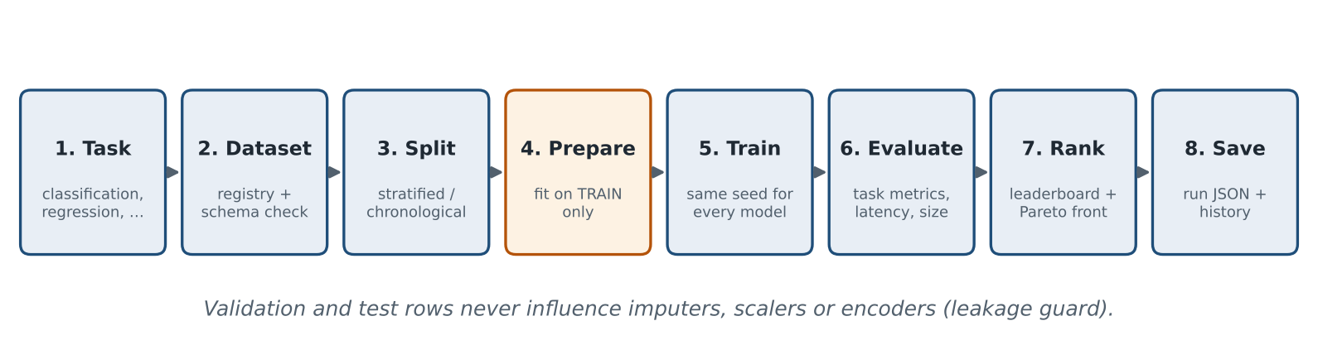
Figure 4.1: Experiment pipeline; preprocessing (step 4) is fitted on training rows only
Table 4.3: Preprocessing steps and when they are applied
Step | What it does | When it is applied
Duplicate removal | Drops repeated rows before splitting | Optional, on by default
Imputation | Median for numbers, most frequent value for categories | Always; statistics from training data
Scaling | Standardises numeric features | Only for scale-sensitive models (SVM, k-NN, linear, neural)
Encoding | One-hot encoding; unseen categories are safely ignored | When categorical columns exist
Outlier clipping | Winsorises at training-set quantiles | Optional
Class weighting | Balances rare classes during training | Optional, for imbalanced data
Windowing | Turns a time series into (past window → future horizon) samples | Forecasting and sequential anomaly tasks

Time-dependent data is always split chronologically, and windows are created after splitting so that no future value can appear in a training window. All preprocessing settings are saved with each run for reproducibility.
CHAPTER 5

BENCHMARKING AND EVALUATION

5.1 FAIR BENCHMARKING PROCEDURE
A benchmark compares several algorithms on one dataset. To keep the comparison fair, EPM uses one shared split and one random seed for every model, an optional k-fold cross-validation on the training data, and the same evaluation code for every model. For each model it records the task metrics, training time, inference latency per sample (including preprocessing), serialised model size and parameter count. Models are ranked by a primary metric, and a Pareto front marks the models that offer the best accuracy-speed trade-offs. Each run is saved as a JSON record with a configuration fingerprint so that it can be reopened or reproduced later.

5.2 EVALUATION METRICS
Table 5.1: Metrics used for each task
Task | Metrics reported | Primary (ranking) metric
Regression | MAE, MSE, RMSE, R² | RMSE (lower is better)
Classification | Accuracy, balanced accuracy, precision, recall, F1, ROC-AUC, PR-AUC, confusion matrix | F1 (higher is better)
Clustering | Silhouette, Davies–Bouldin, Calinski–Harabasz; ARI against held-out labels when available | Silhouette (higher is better)
Forecasting | MAE, RMSE, MASE, sMAPE, comparison with naive baselines | RMSE (lower is better)
Anomaly detection | Precision, recall, F1, PR-AUC, ROC-AUC | PR-AUC (higher is better)

Metrics that cannot be computed in a given situation (for example ROC-AUC when the test set has a single class, or a silhouette score when DBSCAN finds only one cluster) are reported as "not defined" instead of a misleading number.

5.3 CLASSIFICATION RESULTS
Table 5.2 shows a ten-model benchmark on the Breast Cancer Wisconsin dataset (398 training and 114 test rows, stratified split, seed 42, 5-fold cross-validation). Figure 5.1 shows how a run appears in the Experiment Lab.
Table 5.2: Breast Cancer Wisconsin – classification benchmark
# | Model | F1 | Acc. | CV F1 (mean ± std) | Latency (µs) | Size (KB)
1 | Logistic Regression (scratch) | 0.964 | 0.974 | 0.946 ± 0.049 | 24.8 | 12.7
2 | Random Forest | 0.963 | 0.974 | 0.928 ± 0.032 | 177.0 | 583.0
3 | Logistic Regression (sklearn) | 0.951 | 0.965 | 0.943 ± 0.051 | 22.6 | 3.8
4 | Support Vector Machine (RBF) | 0.951 | 0.965 | 0.955 ± 0.029 | 45.6 | 28.8
5 | Gradient Boosting | 0.950 | 0.965 | 0.930 ± 0.038 | 26.1 | 199.7
6 | k-NN (k = 5) | 0.938 | 0.956 | 0.942 ± 0.043 | 42.8 | 100.0
7 | XGBoost | 0.937 | 0.956 | 0.940 ± 0.040 | 31.2 | 189.3
8 | Gaussian Naive Bayes | 0.909 | 0.939 | 0.916 ± 0.047 | 30.8 | 3.4
9 | Decision Tree (depth 8) | 0.905 | 0.930 | 0.875 ± 0.037 | 24.4 | 6.4
10 | Majority-class baseline | 0.000 | 0.632 | 0.000 ± 0.000 | 18.9 | 2.4

The from-scratch logistic regression written in Stage 2 matches the library models, which confirms that implementation. The top five models differ by less than the cross-validation standard deviation, so they should be treated as equally accurate; logistic regression is then the sensible choice because it is about 45 times smaller than the random forest and seven times faster. The majority baseline reaches 63% accuracy but an F1 of zero, showing why accuracy alone is misleading.
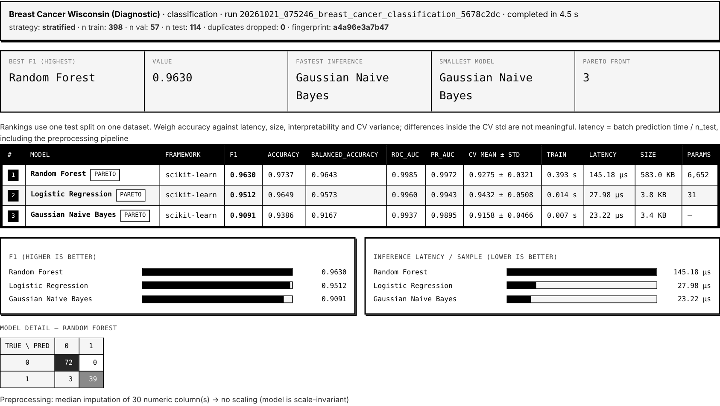
Figure 5.1: Experiment Lab result view with leaderboard, charts and confusion matrix

5.4 REGRESSION RESULTS
Table 5.3 shows the same procedure on the Diabetes dataset (308 training and 89 test rows, random split, 5-fold cross-validation).
Table 5.3: Diabetes progression – regression benchmark
# | Model | RMSE | R² | CV RMSE (mean ± std) | Size (KB)
1 | Gradient Boosting Regressor | 52.80 | 0.474 | 57.47 ± 5.70 | 153.6
2 | Support Vector Regression | 52.99 | 0.470 | 58.93 ± 5.08 | 30.2
3 | Random Forest Regressor | 53.29 | 0.464 | 57.92 ± 4.74 | 909.4
4 | XGBoost Regressor | 53.32 | 0.463 | 59.49 ± 5.43 | 228.8
5 | Ridge Regression | 54.04 | 0.449 | 55.14 ± 4.12 | 2.2
6 | Linear Regression (OLS and scratch) | 54.06 | 0.448 | 55.14 ± 4.11 | 2.3
8 | Decision Tree (depth 8) | 55.02 | 0.429 | 68.35 ± 6.14 | 4.4
9 | k-NN Regressor | 56.32 | 0.401 | 58.55 ± 4.24 | 34.4
11 | Mean baseline | 72.97 | −0.005 | 78.48 ± 5.24 | 1.5

Gradient boosting wins on the single test split, but Ridge and linear regression have the best cross-validated error and are about 70 times smaller. This illustrates a key design decision in EPM: the leaderboard shows cross-validation spread next to the test score so that users do not over-trust one split.

5.5 RESULTS ON OTHER TASKS
Table 5.4: Best models on clustering, anomaly, forecasting and image tasks
Task / dataset | Best model (primary metric) | Observation
Clustering / Wine | K-Means (silhouette 0.285) | Also best agreement with true cultivars (ARI 0.897)
Clustering / Iris | DBSCAN (silhouette 0.597) | GMM scores lower silhouette but far better ARI (0.904 vs 0.555)
Clustering / Synthetic blobs | DBSCAN (silhouette 0.690) | K-Means, Ward and GMM recover the true clusters exactly (ARI 1.0)
Anomaly / NAB machine temp. | Isolation Forest (PR-AUC 0.781) | One-Class SVM 0.655; LOF 0.428; Autoencoder 0.367
Anomaly / Synthetic | Isolation Forest (PR-AUC 1.000) | Easy controlled case; all methods ≥ 0.997
Forecasting / Telemetry (1 step) | Naive persistence (RMSE 0.437, MASE 0.32) | Beat Linear AR (0.890), XGBoost (4.28), GRU (4.69), LSTM (6.44)
Classification / Digits 8×8 | PyTorch MLP (F1 0.978) | SVM 0.975; Random Forest 0.972; Naive Bayes 0.813

Two lessons stand out. First, internal clustering scores and label agreement can disagree (Iris), so EPM reports both and never uses labels for training. Second, on short-horizon forecasting the simplest baseline beat every learned model, including the deep networks; without baselines and MASE this would have gone unnoticed.
CHAPTER 6

USER INTERFACE AND EPM CHATBOT

6.1 WEB DASHBOARD
Running python run.py --serve opens the EPM dashboard at http://localhost:3000. Its navigation bar leads to the project overview, methodology, a stage-by-stage Lab Workbench, the Experiment Lab, the Chat page, the leaderboards, the figures and a verification page that shows the live test status (Figure 6.1).
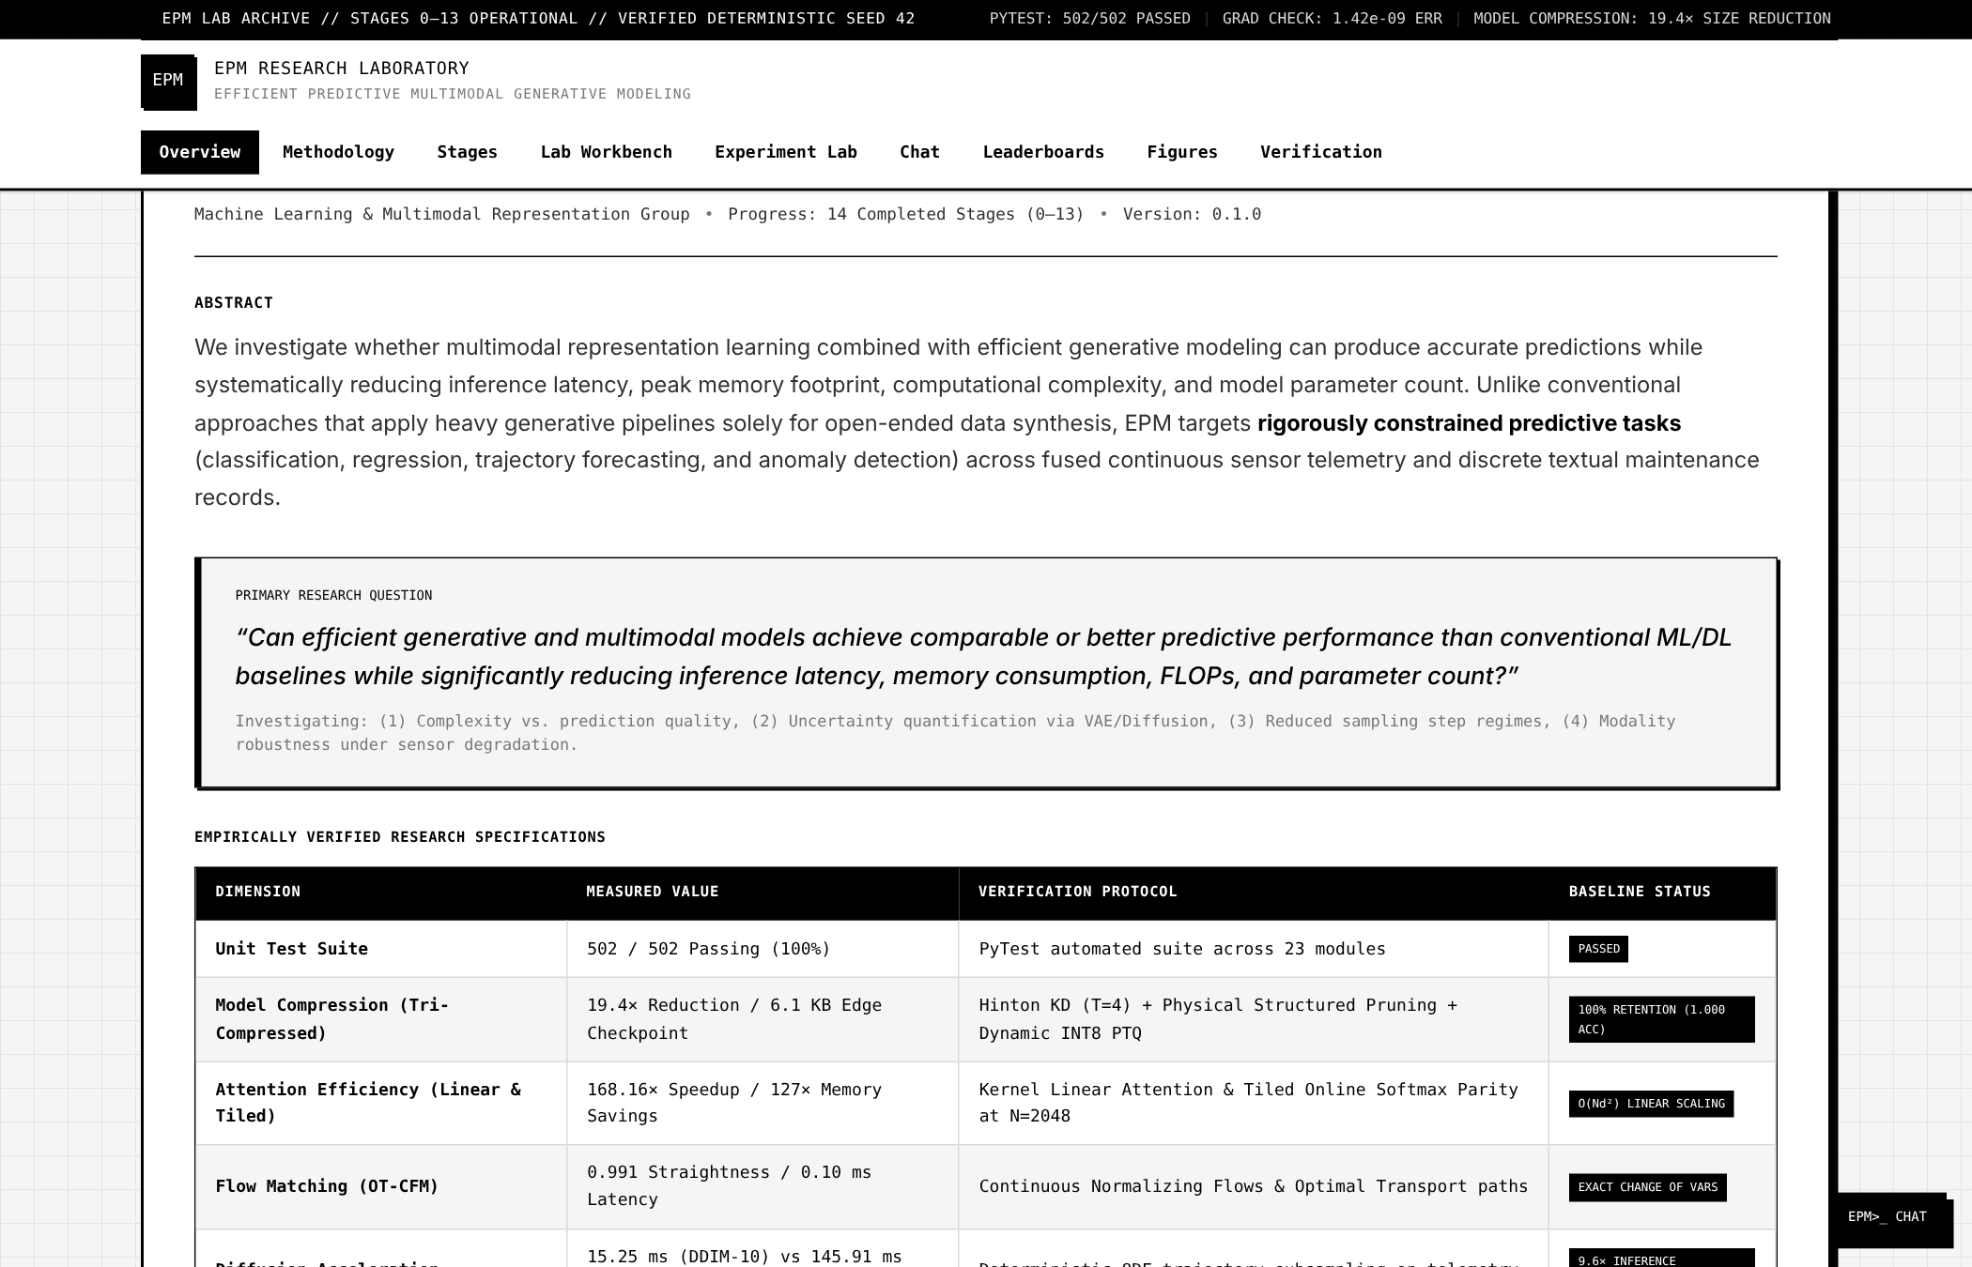
Figure 6.1: EPM dashboard overview page with the research question and verified results

6.2 EXPERIMENT LAB
The Experiment Lab guides the user through six numbered steps: (1) choose a task, (2) choose a dataset from the catalogue, which shows its source, size and download status, or upload a CSV file, (3) select algorithms using the Recommended or All compatible buttons, (4) adjust the configuration (seed, test fraction, cross-validation folds, scaling, class weighting, resource limits), (5) run the benchmark and watch the progress bar, and (6) reopen any earlier run from the experiment history (Figure 6.2).
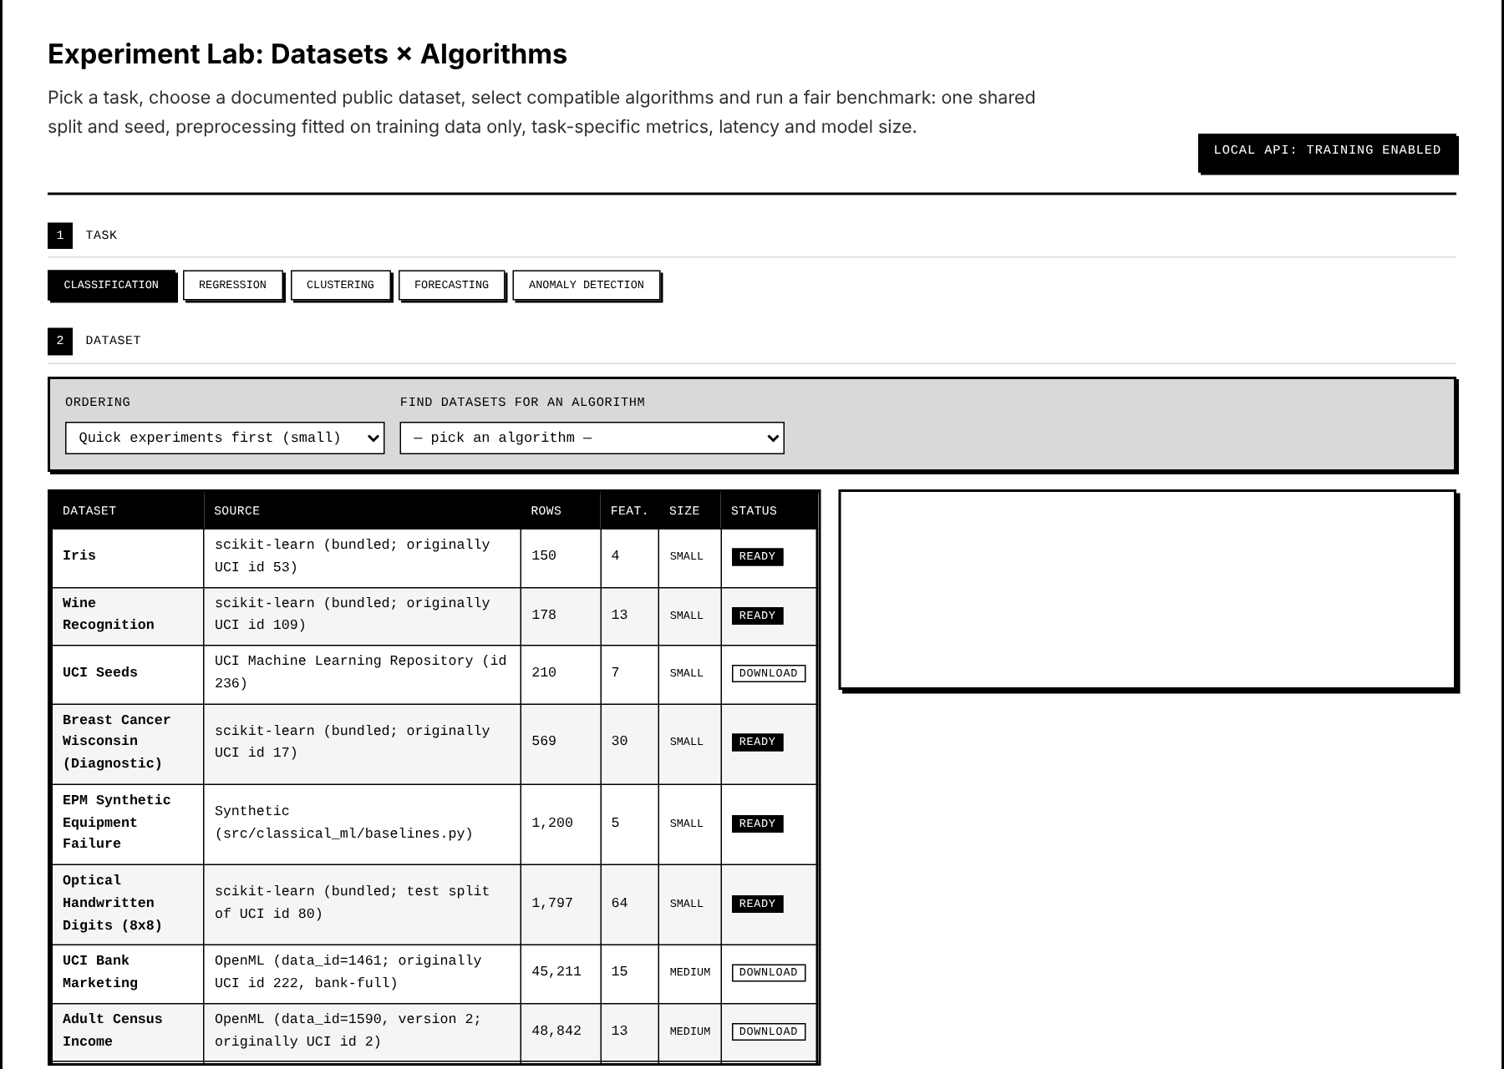
Figure 6.2: Experiment Lab: task tabs, dataset catalogue and algorithm finder

6.3 CHATBOT DESIGN
The EPM chatbot lets users run experiments in plain English, for example "classify iris with random forest" or "forecast the next 6 steps of sensor telemetry". It is fully offline and uses no large language model. Each message passes through three steps. Intent recognition uses ordered regular-expression rules, with a small TF-IDF and logistic-regression classifier as a fallback when no rule matches. Slot extraction finds the dataset, algorithms, task and settings by exact phrase matching, then regular expressions, then fuzzy matching for typing mistakes. A state machine (Figure 6.3) asks for missing information, confirms large jobs, runs them in the shared job queue and shows the results.
Table 6.1: Chatbot intents (25 in total)
Group | Intents | Example message
Run experiments | classify, regress, cluster, benchmark, train, forecast, detect_anomalies | "benchmark all algorithms on wine"
Generative and efficiency | generate, compare_generative, compress, uncertainty | "compare diffusion vs flow matching"
Explore | list_datasets, list_algorithms, describe_dataset, preview_data, download, recommend, explain | "what is the best model for diabetes?"
Results | show_results, compare | "compare knn and naive bayes"
Conversation | help, status, cancel, confirm, deny | "cancel the job"

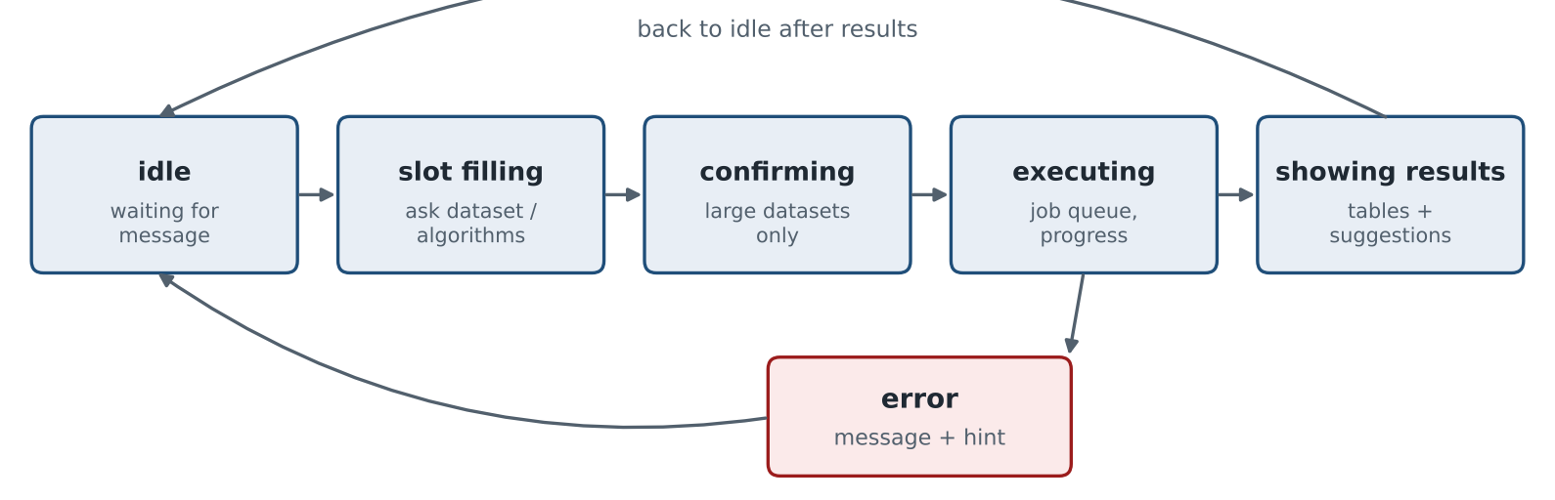
Figure 6.3: Conversation state machine of the EPM chatbot
Figure 6.4 shows a real conversation. The chatbot resolved three algorithm names, used the stratified split, reported the leaderboard with a Pareto marker, and offered follow-up suggestions such as "run again with 5-fold cv".
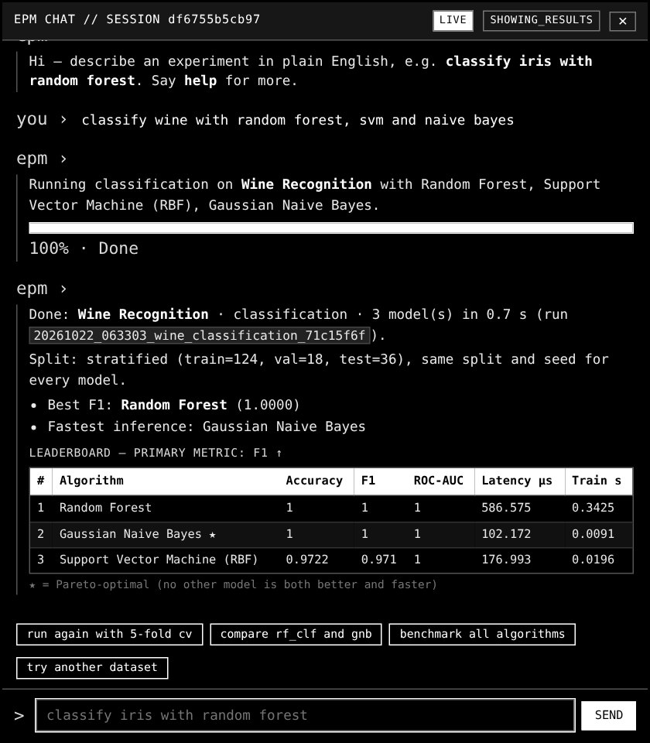
Figure 6.4: Chat panel running a classification benchmark on the Wine dataset

6.4 SAFETY GUARDRAILS
- The chatbot only calls existing EPM functions; it never executes arbitrary code.
- Inputs are validated: message length up to 1,000 characters, CV folds 2–10, epochs 1–300, horizon 1–168.
- At most five jobs can be queued, and any job can be cancelled at the next model boundary.
- Data previews are limited to 20 rows, and unknown dataset names are never replaced by a guess.
CHAPTER 7

TESTING AND RESEARCH RESULTS

7.1 AUTOMATED TESTING
The project contains 502 automated tests in 23 modules, and all 502 pass (python run.py --test). Table 7.1 groups them by area. The tests check, among other things, that preprocessing is fitted on training rows only, that chronological splits never place future rows in training, that metrics match hand-calculated values, that failed downloads and malformed files are handled gracefully, and that the same seed reproduces the same results.
Table 7.1: Summary of the automated test suite
Area | Test modules | Tests
Foundations | math_foundations, config, reproducibility, experiment | 111
Chatbot and API | chatbot, local_api | 110
Datasets and preprocessing | datasets, preprocessing_pipelines | 70
Benchmarking and metrics | benchmarking, task_metrics, metrics | 66
Efficiency, compression, research | efficiency, compression, research | 44
Classical, neural, NLP | classical_ml, neural_networks, nlp | 39
Generative models | generative, diffusion, flow_matching | 34
Time series and multimodal | timeseries, multimodal, timeseries_diffusion | 28
Total | 23 modules | 502 (100% pass)

7.2 STAGE 13: REDUCED-STEP GENERATIVE FORECASTING
The research hypothesis H1 states that a diffusion forecaster sampled with fewer steps can keep competitive accuracy while greatly reducing inference cost. To test only the effect of the step count, the same trained network was sampled with 100, 50, 20, 10 and 5 DDIM steps on synthetic industrial telemetry (24-step window, 12-step horizon, chronological split, two seeds, 95% bootstrap confidence intervals). Real baselines (linear autoregression, LSTM, Transformer) were trained on the same split.
Table 7.2: Stage 13 efficiency analysis (reference: 100 steps)
Steps (NFE) | RMSE | Latency (ms) | Speed-up | Change in RMSE | Within full-step CI?
50 | 2.75 | 100.9 | 2.09× | −2.5% | Yes
20 | 2.88 | 43.1 | 4.89× | +2.0% | Yes
10 | 3.00 | 27.5 | 7.66× | +6.2% | Yes
5 | 5.20 | 14.6 | 14.4× | +84.1% | No

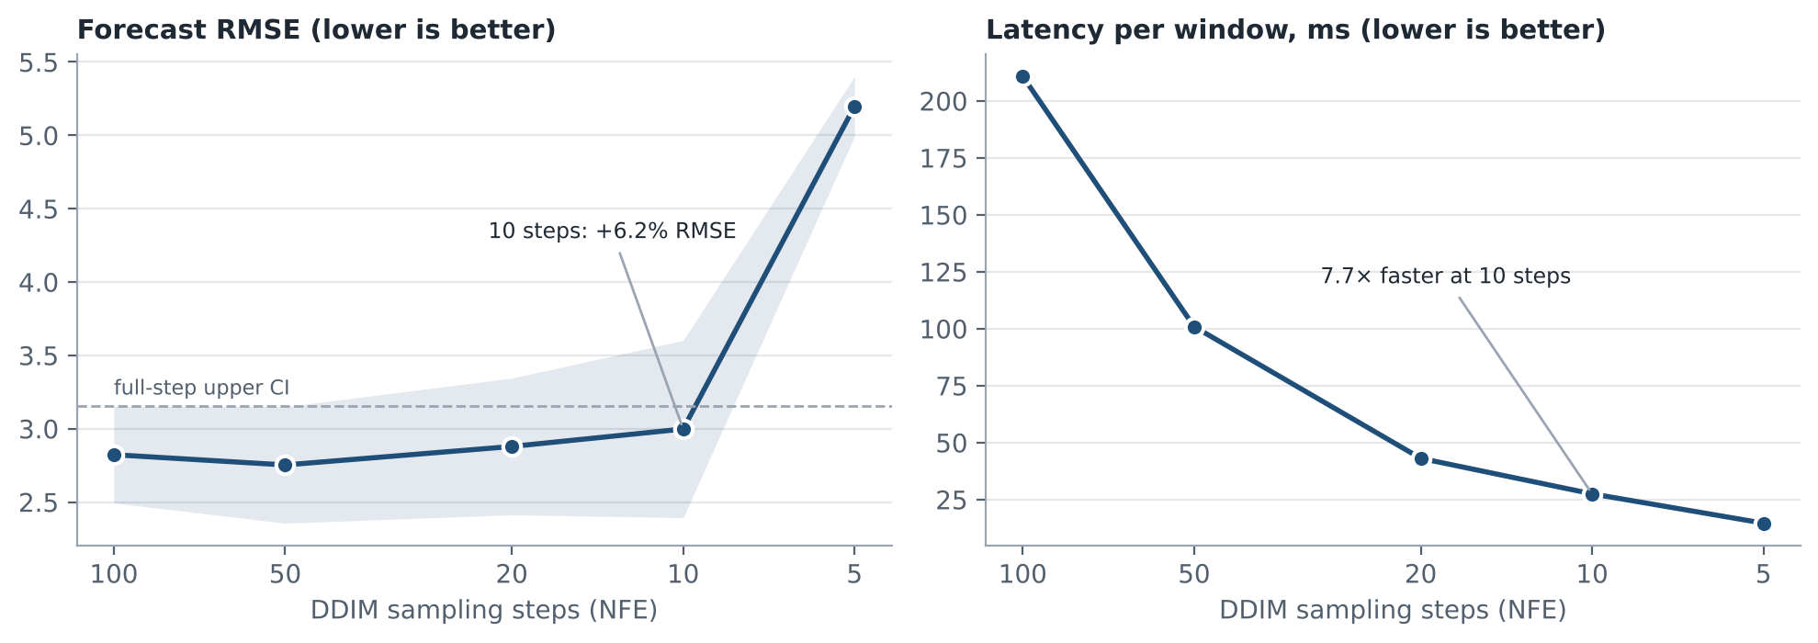
Figure 7.1: Accuracy and latency of one diffusion model at different step counts
The reference 100-step sampler reached an RMSE of 2.82 at 210.8 ms per window. With 10 steps the model is 7.66 times faster and its error stays inside the confidence interval of the full 100-step sampler, which supports H1 on this dataset. At 5 steps the error rises by 84%, which marks the limit. The diffusion model (RMSE ≈ 2.8) was also more accurate than the trained linear (4.53), LSTM (7.50) and Transformer (8.49) baselines, and additionally provides prediction intervals.

7.3 FINDINGS AND LIMITATIONS
- Simple baselines are essential: on one-step telemetry forecasting, "repeat the last value" beat all learned models.
- Clipping the denoised estimate (an optional setting added to the diffusion sampler) reduced a sampling blow-up on sensor telemetry from a sliced-Wasserstein distance of 146 to 0.149.
- A VAE with the default weighting collapsed to near-constant samples on small tables; a corrected weighting (β = 0.5/d) is used and reported.
- The Stage 13 study uses synthetic telemetry and CPU timings; results on real sensors and GPUs may differ.
CHAPTER 8

CONCLUSION AND FUTURE SCOPE OF WORK

8.1 CONCLUSION
EPM has grown from a series of learning stages into a reliable and reproducible machine-learning experimentation platform. Twenty documented datasets and 44 algorithm configurations covering five task families are connected through a central registry, compatibility rules, leakage-free preprocessing pipelines and a single fair benchmarking protocol. Results are presented with task-appropriate metrics, cross-validation spread, latency, model size and a Pareto front, so that users can choose models sensibly rather than by accuracy alone. The Experiment Lab and the offline chatbot make correct experiments accessible to beginners, and 502 passing tests verify the behaviour. The Stage 13 study showed that a diffusion forecaster can run 7.66 times faster with 10 sampling steps while staying within the accuracy confidence interval of the 100-step sampler.

8.2 FUTURE SCOPE
- Add image datasets such as Fashion-MNIST and CIFAR-10 to the benchmark runner for CNN models.
- Integrate NASA C-MAPSS turbofan data for remaining-useful-life prediction.
- Add rolling-origin cross-validation for every forecasting model and ARIMA/SARIMA baselines.
- Provide a GPU-backed hosted version so that experiments can be run from the public website.
- Add fairness metrics for the Adult and Bank Marketing datasets.
- Repeat the Stage 13 study on real industrial sensor archives.

APPENDIX A: HOW TO RUN THE PROJECT
Step 1 – Get the code. Install Python 3.10 or newer and Git, then run:
git clone https://github.com/webex042/effective-prediction-model.git
cd effective-prediction-model

Step 2 – Create an environment and install the dependencies.
python -m venv venv
# Windows: venv\Scripts\activate
# macOS/Linux: source venv/bin/activate
pip install -r requirements.txt

Step 3 – Use the platform.
# open the dashboard at http://localhost:3000
python run.py --serve
# chat with EPM in the terminal
python run.py --chat
# benchmark one dataset from the command line
python run.py --benchmark breast_cancer --cv 5
# run all 502 tests / check datasets / run a stage demo
python run.py --test
python run.py --verify-datasets
python run.py --stage 13

Step 4 – Read more. Each concept has its own guide in the docs folder of the repository, and the README lists every command and folder.
Table A.1: Useful example chat messages
You type | EPM does
classify iris with random forest | Trains and evaluates Random Forest on Iris and shows the leaderboard
benchmark all algorithms on diabetes | Runs every compatible regression model with the same split
forecast sensor telemetry 6 steps ahead | Runs forecasting models with a chronological split and baselines
describe adult | Shows source, licence, size, target and caveats of the dataset
what is flow matching? | Answers with an excerpt from the project documentation

REFERENCES
[1] F. Pedregosa et al., "Scikit-learn: Machine Learning in Python," Journal of Machine Learning Research, vol. 12, pp. 2825–2830, 2011.
[2] A. Paszke et al., "PyTorch: An Imperative Style, High-Performance Deep Learning Library," in Advances in Neural Information Processing Systems (NeurIPS), 2019.
[3] T. Chen and C. Guestrin, "XGBoost: A Scalable Tree Boosting System," in Proc. 22nd ACM SIGKDD Int. Conf. Knowledge Discovery and Data Mining, 2016, pp. 785–794.
[4] S. Kaufman, S. Rosset, C. Perlich and O. Stitelman, "Leakage in Data Mining: Formulation, Detection, and Avoidance," ACM Trans. Knowledge Discovery from Data, vol. 6, no. 4, 2012.
[5] R. J. Hyndman and A. B. Koehler, "Another look at measures of forecast accuracy," International Journal of Forecasting, vol. 22, no. 4, pp. 679–688, 2006.
[6] P. J. Rousseeuw, "Silhouettes: A graphical aid to the interpretation and validation of cluster analysis," Journal of Computational and Applied Mathematics, vol. 20, pp. 53–65, 1987.
[7] F. T. Liu, K. M. Ting and Z.-H. Zhou, "Isolation Forest," in Proc. IEEE Int. Conf. Data Mining (ICDM), 2008, pp. 413–422.
[8] A. Lavin and S. Ahmad, "Evaluating Real-Time Anomaly Detection Algorithms – The Numenta Anomaly Benchmark," in Proc. IEEE ICMLA, 2015.
[9] D. P. Kingma and M. Welling, "Auto-Encoding Variational Bayes," in Int. Conf. Learning Representations (ICLR), 2014.
[10] J. Ho, A. Jain and P. Abbeel, "Denoising Diffusion Probabilistic Models," in Advances in Neural Information Processing Systems (NeurIPS), 2020.
[11] J. Song, C. Meng and S. Ermon, "Denoising Diffusion Implicit Models," in Int. Conf. Learning Representations (ICLR), 2021.
[12] Y. Lipman, R. T. Q. Chen, H. Ben-Hamu, M. Nickel and M. Le, "Flow Matching for Generative Modeling," in Int. Conf. Learning Representations (ICLR), 2023.
[13] A. Tong et al., "Improving and generalizing flow-based generative models with minibatch optimal transport," Transactions on Machine Learning Research, 2024.
[14] A. Vaswani et al., "Attention Is All You Need," in Advances in Neural Information Processing Systems (NeurIPS), 2017.
[15] G. Hinton, O. Vinyals and J. Dean, "Distilling the Knowledge in a Neural Network," arXiv:1503.02531, 2015.
[16] C. Guo, G. Pleiss, Y. Sun and K. Q. Weinberger, "On Calibration of Modern Neural Networks," in Proc. Int. Conf. Machine Learning (ICML), 2017.
[17] M. Kelly, R. Longjohn and K. Nottingham, "The UCI Machine Learning Repository," University of California, Irvine. [Online]. Available: https://archive.ics.uci.edu
[18] J. Vanschoren, J. N. van Rijn, B. Bischl and L. Torgo, "OpenML: Networked Science in Machine Learning," SIGKDD Explorations, vol. 15, no. 2, pp. 49–60, 2013.
[19] EPM project repository and documentation, GitHub. [Online]. Available: https://github.com/webex042/effective-prediction-model

