

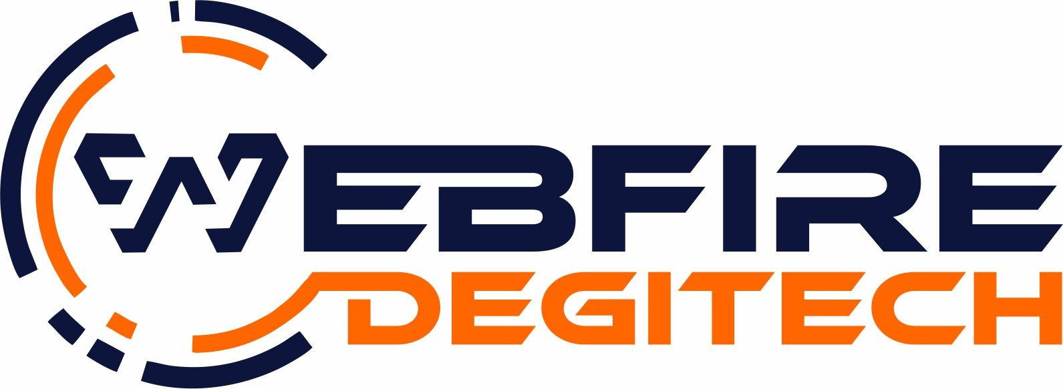
Address : 1/206,SUHAGNAGAR,
Firozabad, Uttar Pradesh, India Phone: +91 9105190096, +91 9456614612
Email: webfiredegitech@gmail.com Website: webfiredegitech.com

Company/Client | First Origin | Date | 2026-04-  12
Subject | Quotation for Live Class Monitoring System Development | Quotation No. | WD--0036

Dear Client,

We are pleased to submit this quotation for the development of a Live Class Monitoring System, designed to efficiently manage and monitor live classes across multiple colleges.

The proposed system will provide a centralized platform with dedicated panels for Admin, Colleges, and Students. It will ensure secure access, real-time tracking of student participation, and streamlined management of attendance and reports.

The solution is scalable, user-friendly, and capable of handling large numbers of students simultaneously, even when accessed from the same network environment.

Features:
- User Roles & Panels Super Admin Panel
Complete system control and access View all colleges and students data
Monitor total students, active users, and attendance Access all reports and analytics
Manage colleges (Add/Edit/Delete) System-wide settings management College Panel
Separate login for each college
Manage student records (Add/Edit/Delete) Bulk upload students via Excel
Generate Student ID & Password
View total students under the college Track attendance and activity
Access class participation reports Student Panel
Secure login using unique ID & Password Personal dashboard access
One-click join live class
Embedded live class video access


Automatic session tracking (active/inactive) Logout functionality
- Live Class Integration
Embedded live video player integration Secure access (no direct link sharing)
Accessible only after login
Smooth one-click join system
- Attendance & Tracking System Track student join and exit time
Real-time monitoring of active students Automatic attendance marking
Background system for activity detection
Accurate tracking independent of IP address
- Admin Dashboard Features
Total number of colleges and students Total joined students
Live active student count
Student-wise activity tracking Date-wise attendance records
- Reports & Data Management Attendance report generation
Download reports (Excel/PDF)
Filter by college, class, date, or student Maintain session history
- System Management
College management system Student management system Class/session management
Centralized control panel
- Optional Features (If Required) SMS/Email notifications
Mobile responsive design
Single device login restriction Multiple class/session handling
Custom branding (logo, theme, colors)
- Security Features
Secure authentication system Role-based access control
Session-based tracking
Protection from unauthorized access

Technical Features:
Web-based application (Mobile, Tablet, Desktop compatible) Supports 100+ colleges with independent access
Capable of handling 2500+ concurrent students
Works efficiently on same network/IP environments


Built using scalable and secure technologies
Optimized database structure for large data handling

Pricing & Payment Terms
Total Project Cost: ₹35,000.00/-

Total Project Cost: ₹35,000
Advance Payment: 50% before project initiation Remaining Payment: 50% upon project completion
Development Time: 25–30 working days (after confirmation and data submission)

Note: Domain charges are not included and will be charged extra as per actual cost.

We assure you of quality work, timely delivery, and complete support throughout the project. Kindly review the proposal and let us know your approval so we can proceed further.
Looking forward to working with your esteemed organization.

Note: We provide 3-month free support on any web development project & will charge if any addition of services required.

Need More Information, Call us at 9105190096, 9456614612 or Email: info@webfiredegitech.com, webfiredegitech@gmail.com

