Solar Automatic Plant Waterer
Project specification: 6 V panel, two 18650 cells, ESP32 dev board
Status: design stage. Nothing here has been built or tested. Sizes, ratings and pin numbers are typical values to confirm against your actual parts. Parts have not been priced.

1. System layout
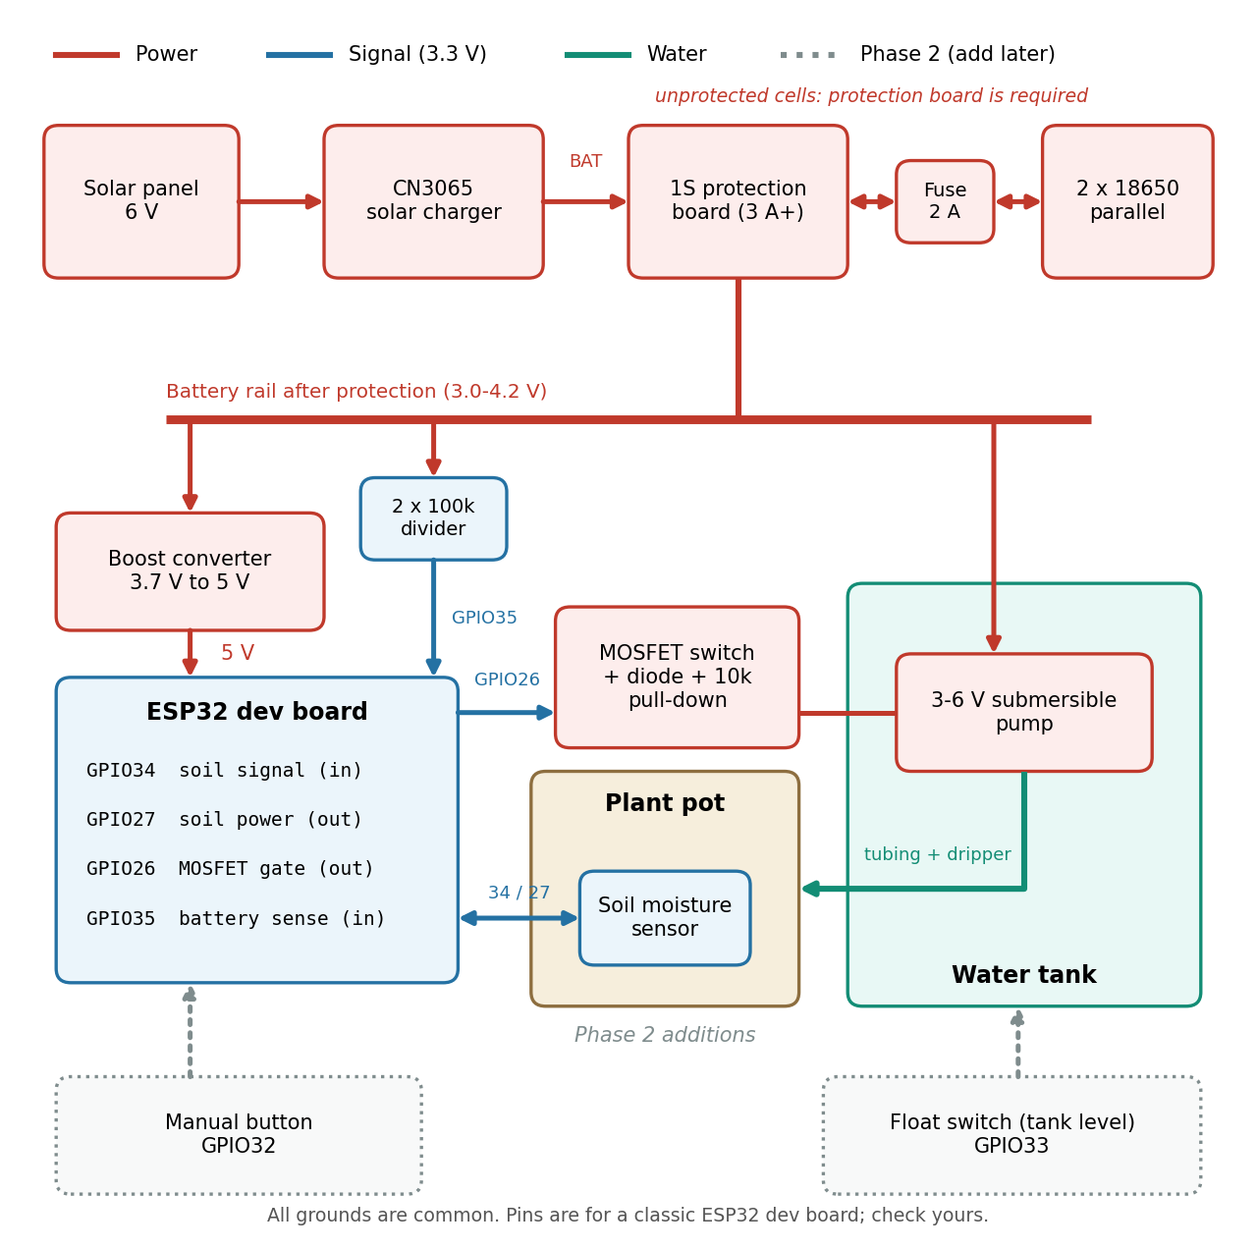
Figure 1. Phase 1 layout. Dotted boxes are Phase 2 additions.
The panel feeds the CN3065 charger, which charges the two cells through the protection board. The protection board output (the battery rail) feeds the boost converter that powers the ESP32, the pump through a MOSFET, and a voltage divider so the ESP32 can read the battery level. The ESP32 never drives the pump directly: it switches the MOSFET.

2. Goals and approach
- Water one or more plants automatically using a small pump powered by a solar panel and lithium cells.
- Use the ESP32 so features can be added over time without changing the core design.
- Start with the simplest version that works: read soil moisture, run the pump for a fixed time when dry, sleep.
- Add water-level sensing, a manual button, Wi-Fi reporting and more plants only after the basic version is reliable.

3. Parts already available and open questions
Item | What is known
ESP32 dev board | AZ-Delivery ESP32 Dev Kit (classic ESP32-WROOM-32). The exact version (V2, V4, 30 or 38 pin) must be confirmed from the silkscreen.
Solar panel | Believed to be 6 V. Label voltage and watts are not yet known. Measure the open-circuit voltage in full sun.
Battery cells | Two 18650 cells with no built-in protection. Capacity not yet known.

Still undecided, and these determine the pump and tank:
- How many plants or pots, and roughly how much water each needs per watering.
- Water source: mains tap, water butt, or a dedicated tank. A submersible pump in a tank is assumed.
- Distance and height from the tank to the plants (pump head).
- Whether the site has Wi-Fi coverage (needed from Phase 3).

4. Phase 1: the simple version

4.1 Behaviour
- Wake from deep sleep every 30 minutes (timer).
- Read the battery level through the divider. If it is below about 3.3 V, skip watering and go back to sleep.
- Power the soil sensor (GPIO27 high), allow a short settling time, take several readings, average them, and switch the sensor off.
- If the reading is outside a sane range (for example a disconnected sensor), skip watering.
- If the soil is drier than the threshold, enough time has passed since the last watering, and the daily limit has not been reached, run the pump for a fixed number of seconds (GPIO26 high).
- Remember the last watering time and daily count in RTC memory (lost if power is fully lost).
- Return to deep sleep.

4.2 Bill of materials
Item | Qty | Details | Notes
ESP32 dev board | 1 | AZ-Delivery ESP32 Dev Kit (already available). | May need pin headers soldered; may need a USB driver.
Capacitive soil moisture sensor | 1 | Analog capacitive type (for example DFRobot SEN0193). | Avoid resistive sensors; they corrode.
Submersible pump, 3-6 V DC | 1 | Small pump sized to your lift and flow. | Check current draw; never run dry.
Logic-level N-channel MOSFET | 1 | Must switch well at 3.3 V gate drive. A 3.3 V-rated MOSFET module is a safe choice. | Check the datasheet on-resistance at 3.3 V.
Flyback diode | 1 | 1N5819 or 1N4007 across the pump terminals. | Cathode to the + side.
Resistors | 5 | 10 kOhm gate pull-down; 100-220 Ohm gate series; 2 x 100 kOhm for the battery divider.
18650 cells | 2 | Already available, unprotected. | Match voltage; keep as a pair.
2-cell parallel holder, or two holders | 1 | Short, equal-length leads. | Never wire in series.
1S Li-ion protection board | 1 | Rated 3 A or more; one board protects both cells wired in parallel. | Prefer a cutoff near 2.9-3.0 V if available.
CN3065 solar charger module | 1 | Input 4.4-6 V, up to 500 mA charging. | No protection of its own.
5 V boost converter | 1 | Fixed 5 V output, at least 1 A, low idle current. | Check idle draw.
Fuse holder and 2 A fuse | 1 | On the pack positive lead, before the protection board.
Water tank | 1 | Sized to your watering volume and refill interval.
Tubing and drippers | 1 set | 4/7 mm tubing, connectors, drippers.
IP65 enclosure and cable glands | 1 | Holds the ESP32, boost converter, MOSFET and terminals. | Add a silica gel pack; glands face down.
Wire, terminals, zip ties | 1 set | Thicker wire for the power path, thin wire for signals.

4.3 Connections
From | To | Notes
Two cells in parallel, + side | Fuse, then protection board B+ | Cells matched within about 0.1 V first.
Two cells in parallel, - side | Protection board B-
Solar panel + / - | CN3065 solar input | Check panel voltage and polarity.
CN3065 BAT + / - | Protection board P+ / P- | Not directly to the cells.
Protection board P+ / P- | Boost converter input and the pump supply | Everything loads from P+ / P-.
Boost converter 5 V out | ESP32 5V / VIN pin | Common ground.
Pump - | MOSFET drain | Diode across the pump.
MOSFET source | Ground
MOSFET gate | GPIO26 (via 100-220 Ohm), 10 kOhm to ground | Keeps the pump off at boot and in sleep.
Soil sensor VCC | GPIO27 | Powered only while measuring.
Soil sensor signal | GPIO34 (ADC1, input only) | Calibrate dry and wet.
Battery divider | P+ - 100 kOhm - GPIO35 - 100 kOhm - ground | About 2.1 V at 4.2 V battery.

Do not connect USB and the boost converter to the board at the same time unless the board is known to protect against it. Unplug one before connecting the other.

4.4 Battery pack rules
- Wire the two cells in parallel only. Series wiring (about 7.4 V) is not compatible with this design.
- Use cells of the same type, capacity and age, and measure each before joining them. They should be within about 0.1 V of each other.
- Keep them together as a pair for their whole life; do not swap in a different cell later.
- Unprotected cells must never connect straight to the charger or load. Everything connects through the protection board P+/P- side.
- Do not charge lithium cells below 0 C. No temperature cutoff was listed for the charger.
- Avoid damaged or badly worn cells.

4.5 Safety rules to build in from the start
- Limit each watering to a fixed run time (for example 10 seconds) and allow at most one watering every few hours, so a failed sensor cannot flood the plant.
- If the soil sensor reading is out of range, do not water.
- If the battery is low (about 3.3 V or less), skip watering, so the protection cutoff is a last resort and not the normal way the system stops.
- Keep the gate pull-down so the pump is off during boot and sleep.
- Do not let the pump run dry. Use a fixed run time in Phase 1 and a float switch in Phase 2.
- Keep wiring inside a weatherproof enclosure with glands pointing down.

4.6 Calibration
- Record the sensor reading in dry air and in a glass of water.
- Set the dry threshold between the two for your plant, with a margin (hysteresis) so it does not water repeatedly.
- Measure how much water the pump delivers per second, then set the run time from that.

4.7 Rough energy budget
These are assumptions to check by measuring. Two cells of about 2500-3000 mAh each give roughly 5000-6000 mAh, if the labels are accurate (used cells are often less). Assume the dev board plus boost converter draw about 10 mA on average from the battery, roughly 0.25 Ah per day, which gives around three weeks of reserve with no sun. A small pump drawing 0.5 A for 30 seconds per day adds only a few mAh.
The panel is the limit. Its watts are unknown. A 2 W panel gives about 0.3 A at peak, which should cover daily use in spring and summer but may fall short on dull winter days. Options if needed: a larger panel, lowering idle draw, sleeping longer between checks, or a lower-draw board.

5. Charger alternative
If the panel open-circuit voltage is above about 6 V, the CN3065 input limit is exceeded. Two options:
- A TP4056-based charging module with built-in protection (all in one board). Input is typically up to about 8 V. It is not designed for solar. Check the listing for input range, charge current and protection voltages.
- A CN3791-based MPPT module designed for higher panel voltages. It needs a separate protection board as in this design. Check the listing input range.
Many cheap protection chips cut off around 2.4 V per cell, which is low for battery life, so the firmware low-battery rule above matters.

6. Later phases
Phase | Adds | Parts | Pins (classic ESP32)
2 | Tank level protection, manual water button | Float switch; push button | GPIO33 (float, internal pull-up); GPIO32 (button, wake source)
3 | Wi-Fi reporting, notifications | Home Assistant or MQTT broker | None extra
4 | More plants and sensors | Extra pumps or valves, multi-channel ADC, air temperature/humidity sensor, OLED, optional LoRa | Depends on additions

Keep analog readings on ADC1 pins (GPIO32-39) if Wi-Fi is used, as in the pin choices above.

7. Commissioning checklist
- Measure each cell. Match them within about 0.1 V, then wire them in parallel through the fuse to the protection board B+ / B-.
- Check the voltage at the protection board P+ / P-.
- Measure the panel open-circuit voltage in sun. If it is under the charger limit, connect panel to the CN3065 and CN3065 BAT to P+ / P-. Confirm charging.
- Connect the boost converter and confirm 5.0 V at its output before connecting the ESP32.
- Test the MOSFET with an LED or small load, then the pump in a bucket of water.
- Confirm the pump is off at power-up and during deep sleep.
- Calibrate the soil sensor, then run a supervised watering cycle.
- Leave it running for a week, watching the battery voltage, before adding Phase 2.

8. Open items to verify
- Panel label voltage and watts, and measured open-circuit voltage.
- Actual capacity of the two cells.
- Exact version, pinout and size of the AZ-Delivery board.
- Pump current and voltage rating, and its flow at battery voltage.
- Protection board cutoff voltages and current rating.
- Boost converter idle current, and real sleep current of the assembled system.
- Plant count, water volume per watering, water source and pump head.

