**Experiment No 7**

**Aim:** Write a program to implement Two Pass Assembler

**Learning Objective:** Translating mnemonic operation codes to their machine language equivalents. Assigning machine addresses to symbolic labels used by the programmer. Lastly to convert assembly language to binary.

**Algorithm:**

**Pass 1:**

1. Start

2.Intialize location counter to zero

3.Read opcode field of next instruction.

4.search opcode in pseudo opcode Table(POT)

5.If opcode is found in POT

5.1 If it is ‘DS’ or ‘DC’

Adjust location counter to proper alignment.

Assign length of data field to ‘L’

Go to step 9

5.2 If it is ‘EQU’

Evaluate operand field

Assign values to symbol in label field

Go to step 3

5.3 If it is ‘USING’ or ‘DROP’ Go to step 3

5.4 If it is ‘END’

Assign value to symbol in label field

Go to step 3

6. Search opcode in Machine Opcode Table.

7. Assign its length to ‘L’.

8. Process any literals and enter them into literal Table.

9.If symbol is there in the label field

Assign current value of Location Counter to symbol

10. Location Counter= Location Counter +L.

11.Go to step 3.

12. Stop.

**Pass2:**

1.Start

2.Intialize location counter to zero.

3. Read opcode field of next instruction.

4.Search opcode in pseudo opcode table.

5.If opcode is found in pseudo opcode Table

5.1 If it is ‘DS’ or ‘DC’

Adjust location counter to proper alignment.

If it is ‘DC’ opcode form constant and insert in assembled program

Assign length of data field to ‘L’

Go to step 6.4

5.2 If it is ‘EQU’ or ‘START’ ignore it. Go to step 3

5.3 If it is ‘USING’

Evaluate operand and enter base reg no. and value into base table

Go to step 3

5.4 If it is ‘DROP’

Indicate base reg no . available in base table . Go to step 3

5.5 If it is ‘END’

Generate literals for entries in Literal Table

Go to step 12

6 Search opcode in MOT

7. Get opcode byte and format code

8. Assign its length to ‘L’.

9. Check type of instruction.

10.If it is type ‘RR’ type

10.1 Evaluate both register expressions and insert into second byte.

10.2 Assemble instruction

10.3 Location Counter= Location Counter +L.

10.4.Go to step 3.

11. If it is ‘RX’ type

11.1 Evaluate register and index expressions and insert into second byte.

11.2 Calculate effective address of operand.

11.3 Determine appropriate displacement and base register

11.4 Put base and displacement into bytes 3 and 4

11.5 Location Counter= Location Counter +L.

11.6 Go to step 11.2

13 Stop.

**Implementation Details**

1. Read Assembly language input file
2. Display output of Pass1 as the output file with Op-code Table, Symbol Table
3. Display output of pass2 as the Op-code Table, Symbol Table , Copy file

**Test Cases:**

**1** Input symbol which is not defined

2 Input Opcode which is not entered in MOT

**Output :**

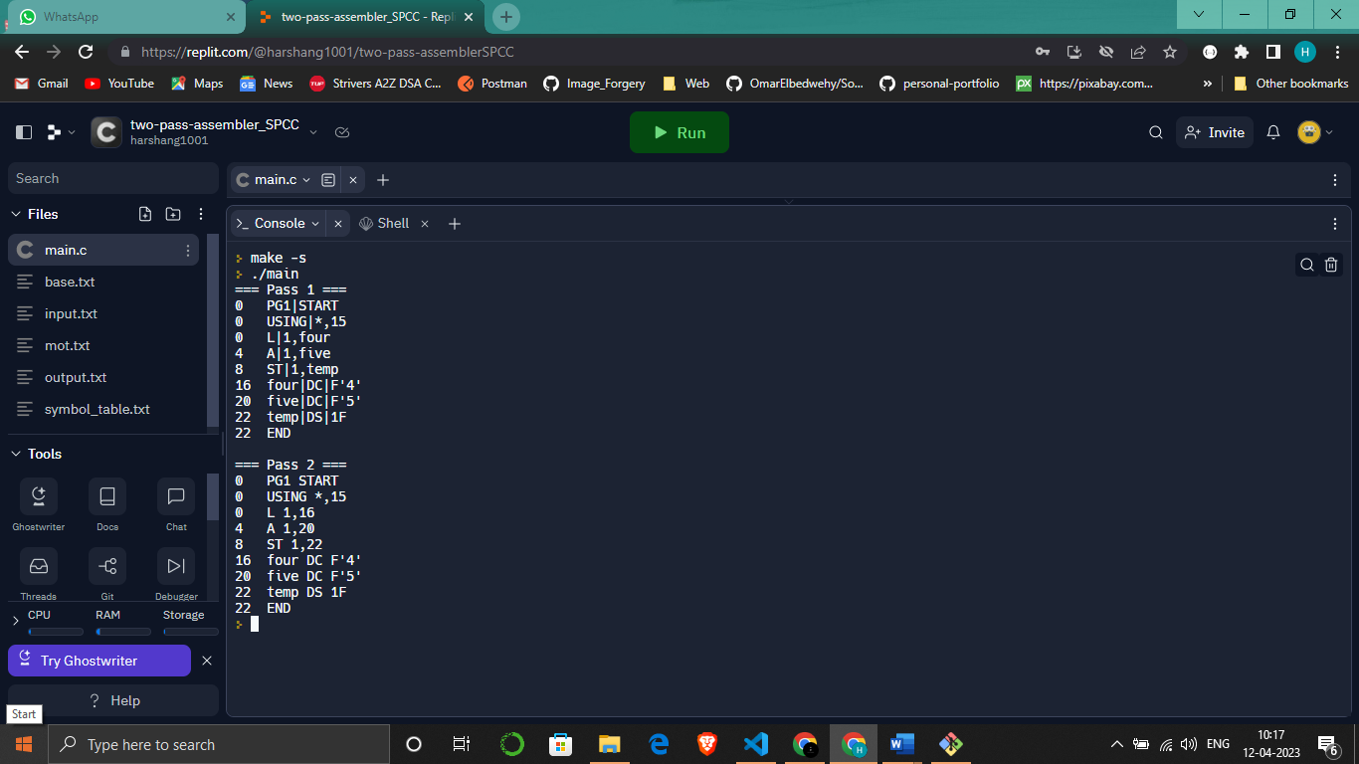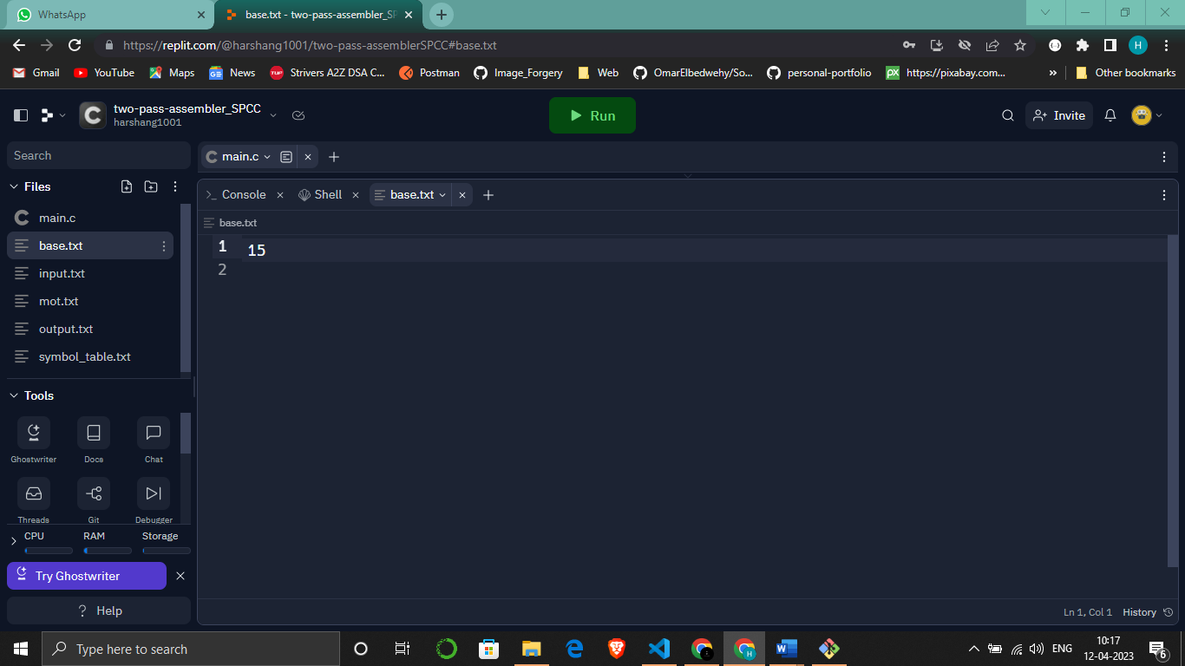

**Input.txt mot.txt**

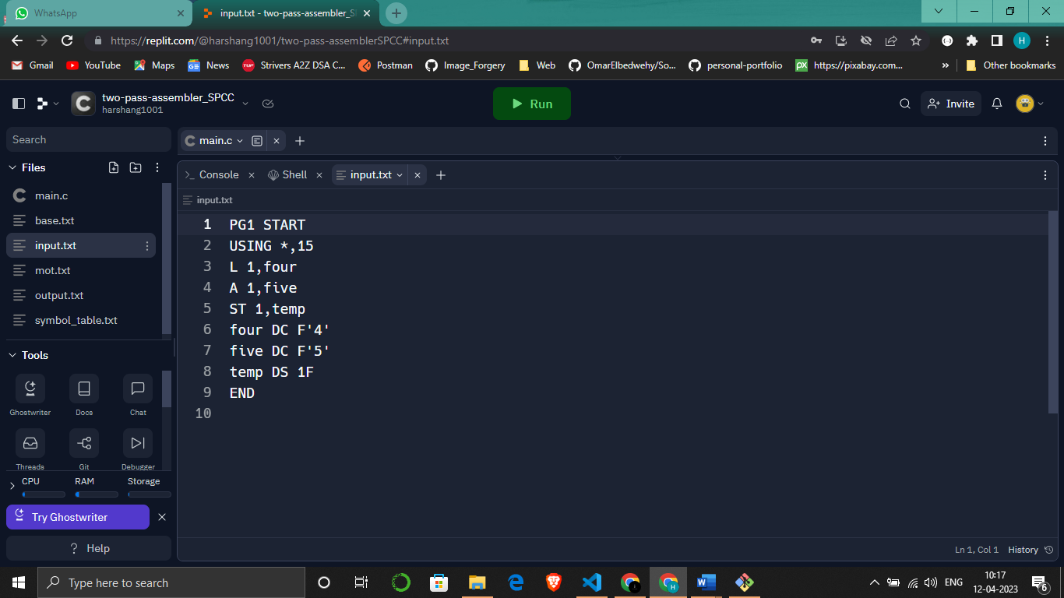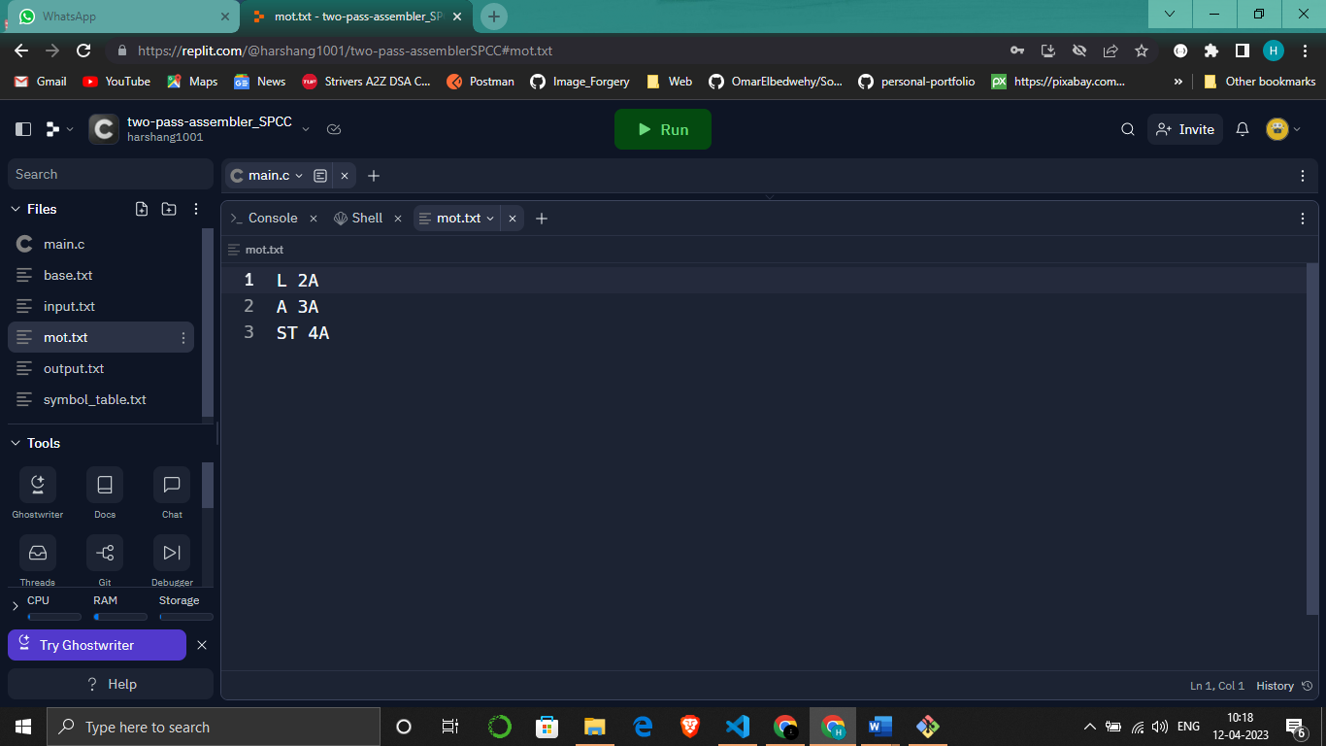

**Output.txt symbol_table.txt**

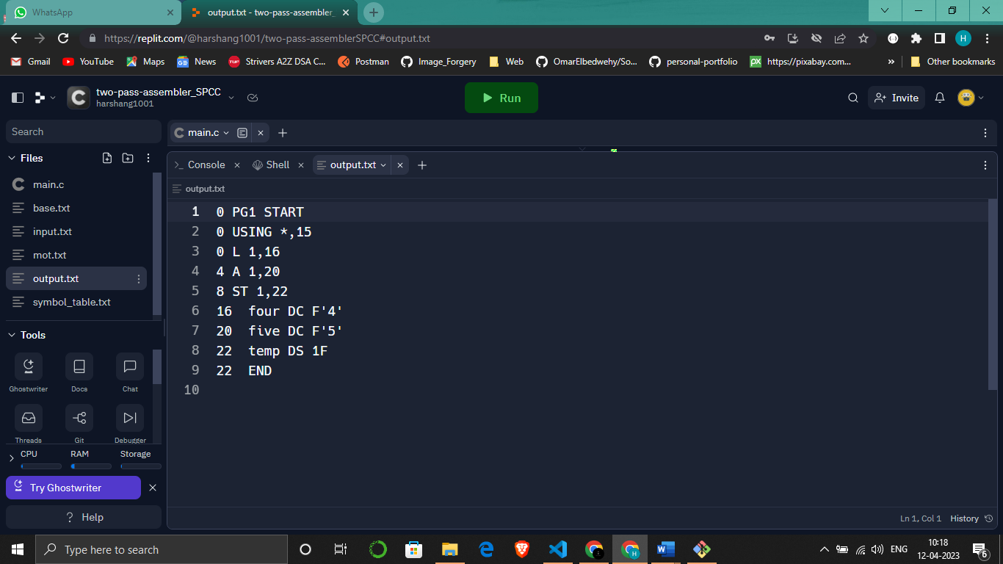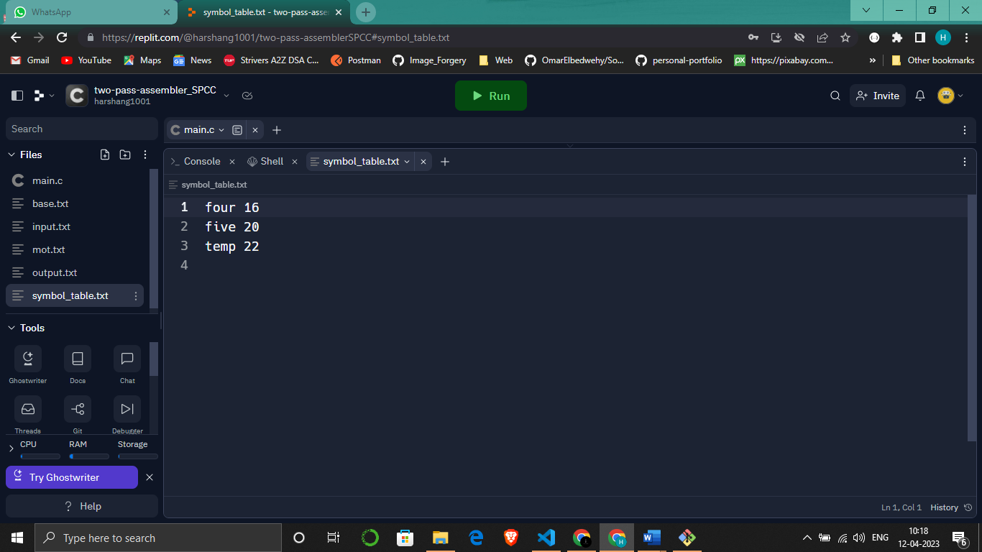

**Post Lab Questions:**

1. **Define the basic functions of assembler.**
2. **What is the need of SYMTAB (symbol table) in assembler?**
3. **What is the need of MOT in assembler**
4. **What is meant by one pass assembler?**