

**KHULNA UNIVERSITY OF ENGINEERING & TECHNOLOGY**

**Department of Computer Science and Engineering**

CSE 4128

Image Processing and Computer Vision Laboratory

Assignment 02

**Date of Submission:** 13 March, 2024

|  |  |
| --- | --- |
| **Submitted By** | **Submitted To** |
| Habibur Rahman  Roll: 1907036  Year: 4th Semester: 1st  Department of Computer Science and Engineering (CSE)  Khulna University of Engineering and Technology (KUET), Khulna-9203 | **Dr. Sk. Md. Masudul Ahsan**  Professor  **Dipannita Biswas**  Lecturer  Department of Computer Science and Engineering (CSE)  Khulna University of Engineering and Technology (KUET), Khulna-9203 |

**Final Input and Output:**

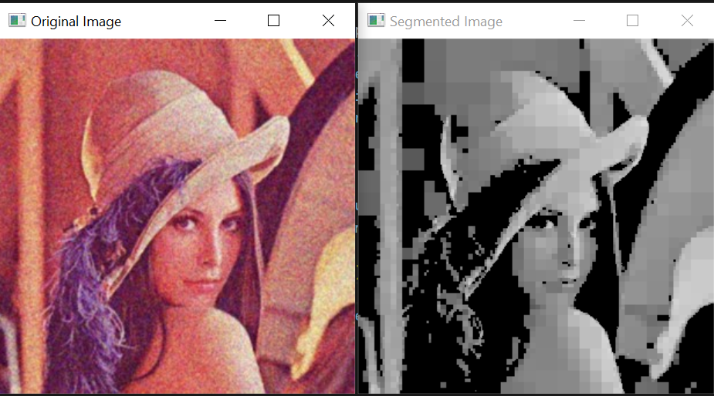

**Fig-6:** Final Input and Output Image