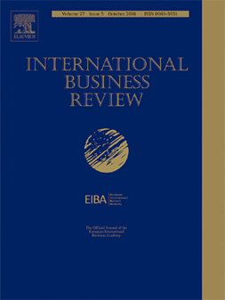

***International Business Review***

**Professional Development Workshop**

**The 47th Annual Conference of the**

**European International Business Academy (EIBA)**

**Complutense University of Madrid, Somosaguas campus, Madrid, Spain**

**Conference website: https://eiba2021.eiba.org/**

**Friday 10 December 2021**

We are delighted to announce a Professional Development Workshop (PDW) hosted by the Editor-in-Chief of *International Business Review*. The PDW is aimed at early career researchers and Ph.D students, and will focus on four key issues:

1. What constitutes a “good” academic paper?

2. Common pitfalls to avoid when preparing the original submission to a

journal

3. Responding to reviewers

4. How to make effective presentations at academic conferences

There will be ample opportunities to ask questions.

All participants are expected to have registered for the EIBA Conference, and also to have pre-registered for the PDW.

Roger Strange

Editor-in-Chief, *International Business Review*