Mohammad Mushfequr Rahman

100438290, University of Derby, 27/10/2017

Abstract

From Design to Fully Implemented, Optimized and Secured Database

Database for historical site

Design and Implementation

Contents

ERM 2

Entities 2

Constraints 4

Assumptions 4

Normalization 4

1NF 4

2NF 5

3NF & BCNF 6

Implementation 7

Command 7

Output 7

Meta-Data 7

Queries 7

Optimization 8

Security 8

Web Interface For Trainer Table 8

CRUD operations in order: 8

# ERM

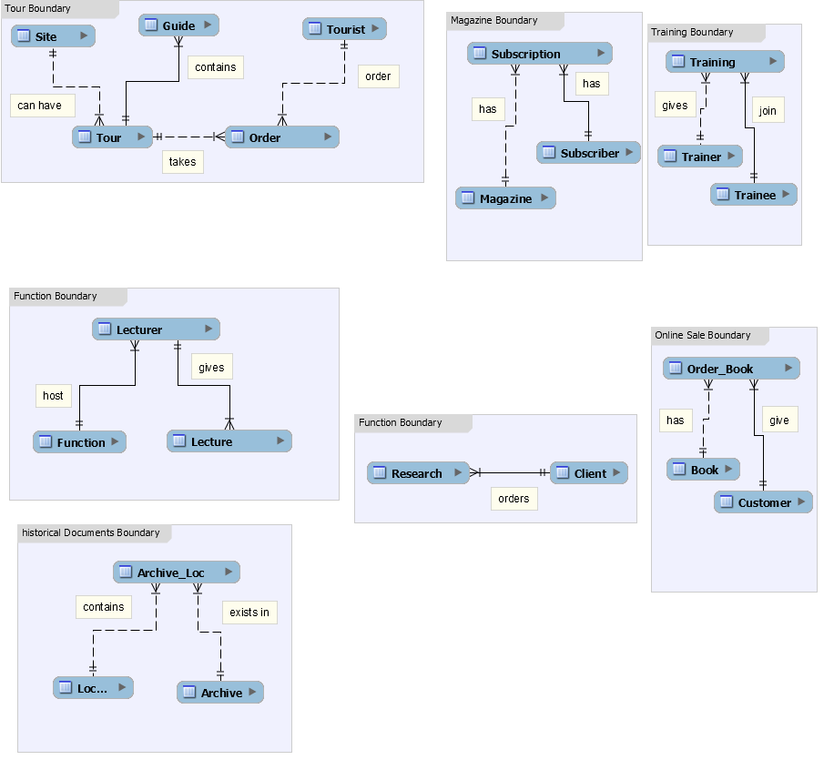

## Entities

Guide: (id, name, email, {address}, telephone)

Reason for data capture: Tour needs guides

Tour: (id, name location description comment {type}, price)

Reason for data capture: It’s a tour of historical sites

Site: (id {location} history condition type)

Reason for data capture: Site contains building, battlefield and archeology

Tourist: (id name email phone {address})

Reason for data capture: Tour has tourists.

Order_tour: (invoice date guide tour tourist)

Reason for data capture: Tourists order/book tour. There will be other PK

Lecture: (id topic duration date, function)

Reason for data capture: There will be lecture on.

Lecturer: (id name email phone {address} expertise, function)

Reason for data capture: Who will give lectures?

Function: (id name email {address})

Reason for data capture: Lecture takes place in function

Research: (id details deadline)

Reason for data capture: Research on genealogy

Client: (id name email {address})

Reason for data capture: Who will order research?

Archive: (id name age fragility detail)

Location: (id postcode area city country)

Archive_Loc: (id_arch id_loc date_placed date_shift)

Book: (isbn title author date edition pages genre cost)

Reason for data capture: Online book sale

Author: (id name)

Reason for data capture: Written by who?

Order_book: (invoice book_id cust_id book date_order price {dispatch_addr})

Customer: (id name email phone {address})

Subscriber: (id name email phone {address})

Reason for data capture: Subscriber information

Magazine: (id issue date genre pages issue_type)

Reason for data capture: magazines available for subscription

Subscription: (id subscriber magazine date_start date_end cost)

Reason for data capture: The subscription. There will be other PK for this

Trainer: (id name phone email {address} expertise status)

Trainee: (id name phone email {address})

Training: (id trainer trainee type location start_time end_time)

## Constraints

* Site must be areas, buildings and battlefields
* A historical document can have more than one copies hence multiple locations
* Lecturer titles: Dr. Mr. Miss. Prof.
* Archive fragility: Low, Critical and Moderate.

## Assumptions

* This company does not need database for email/phone messages as this company is not an email service company or a phone service company. Company employees can just refer to their relevant company emails which user can find in relevant company website.

# Normalization

## 1NF

All attributes with in {} are repeating and/or duplicate so we make new tables for them in order of occurrence.

Addr_guide: (id street postcode city country)

Loc_site: (id street postcode city country)

Addr_tourist: (id street postcode city country)

Loc_func: (id street postcode city country)

Addr_client: (id street postcode city country)

Addr_cust: (id street postcode city country)

Addr_subs: (id street postcode city country)

Dispatch_addr: (id street postcode city country)

## 2NF

No partial dependency/Atomic PK/No non-primary key attributes

***Tour***: (id, name description comment {type})

We have type and location as non-primary key attribute so remove it

***Order_tour***: (invoice date guide tour tourist)

We have guide, tour and tourist as non-primary key attributes so remove them

***Order_book***: (invoice book_id cust_id book date_order price)

We have book_id, cust_id, price and book as non-primary key attribute and PD so we remove them

***Lecture***: : (id topic duration date, function)

We have function as non-primary key attribute so we remove them

***Lecturer***: (id name email phone, expertise, function)

We have function as non-primary key attribute so we remove them

***Subscription***: (id subscriber magazine date_start date_end cost)

We have subscriber, magazine and cost as non-primary key so we remove them

***Training***: (id trainer trainee type location start_time end_time)

We have trainer, trainee as non-primary primary key attribute and type as PD so we remove them

Finally we have

***Tour***: (id, name description comment)

***Order_tour***: (invoice date)

***Order_book***: (invoice date_order )

***Function***: (id name email)

***Subscription***: (id date_start date_end )

***Training***: (id location start_time end_time)

## 3NF & BCNF

Training: (id trainer trainee type location start_time end_time)

Table is already in 3NF/BCNF as there are no transitive dependency and every candidate key is a determinant. So we have

* + Guide: (id, name, email, telephone)
  + Site: (id history condition type)
  + Tourist: (id name email phone)
  + Lecture: (id topic duration date)
  + Lecturer: (id name email phone, expertise)
  + Function: (id name email)
  + Research: (id details deadline)
  + Client: (id name email {address})
  + Archive: (id name age fragility detail)
  + Location: (id postcode area city country)
  + Archive_Loc: (id_arch id_loc date_placed date_shift)
  + Book: (isbn title author date edition pages genre cost)
  + Author: (id name)
  + Customer: (id name email phone)
  + Subscriber: (id name email phone)
  + Magazine: (id issue date genre pages issue_type cost)
  + Trainer: (id name phone email expertise status)
  + Trainee: (id name phone email)
  + Tour: (id, name description comment)
  + Order_tour: (invoice date)
  + Order_book: (invoice date_order )
  + Subscription: (id date_start date_end )
  + Training: (id type location start_time end_time)
  + Addr_guide: (id street postcode city country)
  + Loc_site: (id street postcode city country)
  + Addr_tourist: (id street postcode city country)
  + Loc_func: (id street postcode city country)
  + Addr_client: (id street postcode city country)
  + Addr_cust: (id street postcode city country)
  + Addr_subs: (id street postcode city country)
  + Dispatch_addr: (id street postcode city country)

# Implementation

NOTE: If you are unable to access these files, which otherwise if pasted here would make thousands of lines of code/output, then please visit

[View at My Academia](https://www.academia.edu/34974011/Database_for_historical_Site_Design_and_Implementation)

OR

[View at My Github](https://github.com/webiondev/database_D-D)

## Command



## Output



## Meta-Data



# 

# Queries



# Optimization



# Security



# Web Interface For Trainer Table







## 

## CRUD operations in Order of Occurrence:

* Updated
* Update
* Form Loaded
* Insert
* Inserted
* Deleted
* Delete

