***Preliminary DB Tables***

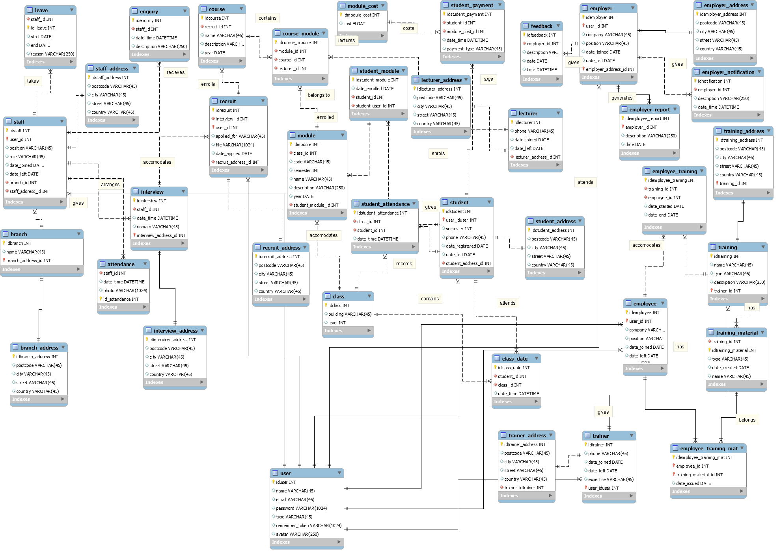

***Preliminary DB in 3NF/BCNF Form***

**User**

User: id, name, email, type,role, password, remember_token, avatar

**Management**

Staff: id, position, role, date_joined, date_left

Branch: id, name

Branch_address: id, postcode, city, street, country

Staff_address: id, postcode, city, street, country

Attendance: id, date_time, photo

Leave: id, start, end, reason, status

**Recruit**

Enquiry: id, date_time, description

Interview: id, date_time, domain

Interview_address: id, postcode, city, street, country

Recruit: id, applied_for, file, date_applied

Recruit_address: id, postcode, city, street, country

**Education**

Course: id, name, description, year

Module: id, code, semester, name, description, year

Course_module: course_id, module_id

Student_module: id, date_enrolled

Class: id, building, level

Student: id, semester, phone, date_registered, date_left

Student_address: id, postcode, city, street, country

Student_attendance: id, date_time

Class_date: id, date

Lecturer: id, phone, date_joined, date_left

Lecturer_address: id, postcode, city, street, country

**Finance**

Module_cost: id, cost

Student_payment: id, date_time, payment_type

**Employer**

Employer: id, company, position, date_joined, date_left

Employer_address: id, postcode, city, street, country

Employer_report: id, description, date

Employer_notification: id, description, date_time

Feedback: id, description, date, time

Employment history:

**Employee**

Employee: id, company, position, date_joined, date_left

Employee_training: id, date_started, date_end

Training_material: id, type, date_created, name

Employee_training_material: id, date_issued

Training: id, name, type, description

Training_address: id, postcode, city, street, country

Trainer: id, phone, date_joined, date_left, expertise

Trainer_address: id, postcode, city, street, country

**Constraints (if any):**

User: staff, recruit, employer, employee, student, lecturer, trainer

Leave: maximum ?

Leave Status: accepted, rejected

Staff role: hr, sales, trainer, lecturer, admin

**Assumptions (if any):**

**SQL:**

