

**NAME**  : RYAN MAH SONG WENG

**LOGIN ID**  : mahsongweng@oasis-portal.my

**COURSE TITTLE** : Executive Diploma In Hospitality Management

**SUBJECT CODE** : DHM02

CONTENT

|  |  |  |
| --- | --- | --- |
| **NO** | **CONTENTS** | **PAGE** |
| 1. | Executive Summary | 1 |
| 2. | Introduction | 2 |
| 3. | Part 1  3.1 Understanding about Marketing in Hospitality  3.2 Important of Hospitality Marketing | 3  4 |
| 4. | Part 2  4.1 Differences between Marketing and Customer Service  4.2 Ethics of Marketing and Customer Service | 5-6  7-8 |
| 5. | Part 3  5.1 The Marketing Strategies  5.2 The Ways to Apply Marketing Strategies in Hospitality Management | 9-10  11 |
| 6. | Part 4   * 1. Understanding of Customer Service Skills and Characteristics   2. Importance of Hospitality Customer Service | 12-13  14-15 |
| 7. | Appendix | 16-17 |
| 8. | References | 18 |

**1.0 EXECUTIVE SUMMARY**

In the module, I covered the topic about Hospitality Marketing and Customer Service. In assignment part, I have introduction of marketing hospitality. In first part, I explain about the marketing hospitality, important of marketing hospitality and differences between marketing and customer service. In second part, I define meaning of ethical marketing and customer service. In third part, I describe the marketing strategy. Lastly, I will explain and description of the customer service, characteristics and important of customer service. I will give some appendix and references in this assignment for more clearly understanding about the hospitality and tourism.

**2.0 INTRODUCTION**

Marketing is to the process that provide goods and service to the customer which bases on the customer needs and their satisfaction. The role of marketing strategies is to help the marketer to sense the future needs of customers, create new and attractive solutions. The marketing strategies is a good marketing tool to increase the profit of company through research, awareness, promotion and relationships.

A marketing strategy is based on research that focuses on a marketer’s competitors, customers, market size and the potential for market growth. Marketing play an important role for a company to build their excellent brand in the customer mind. Besides, the creative and effective strategy help the company to attract new customers and maintain loyalty, returned customers.

Therefore, the marketer should consider all the ethical of marketing and customer service to maintain loyalty or returned customers. That is because marketer show how appreciated of their customer through giving memorable experiences and maintaining a high level of customer service. In a nutshell, to meet the customer needs and their satisfaction is the goal of marketing.

**3.0 PART 1**

**3.1 MARKETING IN HOSPITALITY**

Marketing is the process for getting a company's product or service out to consumers. Marketing hospitality is to understanding the knowledge of marketing hospitality industry and capture value from the customers to increase the income of the hospitality industry. Hospitality marketing takes a look at how segments of the hospitality industry, such as hotels, restaurants, resorts and amusement parks, utilize marketing techniques to promote their products or services.

Marketing is use different ways of advertising to let the public see and attract them. Consumer want the best things to satisfying their demand when they are travelling or check in the hotels and the hospitality industry will use different ways to satisfying them because different people have different needs, wants and demand.

A transaction is marketing’s unit of measurement and consists of a trade of values between two parties. Marketing also can build a good relationship with customers and understanding what they want, what kind they like, or even how they feel after the services. Relationship marketing builds relationships with valued customers, distributors, dealers, and suppliers by promising and consistently delivering high-quality products, good service, and fair prices. Marketing can help hospitality to managing the customer’s behavior and understand how to attract them. That is why we need the marketing.

Hospitality industry have a lot of competitive job market and facing a unique set of challenges so must be overcome. Marketing also can help the hospitality industry increasing the brand awareness, the brand can be the top in the market and get beyond the other competitive job market.

**3.2 IMPORTANT OF HOSPITALITY MARKETING**

1. Build a brand

Branding is very important in a business because branding show an image or ideas in market of a certain service or product to the customers when there are lots of same service and product which offering by others companies. While, when marketer creates sales promotion or lower priced deal, these may influence customers difficult to stick with one brand because they can get a better deal between other difference brands. Creates a good and excellent branding may lead company to build their reputation and expend their service or product which may increase the profit of company.

1. Attract new customer

Market competition encourages healthy change and keeps business exciting. That is because consumer demand always changing, the marketers are always adventurous to try out new products and plans to create and attract new customers. Every companies have their own and particular ways to attract the customers, such as create an event or promotion. Every marketing strategies that run by every company may attract lots of new customer which meets their demand.

1. Maintain loyalty or returned guest/customers

Marketing lead maintain loyalty or returned customers that is because they show how appreciated their customer through giving memorable experiences, maintaining a high level of customer service to stages of interest in company’s brand. If customers feel that they are getting a good quality and service from your company they are less likely to go other where. They will becomes truly loyal customers.

**4.0 PART 2**

**4.1 DIFFERENCES BETWEEN MARKETING AND CUSTOMER SERVICE**

Marketing is a management process that provide goods and service to the customer which bases on the customer needs and their satisfaction. According to Peter Drucker, marketing is encompasses the whole business that seen from the views of customers. Therefore, he believes that concern and responsibility must be exist by every marketer.

As summary, marketing is everything a marketer does to create customers and maintain a relationship with them. For examples, send a thank you letter through email, returning a call immediately without delay and meet up with customers for coffee. The goals of marketing is to ensuring profitability through match and provide the products and service according to the customers need.

According to Dr. Philip Kotler, marketing is to increase the standard and qualities of living throughout the world. The role of marketing is to sense the future needs of customers, create new and attractive solutions. Marketing is not a selling that is because selling only happens when there is a customer getting to exchange their cash for something. Therefore, marketing is a long-term investment effort which is a more comprehensive process through determines how to organize, price, publish and promote the product or service offering at the places.

In contrast, customer service is the service which provided to customers before, during and after purchasing. Customer service play the important role to generate income and revenue of an organization or marketer. A good customer service may provide a good experience to the customers which match their expectation and it produces satisfied of customers. The role of customer service is to provide the information and help resolve any customer complaints.

A good customer service help developing a good relationships with the customers and this lead a long-term relationship between customers and business. There is a win-win situation and benefits both when the business is providing services that meet their needs then the satisfied customers will be repeat customers. Below is the tables of analysis the difference between marketing and customer service.

|  |  |  |
| --- | --- | --- |
| **MARKETING** | **COMPARISON** | **CUSTOMER SERVICE** |
| Refer to the process that provide goods and service to the customer which bases on the customer needs and their satisfaction. | **MEANING** | Customer service is the support you offer your customers before, during and after purchasing and help customers have an easy and enjoyable experience with you. |
| To sense the future needs of customers, create new and attractive solutions. | **ROLE** | To provide the information and to address inquiries regarding products and services |
| To create customers and maintain a relationship with them | **AIM** | To help resolve any customer complaints. |
| Through received response from customers | **IMAGERY** | Through customers experiences with the service provide |

**4.2 ETHICS OF MARKETING AND CUSTOMER SERVICE**

Ethical marketing is less of a marketing strategy and more of a philosophy that informs all marketing efforts. It seeks to promote honesty, fairness, and responsibility in all advertising. It is between doing the right thing and making money. Ethics marketing is the most ethics discussions revolve around moral values of good and bad, right and wrong, which can vary significantly depending on your spiritual, religious, and cultural backgrounds because everyone has subjective judgments. For this reason, ethical marketing is not a hard and fast list of rules, but a general set of guidelines to assist companies as they evaluate new marketing strategies.

Ethics in marketing means applying all possible standards of fairness, honesty, responsibility, respect and transparency. In the majority of cases marketers overstep the line as it gives the only opportunity to escape high costs, high overheads and a danger of building up false expectations. The most common ethical issues that marketing managers are facing daily are: false advertising, selling a product that is bad for the consumer’s health or environment and deciding between making considerable profit or making the product more affordable. Unfortunately, ethics not always wins the battle, although it is of paramount importance for those companies that want to keep a good image, especially in today’s world where the competition is getting tougher and tougher from day to day.

Customer service refers to a series of activities by a business person that lead to the final satisfaction of the customer. Customer service or customer relations involve interacting and servicing of prospective customers before and after the sales are made. It can be said to be planned activities formulated to improve the degree of customer satisfaction.

"The customer is always right" is a famous business slogan. The underlying truth behind this statement is recognizing that customers are the life blood for any business. Good customer service is all about bringing customers back and about sending them away happy - happy enough to pass positive feedback about your business along to others. Understanding the importance of good customer service is essential for a healthy business in creating new customers, keeping loyal customers, and developing referrals for future customers. Customer service is important because customer service does more than simply provide a means to drive sales. It is also said that when companies have a commitment to a customer service this raises the bar of competition.

**5.1 THE MARKETING STRATEGIES**

A marketing strategy is based on research that focuses on a marketer’s competitors, customers, market size and the potential for market growth. The strategies will help to determine what and which aspects of the industry have the most influence on its customers. It is a way to maximize the results from money and time spent on marketing. The following are some general strategies that marketers use for brand success:

1. Research

Research use to analysis and gain valuable advice from customers, market conditions and competitive landscape. Research is very important to maximize effectively of the market through four W – who, what, why and where which has baked into customers, trends, media and competition. This analysis will show that how and where customers seek the information, how customers evaluate to your market, what have influence customers choose a particular hospitality service and how customers make purchases.

1. Awareness

Marketer may build their hotel, resorts and restaurants awareness through many ways. The most important is the information of hotel is easy to find by customer and always be up-to-date. While, marketer may improve the awareness through power of internet to getting the hotels name known by public, such as create an engaging website. Besides, marketer may invest in signage that displays the hotel’s name where can easily see by the roadside. Therefore, the potential customers understand about your hotels, so they can purchase it.

1. Promotion

Promotion is the one of the effective strategy to attract customers. Promotions designed to create a short term increase in sales. Promotion include advertising, sale promotion, packaging, personal selling and public relation. Therefore, marketer may create an event in their hotel, such as give out discount coupons and discount codes to the customers who have visits to your hotel. Promotion may convey through social media like email, Facebook Pages and Twitter to keep customers interested in any organization. The promotion which meet the needs of customers enough to attract customers.

1. Relationships

In marketing, relationship play an important role which may influence economic of marketing. Relationship in marketing is created the state of being connected with valued customers by promising and provide high-quality products, good service, and fair prices. When we meet the customer's requirements and needs, they will be the repeat customers. The customers may recommend to other guest and thus will lead to increased profit and partnership. Therefore, all we have to treat customer fairness, trust and honesty to build loyalty.

**5.2 THE WAY TO APPLY MARKETING STRATEGIES IN HOSPITALITY MANAGEMANT**

First of all, as a marketer I would like select a location that convenience for guests which is nearby airport, city town and shopping complex. Location is one of the important elements in marketing which is the first things that concerns by the visitors. The guest will choose the hotel which according to their needs and requirements that based on their travel planning.

After that, I would like to create image of my hotel after I have set my target and objective. Do some research and try to determine the audience that I want to reach. Image is very important for a hotel to the public and customers. Have a good image may help to build awareness of public and customer to my hotel. Therefore, I will create a webpage which show my hotel’s location, environment pictures of my hotel and hotel’s facilities. In this webpage should have the review form the other guest as reference and purchase way for visitor.

Next, I will promote my hotel through difference ways, such as advertising on newspapers, magazines, TV, radio, flyers, and direct mail to the public. The more effective ways is promote through advertising online such as Facebook, Twitter and mobile marketing. Through these difference ways, public may get the information and promotion or event that has been created by my hotels. In the same times, I should determine that information are always up-to-date.

Lastly, I will develop or create relationship with our customers or guest. I should consider and determine that my hotel’s members or worker are giving professional training which may providing great service so I can develop a loyal customer base for my hotel. Then, we can use the mailing list to send thank-you notes to the visitors who stayed at my hotel and ask for feedback form the visitor. Good remark or comment may improve hotel’s image and reputation to keep their guests coming back time after time.

**6.1 UNDERSTANDING OF CUSTOMER SERVICE SKILLS AND CHARACTERISTICS**

Customer service is the act of taking care of the customer's needs by providing and delivering professional, helpful, high quality service and assistance before, during, and after the customer's requirements are met. Customer service is meeting the needs and desires of any customer.

Characteristics of Customer Services Skills :

1. Promptness

Promises for delivery of products must be on time. Delays and cancellations of products should be avoided. Make sure you are ready for an appointment early. This allows time for you to prepare, review client notes, and not be rushed or even appear to be rushed. You're also showing respect for your customer's time. Running late or bumping a client's appointment time doesn't make a good impression. Our clients are depending on us and we have to be ready and willing to get it done as soon as we can.

2. Politeness

Politeness is almost a lost art. Saying 'hello,' 'good afternoon,' 'sir,' and 'thank you very much' are a part of good customer service. For any business, using good manners is appropriate whether the customer makes a purchase or not. Good manners and a little bit of warmth are basic expectations for most people. Using your manners can go a long way with customers. Treat them like someone who is paying your hard-earned money to deliver quality products or services. When customers feel respected they will stay engaged and want to do additional business with you. Showing respect starts with being polite.

3. Professionalism

All customers should be treated professionally, which means the use of competence or skill expected of the professional. Professionalism shows the customer they're cared for. People seek out professionals because they need access to knowledge and skills they don’t have themselves. All customer interactions should be professional. Demonstrate your competence, knowledge, and expertise in your field. Don't demonstrate anxiety, frustration, fear, or weakness. Give your customer the confidence they will receive a job well done. Don't complain about your personal or business life. In your business interactions, keep the conversation upbeat and your energy channeled on serving your customer's needs. If a client ever voices concern about their service, make sure respond quickly.

4. Personalization

Using the customer's name is very effective in producing loyalty. Customers like the idea that whom they do business with knows them on a personal level. Do what you can to personalize a customer's experience. Clients love when a business owner remembers their name, their preferences, and their unique needs. Incorporate personalization wherever you can in your service delivery. It makes people feel valued and increases their loyalty and engagement to your business. Be a good listener and advocate for their needs. View the situation from their perspective and ask, "What would make me happy in this situation?" Align your efforts with your customers' needs and you'll be assured of providing great customer service.

**6.2 IMPORTANCE OF HOSPITALITY CUSTOMER SERVICE**

As far as Tourism and Hospitality Industry is concerned customer service is the most important factor that drives future business. Tourism and hospitality industry usually covers hotels restaurants resorts cruise etc. through which people are served. Each guest coming to these entities are treated for the best experience.

There is several kind of training programs are available for the travel and tourism industry. The training given for restaurant industry usually involves culinary training and special guideline about how food is served. Hotels and resorts will having staffs trained to sell properties on rental basis and front desk management. Even though at the time of recruitment staffs are selected on the basis of skills proper training is needed for further experience. Otherwise poor customer service will result in more complaints and bad reputation for the company. A well trained staff can keep the customer happy and in that way can drive more customers to avail the services in future.

Another factor that is critical for tourism and hospitality industry is the stress that employees have to handle during the work. Reacting to situation with anger can create a wrong impression among the guest which may affect the reputation of the firm. Employees also need to be trained to manage conflicts occurring inside the hotel or restaurant. Excellent customer service is vitally important in the hospitality industry. It’s the first point of contact, between for example, the hotel guest and the representative of the hotel. Hotels and restaurants and everything in between in this type of industry, is a hospitality service provider that has a job to sustain customer happiness and satisfaction to keep the business afloat.

We have to satisfying what customer expectations. Satisfied customers are looking for a memorable experience and an energetic service, where it matters the most. Businesses need to be aware that it’s becoming ever more popular for guests to leave a review of their experience on a number of feedback sites, whether their experience was a good or bad one. Hospitality outlets need to me mindful of this as bad feedback can be extremely damaging. We also have to deliver on customer promise. Any business needs to keep customers and clients happy, but in the hospitality industry it’s so important to keep guests engaged in order for repeat business and for referral purposes. For the customer to return all you need to do is deliver what was promised, if you can exceed expectation where possible this is always a good tool to help gain referrals.

Remember happy customers are loyal customers, go understanding what they want, what they need and what they like, provide additional items where possible, this always tends to impress. Just remember, customers are the most important part of the business without them what would you have – focus on them at all times – and they will be happy. Customer's feedback is important. If a customer is unfortunate enough to have a bad experience, for any reason, you need to make sure it’s made easy and clear for them to tell you about it. At the same time be understanding and allow them to get it off their chest to you, so they’re not inclined to tell someone else. Try hard to fix the problem – communication is key – and remember keep calm and try to resolve the situation so the customer ultimately goes away happy.

**Appendix**

Appendix 4.1

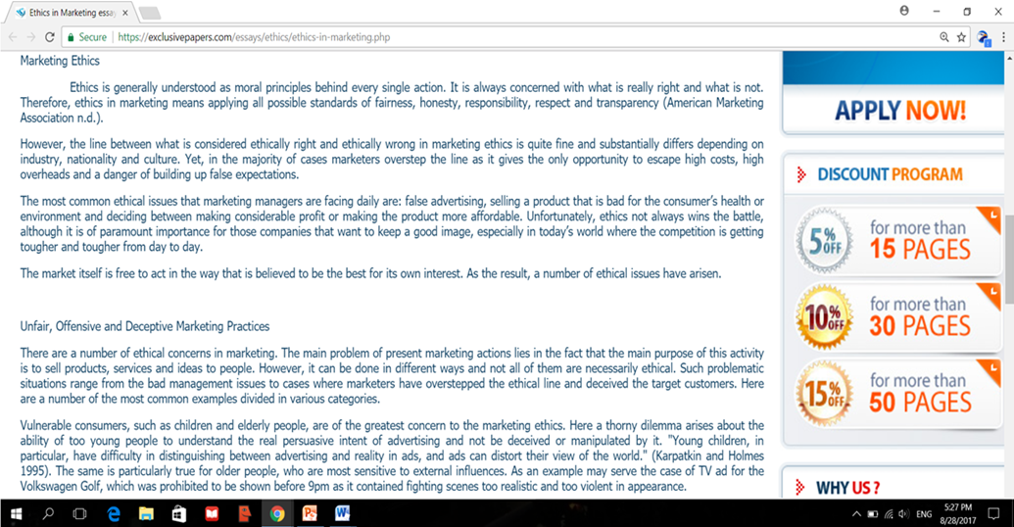

Appendix 4.2

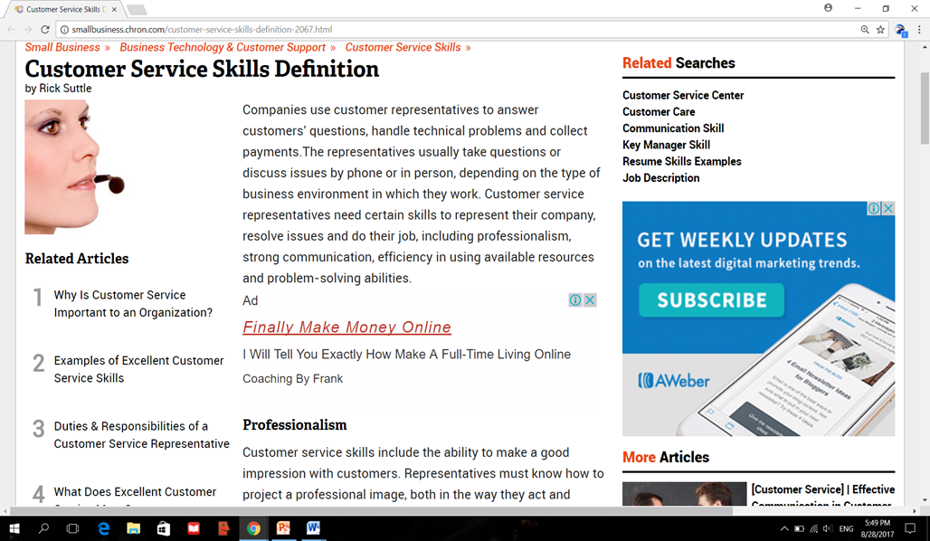

Appendix 6.1

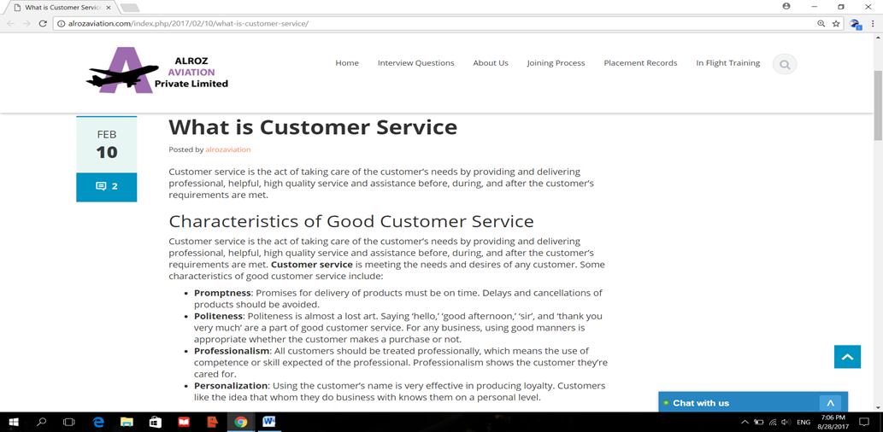

# **References**

alrozaviation. (2016). *What is Customer Service*. Retrieved from Alroz Aviation Private Limited: http://alrozaviation.com/index.php/2017/02/10/what-is-customer-service/

Brenner, M. (2017). *MARKETING IS BUSINESS: THE WISDOM OF PETER DRUCKER*. Retrieved from Marketing Insider Group: https://marketinginsidergroup.com/strategy/marketing-is-business-the-wisdom-of-peter-drucker/

*Custom Ethics in Marketing* . (2017). Retrieved from Exclusive paper.com: https://exclusivepapers.com/essays/ethics/ethics-in-marketing.php

*Dr. Philip Kotler Answers Your Questions on Marketing*. (2001-2016). Retrieved from Kotler Marketing Group: http://www.kotlermarketing.com/phil_questions.shtml

Guchy09. (2009, OCT 24). *Marketing for Hospitality and Tourism*. Retrieved from SCRIBD: https://www.scribd.com/doc/21564150/Chapter-1-Introduction-Marketing-for-Hospitality-and-Tourism

*marketing*. (2017). Retrieved from Business Dictionary : http://www.businessdictionary.com/definition/marketing.html

Stevens, D. (2017). *What Is the Meaning of "Marketing Strategy"?* Retrieved from Chron: http://smallbusiness.chron.com/meaning-marketing-strategy-74847.html

Stevens, D. (2017). *What Is the Meaning of "Marketing Strategy"?* Retrieved from Chron: http://smallbusiness.chron.com/meaning-marketing-strategy-74847.html

Suttle, R. (2017). *Customer Service Skills Definition*. Retrieved from Chron: http://smallbusiness.chron.com/customer-service-skills-definition-2067.html

Suttle, R. (2017). *Customer Service Skills Definition*. Retrieved from Chron: http://smallbusiness.chron.com/customer-service-skills-definition-2067.html

*What is customer service?* (1995-2017). Retrieved from Business Case Studies: http://businesscasestudies.co.uk/first-direct/using-customer-service-to-position-a-business/what-is-customer-service.html