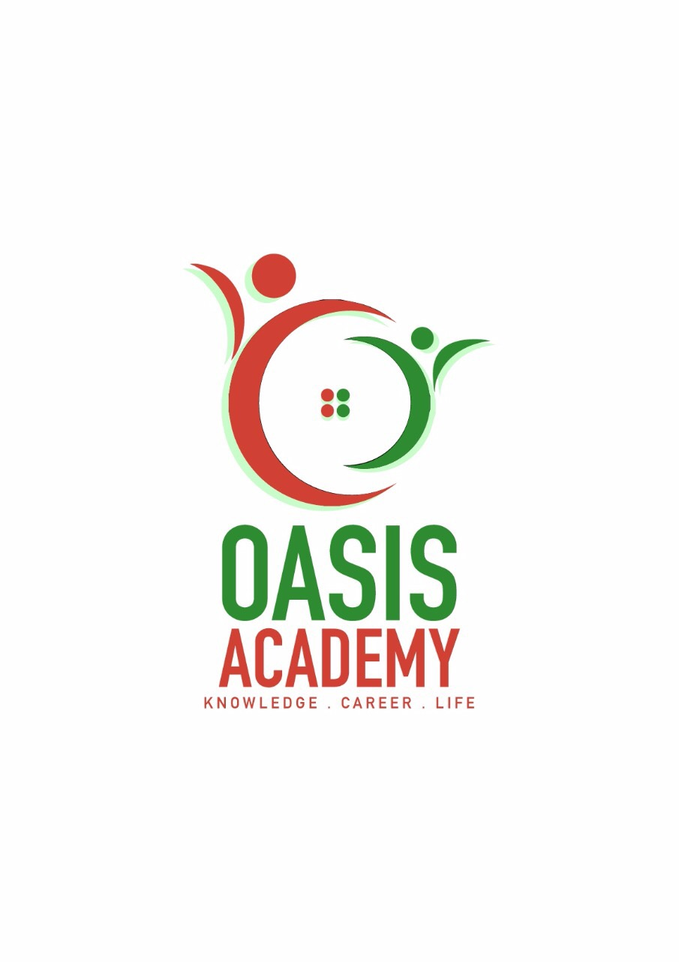

Name: Heng Chia Ching

Login ID:hengchiaching@oasis-portal.com

Course Tittle: Tourism and Hospitality

Subject Code: BHM04

Submitted Date: 11-09-2017

**Table of Contents**

|  |  |  |
| --- | --- | --- |
| No | Details | Page |
| 1 | Summary | 2 |
| 2 | Introduction | 3 |
| 3 | Assignment Question |  |
|  | Question 1 | 4-5 |
|  | Question 2 | 6-7 |
|  | Question 3 | 8 |
|  | Question 4 | 9-10 |
| 4 | Conclusion | 11-12 |
| 5 | Reference | 13 |

**Summary**

In this assignment, I have studied the tourism and hospitality. For the first part of the assignment, I will introduce the tourism and hospitality. And then second part of assignment, I will explained the four questions about the tourism and hospitality. For the first question I will define the Tourism and Hospitality**.** And then I will explain mine understanding about Hospitality industry. The second question I will brief on different type of tourism categories.

.After I will define about the tourism. And then the third part of the question, I will describe the lodging accommodation and types of Hotels accommodation. For the last part of the question, I will explain the Significant of Entertainment in this industry.

**Introduction**

In this assignment, I will introduction about the tourism and hospitality. Now travel has become a project that people to relax, relieve stress and broaden their horizons, and get spiritual satisfaction. More and more people are willing to spend money on the trip, so that the development of tourism is getting better and better. The development of the tourism industry has also led the relevant industries, such as the hotel industry. Due to travel is almost indispensable to eat, accommodation and transportation. So the tourism industry and hotel industry cannot be separated from the relationship between cooperation. The hotel’s work is to provide visitors with accommodation and catering services, so that visitors can easily find a comfortable place to rest and eat. Good hotel facilities and a comfortable environment allow travelers to relax and have a good rest.

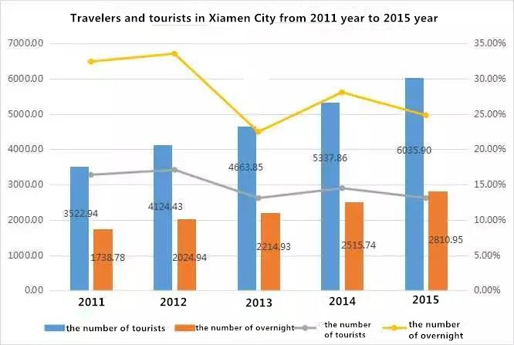

Figure 1

According to the above figure 1, we can see that the total number of overnight visitors is half of the total number of visitors. In each year, the number of visitor and the number of overnight visitors to the hotel are increasing. This also shows that the number of tourists increased, the number of overnight visitors will follow the increase. So the tourism industry and the hotel industry have inseparable relationship.

**Assignment Questions**

**Question 1**

**Define the Tourism and Hospitality.**

The hotel industry is a service-oriented industry, regardless of the size of the service, their purpose is the same, is for the guests and visitors to provide food, clothing, shelter, entertainment and the needs of the passengers arising from the Kind of service items. The hotel has a wide range of roles, in addition to providing dining and accommodation, as well as the functions of meeting venues, leisure activities, social gatherings, recreational activities and shopping. The hotel is through the provision of accommodation, catering and other related services to obtain a reasonable remuneration of the industry. All hotel accommodation prices are sanity, the price level will be based on the hotel's building materials and services provided to fix a reasonable price.

The hotel industry also belongs to the service industry, it has the basic characteristics of the service industry:

1. intangible

Most of the services sold by the hotel are products that are intangible, and most of the services do not provide samples or trials to customers, since services usually refer to a process of behavior. Service is the customer cannot see and touch the content and value before the purchase, the customer will only appreciate the real value of the service after the purchase. There are many parts of the hotel products in the intangible, such as the quality of service, service staff attitude.

2. indivisible

Most of the service industry products are done by labor. Customers in the consumer process, and ultimately, ultimately, participate in the entire process of service, which also allows service personnel and customers have generated communication between the behavior. Because each customer's response is not consistent, so the interaction between the service staff and the customer is very important, he decided the quality of the service.

3. variability

The process of service must be done by means of human labor, so the service industry has a great change Even if the customer then accept the same service staff reception, service quality may also be because the service staff and customers at the time of the external factors vary. There are many external factors, such as customer sentiment, service time and project, and the attitude of response between customers and so on. So the quality of most services is not easy to remain the same.

In simple terms, travel refers to people for leisure, business or other purposes to leave their habit of adapting to the environment, to other unfamiliar places to visit, play, rest and so on. Tourism activities do not refer to these people in the destination of tourism and employment. Tourism arrangements include travel itineraries, transportation, hotels and recreational activities. Tourism is formed by several organizations, that is, travel agencies, transport passenger transport enterprises, restaurants and entertainment companies. Tourism is an industry that provides travel services to tourists. Their travel resources (such as information about famous attractions) come from travel agencies, and their tourist facilities include transportation, accommodation, catering and so on.

The hotel offers services such as basic necessities and services, and tourism is closely related to these projects. So the hotel contains tourism, belonging to tourism products. For example, simply, is a place of tourist attractions is famous, so will usher in a lot of visitors to visit or play, for those who want to stay for more than two days the number of passengers, the hotel has become their indispensable choice one. So once the rapid development of tourism, it will also promote the development of the hotel industry. The two places are different places is one of the famous attractions to attract more visitors to visit, one is to stay comfortable and beautifully decorated features to attract more passengers to stay. To sum up the two industries is to rely on each other to help each other to develop better. The development of the tourism industry is certainly inseparable from the support of the hotel industry, only the two coordinated development, in order to make its common progress.

**Explain your understanding about Hospitality industry.**

The hotel industry refers to those who can provide accommodation and catering services and other comprehensive services business. The hotel is basically a host of accommodation facilities, a variety of services and a variety of convenient facilities. The hotel is also known as a motel, roadside inn, suite hotel and other name accommodation. The hotel industry is a well-established reception facility with a government-approved business. They have a certain number of the rooms, and then the size of these rooms is based on a reasonable proportion of the composition of the room, and has the appropriate service facilities. In addition to providing passenger accommodation and catering, there are also shopping, fitness, entertainment, free network, transportation and other services. The hotel is divided into five major standards, according to the national star standard can be divided into one to five stars. According to the cost of construction investment can be divided into economic, comfortable, luxury; one or two stars for the economy, three-star for the comfortable, four or five star for the luxury. At the same time a star as well, two stars for very well, three-star excellent, four stars as outstanding, five-star for one of the best in the country.

**Question 2**

**Brief on different type of tourism categories.**

The tourism industry is divided into the following different types of travel according to the travel destination of different travelers:

Leisure Tourism

Leisure travel is part of the trip, mainly in daily life through the holidays. The leisure travel feature is to choose to live in a beautiful hotel or resort, put aside all the troubles to carry out self-relaxation of travel, or choose to experience the local tourist attractions. In this case the purpose of the tour is entertainment. So this traveler will usually choose to go to the resort and stay at the resort hotel.

Cultural tourism

The purpose of cultural tourism is to join with tourists in some countries to participate in cultural practices or regional culture of tourism. Cultural tourism is in places related to cultural facilities (such as museums, large cities, theaters, historical and cultural cities, etc.). It also includes some of the traditions of farmers 1 (such as rituals, festivals, etc.), as well as their values ​​and lifestyles.

Religious tourism

Religious tourism is also called faith tourism, belonging to a kind of tourism. The main purpose is to leave the country to visit other countries or watch their religious activities of a trip. In many cases, these religious visitors travel to these sites on the anniversary of important events of specific religious believers.

Family Tourism

The purpose of family travel is to promote family reunion, maintain family relationships and create good memories for the family. Family travel is simple to travel with someone in their own family, that is, only their own parents and children. The role of participation does not include other people, such as friends.

Health Tourism

The purpose of health tourism is to improve and improve the physical and mental health of tourists, including the following 3 points: 1. Tourism purpose is to be healthy, healthy tourism activities not only focus on the purpose of appreciation, but also stressed that their own quality and cultural connotation of the increase; 2.Tourism in the process of tourism behavior should be healthy, should not arbitrarily destroy the natural environment and local culture; 3. Tourism effect to be healthy, not only to improve the physical and mental health of tourists, but also to promote regional natural and social health and development.

Sports Tourism

The main purpose of sports tourism is to watch, appreciate and participate in a variety of sports activities based on a trip. Sports tourism is also part of the national tourism industry, it is based on sports resources and sports facilities for sports tourism consumers in the course of travel to provide relevant services to the economic sector.

Educational Tourism

Education tourism belongs to a tourism activity whose purpose is to study, and its passenger objects are mainly concentrated in young students. Mainly to the Local education and remote education through school and school exchange visits. Broaden the horizon as a basic purpose of a learning approach and methods, including culture, management, teaching and other aspects.

Business Tourism

Tourist with relation to business is known as business tourism. Business travel is the participation of work and related activities (such as meetings, exhibitions and so on), their main purpose is to work in a specific place. An example of a business tour is a salesman who travels to another city to trade a trade show and sells the product he sells.

**Define Tourism.**

Tourism is also known as the tourism industry. They are equipped with tourist resources and facilities to provide passengers with complete facilities, such as transportation, accommodation, place of meal, shopping, entertainment and so on. Tourism is mainly composed of three major industries; tourism, transportation and passenger transport industry. They are an indispensable pillar of tourism.

The three elements of tourism development include tourism resources, tourism facilities and tourism services.

Tourism resources: including the natural scenery, the history of attractions, ethnic customs and so on.

Tourist facilities: including travel facilities, travel overnight accommodation facilities, catering facilities, recreational facilities and so on.

Travel services: a variety of labor to complete the service and management behavior is the tourism industry is essential to the reception capacity.

The main purpose of the tourism industry is to travel according to the needs of travelers for all the tourist attractions of the trip and the hotel, to collect passengers a reasonable price, so that visitors can enjoy the value of travel.

**Question 3**

**Describe the lodging accommodation and types of Hotels accommodation.**

Lodging is a room in someone’s house that you need to pay money to live in. Live is a type of accommodation. Travels and leave the family more than one day people need to sleep, rest, safe, avoid accommodation, place luggage and enter common family functions. Accommodation may be self-catering, in which case no food is provided, but cooking facilities also can be used. Accommodation is conduct in hotels, motels, private homes, tents, caravans and campsites.

Hotel

Hotel provides guests with paid accommodation and other services for the guests. According to the size, location and facilities, the hotel is usually from one star to five stars, but grading (from “A” to “F”) and other rating programs are also used to classify hotels around the world. A boutique hotel is a five star hotel offering all the features and amenities of a normal hotel, unique and unique style. These properties are usually very small, first- class services and are sold the affluent market.

Hostel

Ideal for budget travelers and backpackers, the hotel is an inexpensive accommodation, usually with shared bedrooms and public facilities. The hostel is usually the largest of all accommodation types. There is usually a common reception area where the room is usually opened directly in the corridor. The on-site restaurant and other facilities are more accessible to the public than other types of accommodation. Hostel offers a variety of customer service such as room service. The hotel is usually a member of a large hostel group, and different organizations within the group may provide a similar stay experience.

Resort

Although the resort is mainly called vacationers often patronize the destination for relaxation and entertainment, but the term is also used to describe a full range of accommodation with a wide range of customer service and recreational facilities.

Business hotel

Mainly for business travelers, business hotel located in (city center, business district, or near the main business center), and equipped with conference rooms, conference rooms, internet access and dining options and other corporate facilities.

Guest house

Guest house is a private residence, offering cheap accommodation for tourists. The guest house has been converted into dedicated and exclusive use of accommodation. The establishment of public places is for guest exclusive use. Owners or managers are not living in the field or in areas where the property is completely independent. A hotel offers a wider range of services, usually suitable for all meals.

**Question 4**

**Explain the Significant of Entertainment in this industry.**

Entertainment industry refers to the entertainment industry to pride places and services industries, including the operating karaoke, dance halls, karaoke OK dance halls, music café, billiards, golf, darts station, bowling, internet cafes, entertainment and other entertainment venues, and entertainment for customer recreational activities. Entertainment services of customers to provide catering services and other services are also in accordance with the entertainment industry tax. They provide entertainment and services based on the needs of their customers by providing entertainment for customers to trade. The entertainment industry is very important for the modern people, not only can help people to remove the pressure and relaxation, but also can reduce the unemployment rate (such as bars need bartenders, cleaners, service, chefs, etc.).

Internet cafes

It is a place for the public to provide a place for online public service, and the public can use internet cafe, such as computer and internet access equipment for web browsing, learning, learning, online games, chat, video, music or other activities. Internet operators through receive royalties or provide additional value-added services to earn income. Internet cafes are also a place for adults to study, recreation and other activities of the place, the most important things is to prohibit minors to enter. Internet cafes entertainment is currently the most suitable for young people to spend leisure, is also the best platform for training network applications.

Games

A game can refer to a recreational activity or a process of activity. The game props can be toys. In English, sport is also a game, and sports is also evolved play, usually for the purpose of entertainment, and sometimes there are educational purposes. The game is different from the work of the corresponding monetary reward, but also different from the aesthetic or conceptual elements of the art. But the boundaries between each other is not necessarily clear, like professional athletes and the work of the game may be one, and like jigsaw puzzle games with both the composition of the game and art. The main components of the game are purposeful, rules, challenges and interactions. The game is usually psychological or stimulation of physical, games also can develop relevant skills, physical, educational, analog or psychological significance.

Bar

Bar (also can call pub or tavern) refers to the provision of beer, wine, cocktails and other alcoholic beverage consumption sites. Bar refers to the entertainment and leisure class bar, providing live bands or singers, dancers performing. The senior Bar also has a bartender’s wonderful fancy bartender. Usually located in the hotel lobby or near. Many of the hotel’s lobby bar and leisure bar mostly belong to this kind. Cocktail bar is designed to be elegant, beautiful environment, comfortable, generally more spacious than the vertical bar, mostly piano, harp or small band playing, the atmosphere is quiet, slow pace of music, customers can enjoy here. There are other classification methods, such as by the source object is divided into men’s bars, ladies bars, membership bars, public bars, etc. According to the location and important of the bar is divided into lobby bar, roof bar, center bar and so on.

Marinas

Now abandoned the dock has also become people’s entertainment, such as Singapore’s largest entertainment area, one of the Clarke Quay. After several years of specialization and renewal, the central area of the Clarke Quay has been transformed into a trendy, bold and fascinating world class entertainment center. Clarke Quay is an entertainment paradise that brings together shopping, dining and entertainment. The Clarke Quay seems to be in a festive atmosphere all day, with a bar on the street and the restaurant making the atmosphere so very relaxed. Such a festive atmosphere of the pier is to attract a large number of tourists come to play and relax.

Nightclub

Nightclub is the kind of business that is the next day to the service industry, such as night entertainment, leisure and relaxation of entertainment, including KTV, bar, Di bar, discount KTV, performing arts hall, dance hall, DISCO, Nightclubs, etc., the common feature of the nightclub is to provide guests with drinks, food, space, facilities and equipment, so that people enjoy eating, drinking, playing, music, relax as one of the spiritual consumption. Let the people from early to late can find places where they can relax and relieve stress after work. Nightclub not only has a very rock and roll, or a free swing ballroom. Here, people can choose to eat and drink while watching other customers dance, or choose to know more friends to share the troubles encountered.

**Conclusion**

In this assignment, I will be taught about the first things is define the Tourism and Hospitality. The hotel industry is a service-oriented industry, whether it is the size of the service, the purpose is the same, is for the guests and tourists to provide food, clothing, accommodation, entertainment and passenger demand arising from the service. The hotel also serves a wide range of roles, as well as venues, leisure activities, social gatherings, recreational activities and shopping. Usually the hotel industry through the provision of accommodation, catering and other related services, access to industry reasonable remuneration. And then I will explainyour understanding about Hospitality industry. As far as I know, the hotel industry is to provide accommodation and catering services and other integrated services business. The hotel is basically a series of accommodation facilities, a variety of services and a variety of facilities. The hotel also has other names such as motels, roadside huts, suites hotel and other name accommodation. The hotel industry is a better received reception facility with government approval. They have a certain number of rooms, and then the size of the room is based the reasonable composition and have the appropriate service facilities. They also provide passenger accommodation and catering, as well as shopping, fitness, entertainment, free internet, transportation and other services. Because the hotel industry to allow visitors to have a stable place to rest. The second thing, I will brief on different type of tourism categories**.** According to the tourist destination of different travelers, the tourism industry is divided into the following different types of tourism. Such as the leisure travel, it’s mainly in the daily life of the holidays. The leisure travel function is to choose to live in a beautiful hotel or resort, put down all the worries, carry out self-relaxation travel, or choose to experience the local tourist attractions. The purpose of cultural tourism is to participate in cultural activities or regional tourism culture with tourists from some countries. It also includes some traditions of farmers and their values ​​and lifestyles. Religious tourism belongs to a kind of tourism. The main purpose is to leave the country to visit other countries or watch their religious activities. The purpose of family travel is to promote family reunion, maintain family relationships, and create good memories for the family. The purpose of health tourism is to improve and improve the physical and mental health of tourists. Simply is the main health. The main purpose of sports tourism is to watch, appreciate and participate in various travel-based sports activities. The purpose of educational tourism is to study the main tourism activities, mainly to young students to foreign and other school students to communicate with each other. Business travel is the participation of work and related activities (such as meetings), whose main purpose is to work in specific places. And then I will define tourism. Tourism is also known as tourism. It is mainly equipped with tourism resources and facilities for passengers to provide transportation, accommodation, catering, shopping, entertainment and other facilities. Tourism is mainly composed of three major industries, tourism, transportation and passenger transport industry. They are an indispensable pillar of tourism. For the third things, I willdescribe the lodging accommodation and types of Hotels accommodation. Accommodation is a room in someone house, you need to pay to live. Living is a kind of accommodation. The hotel offers paid accommodation and other services for guests. According to the size, location and facilities, the hotel usually from one star to five stars, the greater the number of stars on behalf of the hotel's higher accommodation, the better equipment. The hostel is usually the largest of all accommodation types. There is usually a common reception area where the room is usually opened directly in the corridor. Although the resort is mainly called vacationers often patronize the destination to relax and entertain, but the term is also used to describe a wide range of accommodation with a wide range of customer service and recreational facilities. Mainly for business travelers, business hotel located in (city center, business district, or near the main business center), and equipped with conference rooms, conference rooms, internet access and dining options and other corporate facilities. The hotel is a private residence offering cheap accommodation for tourists. The hotel has been converted into dedicated and exclusive accommodation. At the last things, I willexplain the Significant of Entertainment in this industry**.** The entertainment industry refers to the entertainment industry as a proud place and service industry, including operating karaoke, entertainment and entertainment venues for recreational activities. Entertainment services to provide customers with catering services and other services also meet the entertainment industry tax. They provide entertainment and services to their customers' needs and provide entertainment transactions for their clients. The entertainment industry is very important for modern people, not only to help people eliminate stress and relaxation, but also to reduce the unemployment rate (such as bars need bartenders).

**Reference**

1. Figure 1

RETRIVED FROM:

<https://www.google.com.sg/search?biw=1366&bih=662&tbm=isch&sa=1&q=%E6%97%85%E6%B8%B8%E4%B8%9A%E4%B8%8E%E9%85%92%E5%BA%97%E4%B8%9A%E7%9A%84%E5%9B%BE%E8%A1%A82011-2015&oq=%E6%97%85%E6%B8%B8%E4%B8%9A%E4%B8%8E%E9%85%92%E5%BA%97%E4%B8%9A%E7%9A%84%E5%9B%BE%E8%A1%A82011-2015&gs_l=psy-ab.3...44949.48704.0.48948.9.9.0.0.0.0.130.757.5j3.8.0....0...1.1j4.64.psy-ab..1.0.0.3One4j3RsWw#imgrc=XobfX3Nhk1dg7M>

1. the different type of tourism categories

RETRIVED FROM:

<https://www.slideshare.net/ALTINBAKU/the-different-types-of-tourism>

1. the lodging accommodation and types of Hotels accommodation

RETRIVED FROM:

<http://www.buildinghistory.org/buildings/lodges.shtml>

1. the Significant of Entertainment in this industry

RETRIVED FROM:

<https://en.wikipedia.org/wiki/Entertainment>

**THE END**