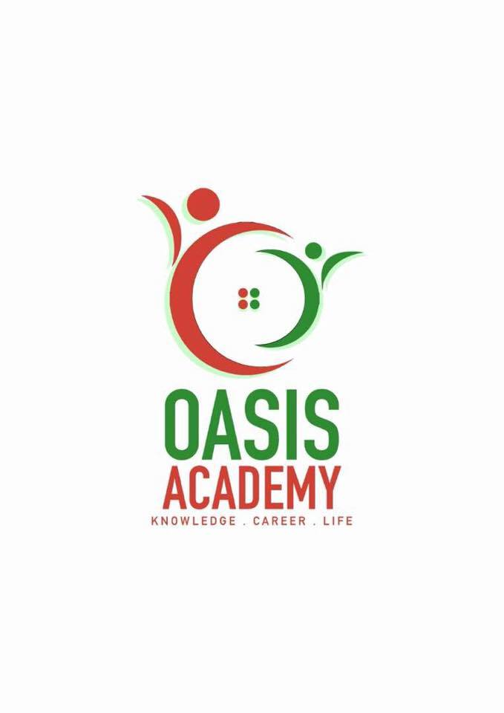

**Name:**  Ng Kah Jun

**Login ID**: ngkahjun@oasis-portal.com

**Course title:** Essentials of Human Resource

**Subject Code**: BHM01

Submitted date: 5/6/2017

**Table of Contents**

|  |  |  |
| --- | --- | --- |
| No | Details | Page |
| 1 | Executive Summary | 3 |
| 2 | Introduction | 4 |
| 3 | Part 1 | 5-7 |
|  | Part 2 | 8-12 |
|  | Part 3 | 13-15 |
|  | Part 4 | 16-18 |
| 4 | Conclusion | 19 |
| 5 | References | 20 |
|  |  |  |

**Executive summary**

The motivation driving doing this errand is to give learning or to get more information of HRM part in the connection. Regardless, we examined significance of HR, dependably we besides investigated on the focuses important exercises, which are payrolls, benefits, enrollment, prepare and success and security also. this are the genuine activities of the HR operation.

By then we lit up a little centrality about re-sketching out work handle for enhanced profitability; startling workforce; mass customization; decentralized work objectives; worker's consolidation.

In addition, in the third part we have illustrated about the payrolls; benefits; enlistment; prepare furthermore success and security in detail. As a last touch, we comparably conveyed a few focuses on genuine structures.

**Introduction**

The objective of the assignment is to having the ability to grasp tourism and neighborliness better and likewise knowing the essentials in tourism and settlement operations. Human resource consolidates everything identified with the business pro relationship and is about supporting and dealing with the association's associated methods. It's viewed as an inside business work major to the association's sensible operation.. Human resource operation and guides work compel movement to ensure correct status and record keeping for business record. HR operation masterminds, cooperates and supports academic issue, the back office and workplaces and unit across over grounds to ensure advantageous and correct treatment of records related with each workforce and staff part's business status. A bit of the organization HR operation does would be process business movement outlines, issues work contracts, support and assistants office specialists with summits of structures and push work action request underwriting.

Question1

Human resource is known as the back of the house whereby they run activities to improve the organization for its production or a better service served by the employees or can be stated as enhancing the workers to perform at their best. Nevertheless, there are a couple critical activities of human resource operation which are recruiting, representatives connection, safety and health, preparing and improvement, and benefits.

Recruiting. This consolidates the activities of enrolling new full-time or low support laborers, securing legally binding specialists, and terminating delegate contracts. Staffing practices incorporates, Recognizing and fulfilling capacity needs through enlistment, primarily. Utilizing diverse enrollment developments to pick up a high volume of hopefuls and to divert in light of involvement. Ending contracts when is vital. Keeping up good acquiring practices and agreeing with the managerial condition. Composing delegate contracts and orchestrating pay and points of interest.

Representatives connection. Delegate relationship organization implies developing a positive work environment and managing associations among organization and agents. Making positive laborer relationship is key in light of the fact that delegate satisfaction clearly impacts proficiency. The piece of HR in agent relationship organization is basic since it arranges get ready projects, insists execution overviews, manages a hot-line for specialist conditions, completes leave traditions, and handles disciplinary and grievances issue. By following up on standard courses of action and procedure, HR ensures proper business correspondence among specialists and does compelling peace making.

Safety and health. Achieving best practices in various endeavours fuse vigilant considering of prosperity and prosperity stresses for representatives. Wellbeing and prosperity practices consolidates of Ensuring consistence with legitimate requirements in light of occupation limit with respect to safety efforts (i.e. hard tops being developed, available managing for law usage, appropriate security intend for logical specialists, etc.)Implementing new prosperity measures when laws change in a given industry. Discussing security and consistence with critical government offices. Talking about prosperity and consistence with unions

Preparing and improvement. Supervisors must give laborers the mechanical assemblies fundamental for their success which, overall, suggests giving new agents wide acquaintance planning with help them move into another definitive culture. Various HR divisions moreover give organization get ready and capable change. Organization get ready may be required of as of late obtained and propelled boss and chiefs on subjects, for instance, execution organization and how to manage agent relations matters at the workplace level. Capable progression openings are for agents hunting down constrained time openings or specialists who need to fulfill singular goals, for instance, finishing an expert instruction. Ventures, for instance, instructive cost help and instructive cost reimbursement programs every now and again are inside the area of the HR get ready and headway run.

Benefits. HR is responsible for managing the points of interest packs offered by the business. Diverse social protection masterminds, advantage sharing information and annuities are among the offering of numerous associations. The HR specialists require a sensible perception of these changed points of interest, help make judgments on the best package for their association and be fit at revealing these favourable circumstances to the staff.

Question 2

**Changing expertise prerequisites. Enlisting and creating gifted work is imperative for any organization worried about intensity, efficiency, quality and dealing with a different work drive successfully. Ability inadequacies convert into critical misfortunes for the association as far as low quality work and lower efficiency, increment in worker mishaps and client objections. Since a developing number of employments will require more instruction and larger amounts of dialect than current ones, HRM experts and masters should convey this to teachers and group pioneers and so forth. Vital human asset arranging should painstakingly measure the aptitude insufficiencies and deficiencies. HRM office should devise reasonable preparing and here and now projects to connect the aptitude crevices and inadequacies.**

**Ceaseless change programs, concentrate on the long haul prosperity of the association. It is a procedure whereby an association concentrates on quality and manufactures a superior establishment to serve its clients. This frequently includes an expansive activity to enhance quality and profitability. The organization changes its operations to concentrate on the client and to include specialists in matters influencing them. Organizations endeavor to enhance everything that they do, from procuring quality individuals, to regulatory paper preparing, to meeting client needs. Unfortunately, such activities are not something that can be effectively executed, nor managed down through the many levels in an association. Or maybe, they resemble an association wide improvement prepare and the procedure must be acknowledged and bolstered by top administration and driven by synergistic endeavors, all through each fragment in the association. HRM assumes a critical part in the usage of ceaseless change programs. At whatever point an association sets out on any change exertion, it is bringing change into the association. Now association advancement activities overwhelm. In particular, HRM must get ready people for the change. This requires clear and broad correspondences of why the change will happen, what is not out of the ordinary and what impact it will have on workers.**

**Representative involvement. For today's association's to be effective there are various worker contribution ideas that seem, by all accounts, to be acknowledged. These are designation, participative administration, work groups, objective setting, worker preparing and enabling of representatives. HRM has a critical part to play in representative association. What is required is exhibited administration and in addition strong administration. Representatives should be prepared and that is the place human asset administration has a huge part to play. Representatives anticipated that would delegate, to have choices anticipatively dealt with, to work in groups, or to set objectives can't do as such unless they know and comprehend what it is that they are to do. Engaging workers requires broad preparing in all parts of the occupation. Specialists may need to see how new occupation configuration forms. They may require preparing in relational abilities to make participative and work groups work appropriately**

**Confidentiality. The current patterns have been viewed as new difficulties in the terms of costs particularly in the short run however for association to endeavor well in this aggressive market to together with the work versatility it is basic imperative to reexamine the HRM as far as the present patterns at all levels.It abandons say that as longer as there is no certain characterized human asset administration methodologies in the given association there is unquestionably an issue bubbling in a similar association or a blast will undoubtedly happen. With the present pattern in dealing with the most esteemed association asset, associations need to burrow further to keep up**

**Mass Customization. There is a great deal going on as of now inside HR concerning mass customization, the ideal blend of large scale manufacturing with customization. We've seen organizations constructing work game plans in light of learning styles and identities, enabling representatives to pick between lower base pay and higher rewards versus higher base pay and lower rewards, and changing from profession stepping stools with a straight shot to the top to vocation cross sections where a sideways move is viewed as a decent vocation move. Here, HR has made an incredible showing with regards to of applying HR standards to its own particular conventional practical procedures. HR should take the apparatuses of promoting around customization for shoppers and customers and applying them to the errand of ability division. The key is to streamline. At one extraordinary, an individual work bargain for each individual would be disorderly. At the other outrageous, characterizing reasonableness as "same for everybody" dangers missing vital advantages of customization, and in actuality might be ineffective and out of line. In this way, HR ought to create standards for understanding the ideal level of customization in the work relationship. Besides, on the grounds that customization will regularly imply that diverse gatherings of workers get distinctive business game plans in light of their needs or the way they contribute, HR must create rule that prepare pioneers to disclose these distinctions to representatives. Our work proposes that while numerous HR administrators comprehend the requirement for customization and separation on a fundamental level, they oppose it since they basically don't feel very much prepared to clarify them. It is far less demanding to state, "We do a similar thing for everybody, so it's out of my hands." The idea of reasonableness is in some cases mistaken for treating everybody the same.**

Question 3

Recruiting. The achievement of selection representatives and business experts by and large is measured by the quantity of positions they fill and the time it takes to fill those positions. Selection representatives who work in-house - rather than organizations that give enrolling and staffing administrations - assume a key part in building up the business' workforce. They publicize work postings, source competitors, screen candidates, lead preparatory meetings and facilitate procuring endeavors with administrators in charge of making the last determination of applicants.

Representatives connections. For today's association's to be fruitful there are various representative contribution ideas that seem, by all accounts, to be acknowledged. These are assignment, participative administration, work groups, objective setting, representative preparing and enabling of representatives. HRM has a noteworthy part to play in representative inclusion. What is required is exhibited initiative and in addition steady administration. Workers should be prepared and that is the place human asset administration has a huge part to play. Representatives anticipated that would delegate, to have choices anticipatively dealt with, to work in groups, or to set objectives can't do as such unless they know and comprehend what it is that they are to do. Engaging representatives requires broad preparing in all parts of the occupation. Specialists may need to see how new employment configuration forms. They may require preparing in relational aptitudes to make participative and work groups work appropriately.

Safety and health. Great wellbeing and security approaches can shield an association from the cost of lost time, case, fines, and the conceivable loss of notoriety and customer contracts. Be that as it may, a strategy all alone won't change your practices. With a specific end goal to be viable, staff must be prepared. This is the place HR and wellbeing and security chiefs must cooperate. There is a lawful obligation for all organizations to give some level of data and preparing so as to secure the wellbeing and wellbeing of representatives. To the extent is sensibly functional, the Wellbeing and Security at Work Act 1974 obliges you to give whatever data, guideline, preparing and supervision is important to guarantee the wellbeing and wellbeing at work of representatives..

Preparing and improvement. This capacity of human asset administration helps the workers to get abilities and information to play out their employments viably. Preparing an improvement projects are sorted out for both new and existing workers. Representatives are set up for larger amount duties through preparing and advancement.

Benefits. The achievement of selection representatives and business experts by and large is measured by the quantity of positions they fill and the time it takes to fill those positions. Selection representatives who work in-house - rather than organizations that give enrolling and staffing administrations - assume a key part in building up the business' workforce. They publicize work postings, source competitors, screen candidates, lead preparatory meetings and facilitate procuring endeavours with administrators in charge of making the last determination of applicants.

Question 4

Organizational Behaviour is the review and utilization of learning about how people, individuals, and gatherings act in associations. Organizational behaviour relies on upon the survey why people bear on as they do in different condition in an affiliation. In the friendliness business the labourers lead ascends as easy going or formal direct of the individual and get-togethers. Here each one of the delegates work towards improving various levelled direct.

Organizational structure alludes to the way that an association organizes individuals and occupations with the goal that its work can be performed and its objectives can be met. At the point when a work gathering is little, and eye to eye correspondence is visit, formal structure might be superfluous, however in a bigger association choices must be made about the designation of different errands. In this manner, methodology is set up that dole out obligations regarding different function ns. It is these choices that decide the hierarchical structure. In an association of any size or multifaceted nature, workers' duties commonly are characterized by what they do, who they answer to, and for directors, who reports to them. After some time these definitions are relegated to positions in the association as opposed to particular people. The connections among these positions are represented graphically in a hierarchical diagram.

The best authoritative structure for any association relies on upon many elements including the work it does, its size as far as representatives, income, the geographic scattering of its offices, and the scope of its businesses. The hierarchical structure comprises of exercises, for example, assignment distribution, coordination and supervision, which are coordinated towards the accomplishment of authoritative points. It can likewise be considered as the survey glass or point of view through which people see their association and its environment. The authoritative structure influences hierarchical activity in two ways. In the first place, it gives the establishment on which standard working methods and schedules rest. Second, it figures out which people get the opportunity to take an interest in which choice - making procedures, and hence to what degree their perspectives shape the association's activities.

Irrefutably, there are complexities between individual when they are set in practically identical conditions whereby, each one of the overall public don't act alike It does this by adopting a framework strategy. That is, it deciphers human association connections regarding the entire individual, entire group, whole association, and entire social framework. Its motivation is to fabricate better connections by achieving human targets, hierarchical destinations, and social goals.

The association's construct rests in light of administration's reasoning, qualities, vision and objectives. This intern drives the hierarchical culture which is made out of the formal association, informal organization, and the social condition. The way of life decides the sort of leadership, communication, and gathering elements inside the association. The labourers see this as the nature of work life which coordinates their level of inspiration. The ultimate results are performance, singular fulfilment, and self-awareness and advancement. All these elements join to manufacture the model or system that the association works from.

Chiefs play out an expansive scope of exercises like designating assets, making decisions directing the states of mind of others to accomplish objectives. Authoritative Conduct helps supervisors to gain the accompanying results by supplanting instinct with methodical review:

**Conclusion**

Human Resource Organization focuses on planning the prerequisites of the business with the necessities and change of delegates. Landing zone depends on upon its family in light of the way that their aptitudes add to fulfilling its business goals. Pretty much, Human resource operations expect a huge part on enhancing the association's execution whereby, HR supervises and handles the delegates a fitting organization by the HR division can incite unfathomable accomplishment.

**References**

* <http://www.icmrindia.org/courseware/Intro%20to%20Hrm/Human%20Resource%20Management.htm>
* <http://smallbusiness.chron.com/seven-major-categories-hr-management-activities-37354.html>
* <http://yourbusiness.azcentral.com/role-human-resource-department-hospitality-organization-8084.html>
* <https://www.boundless.com/business/textbooks/boundless-business-textbook/human-resource-management-12/the-functions-and-goals-of-hr-82/activities-in-the-human-resources-department-395-1219/>
* <http://hotelexecutive.com/business_review/3009/hotel-human-resources-five-greatest-challenges-and-what-to-do-about-them>
* <http://www.whatishumanresource.com/Human-Resource-Management-functions>
* <http://yourbusiness.azcentral.com/seven-major-categories-hr-management-activities-6406.html>
* <https://www.cipd.co.uk/knowledge/strategy/hr>
* <https://hrtrendinstitute.com/2016/11/23/hr_trends_2017/>
* <https://www.slideshare.net/shatupas/functions-and-activities-of-hrm>
* <https://www.fastcompany.com/3066976/the-top-five-hr-trends-for-2017>
* <https://www.humanresourcestoday.com/hr-trends/>
* <https://www.ingentis.com/orgmanager/orgchartsoftware/org-chart-software/>