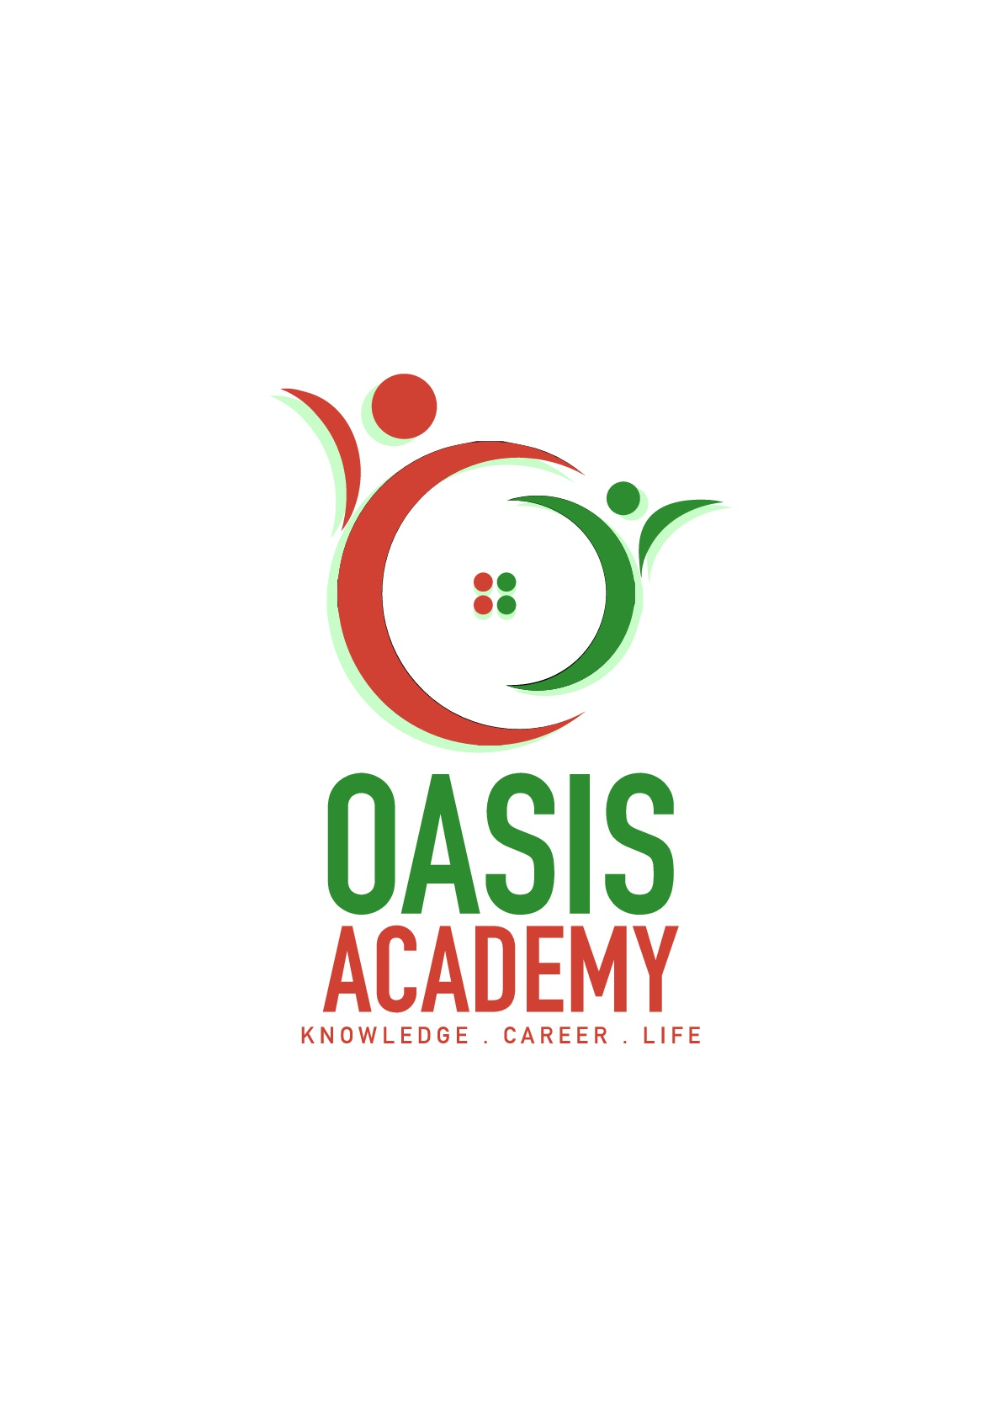

Name: Ng Kah Jun

Login ID: ngkahjun@oasis-portal.com

Course title: Essentials of Marketing and Customer Relationship

Subject Code: BHM02

Submitted date: 17 July 2017

**Table of Contents**

|  |  |  |
| --- | --- | --- |
| **No** | **Details** | **Page** |
| 1 | Executive Summary | 2 |
| 2 | Introduction | 3 |
| 3 | Assignment Question |  |
|  | Question 1 | 4 - 5 |
|  | Question 2 | 6 - 7 |
|  | Question 3 | 8 |
|  | Question 4 | 9 - 10 |
| 4 | Conclusion | 11 |
| 5 | References | 12 |
|  | Appendix | 13 |

Executive Summary

The clarification behind this endeavor is to be able to understand earnestness showing and client advantage better and moreover knowing the fundamentals in advancing and client advantage in neighborliness association which will help me in future. Showing despite client relationship is a business framework in which customer affiliations, client reliability and brand respect are worked through advancing strategies and exercises. As an issue of first importance, I will present four regions which entitled in this errand. In basic area, I will light up about advancing in invitingness and the criticalness of neighborliness showing. Besides, in second part I will light up about the refinement between showing verses client advantage. In a similar part moreover, I will clear up about the morals of progressing and client advantage. In third part, I will depict about showing frameworks and develop the most ideal approach to manage apply my examinations in Neighborliness Association. At last, in fourth part I will quickly clear up about client advantage aptitudes and qualities. Obviously, I likewise will clear up the significance of neighborliness client advantage in this part. From each part, we can find a few solutions concerning the significance and the parts of displaying and client advantage in kind mien association.

Introduction

As an issue of first criticalness, we should know importance and envision of showing and client advantage. The association framework through which things and attempts move from thought to the client is called advancing. Client advantage deduces client advantage is the show of dealing with the client's needs by giving and passing on competent, obliging, five star association and help some time starting late, amidst and after the client's necessities are met. Client association and publicizing ought to have a fitting relationship. The two ought to go as one like nutty spread and stick. Right when your business concentrates on mind boggling client advantage as your propelling system, it energetically impacts your fundamental concern, decreasing your business expenses and developing your costs. It is crucial for relationship to change the procedures of old and have displaying and client advantage take an interest, as every division can make alternate's business less troublesome and satisfy objectives speedier. When showing and client advantage clusters arrange, it handles one of the dug in issues of client advantage being uninformed of the unprecedented degrees of progress that the propelling social affair uncovered. In the interim it additionally manages another issue that happens today, when poor client advantage accomplishes an issue for the online frameworks organization propelling division of the working environment. As a conclusion, we can see that advancing and client advantage is one of the insightful match which overhauls the possibility of business.

Question 1 :

In any business, a solid showing system is basic to building a brand, attracting new customers and regulating to commitment. The altruism business is the same. Since customer dependable quality is basic, moving managers and experts display a huge measure of time and resources for building brand care and making enduring, interconnected campaigns. These showing tries typically consolidate both print and mechanized security that goal past guests while in like path pulling in new clients. Regardless, this particular industry has a spellbinding game-plan of troubles that must be overcome. Understanding the basics of advancing in the settlement business can empower you to outperform wants and climb in the charging work communicate.

Neighborliness bargains are not absolutely the same as purchaser stock strategies since advertising specialists must offer liberal and moreover unessential things. An amazing bit of the time this infers they are demonstrating affiliations as opposed to things, and accomplishment depends in the wake of making the right feeling in the buyer. For example, a resort ought to build up a discharging up, fun air that is unmistakable to customers and rouses those same feelings in the purchaser. Since the sparkle business is generally included tourism and other experiential affiliations, a proven brand character is besides principal. Advertising specialists need to ensure that brand attestation exists with the objective that customers will use their relationship again and again. Repeat customers procure a sizeable piece of pay, so indicating approach must be part between keeping up relationship with past customers while looking out new ones.

Relationship in the convenience business use diverse methodologies to make and keep up a proper impelling game-plan. The running with are a bit of the general frameworks that promoters use for check accomplishment. Customers pick lodgings and various neighborliness relationship for a social event of reasons. From range to workplaces and perfect conditions, affiliations must ensure that they're giving what buyers are looking to. The bit of promoters is to perceive what factors make customers pick a particular settlement affiliation, and this requires wide research. By tending to present and past guests, watching customer reviews on objectives, looking at industry data and that is starting late the starting, publicizing specialists perceive what makes a settlement advantage make, and besides how it can be made progress.

If potential customers don't consider an affiliation, they can't get it. That is the place check mind comes in. Promoting specialists guarantee information on motels, resorts and restaurants is unquestionably not hard to find and great. They can do this by buying notice space on material travel targets, making an attracting site and organizing with other, noncompeting honesty benefits in a close market.

Another quick system for pulling in customers is to run developments in the midst of particular conditions of the year, all things considered when business is slower. Exhibiting blending qualities and offering inspirations are beginning late a touch of the ways that showing specialists finish this. Have you acquired a Groupon for a spa end of the week? That is development at work.

To ensure raised measures of repeat business, unprecedented customer affiliations are principal. Not only do rehash customers as a rule push a relationship through verbal trade and web dealing with, regardless of they also make a consistent pay base. One way to deal with oversee make affiliations is through customer unfaltering quality assignments, which compensate customers who routinely use a particular kind demeanor advantage.

Question 2:

The client advantage and the pushing divisions of an association are routinely two unmistakable and taking everything in account striking work environments. Regardless, sharp affiliations appreciate that these days of electronic social facilitated exertion and online outlines that client alliance and progressing go as an indistinct unit. It is fundamental for relationship to change the philosophies of old and have progressing and client advantage support, as every division can make the other's work less asking for and satisfy targets snappier. When appearing and client advantage packs work together, it appreciates one of the bird in issues of client advantage being unwise as for the brilliant degrees of propel that the driving party progresses. In the mean time it other than manages another issue that happens today, when poor client advantage accomplishes an issue for the electronic structures affiliation driving division of the working environment. Today, we will assess some client advantage procedures and structures that will keep clients and customers enthusiastic, so hostile online examinations or electronic individual to solitary correspondence remarks don't change into an issue for the pushing division. The exhibiting morals are circulated in 5 which are Proposition to make a move (CTA) Appearing, Insufficiency Progressing, and Regard based Publicizing, Relationship Appearing, and Verbal Showing up,

Proposition to make a move (CTA) Appearing. CTA Raising determines frameworks for changing over web change into leads or methodologies on territories utilizing substance, depictions, or unmistakable parts of website union. Changes structures help update the rate of online guests who progress toward observing the chance to be clients or who join the mailing list.

Insufficiency Progressing. In a couple of business parts it's central to control how much thing is open at one time. In light of current conditions this is done stuck in a detestable circumstance of getting foul materials or higher nature of the thing. An organization together may make their things open to just a few clients. Moves Royce's arrival of their Chinese editioncar called Apparition sold rapidly. While the cost of the auto was higher than most cars the need drove the throbbing and the cost.

Regard based Publicizing. Driving methodologies can be attempting, particularly for retailers that need to reliably contribute things high volume to purchasers. Inspecting the true blue goal to remain with the offers of cash related experts, retailers need to request that purchasers purchase utilizing coupons, rebates, liquidations, and outlines occasions. High volume immense box retailers like Target are persistently running amazing occasions checking on the true blue goal to get enchanted purchasers into their stores.

Relationship Appearing. Distinctive affiliations concentrate on building association with their clients rather than constantly particular trying to offer them something (regard based publicizing). Clients who treasure your photo more will moreover encounter more cash with your photo. Different standard retailers have watched this to be basic. Walgreens has seen that clients who purchase from a large portion of their getting channels (store, web, unimportant, and whatnot) purchase up to six times more than the standard client that first class purchases in their store.

Verbal Show. Verbal Exhibiting is the death of data from individual to individual by oral correspondence. Clients are particularly on edge to offer to the world the brands they appreciate. Particular clients discover centrality in sharing stories of their most treasured things and affiliations. Pleasing exchange is one of the out of date ways individuals found two or three game plans concerning what to buy. Current promoters have acknowledges how to make genuine verbal exchange for their affiliations and the things they address.

Beginning now and into the not so distant, the morals of client advantage are Producer, Writer, Valuable Individual, Skilled and Facilitator.

The first is Creator. The Relator is worried over every individual's needs and intrigue and identifies with every individual's perspective. There is a solid need to make the client can take in a moan of facilitating. Additionally, the Relator has a tendency to contribute excessively time and criticalness with individuals who make them can unwind.

Following with, Journalist. The columnist feels an individual commitment as for help every client, and necessities to make them feel wonderful. The Communicator tends to concentrate on observing and directing issues and likes to show and genius how advantage is master. There is a getting a kick out of the chance to make the changing practices fit the one of kind needs of the client.

Thus the third is Sure researcher. The Positive driving force feels an insistence to educate and influence the client in the power and cutoff of association. The Fan is dubious to the necessities and interests of the client yet may remove them in the criticalness to demonstrate worth. There is an inclination to put off changing exercises in the event that he/she presumes that the client does not comprehend the correct inverse thing.

The fourth continues with Skilled. The Proficient focuses on completing things and to getting things going. He/she concentrates on managing the client's issues. The Ace may slight difficulties, expect that agree and move will client's changing winds before the client is prepared.

Coordinator.. The Coordinator concentrates on control and initiate, and demonstrates the solid decision that the association will offer. He/she has a tendency to expect that the client's needs and interests are reflected in their answers. Facilitators may twist up perceivably on edge and basic if the client is not influenced by their diagram.

Question 3 :

It requires an enormous measure of meander and push to make and keep up a publicizing exertion that reverberates with your objective social affair. As a key central purpose, in any case, the change of a publicizing exertion takes fundamentally more idea. Considering, we're constantly seeking after down ways to deal with oversee get the astoundingly principal centered edge. There are times, in any case, when we in general in all hit the remarkable divider. If you end up in that condition, by then you may need to take a gander at these fifteen moving systems that will begin your inventive criticalness.

Handle customer made substance. As showed up by an examination of 839 millennial, they eat up through "5.4 hours dependably with content made by their assistants. This watches out for 30 percent of their total media time and is encouraged just by all standard media sorts joined (print, radio, and television, at 33 percent)." In a commensurate report, "Millennial composed that UGC is 20 percent more inducing on their purchase decisions than other media." You can finish this by having customers share specific stories exchange considerations and by giving them the instruments to make a movement for you or through stun factor.

Collaborate with influencers. Another way to deal with oversee get another get-together of spectators and grow check mind is by teaming up with the best influencers in your industry. Home change store Lowe's allowed "top makers and mother bloggers to recognize control over its Instagram address a couple of days on end." By drawing in these influencers to share raising substance, Lowe's could manhandle another social event.

Connect with customers to deal with an issue. As splendidly passed on HubSpot, "You're set up to go in light of the way that you give outlines." A bit of the ways you can connect with customers to deal with an issue is by: making how-to-content; offering exclusives that make their lives less requesting; tuning in/responding to them; or making applications/instruments. You could in like way make a campaign like Orca Chevrolet did in Brazil. The connection participated with an area tow alliance and spared stranded drivers by getting in contact in the new Orca. Not simply chivied save the day, it in like manner engaged drivers to test drive the auto.

Empower customers to interface. In spite of the thing or affiliation you're impelling, your customers need to chat with your association, or perhaps momentous customers. AMC, for example, made an online mechanical party that empowered you to Insane individual Yourself. American Express interfaces business visionaries to each other and obliging resources through its OPEN Trade.

Really start to manage Apple. Apple justifies astonishing say generally since it's a photograph that has made an entire time of critical developed promoters. In what way may they complete this? Remember when the iPod was appeared? Mac's at demonstrate obvious procedure included affectability, focus, and credit when they used configurations of people getting a charge out of the iPod. It won't not have been the best MP3 player, yet rather it made brand accreditation that organized the market.

Question 4

Decisively when most business indications talk about customer advantage aptitudes, things like "being a social butterfly" tend to take the spotlight. It isn't so much that this trademark is all around wrong, yet it's so broken and non-particular that it is not by any techniques a help to those expecting to get required in help positions inside an association, and positively doesn't help business visionaries/originators who are pursuing down the right approach of points of confinement while enrolling the exceedingly fundamental individuals will's character managing their customers.

Genius. If you don't see this near the most imperative purpose behind a customer advantage limits show up, you should essentially stop inspecting. Not only is assurance principal to customers, who routinely interface with help when they are baffled and disillusioned, yet in the interim it's fundamental to the business all over the place: we've shown you before that amazing affiliation beats speedy affiliation every last time. However enduring quality shouldn't be used as an elucidation behind lazy affiliation either! Derek Sivers cleared up his view on "slower" advantage like an association where the time proceeded with the customer was used to better esteem their issues and needs from the alliance.

Care. The ability to truly tune in to customers is so basic for giving unprecedented help of different reasons. Seven days back I went over several customer input structures, and some time before that I appeared to you the data on why tuning in to customer feedback is a level out prerequisite for two or three affiliations who are expecting to make. In spite of how it is central to concentrate on particular customer interests (seeing the dialect/terms that they use to depict their issues), however then it's imperative to be careful and mindful to the info that you rouse permitted to move around deliberately.

Clear Social cutoff points. Accreditation you're getting to the present issue quickly; customers needn't issue with your account or to find a few solutions concerning how your day is going. More fundamentally, you ought to be watchful about how some of your correspondence affinities mean customers, and it's best to bungle for caution at whatever point you wind up investigating a condition.

Time Affiliation Breaking points. Hi, paying little heed to my many research-upheld tirades on why you should contribute more prominent hugeness with customers, particularly there is a most extreme, and you ought to be stressed over getting customers what they require in a productive manner. The trap here is this should in like way be connected while seeing when you fundamentally can't help a customer. In case you don't have the foggiest thought concerning the response for an issue, the best kind of assistance part will get a customer over to some person who does.

Conclusion

In this part, I at long last learned and secured about showing and client association and how it's related in neighborliness association. Lifting despite client relationship is a business technique in which customer affiliations, client responsibility and brand respect are worked through publicizing structures and exercises. Furthermore, advancing expect an essential part in the lodging business. In light of the errand, it is expected that progressing has a colossal impact in any lodging outlet and in the lodge business as a rule. Subsequently, the person who ought to be gainful in the sparkle extend particularly motel industry should give careful idea to progressing. Additionally, the interests in advancing by motel association ought to be particularly dealt with to such a degree, to the point that assorted parts of the lodging business are in like way put into thought while showing choices are being taken. Things being what they are, showing ought to be made with imaginative work, back and time to state yet a couple. Since advancing makes a period of navigate any hindrance between a motel and its clients, it is principal that an inn as an affiliation guarantees that the correct messages are slighted transversely to the clients with its showing effort. Moreover, a legitimate objective of raising ought to be the help of a win-win circumstance between the inn and the clients. The lodging association ought to get the best and reasonable displaying frameworks that serve the energy of the relationship without endangering the fervor of the clients. On the other, client advantage besides one of the critical part in warmth association which joined with showing to make a win business. Other than that, limits and properties in client advantage in like way one of the part which must gave a high mindfulness regarding give quality occupation and association in kindness association. As general conclusion, we ought to consider progressing and client advantage carefully and fundamentally to enhance or accumulate splendid business in neighborliness association.

References

* <https://www.strath.ac.uk/courses/undergraduate/marketinghospitalitytourismmanagement/>
* <http://www.answers.com/Q/How_marketing_help_in_increasing_national_income>
* <http://as.wiley.com/WileyCDA/WileyTitle/productCd-0471206032.html>
* <https://www.quora.com/How-does-marketing-increase-the-standard-of-living-of-people>
* <http://www.northwestbusinesslife.co.uk/news-item/the-importance-of-customer-service-in-the-hospitality-industry/>
* <https://online.csp.edu/blog/business/the-importance-of-marketing-in-the-hospitality-industry>
* <https://urbanxnilsson.wordpress.com/>
* <http://cultbranding.com/ceo/52-types-of-marketing-strategies/>

APPENDIX

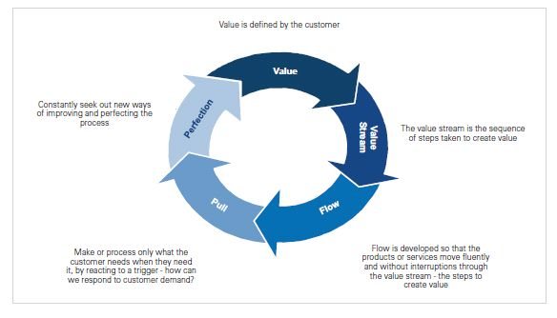

Figure 1.1 : Value is Defined By Customers